The InfoSlicer GUI panes
All of the screenshots are based on the Giraffe Wikipedia article at http://en.wikipedia.org/wiki/Giraffe in September 2008.

The Library Pane
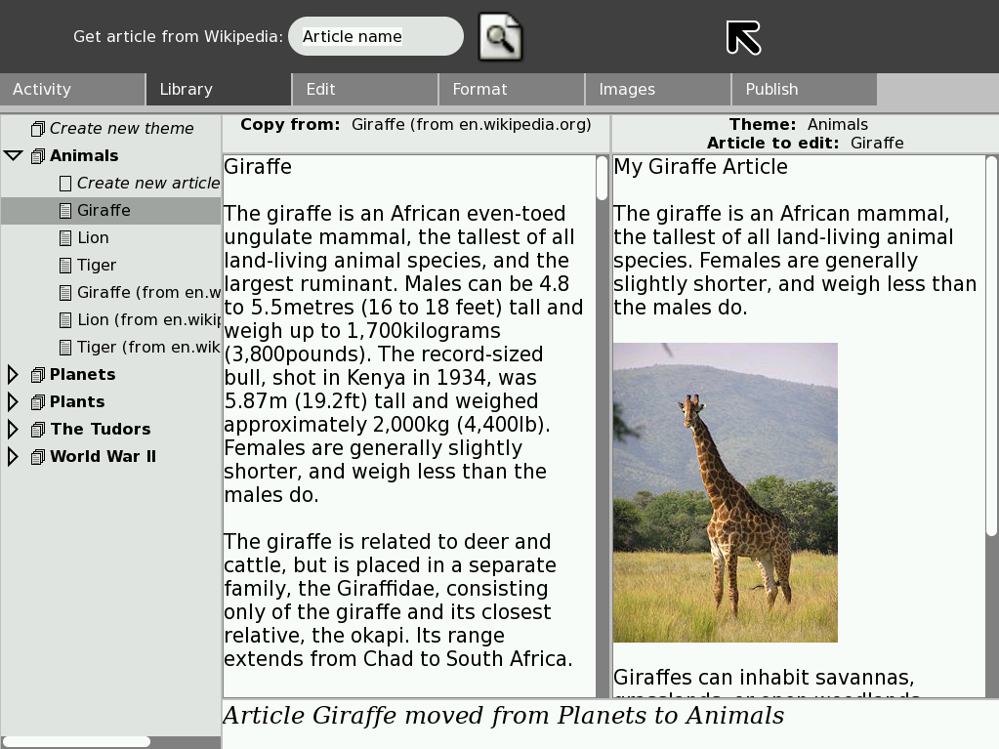
The Library pane deals with the creation, saving, loading and organising of articles. The diagram below shows a screenshot of the library pane.

The tree-view on the left hand side of the diagram shows the articles and themes. The article that is highlighted is the “Giraffe” article, which is in the “Animals” theme. There is a status bar at the bottom of the page.

In the toolbar at the top of the page, there is a search dialog, which will download and save articles from Wikipedia into the currently selected theme.

Users can drag articles from the tree on the left into the two main text boxes in the middle of the screen. The two text boxes represent a “source” article, from which content can be copied, and the user's version of the article.

The user selects which article is to be used as the source, and which article is to be edited. They would then proceed to the edit pane.

The Edit Pane

The edit pane is the first place the user would go after selecting articles in the library pane. It allows dragging and dropping from the source article into the destination article. There are various levels of selection snapping available to make the copying as simple as possible.

The diagram below shows a screenshot of the Edit pane.

The source article is displayed on the left, and the user's editing version is displayed on the right. The user can select text on the left but editing is disabled. There is a drop-down menu for users to select different source articles from the theme they are currently working in.

The Format Pane
The format pane only deals with the user's working version. It gives them a standard formatting toolbar and they can apply formatting like they would in any regular text editor. Most of the formatting options are disabled in the prototype InfoSlicer tool.

The diagram below shows the Format pane:

The Images Pane
The images pane loads the images associated with an article. In the prototype tool, when articles are downloaded from Wikipedia, the associated images are also downloaded. The user is presented with a view very similar to the Edit pane, except instead of viewing the text of the source article, they see the images.

The diagram below shows a screenshot of the Images pane.

Much like the Edit pane, there is a drop-down menu for users to change article to other articles in the current theme. Clicking and dragging an image from the left will allow users to insert the image and caption into their article. The example shows that an image of a giraffe has been inserted.

The Publish Pane

The Publish pane allows users to select articles within a theme to publish. Clicking the publish button will then perform the platform-specific publishing action, as detailed in the InfoSlicer overview.
The diagram below shows the publish pane.

Output
On the Sugar platform, publishing content results in a book being added to the browse application. The diagram below shows this.

Clicking on the book brings up the index web page. In a Windows or Linux environment, the user would double-click on the output file, which would open the same page below but in their default browser.
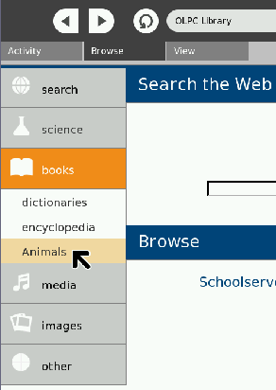

The diagram below shows the output article.
