InfoSlicer tutorial

InfoSlicer is an open source tool
to enable teachers to quickly and easily
select web-based content to edit, package,

and distribute as teaching materials.
When you start InfoSlicer, the Edit view is displayed. A selection of articles from Wikipedia is downloaded already. One of the articles, the Wikipedia article called Giraffe is displayed in the left pane. In the right pane is an empty article called Giraffe.
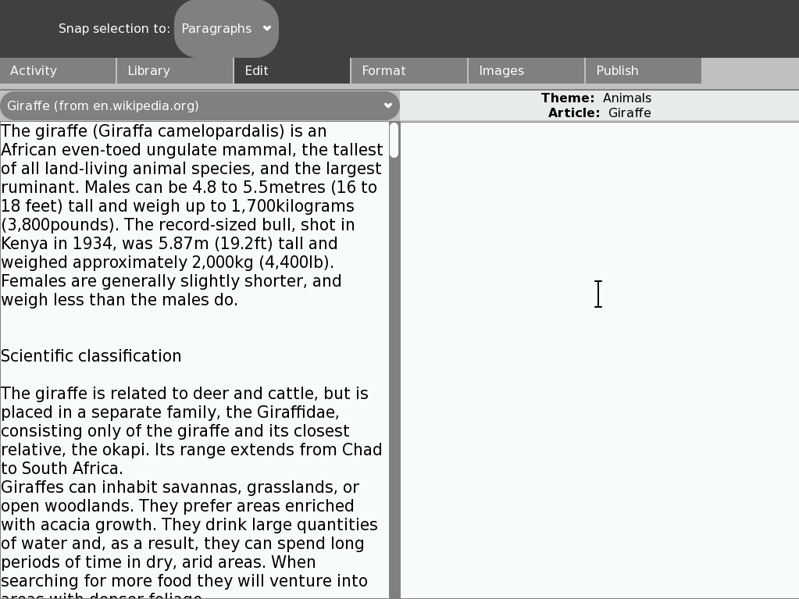
1. Add information to your article
First, add information to the empty Giraffe article by copying information from the Wikipedia Giraffe article:
- Click and drag the mouse pointer over a sentence in the Wikipedia Giraffe article (left pane). The sentence is highlighted to show that you have selected it.
- Click the sentence again and drag it across to the empty Giraffe article (right pane).
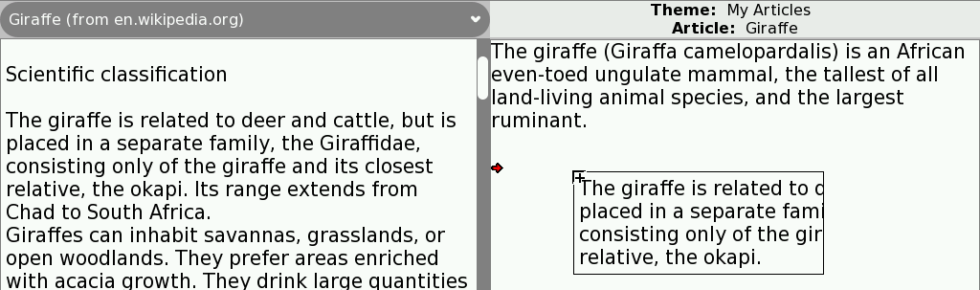
- Continue to copy as many of the sentences as you like from the Wikipedia article into your new article.
- At any time, you can click in the right pane and edit (type new text or delete existing text) the information in the new Giraffe article.
You can also select text in the new article and move it to a new position in the article.
You can remove text from your article by selecting it and then pressing the erase key.
When you click a tab to move to a different page, the content that you add to your article is automatically saved in the Journal so that you won't lose your work.
2. Add pictures to your article
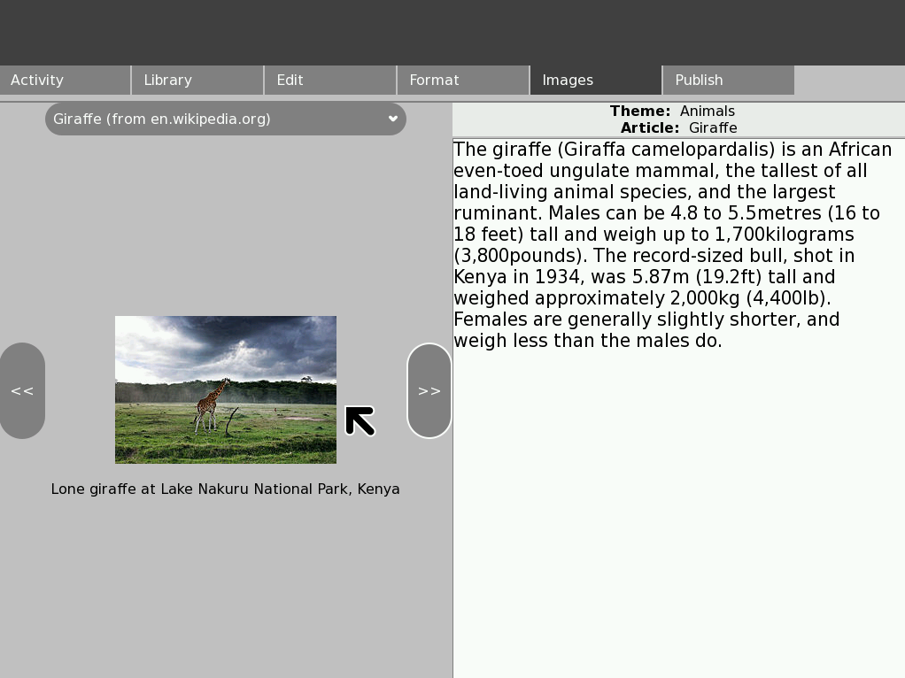
- If you want to add pictures to your Giraffe article, click the Images tab.
- In the Images view, click the arrows to see the images, then click and drag each image that you want into your article. You can remove an image from your article by selecting it and then pressing the erase key.
3. Format the text in your article
The Format page is not complete but, in a future release, you will be able to apply formatting (for example bold text) to the text in your article.
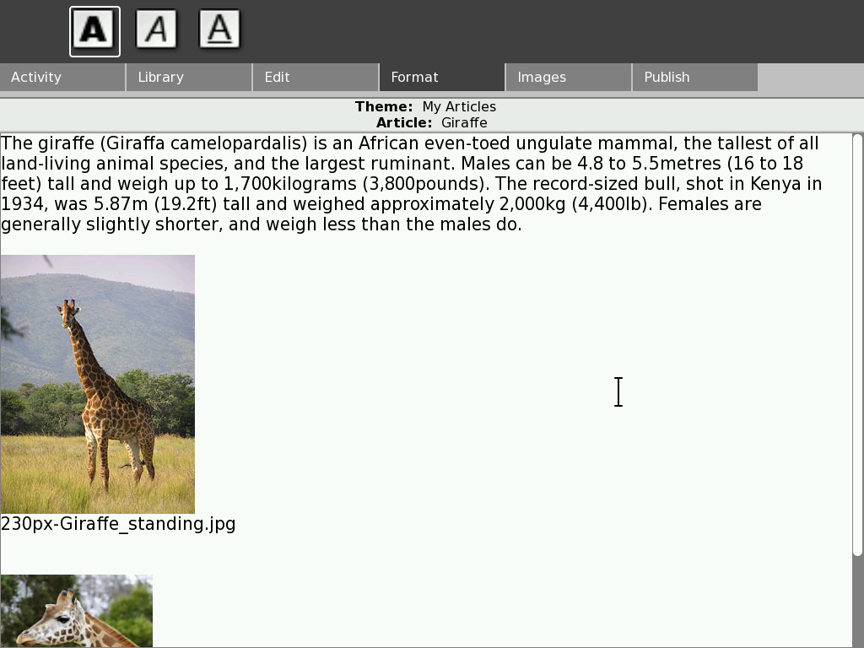
4. Add information from another Wikipedia article
You can use information from several Wikipedia articles in your article. For example, you could add information from the Lion article if you want to include in your article information about whether lions like to eat giraffes.
- Return to the Edit view by clicking the Edit tab.
- Click the drop-down menu above the Wikipedia article in the left pane, then click the Lion article. The Lion article from Wikipedia is now displayed in the left pane (your Giraffe article is still displayed in the right pane).
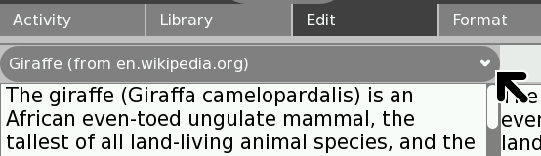
- Click and drag relevant sentences from the Lion Wikipedia article (left pane) into your Giraffe article (right pane).
- You can add more pictures if you want.
5. Create a new empty article and organise the articles in a theme
As you create new articles, organise those articles in themes so that you can publish the set of articles.
Click the Library tab to open the Library view.
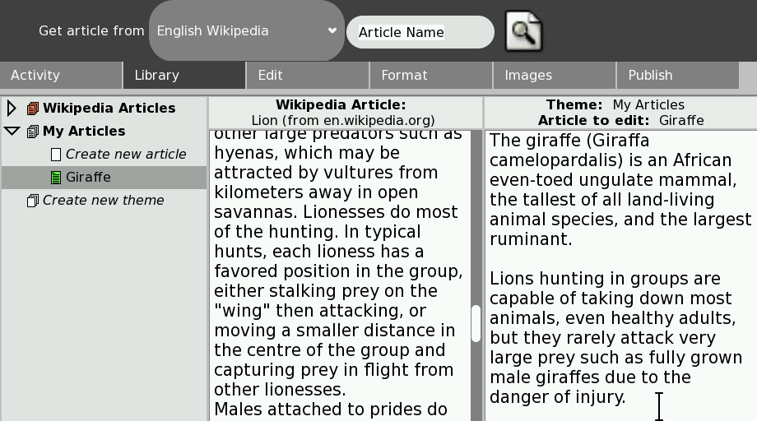
The Library view shows the contents of your library on the left (all the Wikipedia articles you have stored on your computer and all the articles that you have created yourself).
The middle and right panes of the Library view show a preview of the two columns in the Edit view.
In the left pane is a list of the Wikipedia articles that are stored on your computer. They are automatically organised into a theme called Wikipedia Articles. The Wikipedia Articles theme is a special theme that can contain only articles from Wikipedia. You cannot change the name of this theme or create new articles in this theme.
Below the Wikipedia Articles theme is a theme called My Articles. The Giraffe article that you just edited is stored in the My Articles theme.
Now, you will create a new theme called Animals and move your Giraffe article into the Animals theme:
- In the list, click the Create new theme entry to select it then click it again so that you can rename it. Type Animals, then press enter to rename the theme. This is your new Animals theme.
- In the list, click and drag your Giraffe article from the My Articles theme and drop it on your new Animals theme. Your Giraffe article is now displayed in the Animals theme instead of the My Articles theme.
- Under the Animals theme entry in the list, rename the Create new article entry to Zebra. You have now created a new, empty article called Zebra in the Animals theme.
- Click and drag your new Zebra article to the right pane of the Library view (the third pane which currently contains your Giraffe article). The new, empty Zebra article replaces the Giraffe article (the Giraffe article is stored safely on your computer so you haven't lost it).
- In the Wikipedia Articles theme is an article from Wikipedia called Zebra (en.wikipedia.org). Click this Zebra Wikipedia article and drag it to the middle pane so that it replaces the Lion Wikipedia article.
- Click the Edit tab to return to the Edit view. The left pane contains the Zebra Wikipedia article, and the right pane contains your new, empty Zebra article.
- You can now add content to your new Zebra article in the same way as you added content to your Giraffe article.
6. Publish a theme of articles
The Animals theme contains two articles called Giraffe and Zebra. You can publish these articles so that they can be viewed in the Browse activity.
- Click the Publish tab to open the Publish view.
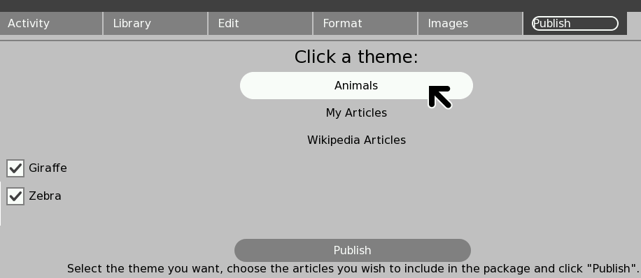
- Click the Animals button to select the Animals theme. The articles that are available in the Animals theme are listed. At the moment there are only two articles in the theme and you want to publish both articles.

- Make sure that the check boxes next to both articles (Giraffe and Zebra) are checked, then click the Publish button. The Animals theme is published to the Journal.
7. View your published articles on your own computer
To view the published articles on your own computer:
- Start the Browse activity. In the menu on the left of the Browse activity,
- Click books. Your published Animals theme is listed there.
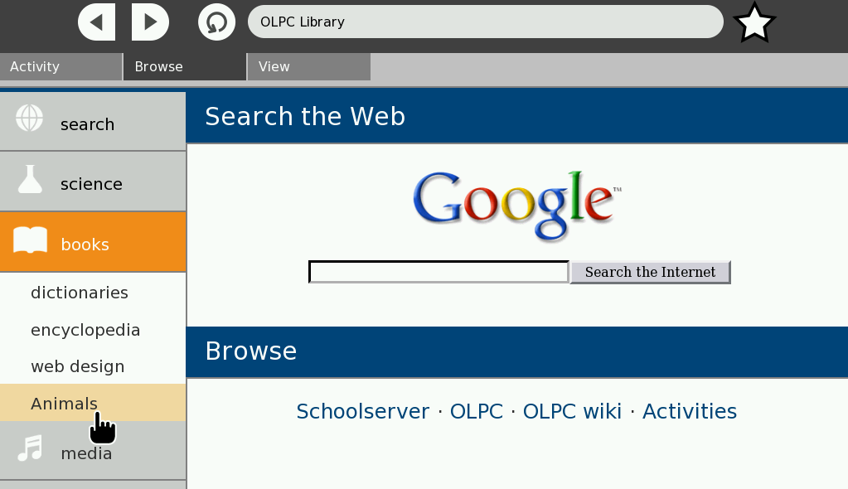
- Click Animals to display the articles.
8. Send your published articles to other computers
In the Journal, you can copy the Animals theme that you published to a USB drive so that you can copy the published articles to other computers.
- Open the Journal. The Animals theme that you published has an entry in the Journal.
- Put the USB drive into your computer then copy the published Animals theme from the Journal to the USB drive.
- Put the USB drive into another computer then copy the Animals theme from the USB drive to the Journal of that computer. The published Animals theme is now displayed in the Journal on the computer.

To view the articles in the Browse activity:
- Start the Browse activity. In the menu on the left of the Browse activity.
- Click books. Your published Animals theme is listed there.
- Click Animals to display the articles.
9. Get more articles from Wikipedia
So far, you have edited and published articles based on Wikipedia articles that were already stored on your computer as part of the InfoSlicer activity. You can get more articles from Wikipedia to create information for other teaching themes.
- In InfoSlicer, click the Library tab to display the Library view. On the toolbar at the top of the screen is a box where you can type the title of the article that you want to get from Wikipedia.
- Type in the box (where it says Article name) the title of the article (for example, Saturn, Romans, or Dinosaur), then press .
- Wait for a moment while the article is downloaded from Wikipedia to be stored on your computer.
- Type in the names of other articles, one at a time, to download as well.
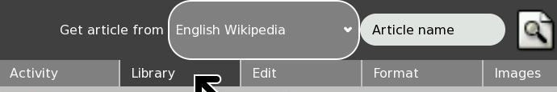
All of the articles that you download from Wikipedia are added to the Wikipedia Articles theme in your library.
You can now create a new theme and create new articles in that theme. You can then add information from one or more Wikipedia articles to your new articles.
When you have finished creating your new articles, you can publish the new theme of articles so that you can distribute it to the computers of the children in your class.

