**JHRM**Information Technology

**Daftar Isi**

Job …………………………………………………………………………………………………………………………………………………………

Job Titles ……………………………………………………………………………………………………………………………………….

Pay Grades ……………………………………………………………………………………………………………………………………

Employment Status ………………………………………………………………………………………………………………………

Job Categories ………………………………………………………………………………………………………………………………

Organization ………………………………………………………………………………………………………………………………………….

General Information ……………………………………………………………………………………………………………………..

Location ………………………………………………………………………………………………………………………………………..

Structure ……………………………………………………………………………………………………………………………………….

Qualification ………………………………………………………………………………………………………………………………………….

Skill ……………………………………………………………………………………………………………………………………………….

Education ………………………………………………………………………………………………………………………………………

Licenses …………………………………………………………………………………………………………………………………………

Languages …………………………………………………………………………………………………………………………………….

Memberships …………………………………………………………………………………………………………………………………

Nationality ……………………………………………………………………………………………………………………………………………..

Employee ……………………………………………………………………………………………………………………………………………….

Leave ……………………………………………………………………………………………………………………………………………………..

Leave List ………………………………………………………………………………………………………………………………………

Assign List …………………………………………………………………………………………………………………………………….

Recruitment …………………………………………………………………………………………………………………………………………..

Candidates …………………………………………………………………………………………………………………………………….

Vacancies ………………………………………………………………………………………………………………………………………  
*Parameter Upload**– New* ………………………………………………………………………………………………………………………*Upload Currency*…………………………………………………………………………………………………………………………..

* **Master**

1. Job
2. Job Titles

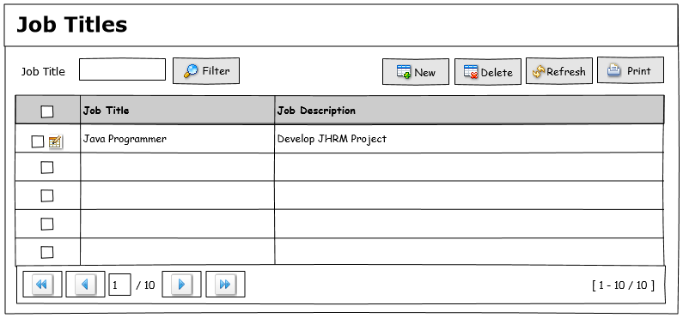

Database : dbhr  
Schema : schema_hr  
Tabel : mst_jobtitle  
Keterangan : -

|  |  |  |
| --- | --- | --- |
| **Column Name** | **Type Data** | **Description** |
| id_job_title | integer NOT NULL |  |
| job_name | character varying(25) |  |
| job_description | character varying(100) |  |
| job_note | character varying(100) |  |

|  |  |
| --- | --- |
| **Component** | **Function** |
| List Data | * SELECT * FROM SCHEMA_HR.MST_JOBTITLE MJT ORDER BY MJT.JOB_NAME ASC; * Row 15/page * Paging 10/page * Paging table |
| Button Filter | * Searching like Job Title |
| Button New | * Pastikan Component Textboxt terbuka di baris pertama saat button di klik |
| Button Delete |  |
| Button Refresh | * Refresh db dan refresh listbox |
| Button Print | * - |
| Edit Cell | * Pastikan Component Textboxt terbuka saat memilih row yang akan di edit dan terisi sesuai value yang terpilih * Update ke table saat button save di klik * UPDATE SCHEMA_HR.MST_JOBTITLE SET JOB_NAME=?, JOB_DESCRIPTION=?, JOB_NOTE=? WHERE ID_JOB_TITLE = 1; * Pastikan pesan sukses dimunculkan setelah eksekusi ke database berhasil * Kembalikan seperti keadaan semua saat buka menu pertama kali |
| Save Cell | * Insert ke table * INSERT INTO SCHEMA_HR.MST_JOBTITLE(ID_JOB_TITLE, JOB_NAME, JOB_DESCRIPTION, JOB_NOTE) VALUES (?, ?, ?, ?); * Pastikan pesan sukses dimunculkan setelah eksekusi ke database berhasil      * Kembalikan seperti keadaan semua saat buka menu pertama kali |
| Reset Cell | * Kembalikan seperti keadaan semua saat buka menu pertama kali |
| Delete Cell | * Delete Row yang dipilih * Pastikan pesan konfirmasi keluar sebelum mengeksekusi delete table ke database * DELETE FROM schema_hr.mst_jobtitle WHERE mst_jobtitle.id_job_title = ?; * Pastikan pesan berhasil keluar setelah klik ok |

1. Pay Grades

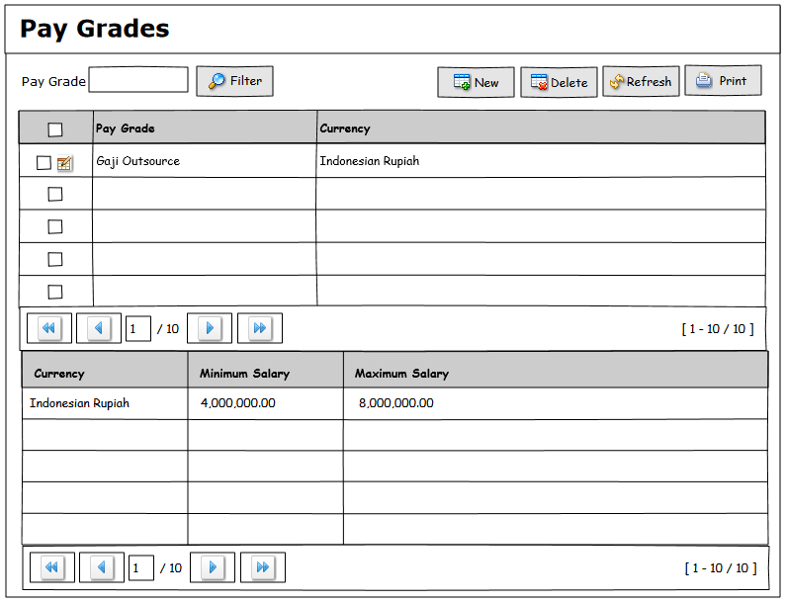

Database : dbhr  
Schema : schema_hr  
Tabel : mst_paygrade, mst_pagrade_currency  
Keterangan : -

|  |  |  |
| --- | --- | --- |
| **Column Name** | **Type Data** | **Description** |
| id_paygrade | integer NOT NULL |  |
| paygrade_name | character varying(25) |  |

|  |  |  |
| --- | --- | --- |
| **Column Name** | **Type Data** | **Description** |
| id_paygrade_currency | integer NOT NULL |  |
| id_currency | character varying(3) |  |
| min_salary | bigint |  |
| max_salary | bigint |  |
| id_paygrade | integer |  |

|  |  |
| --- | --- |
| **Component** | **Function** |
| List Data | * SELECT * FROM SCHEMA_HR.MST_JOBTITLE MJT ORDER BY MJT.JOB_NAME ASC; * Row 15/Page * Paging 10/Page * Paging Table |
| Button Filter | Searching Like Job Title |
| Button New |  |
| Button Delete |  |
| Button Refresh | Refresh DB and Refresh Listbox |
| Button Print | - |

1. Employement Status

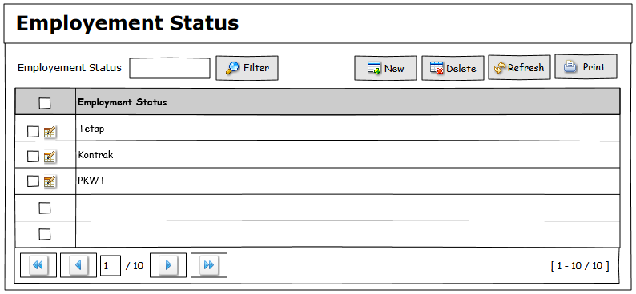

Database : dbhr  
Schema : schema_hr  
Tabel : mst_employement_status  
Keterangan : -

|  |  |  |
| --- | --- | --- |
| **Column Name** | **Type Data** | **Description** |
| id_employement_status | integer NOT NULL |  |
| employement_status_name | character varying(25) |  |

|  |  |
| --- | --- |
| **Component** | **Function** |
| List Data | * SELECT * FROM schema_hr.mst_employement_status ORDER BY mst_employement_status. employement_status_name ASC; * Row 15/Page * Paging 10/Page * Paging Table |
| Button Filter | Searching Like Job Title |
| Button New |  |
| Button Delete |  |
| Button Refresh | Refresh DB and Refresh Listbox |
| Button Print | - |

1. Job Categories

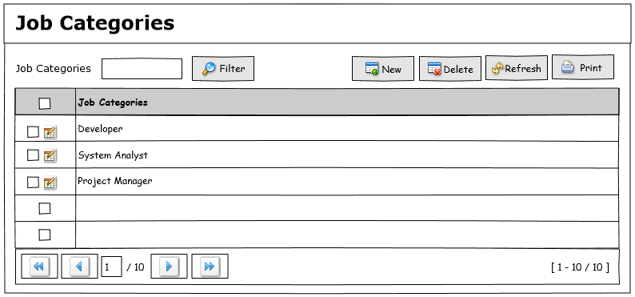

Database : dbhr  
Schema : schema_hr  
Tabel : mst_job_category  
Keterangan : -

|  |  |  |
| --- | --- | --- |
| Column Name | Type Data | Description |
| id_job_category | integer NOT NULL |  |
| job_category_name | character varying(25) |  |

|  |  |
| --- | --- |
| Component | Function |
| List Data | * SELECT * schema_hr.mst_job_category ORDER BY mst_job_category.job_category_name ASC; * Row 15/Page * Paging 10/Page * Paging Table |
| Button Filter | Searching Like Job Title |
| Button New |  |
| Button Delete |  |
| Button Refresh | Refresh DB and Refresh Listbox |
| Button Print | - |

1. Work Shifts
2. Organization
3. General Informations

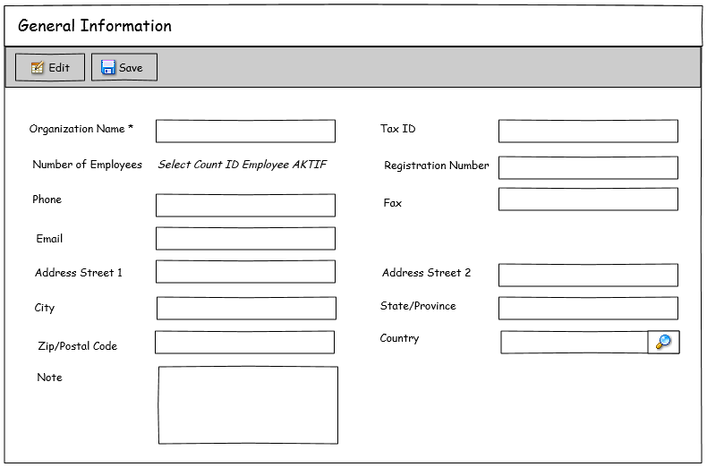

Database : dbhr  
Schema : schema_hr  
Tabel : mst_job_category  
Keterangan : -

|  |  |  |
| --- | --- | --- |
| Column Name | Type Data | Description |
| id_job_category | integer NOT NULL |  |
| job_category_name | character varying(25) |  |

|  |  |
| --- | --- |
| Component | Function |
| List Data | * SELECT * schema_hr.mst_job_category ORDER BY mst_job_category.job_category_name ASC; * Row 15/Page * Paging 10/Page * Paging Table |
| Button Filter | Searching Like Job Title |
| Button New |  |
| Button Delete |  |
| Button Refresh | Refresh DB and Refresh Listbox |
| Button Print | - |

1. Locations

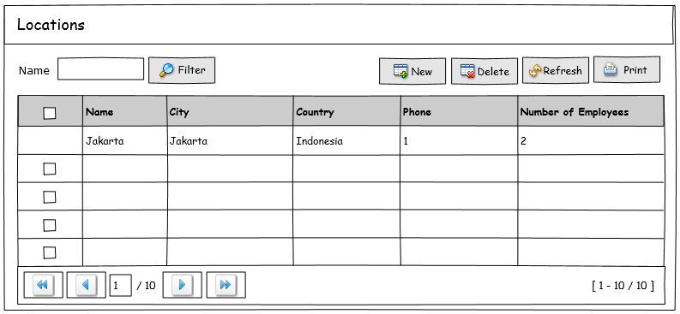

Database : dbhr  
Schema : schema_hr  
Tabel : mst_job_category  
Keterangan : -

|  |  |  |
| --- | --- | --- |
| Column Name | Type Data | Description |
| id_job_category | integer NOT NULL |  |
| job_category_name | character varying(25) |  |

|  |  |
| --- | --- |
| Component | Function |
| List Data | * SELECT * schema_hr.mst_job_category ORDER BY mst_job_category.job_category_name ASC; * Row 15/Page * Paging 10/Page * Paging Table |
| Button Filter | Searching Like Job Title |
| Button New |  |
| Button Delete |  |
| Button Refresh | Refresh DB and Refresh Listbox |
| Button Print | - |

1. Strucure

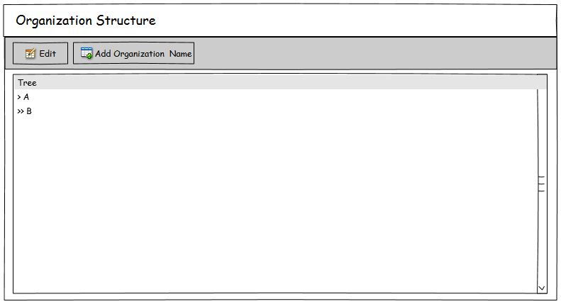

Database : dbhr  
Schema : schema_hr  
Tabel : mst_job_category  
Keterangan : -

|  |  |  |
| --- | --- | --- |
| Column Name | Type Data | Description |
| id_job_category | integer NOT NULL |  |
| job_category_name | character varying(25) |  |

|  |  |
| --- | --- |
| Component | Function |
| List Data | * SELECT * schema_hr.mst_job_category ORDER BY mst_job_category.job_category_name ASC; * Row 15/Page * Paging 10/Page * Paging Table |
| Button Filter | Searching Like Job Title |
| Button New |  |
| Button Delete |  |
| Button Refresh | Refresh DB and Refresh Listbox |
| Button Print | - |

1. Qualifications
2. Skills

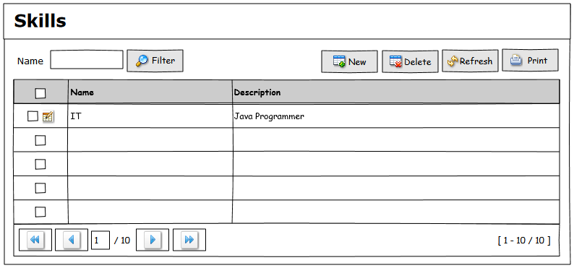

Database : dbhr  
Schema : schema_hr  
Tabel : mst_skill  
Keterangan : -

|  |  |  |
| --- | --- | --- |
| Column Name | Type Data | Description |
| id_skill | integer NOT NULL |  |
| name_skill | character varying(25) |  |
| description_skill | character varying(25) |  |

|  |  |
| --- | --- |
| Component | Function |
| List Data | * SELECT * FROM schema_hr.mst_skill ORDER BY mst_skill. name_skill ASC; * Row 15/Page * Paging 10/Page * Paging Table |
| Button Filter | Searching Like Job Title |
| Button New |  |
| Button Delete |  |
| Button Refresh | Refresh DB and Refresh Listbox |
| Button Print | - |

1. Education

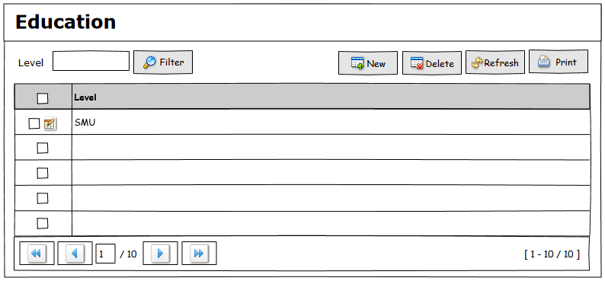

Database : dbhr  
Schema : schema_hr  
Tabel : mst_education  
Keterangan : -

|  |  |  |
| --- | --- | --- |
| Column Name | Type Data | Description |
| id_education | integer NOT NULL |  |
| education_name | character varying(25) |  |

|  |  |
| --- | --- |
| Component | Function |
| List Data | * SELECT * FROM schema_hr. mst_education ORDER BY mst_education.education_name ASC; * Row 15/Page * Paging 10/Page * Paging Table |
| Button Filter | Searching Like Job Title |
| Button New |  |
| Button Delete |  |
| Button Refresh | Refresh DB and Refresh Listbox |
| Button Print | - |

1. Licenses

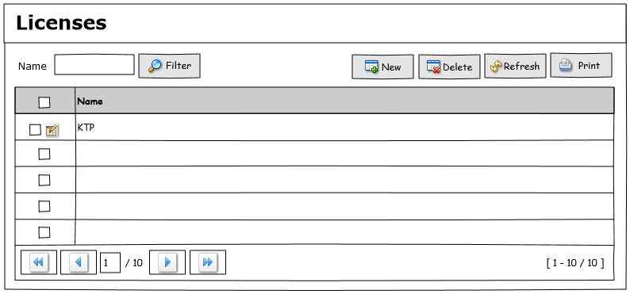

Database : dbhr  
Schema : schema_hr  
Tabel : mst_license  
Keterangan : -

|  |  |  |
| --- | --- | --- |
| Column Name | Type Data | Description |
| id_license | integer NOT NULL |  |
| name_license | character varying(25) |  |

|  |  |
| --- | --- |
| Component | Function |
| List Data | * SELECT * FROM schema_hr. mst_license ORDER BY mst_license.name_ license ASC; * Row 15/Page * Paging 10/Page * Paging Table |
| Button Filter | Searching Like Job Title |
| Button New |  |
| Button Delete |  |
| Button Refresh | Refresh DB and Refresh Listbox |
| Button Print | - |

1. Languages

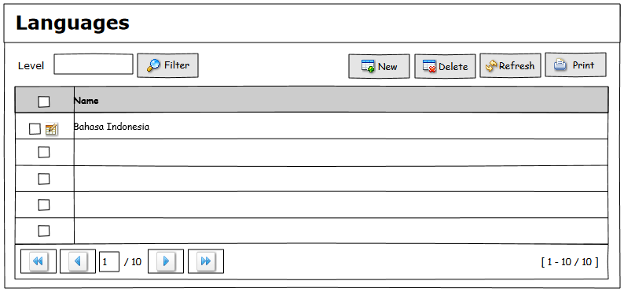

Database : dbhr  
Schema : schema_hr  
Tabel : mst_language  
Keterangan : -

|  |  |  |
| --- | --- | --- |
| Column Name | Type Data | Description |
| id_language | integer NOT NULL |  |
| name_language | character varying(25) |  |

|  |  |
| --- | --- |
| Component | Function |
| List Data | * SELECT * FROM schema_hr.mst_language ORDER BY mst_language name_skill ASC; * Row 15/Page * Paging 10/Page * Paging Table |
| Button Filter | Searching Like Job Title |
| Button New |  |
| Button Delete |  |
| Button Refresh | Refresh DB and Refresh Listbox |
| Button Print | - |

1. Membership

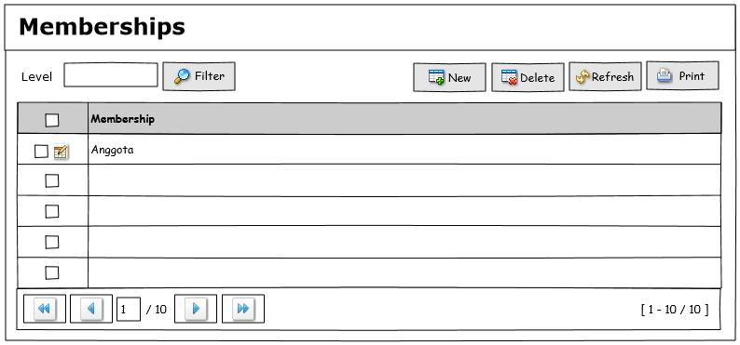

Database : dbhr  
Schema : schema_hr  
Tabel : mst_membership  
Keterangan : -

|  |  |  |
| --- | --- | --- |
| Column Name | Type Data | Description |
| id_membership | integer NOT NULL |  |
| name_membership | character varying(25) |  |

|  |  |
| --- | --- |
| Component | Function |
| List Data | * SELECT * FROM schema_hr.mst_ membership ORDER BY membership.name_ membership ASC; * Row 15/Page * Paging 10/Page * Paging Table |
| Button Filter | Searching Like Job Title |
| Button New |  |
| Button Delete |  |
| Button Refresh | Refresh DB and Refresh Listbox |
| Button Print | - |

1. Nationalities

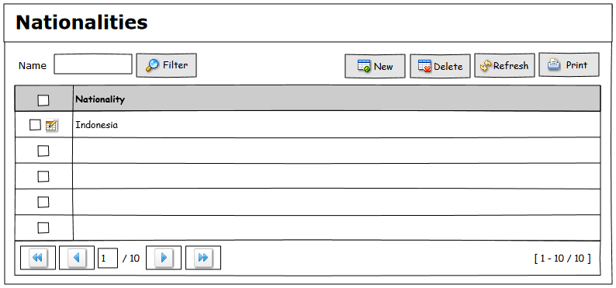

Database : dbhr  
Schema : schema_hr  
Tabel : mst_membership  
Keterangan : -

|  |  |  |
| --- | --- | --- |
| Column Name | Type Data | Description |
| id_membership | integer NOT NULL |  |
| name_membership | character varying(25) |  |

|  |  |
| --- | --- |
| Component | Function |
| List Data | * SELECT * FROM schema_hr.mst_ membership ORDER BY membership.name_ membership ASC; * Row 15/Page * Paging 10/Page * Paging Table |
| Button Filter | Searching Like Job Title |
| Button New |  |
| Button Delete |  |
| Button Refresh | Refresh DB and Refresh Listbox |
| Button Print | - |

* **Transaksi**

1. Employee

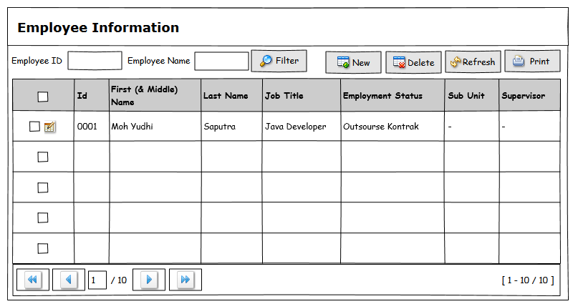

Database : dbhr  
Schema : schema_hr  
Tabel : trs_employee  
Keterangan : -

|  |  |  |
| --- | --- | --- |
| Column Name | Type Data | Description |
| id_employee | character varying(25) |  |
| first_name | character varying(25) |  |
| middle_name | character varying(25) |  |
| last_name | character varying(25) |  |

|  |  |
| --- | --- |
| Component | Function |
| List Data | * SELECT * FROM schema_hr.trs_employee ORDER BY trs_employee. id_employee ASC; * Row 15/Page * Paging 10/Page * Paging Table |
| Button Filter | Searching Like Job Title |
| Button New |  |
| Button Delete |  |
| Button Refresh | Refresh DB and Refresh Listbox |
| Button Print | - |
| Checklist Edit | 1. Tab – Personal Details 2. Tab – Contact Details |

1. Employee – Personal Details

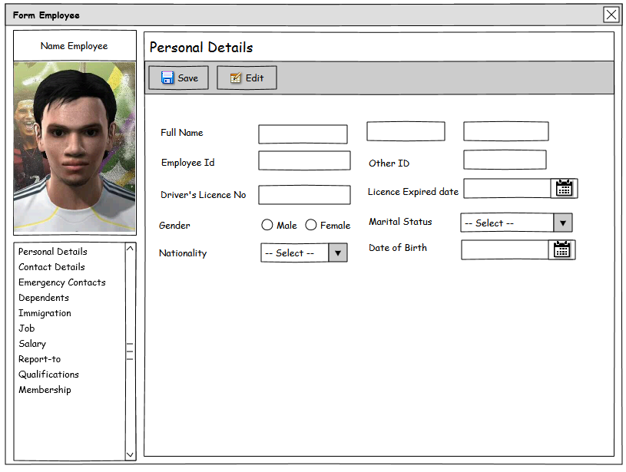

Database : dbhr  
Schema : schema_hr  
Tabel : trs_employee  
Keterangan : -

|  |  |  |
| --- | --- | --- |
| Column Name | Type Data | Description |
| id_employee | character varying(25) |  |
| first_name | character varying(25) |  |
| middle_name | character varying(25) |  |
| last_name | character varying(25) |  |

|  |  |
| --- | --- |
| Component | Function |
| List Data | * SELECT * FROM schema_hr.trs_employee ORDER BY trs_employee. id_employee ASC; * Row 15/Page * Paging 10/Page * Paging Table |
| Button Filter | Searching Like Job Title |
| Button New |  |
| Button Delete |  |
| Button Refresh | Refresh DB and Refresh Listbox |
| Button Print | - |
| Checklist Edit |  |

1. Employee – Contact Details

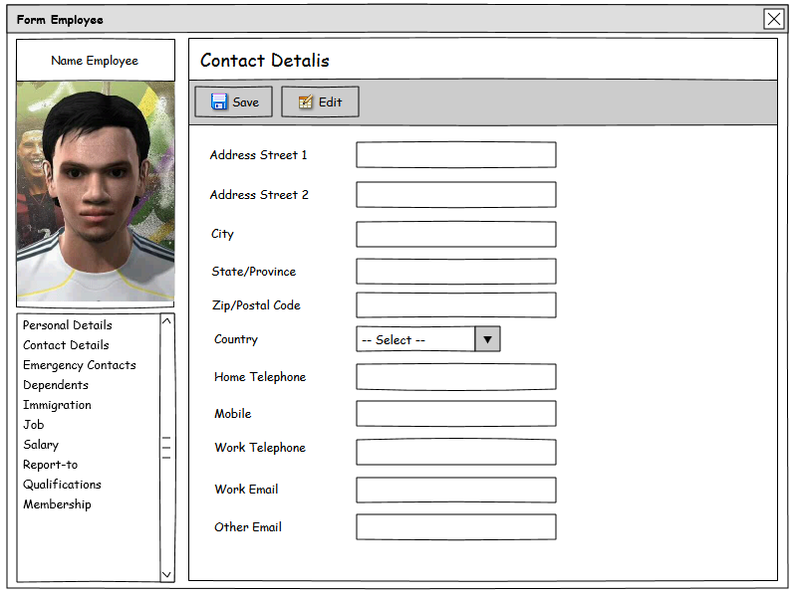

Database : dbhr  
Schema : schema_hr  
Tabel : trs_employee  
Keterangan : -

|  |  |  |
| --- | --- | --- |
| Column Name | Type Data | Description |
| id_employee | character varying(25) |  |
| first_name | character varying(25) |  |
| middle_name | character varying(25) |  |
| last_name | character varying(25) |  |

|  |  |
| --- | --- |
| Component | Function |
| List Data | * SELECT * FROM schema_hr.trs_employee ORDER BY trs_employee. id_employee ASC; * Row 15/Page * Paging 10/Page * Paging Table |
| Button Filter | Searching Like Job Title |
| Button New |  |
| Button Delete |  |
| Button Refresh | Refresh DB and Refresh Listbox |
| Button Print | - |
| Checklist Edit |  |

1. Employee – Emergency Contacts

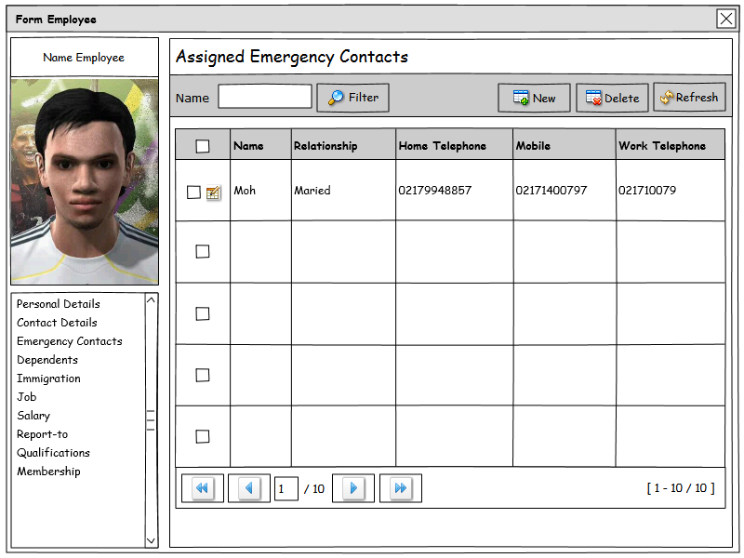

Database : dbhr  
Schema : schema_hr  
Tabel : trs_employee  
Keterangan : -

|  |  |  |
| --- | --- | --- |
| Column Name | Type Data | Description |
| id_employee | character varying(25) |  |
| first_name | character varying(25) |  |
| middle_name | character varying(25) |  |
| last_name | character varying(25) |  |

|  |  |
| --- | --- |
| Component | Function |
| List Data | * SELECT * FROM schema_hr.trs_employee ORDER BY trs_employee. id_employee ASC; * Row 15/Page * Paging 10/Page * Paging Table |
| Button Filter | Searching Like Job Title |
| Button New |  |
| Button Delete |  |
| Button Refresh | Refresh DB and Refresh Listbox |
| Button Print | - |
| Checklist Edit |  |

1. Employee – Dependents

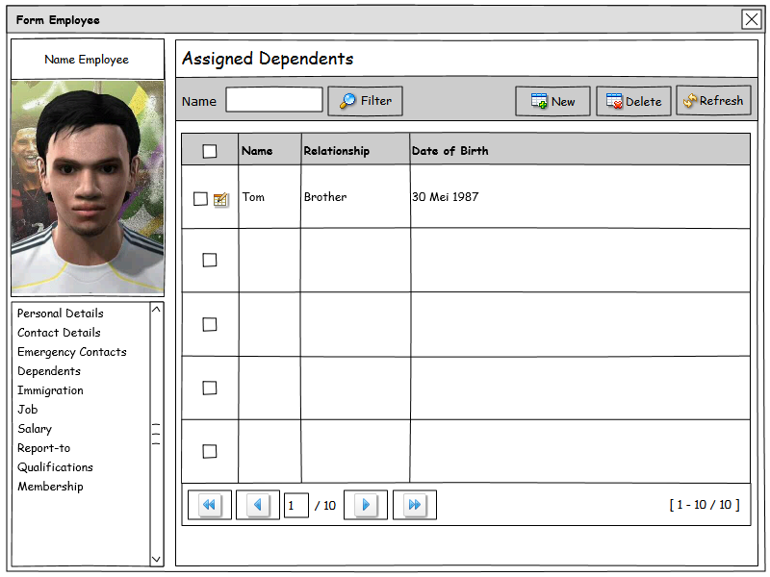

Database : dbhr  
Schema : schema_hr  
Tabel : trs_employee  
Keterangan : -

|  |  |  |
| --- | --- | --- |
| Column Name | Type Data | Description |
| id_employee | character varying(25) |  |
| first_name | character varying(25) |  |
| middle_name | character varying(25) |  |
| last_name | character varying(25) |  |

|  |  |
| --- | --- |
| Component | Function |
| List Data | * SELECT * FROM schema_hr.trs_employee ORDER BY trs_employee. id_employee ASC; * Row 15/Page * Paging 10/Page * Paging Table |
| Button Filter | Searching Like Job Title |
| Button New |  |
| Button Delete |  |
| Button Refresh | Refresh DB and Refresh Listbox |
| Button Print | - |
| Checklist Edit |  |

1. Employee – Immgration

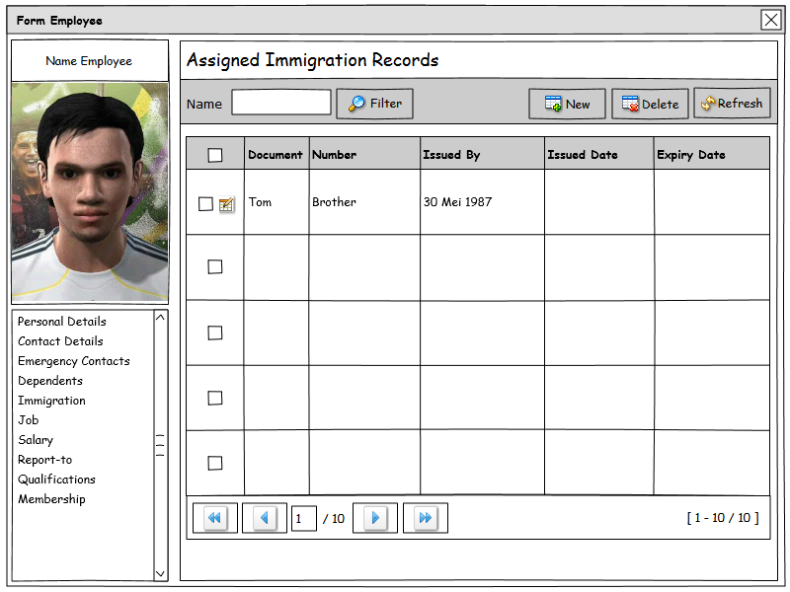

Database : dbhr  
Schema : schema_hr  
Tabel : trs_employee  
Keterangan : -

|  |  |  |
| --- | --- | --- |
| Column Name | Type Data | Description |
| id_employee | character varying(25) |  |
| first_name | character varying(25) |  |
| middle_name | character varying(25) |  |
| last_name | character varying(25) |  |

|  |  |
| --- | --- |
| Component | Function |
| List Data | * SELECT * FROM schema_hr.trs_employee ORDER BY trs_employee. id_employee ASC; * Row 15/Page * Paging 10/Page * Paging Table |
| Button Filter | Searching Like Job Title |
| Button New |  |
| Button Delete |  |
| Button Refresh | Refresh DB and Refresh Listbox |
| Button Print | - |
| Checklist Edit |  |

1. Employee – Job

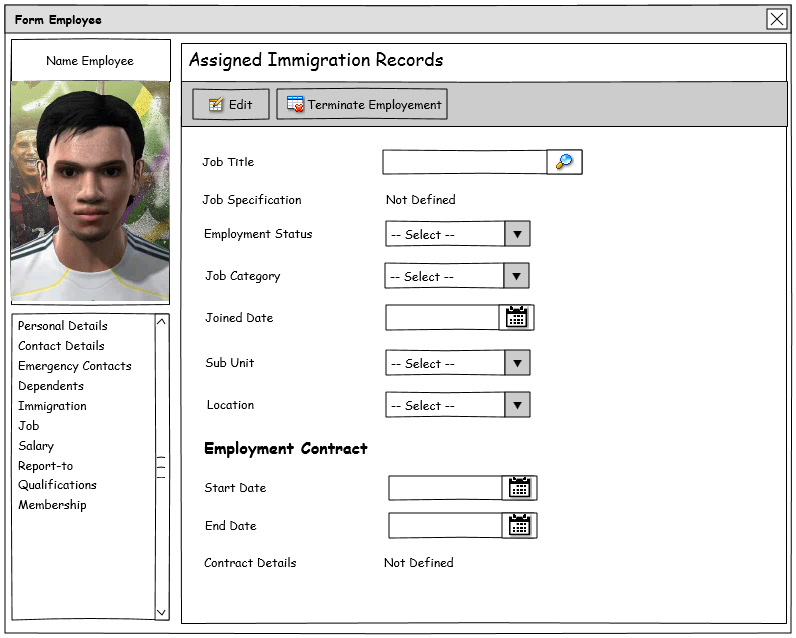

Database : dbhr  
Schema : schema_hr  
Tabel : trs_employee  
Keterangan : -

|  |  |  |
| --- | --- | --- |
| Column Name | Type Data | Description |
| id_employee | character varying(25) |  |
| first_name | character varying(25) |  |
| middle_name | character varying(25) |  |
| last_name | character varying(25) |  |

|  |  |
| --- | --- |
| Component | Function |
| List Data | * SELECT * FROM schema_hr.trs_employee ORDER BY trs_employee. id_employee ASC; * Row 15/Page * Paging 10/Page * Paging Table |
| Button Filter | Searching Like Job Title |
| Button New |  |
| Button Delete |  |
| Button Refresh | Refresh DB and Refresh Listbox |
| Button Print | - |
| Checklist Edit |  |

1. Employee – Salary

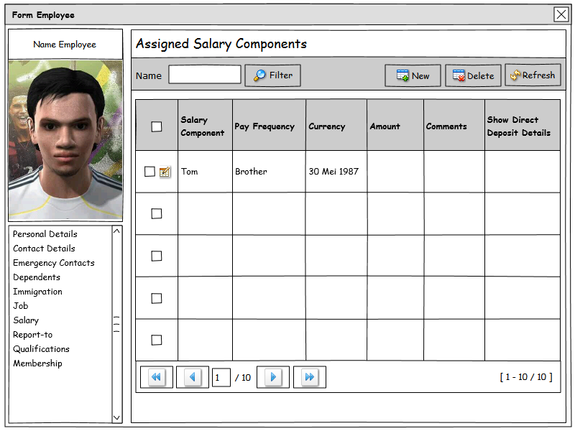

Database : dbhr  
Schema : schema_hr  
Tabel : trs_employee  
Keterangan : -

|  |  |  |
| --- | --- | --- |
| Column Name | Type Data | Description |
| id_employee | character varying(25) |  |
| first_name | character varying(25) |  |
| middle_name | character varying(25) |  |
| last_name | character varying(25) |  |

|  |  |
| --- | --- |
| Component | Function |
| List Data | * SELECT * FROM schema_hr.trs_employee ORDER BY trs_employee. id_employee ASC; * Row 15/Page * Paging 10/Page * Paging Table |
| Button Filter | Searching Like Job Title |
| Button New |  |
| Button Delete |  |
| Button Refresh | Refresh DB and Refresh Listbox |
| Button Print | - |
| Checklist Edit |  |

1. Employee – Report-to

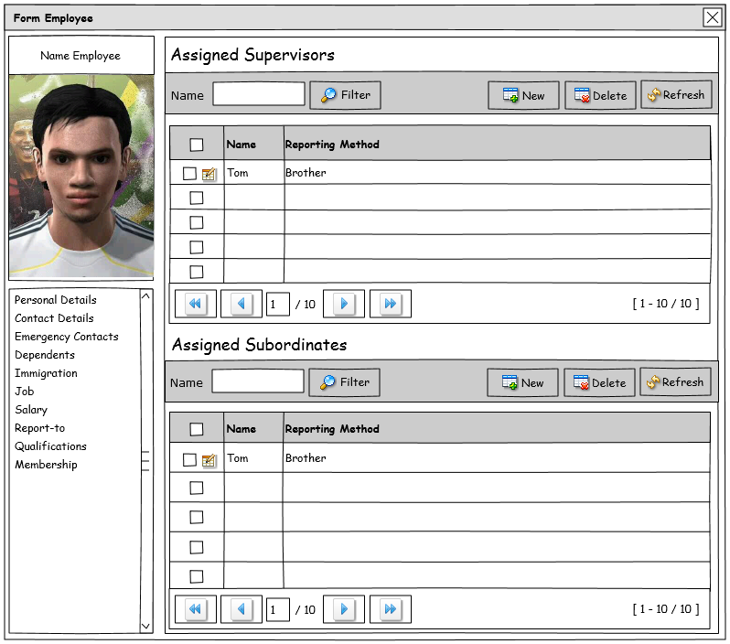

Database : dbhr  
Schema : schema_hr  
Tabel : trs_employee  
Keterangan : -

|  |  |  |
| --- | --- | --- |
| Column Name | Type Data | Description |
| id_employee | character varying(25) |  |
| first_name | character varying(25) |  |
| middle_name | character varying(25) |  |
| last_name | character varying(25) |  |

|  |  |
| --- | --- |
| Component | Function |
| List Data | * SELECT * FROM schema_hr.trs_employee ORDER BY trs_employee. id_employee ASC; * Row 15/Page * Paging 10/Page * Paging Table |
| Button Filter | Searching Like Job Title |
| Button New |  |
| Button Delete |  |
| Button Refresh | Refresh DB and Refresh Listbox |
| Button Print | - |
| Checklist Edit |  |

1. Employee – Qualifications

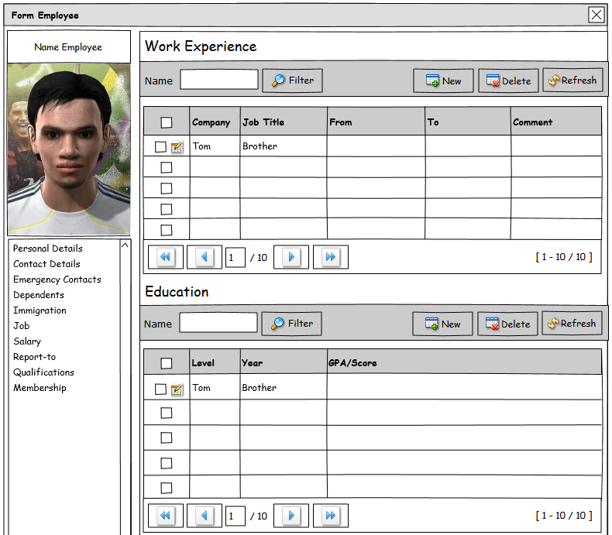

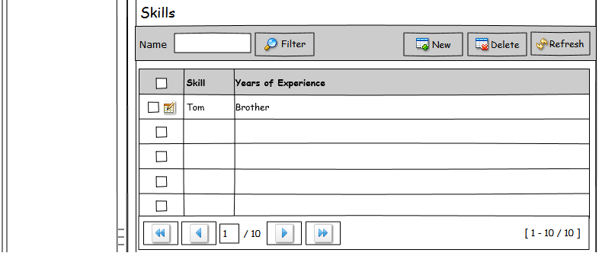

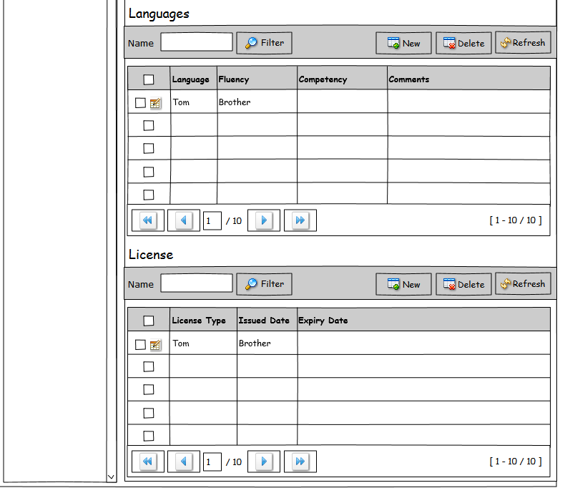

Database : dbhr  
Schema : schema_hr  
Tabel : trs_employee  
Keterangan : -

|  |  |  |
| --- | --- | --- |
| Column Name | Type Data | Description |
| id_employee | character varying(25) |  |
| first_name | character varying(25) |  |
| middle_name | character varying(25) |  |
| last_name | character varying(25) |  |

|  |  |
| --- | --- |
| Component | Function |
| List Data | * SELECT * FROM schema_hr.trs_employee ORDER BY trs_employee. id_employee ASC; * Row 15/Page * Paging 10/Page * Paging Table |
| Button Filter | Searching Like Job Title |
| Button New |  |
| Button Delete |  |
| Button Refresh | Refresh DB and Refresh Listbox |
| Button Print | - |
| Checklist Edit |  |

1. Employee – Membership  
   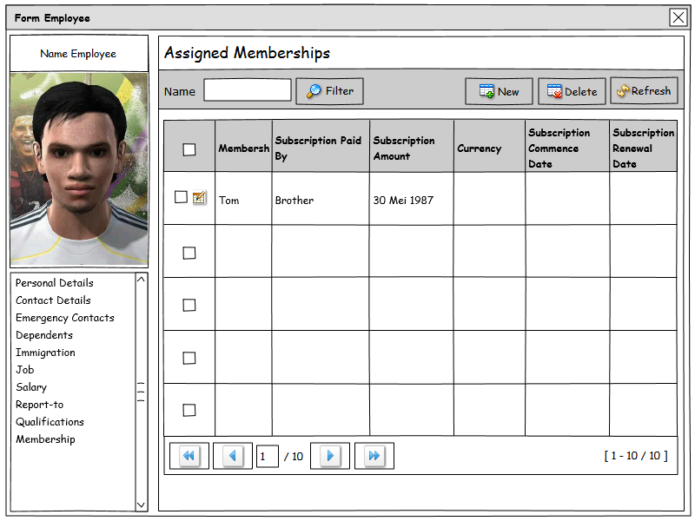  
   Database : dbhr  
   Schema : schema_hr  
   Tabel : trs_employee  
   Keterangan : -

|  |  |  |
| --- | --- | --- |
| Column Name | Type Data | Description |
| id_employee | character varying(25) |  |
| first_name | character varying(25) |  |
| middle_name | character varying(25) |  |
| last_name | character varying(25) |  |

|  |  |
| --- | --- |
| Component | Function |
| List Data | * SELECT * FROM schema_hr.trs_employee ORDER BY trs_employee. id_employee ASC; * Row 15/Page * Paging 10/Page * Paging Table |
| Button Filter | Searching Like Job Title |
| Button New |  |
| Button Delete |  |
| Button Refresh | Refresh DB and Refresh Listbox |
| Button Print | - |
| Checklist Edit |  |

1. Recruitment – Candidates  
   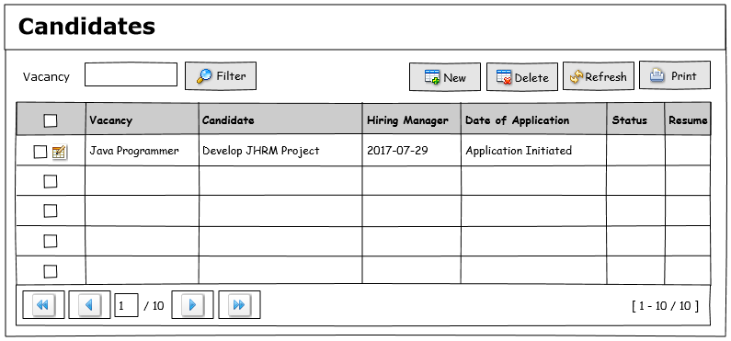

Database : dbhr  
Schema : schema_hr  
Tabel : trs_employee  
Keterangan : -

|  |  |  |
| --- | --- | --- |
| Column Name | Type Data | Description |
| id_employee | character varying(25) |  |
| first_name | character varying(25) |  |
| middle_name | character varying(25) |  |
| last_name | character varying(25) |  |

|  |  |
| --- | --- |
| Component | Function |
| List Data | * SELECT * FROM schema_hr.trs_employee ORDER BY trs_employee. id_employee ASC; * Row 15/Page * Paging 10/Page * Paging Table |
| Button Filter | Searching Like Job Title |
| Button New |  |
| Button Delete |  |
| Button Refresh | Refresh DB and Refresh Listbox |
| Button Print | - |
| Checklist Edit |  |

1. Recruitment – Vacancies

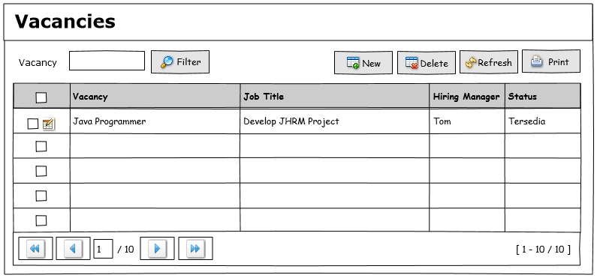

Database : dbhr  
Schema : schema_hr  
Tabel : trs_employee  
Keterangan : -

|  |  |  |
| --- | --- | --- |
| Column Name | Type Data | Description |
| id_employee | character varying(25) |  |
| first_name | character varying(25) |  |
| middle_name | character varying(25) |  |
| last_name | character varying(25) |  |

|  |  |
| --- | --- |
| Component | Function |
| List Data | * SELECT * FROM schema_hr.trs_employee ORDER BY trs_employee. id_employee ASC; * Row 15/Page * Paging 10/Page * Paging Table |
| Button Filter | Searching Like Job Title |
| Button New |  |
| Button Delete |  |
| Button Refresh | Refresh DB and Refresh Listbox |
| Button Print | - |
| Checklist Edit |  |

1. Leave  
   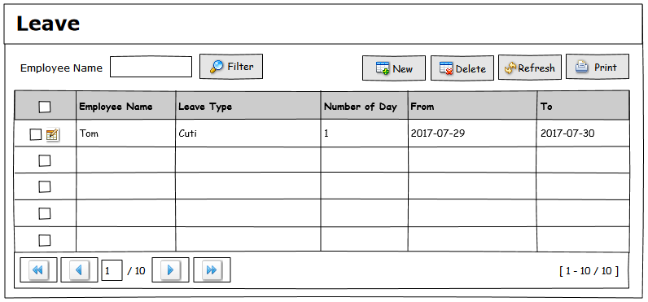

Database : dbhr  
Schema : schema_hr  
Tabel : trs_employee  
Keterangan : -

|  |  |  |
| --- | --- | --- |
| Column Name | Type Data | Description |
| id_employee | character varying(25) |  |
| first_name | character varying(25) |  |
| middle_name | character varying(25) |  |
| last_name | character varying(25) |  |

|  |  |
| --- | --- |
| Component | Function |
| List Data | * SELECT * FROM schema_hr.trs_employee ORDER BY trs_employee. id_employee ASC; * Row 15/Page * Paging 10/Page * Paging Table |
| Button Filter | Searching Like Job Title |
| Button New |  |
| Button Delete |  |
| Button Refresh | Refresh DB and Refresh Listbox |
| Button Print | - |
| Checklist Edit |  |

1. Upload Currency  
   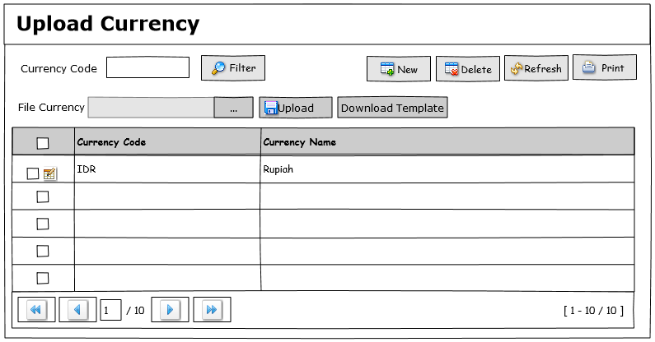

Database : dbhr  
 Schema : schema_hr  
 Tabel : mst_currency  
 Keterangan : -

1. x