LAB Logbook
Name: Sugathri Kandikattu
SID: 2463917

WEEK 1
LAB 1:

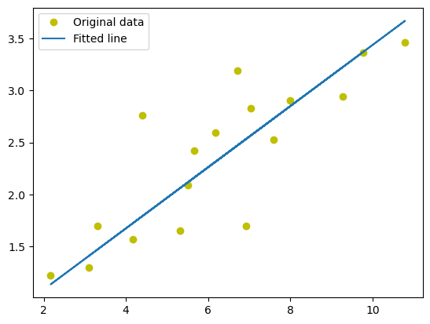

WEEK 2
LAB 2:
Test Accuracy of the model is 0.958

