**Public Health Awareness Campaign Analysis Design and Innovation**

|  |  |
| --- | --- |
| **Date** | 10-10-2023 |
| **Team ID** | 716 |
| **Project Name** | Public Health Awareness Campaign Analysis |

**Table of Contents**

|  |  |
| --- | --- |
| 1 | Introduction |
| 2 | Problem Statement |
| 3 | Design and Innovation Strategies |
| 3.1 | Data Collection and Feature Engineering |
| 3.2 | Data preprocessing |
| 3.3 | Visualization and Analysis |
| 3.4 | Machine Learning for Predictive Insights |
| 4 | Conclusion |

**1.Introduction:**

This project centers around evaluating the effectiveness of public health awareness campaigns by analyzing their data. The main goal is to uncover valuable insights that can aid in assessing these campaigns' impact on the intended audience and informing future strategies. The project involves various essential elements, such as specifying analysis goals, gathering data, creating informative visuals using IBM Cognos, and integrating code for data analysis.

**2.Problem Statement:**

This project entails the examination of data stemming from public health awareness campaigns, with the aim of quantifying their success in connecting with the intended audience and heightening awareness levels. The primary goal is to unearth valuable insights that can be used to assess the campaigns' influence and guide future strategic planning. Key components of this endeavor encompass delineating analysis goals, gathering campaign-related data, crafting pertinent visual representations using IBM Cognos, and employing coding techniques for comprehensive data scrutiny. Ultimately, the objective is to extract meaningful findings that can be employed to appraise the campaigns' impact and shape forthcoming strategies using IBM Cognos tool.

**3.Design and Innovation Strategies**

**3.1. Data Collection and Feature Engineering**

**Innovation: Comprehensive Data Gathering**

Utilize advanced methods for gathering data that encompasses a wide range of information, including the extent of campaign outreach, engagement statistics, demographic details, and the content of the awareness campaigns. Employ feature engineering to generate new variables that offer more profound insights into campaign effectiveness, such as assessing sentiment in campaign content or monitoring social media sentiment throughout the campaign durations.

**3.2. Data Pre-processing**

**Innovation: Natural Language Processing (NLP) for Text Data**

Leverage Natural Language Processing (NLP) methods to prepare text-based data, like social media posts or campaign materials, for analysis, with a focus on extracting valuable information and gauging sentiment. Construct a tailored NLP workflow encompassing tasks such as text cleansing, breaking down text into meaningful units, assessing sentiment, and identifying prevalent topics. This process aims to improve the overall quality of textual data for more insightful analysis.

**3.3. Visualization and Data Analysis**

**Innovation: IBM Cognos for Visualizations Leverage**

Utilize IBM Cognos to craft engaging and enlightening data visualizations that offer stakeholders a comprehensive view of how effective the campaigns have been. Develop tailored dashboards and reports that enable data exploration, showcasing noteworthy trends and patterns in campaign effectiveness.

**3.4. Machine Learning for Predictive Insights**

**Innovation: Predictive Analytics**

We should explore the integration of machine learning algorithms to forecast the effectiveness of upcoming campaigns using historical data as a basis. By building predictive models, we can analyze various campaign characteristics, the demographics of the target audience, and sentiment data. These models will help us anticipate the potential outcomes of future campaigns, offering insights into their likely impact and success.

Step 1: Step 2:  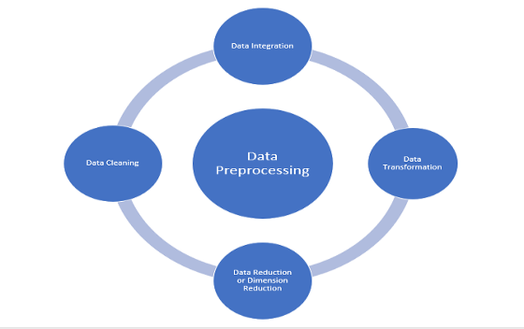

Step 3: 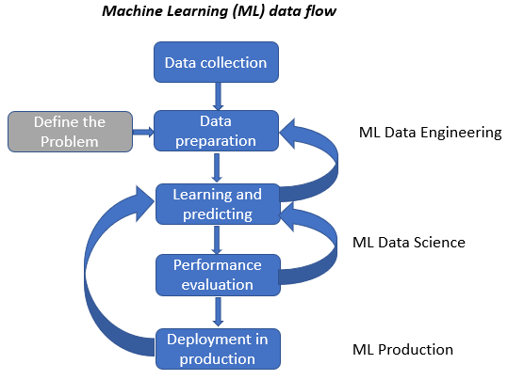 

Step 4:

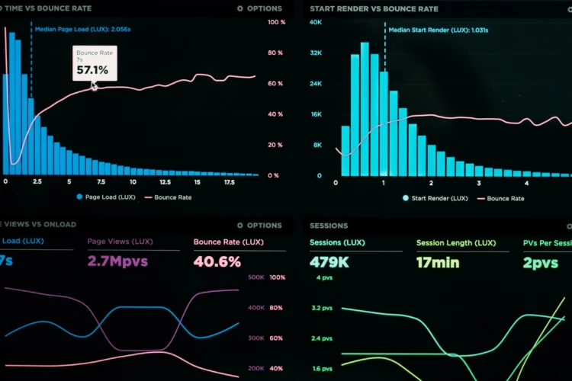

Step 1:

* Collecting data from different resources like Kaggle, Web articles, Government resources.

Step 2:

* Cleaning the data to remove whitespaces, duplicates, null values.
* Transforming the data into preferred format which is suitable for analysis.

Step 3:

* After cleaning the data, Apply machine learning algorithms to test and train the model using the cleaned data.
* Increase the accuracy of the model with trail and error method.

Step 4:

* Using visualization tools, visualize the resultant data to the end users for keen understanding.

**4.Conclusion:**

The primary objective of this project is to conduct a thorough assessment of public health awareness campaigns, with a focus on determining their success and influencing future strategies. This endeavor involves the adoption of innovative techniques, including extensive data gathering, Natural Language Processing (NLP) for text data analysis, IBM Cognos for creating visual representations, and potentially incorporating predictive analytics. The ultimate aim is to provide practical and valuable insights that can improve the effectiveness of public health awareness initiatives. The project is in line with the overarching goal of enhancing public health outcomes by using data-driven decision-making and refining campaign strategies.