**Public Health Awareness Campaign Analysis**

|  |  |
| --- | --- |
| **Date** | 28-10-2023 |
| **Team ID** | 716 |
| **Project Name** | Public Health Awareness Campaign Analysis |

**Table of Contents:**

|  |  |
| --- | --- |
| 1 | Objective |
| 2 | Design Thinking |
| 3 | Development Phases |
| 3.1 | Data Collection and Feature Engineering |
| 3.2 | Data Collection Process |
| 3.3 | Visualization and Analysis |
| 4 | Prediction Insights |
| 5 | Conclusion |

**1.Objective:**

This project centers around evaluating the effectiveness of public health awareness campaigns by analyzing their data. The main goal is to uncover valuable insights that can aid in assessing these campaigns' impact on the intended audience and informing future strategies. The project involves various essential elements, such as specifying analysis goals, gathering data, creating informative visuals using IBM Cognos, and integrating code for data analysis.

**2.Design Thinking:**

**Empathize:**

Before diving into solving the problem, it's crucial to empathize with the users and understand their needs. In this case, our primary users are peoples. We need to gather insights into what factors are most important to them when considering their health conditions and how accurate predictions can benefit them.

**Actions:**

- Conduct surveys or interviews with potential users to gather their perspectives.

- Analyse historical data to identify the most occurred disease.

- Seek feedback from domain experts in the hospital industry.

**Define:**

Based on our understanding of the problem and the users' needs, we will define clear objectives and success criteria for our project.

**Objectives:**

- Develop a model that achieves a Mean Absolute Error (MAE) of less than $X on the test data.

- Create a user-friendly web application for users to input their health observations (Health Conditions)

**Ideate:**

Brainstorm potential solutions and approaches to address the problem. This phase involves thinking creatively and considering various algorithms and techniques for diseases occurrence in future.

**Actions:**

- Explore different machine learning algorithms such as linear regression, decision trees, random forests, and neural networks.

- Experiment with feature engineering techniques to enhance model performance.

- Consider incorporating external data sources (e.g., neighbours affected by any disease, already the person was affected by any other diseases) to improve predictions.

**Prototype**

Create a prototype of the model and the user interface for Diseases occurrence prediction.

After predicting the right model for the further process , apply the actions to achieve accuracy.

**Actions:**

- Develop a Cognos script for data pre-processing, model training, and evaluation.

- Create a simple web interface using tools like Flask or Django to allow users to input their health details.

- Test the prototype with a subset of the dataset to ensure it meets performance objectives.

**Test**

Evaluate the model's performance using appropriate metrics and gather feedback from users.

If users tells any mistakes or any unsolvable problem ,we should take actions to resolve the problems.

**Actions:**

- Split the dataset into training and testing sets.

- Train the model on the training set and evaluate it on the testing set.

- Use metrics such as MAE, Root Mean Square Error (RMSE), and R-squared to assess model performance.

- Collect user feedback on the web interface for usability and accuracy.

**Implement**

Once the prototype meets the defined objectives and receives positive feedback, proceed with full implementation.

**Actions:**

- Train the final model on the entire dataset.

- Deploy the model as part of a production-ready web application.

- Conduct thorough testing to ensure the application is robust and user-friendly.

**Iterate**

Continuous improvement is essential. Gather user feedback and iterate on the model and interface to enhance accuracy and usability.

Continuous the process till you reach the desired model.

**Actions:**

- Monitor the model's performance and retrain it periodically with updated data.

- Address user feedback and make necessary improvements to the web interface.

- Stay informed about advancements in the model for potential enhancements.

**3.Development Phases:**

**3.1. Data Collection and Feature Engineering**

**Innovation: Comprehensive Data Gathering**

Utilize advanced methods for gathering data that encompasses a wide range of information, including the extent of campaign outreach, engagement statistics, demographic details, and the content of the awareness campaigns. Employ feature engineering to generate new variables that offer more profound insights into campaign effectiveness, such as assessing sentiment in campaign content or monitoring social media sentiment throughout the campaign durations.

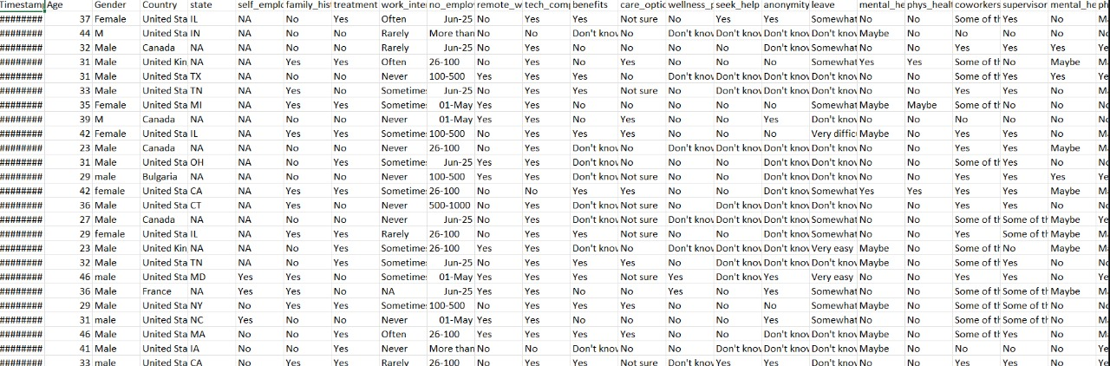

**3.2. Data Pre-processing**

**Innovation: Natural Language Processing (NLP) for Text Data**

Leverage Natural Language Processing (NLP) methods to prepare text-based data, like social media posts or campaign materials, for analysis, with a focus on extracting valuable information and gauging sentiment. Construct a tailored NLP workflow encompassing tasks such as text cleansing, breaking down text into meaningful units, assessing sentiment, and identifying prevalent topics. This process aims to improve the overall quality of textual data for more insightful analysis.

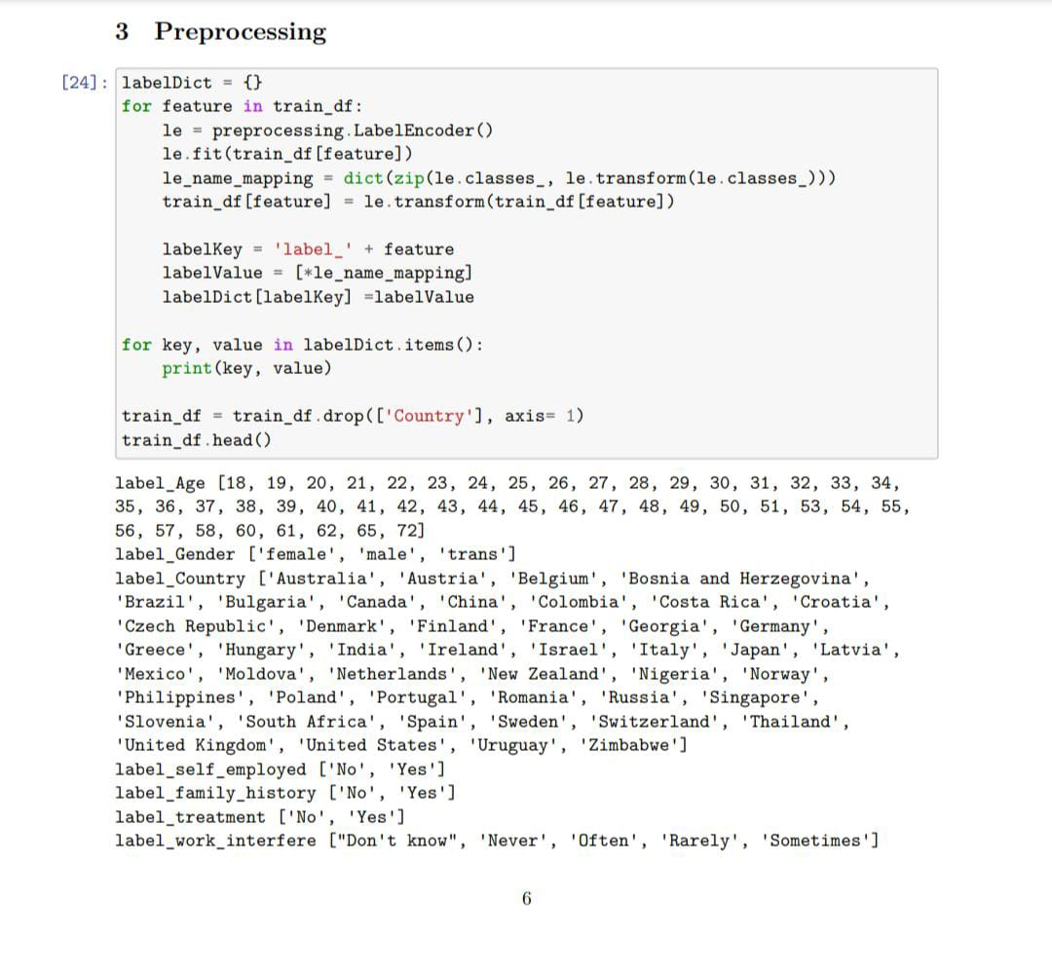

**3.3. Visualization and Data Analysis**

**Innovation: IBM Cognos for Visualizations Leverage**

Utilize IBM Cognos to craft engaging and enlightening data visualizations that offer stakeholders a comprehensive view of how effective the campaigns have been. Develop tailored dashboards and reports that enable data exploration, showcasing noteworthy trends and patterns in campaign effectiveness.

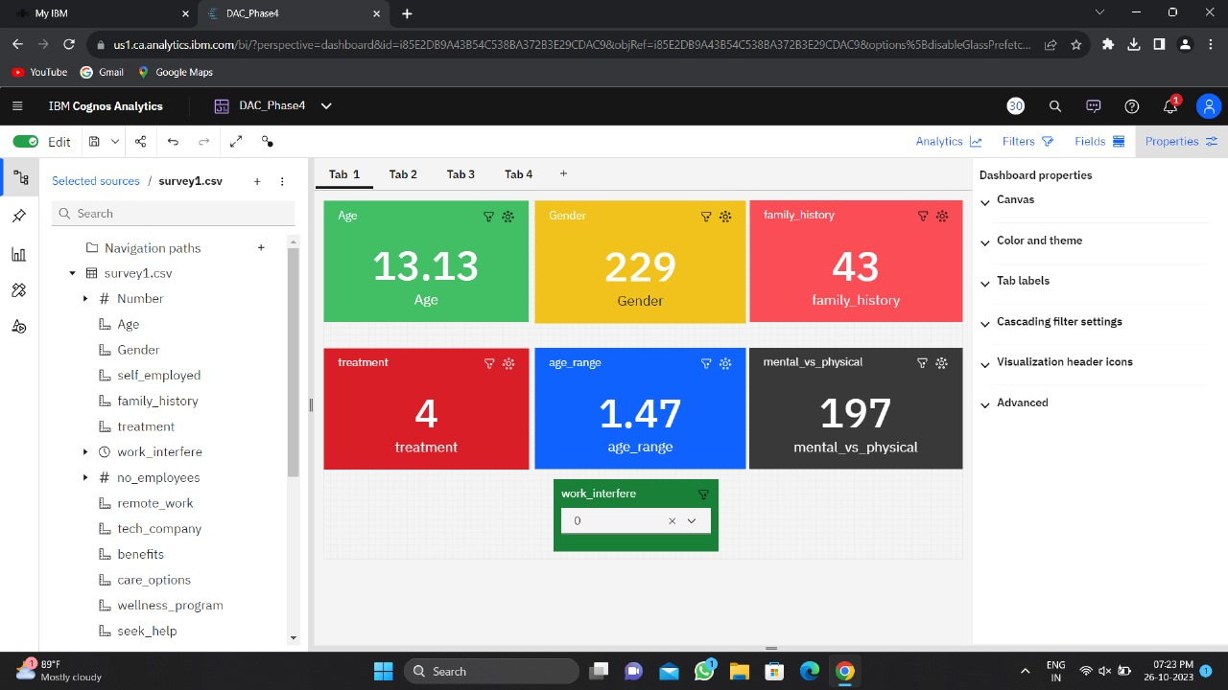

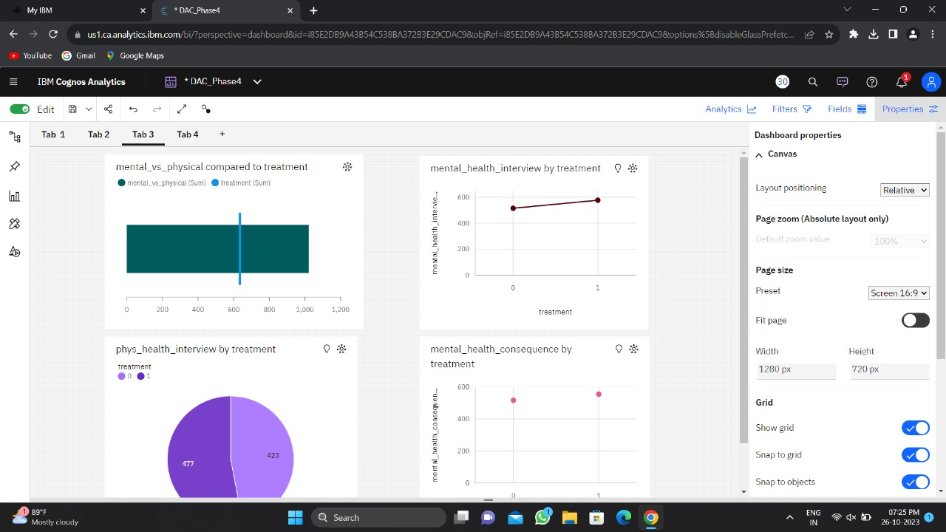

**4.Prediction Insights:**

We should explore the integration of machine learning algorithms to forecast the effectiveness of upcoming campaigns using historical data as a basis. By building predictive models, we can analyze various campaign characteristics, the demographics of the target audience, and sentiment data. These models will help us anticipate the potential outcomes of future campaigns, offering insights into their likely impact and success.

**5.Conclusion:**

The primary objective of this project is to conduct a thorough assessment of public health awareness campaigns, with a focus on determining their success and influencing future strategies. This endeavor involves the adoption of innovative techniques, including extensive data gathering, Natural Language Processing (NLP) for text data analysis, IBM Cognos for creating visual representations, and potentially incorporating predictive analytics. The ultimate aim is to provide practical and valuable insights that can improve the effectiveness of public health awareness initiatives. The project is in line with the overarching goal of enhancing public health outcomes by using data-driven decision-making and refining campaign strategies.