AERO1005 Coursework 2
Solving Engineering Problems with a Programming Language

Name: Liyu MA
Student ID: 20721363
Date: May 2026

Preliminary Task
Arduino UNO was connected to the computer via USB cable. Communication was established using the arduino() function in MATLAB. A GitHub repository was created and linked to the MATLAB working folder for version control. The LED blink test was successfully implemented on digital pin D13.
[INSERT PHOTOGRAPH OF ARDUINO + LED SETUP HERE]

Task 1 – Temperature Data Acquisition

a) Hardware Setup
The MCP 9700A temperature sensor was connected to the breadboard with its VDD pin to the 5V power bus, VSS pin to the ground bus, and VOUT pin to Arduino analog channel A0. A 220Ω resistor was placed between the sensor output and A0 to stabilise the signal and reduce noise from the microcontroller power supply.
[INSERT PHOTOGRAPH OF TEMPERATURE SENSOR SETUP HERE]

[INSERT TEMPERATURE PLOT IMAGE HERE]

Task 2 – LED Temperature Monitoring Device

f) Hardware Setup
Three LEDs (green, yellow, red) were connected to the breadboard. Each LED's anode (long leg) was connected to a digital pin (D9, D10, D11 respectively) via a jumper wire, and each cathode (short leg) was connected to the ground bus through a 220Ω resistor.
[INSERT PHOTOGRAPH OF 3-LED SETUP HERE]

Pre-Implementation Flowchart
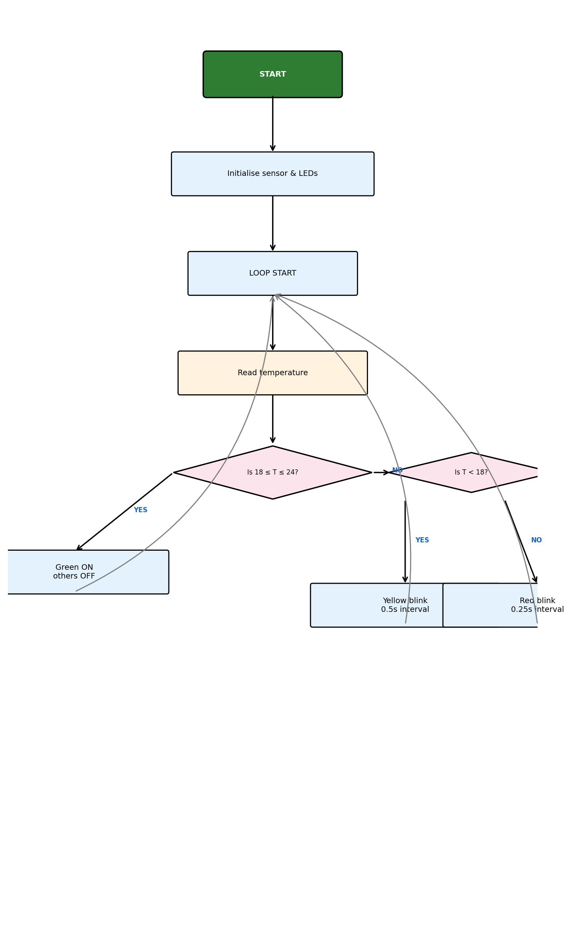

Post-Implementation Flowchart
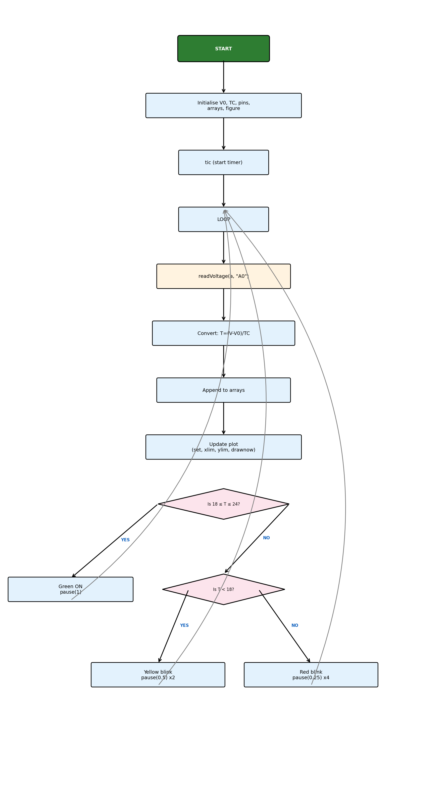

[INSERT LIVE PLOT SNAPSHOT HERE]

Task 3 – Temperature Prediction

Flowchart
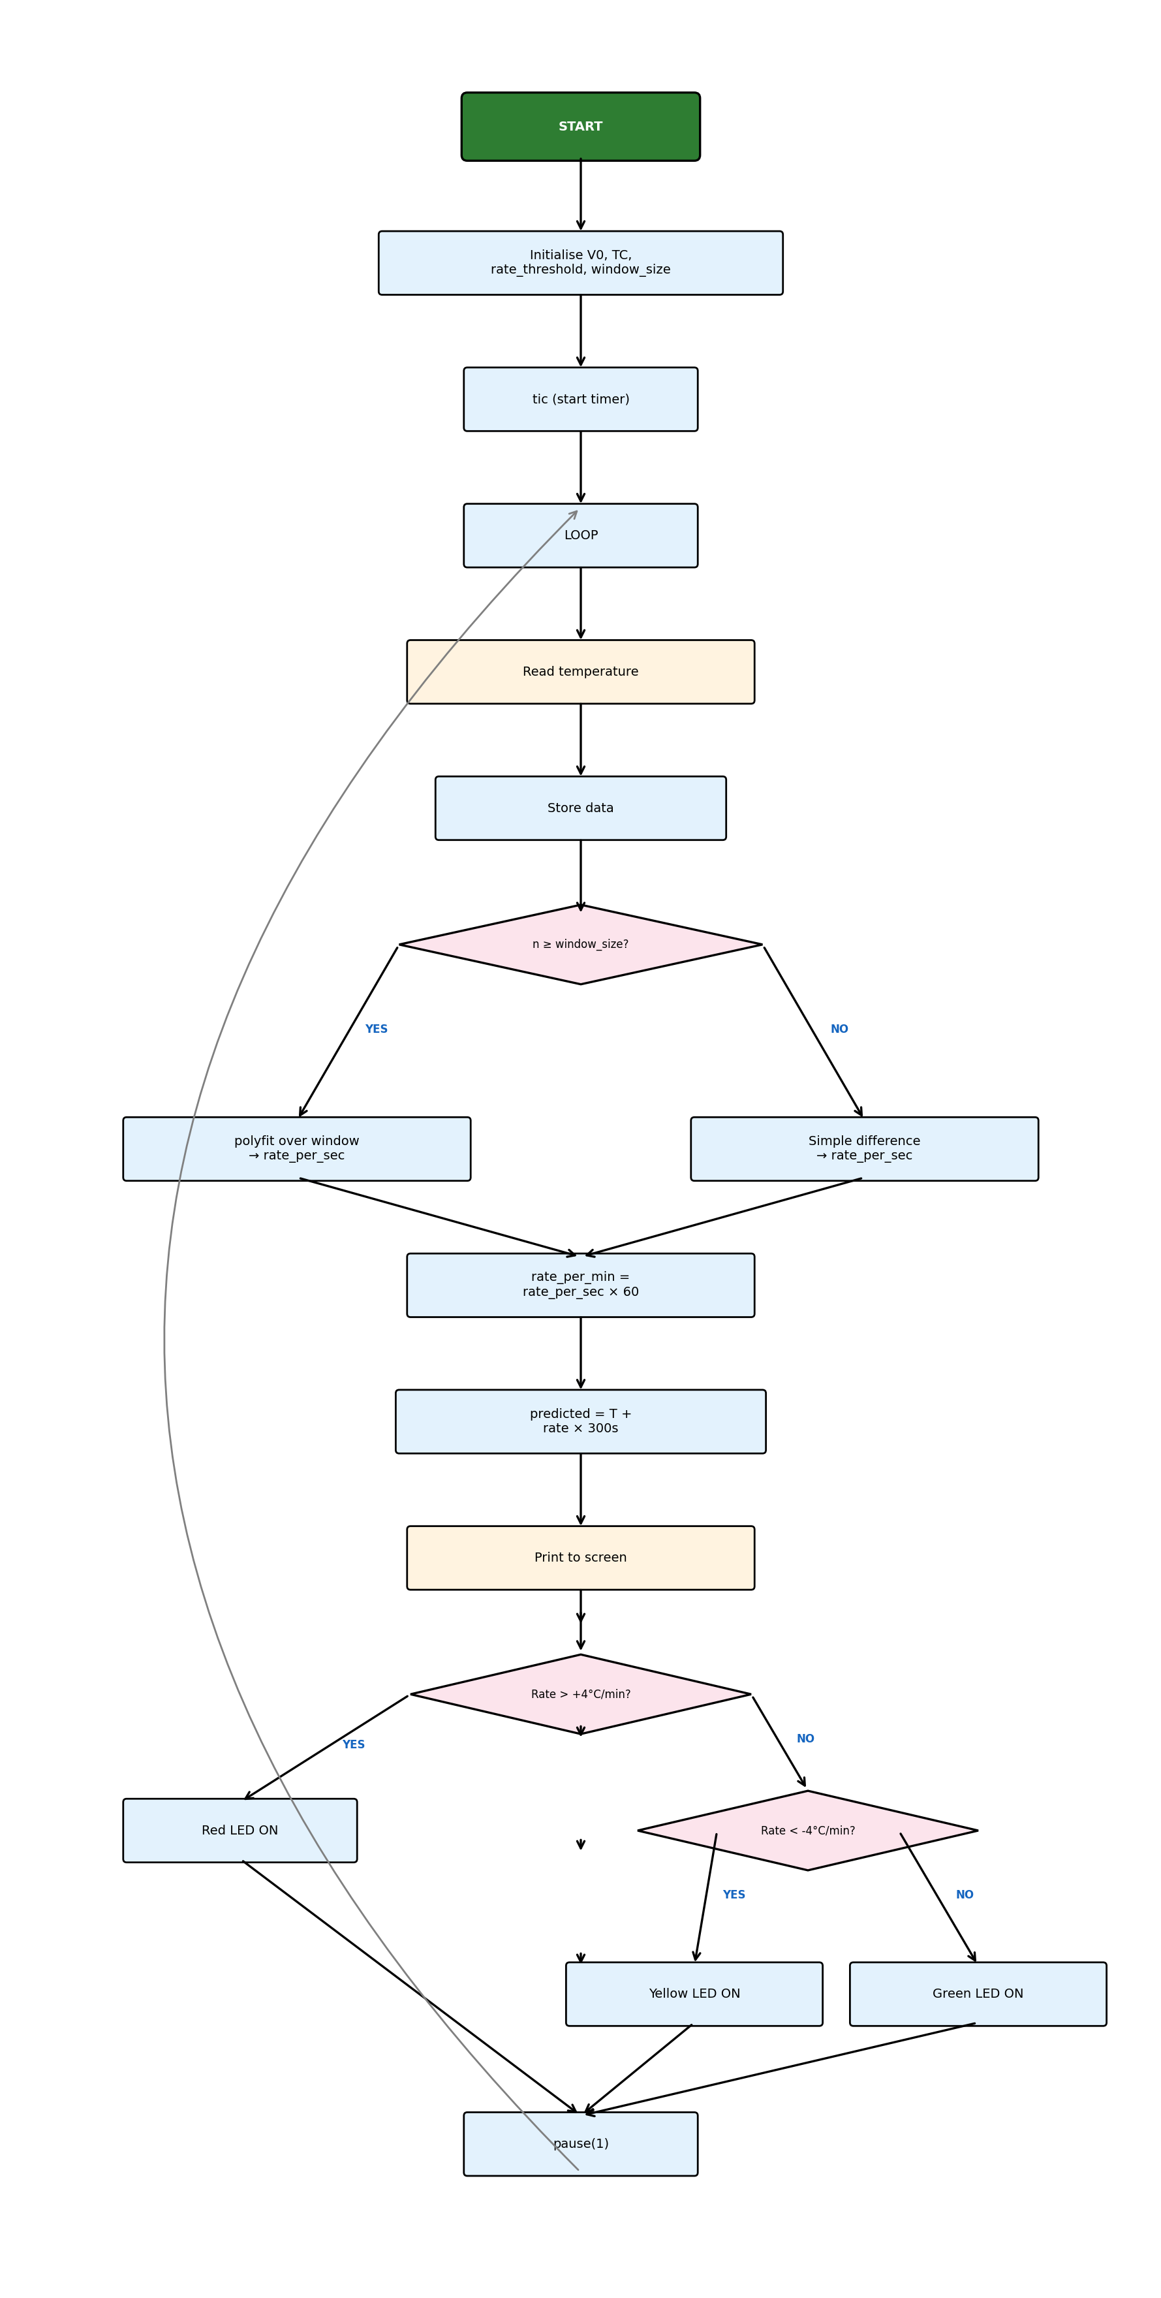

Task 4 – Reflective Statement
This coursework presented several engineering challenges that deepened my understanding of integrating hardware and software for real-time data acquisition. One of the primary challenges was synchronising the LED blinking behaviour with the temperature data acquisition loop. In Task 2, the LED blink timing (0.5s for yellow, 0.25s for red) directly affected the sampling rate of the temperature sensor, since both operations shared the same execution thread. This taught me the importance of considering timing constraints in embedded systems design.
Another significant challenge was managing noise in the temperature readings from the MCP 9700A sensor. Raw voltage readings exhibited fluctuations of approximately ±0.5°C, which could trigger false LED state changes. To address this in Task 3, I implemented a moving window approach using MATLAB's polyfit function over the last 30 samples. This linear regression technique provided a more robust estimate of the temperature rate of change compared to simple point-to-point differences, effectively filtering out short-term noise while preserving genuine trends.
A key strength of my implementation is the modular code structure. By encapsulating the monitoring and prediction logic in separate functions (temp_monitor and temp_prediction), the code remains readable, testable, and reusable. The live plotting feature in Task 2, using MATLAB's set and drawnow commands, provides immediate visual feedback that proved invaluable during debugging and demonstration.
However, there are notable limitations. The temperature prediction in Task 3 assumes a constant linear rate of change, which may not accurately represent real thermal dynamics influenced by convection, radiation, and insulation properties. The MCP 9700A sensor itself has a limited accuracy of ±2°C, which constrains the precision of all derived calculations. Future improvements could include implementing a Kalman filter for more sophisticated noise reduction, using hardware interrupts for LED timing to decouple it from the sensing loop, and employing a higher-precision digital temperature sensor such as the DS18B20. Additionally, incorporating wireless data transmission via Bluetooth or Wi-Fi would enable remote monitoring capabilities essential for real-world capsule applications.

AI Usage Disclosure
The MATLAB Copilot tool was used solely for debugging syntax errors during development, specifically for identifying issues with fprintf formatting and Arduino pin configuration commands. No AI tools were used to generate algorithms, logic, or core code structure.

