

CPSC 662: DBMS
FINAL REPORT
GROUP: G6
SUGETHA KALYANARAMAN
SAKTI ARUNACHALAM

METUBE
Metube is a data-driven, multimedia sharing website that has been inspired from the present day YouTube system. The major differences between the YouTube and the MeTube project is that, our Metube system is designed to deal with several types of file such as images, gifs, etc. along with video types.
A non-registered user can browse through all the public files. A registered user, on the other hand has a lot more power and control over the website. A registered user can upload videos, interact with other users, comment on the videos, and add people as friends, and block users and many more. The detailed functionality is described in the later sections.

REQUIREMENTS
User account:
A user needs to register for an account to use all MeTube system functions. The system contains all the basic functionality that is necessary for smooth navigation. These functions include registration form, user login, and option to update the user profile. The Metube system also has advanced features such as contact list- a list of all valid Metube users, friend/foe lists, user blocking, etc.
Data sharing:
A valid user should be able to upload multimedia files into MeTube system. Any user will be able to download and view media files as long as they are not listed by the owner as private. The more advanced features include block certain users from downloading or viewing media files a user uploaded.
Media organization:
All users will be able to browse the media files by categories. Additionally signed in users can organize their uploaded media files and their interested media files according to their channels, playlists, favorite media lists, etc. The mote advanced feature includes, showing the most-viewed media files, the most-recently uploaded files, etc.
User interaction:
All valid Metube users should be able to interact with each other personal messages and the user can also comment on media files. The advanced features include media rating-rating the media file, group discussion-a forum where any user can discuss a topic, etc.

Search:

The Metube system has YouTube-like search interface to allow users to search media files based on keywords. The advanced features include word cloud, media recommendation, feature-based media search, etc.

SYSTEM DESIGN

The Metube system is designed to be a simple web interface with immaculate power that equals the functionality of the popular media website such as Youtube yet look very simple and intuitive to the user and is very user-friendly.
The languages primarily used are:
- HTML – primarily to display forms and other browser elements
- CSS – to style the page consistantly
- PHP – to link the frontend to the backend and vice versa
- MYSQL QUERIES – to communicate with the database and retrieve exactly what we want.
- Java script – primarily for alert boxes
The way this whole website is built is kind of neat and simple. We wanted to keep the website very simple and intuitive and hence we avoided rather a lot of fancy stuffs. Animation of any sort was completely avoided. The main aim of the course was to emphasize the importance and power of the database and the need to keep any manipulation over the data consistent. In the wake of this, each and every webpage in this Metube system is built with 3 basic elements.
1. The Header
2. The Content
3. The Footer
The Header part is where we include the file “header.php” in all of the webpages. The header.php contains the metube logo and the login option or welcome message depending on who is logged in. Hence, every webpage in the system has a metube logo and the appropriate header.
The content is where the major chunks of php elements are included. This is where important functionality and navigation and stuff like that happen.
The footer is a tiny element added at the end of every page. It has our group name and the course name.
Also at the beginning of every file, is session establishment step and database connectivity. To keep the code neat and precise, all the database connectivity information is stored away in a separate file and is added at the start of every file. It should be noted that once the user has logged on, all his further activities has to be associated to the same person. Hence it is highly important to store session information. We pass the username across all the pages via ‘$_SESSION’ variable. Finally, it is worth mentioning about the CSS. To keep the design of the system consistent along all the webpage, we used an external CSS. The advantage here is external CSS keeps the code very neat by bundling off the CSS part into a separate file. This is imported and linked to every webpage. A typical webpage is divided into segments and each entity is rather included as when necessary into the appropriate segments using the include(‘’); command. The ‘$_SESSION’ holds the username as opposed to userid that would be a very easy information to pass on. But it was found that many queries required the direct mention of the user’s name rather than the userid and hence it was optimal to pass on username rather than userid. Of course, we can query the database to obtain the corresponding userid. In certain case, for instance, consider a user deleting a comment. In case the user accidently presses the delete button, it could lead to disastrous results. To avoid such embarrassing mistakes, we have used very miminal javascript to trigger an alert box. This warns the user about an important event. All the webpage includes a SEARCH BAR. This search option does a very basic search such as searching using the name of the uploaded file to a very advanced search such as searching using categories etc. The nav bar at the top of each file lets you navigate across the webpages. All comments and discussions appear on the same page and are automatically refreshed. To keep the design simple we have displayed all comments and data only in table element. At appropriate location, authenticity of the user who is accessing the webpage, so no one can simply teleport between the webpage and access information not destined for him. At all times, there is a link to go back to the home page. If it’s a non-user, then it takes you to index.php. If it is a user, then that link will take him to his personalized webspace.

ER DIAGRAM

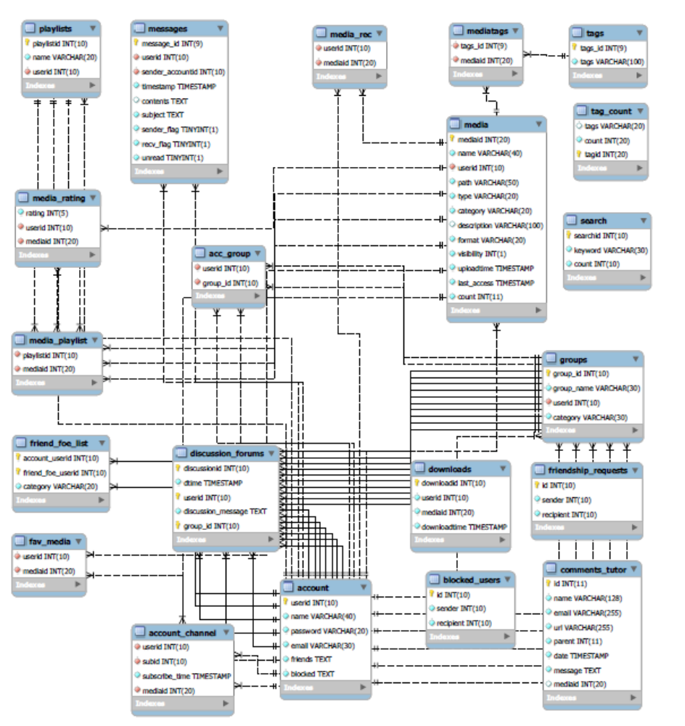

FUNCTION DESIGN

HOMEPAGE, REGISTER AND LOGIN:
In this section, we elaborate on the functionalities of our system. The system starts off with an index page that has a login option for a returning user and a register option for the new user. Of course, the user may also opt to just browse the webpage. The home page lists all the public videos that are available on the Metube database. When the user wishes to register for an account, he provided with a registration form. This appears as a simple form in web interface. On the registration form, we have several validation scripts running on the server side to check the user inputs. This check is important for various reasons. One of the important reasons being, invalid inputs should not be allowed to penetrate into the database. Also the client side type check reduced the overhead and the wait time for the user, wherein the performance degrades while the data is going back and forth from the server side for validation. The validation is primarily done using regular expressions. This reduces the overhead on the client side. It is simple and avoids the time lag in the animation had we used javascript or ajax.

USERPAGE, UPLOAD AND DOWNLOAD:
Now once the user logs on to his account by entering his credentials he is directed to his homepage. On his homepage, he is given a list of all the available videos along with his personal videos. The various categories of the video are also listed. Beside each video is also a link to download that file. This is subject to the fact that the user should have allowed for the video to be downloadable. This works as a right click download type. An upload option is also given to enable a user to upload a file. When you upload a file, various meta information such as the type, description etc are inputted by the user. The href on the media redirects you to the page where you can view the media.

DISCUSSIONS:
The discussion forum is a place where users can discuss on common topics. It has group categories that list only the categories and a list of all the discussions under that area. Clicking on the discussion redirects to the page.

MESSAGEING:
Users can pass personal messages. The page has inbox where all the incoming messages lie, outbox where all the sent messages are listed and a compose mail that lets you write a new message.

SETTINGS, USERPROFILE:
Settings are where a user can access his profile information and change it. This automatically updates the profile of the user using the information that he filled into a form.

IMPLEMENTATION DETAILS

FRONT END:
The front end is done using :
- HTML – primarily to display forms and other browser elements
- CSS – to style the page consistantly
- PHP – to link the frontend to the backend and vice versa
- MYSQL QUERIES – to communicate with the database and retrieve exactly what we want.
- Java script – primarily for alert boxes
The html is what is needed to display all entities onto a webpage. This embeds other elements onto the screen in printable format.
The CSS is used to make the webpage more presentable. It adds consistency to the data. Make the webpage simple and nice. The segments the page into nice and neat elements and applies the same property across similar entities. This used as an external CSS. This makes the code readable and concise.
PHP is a very powerful scripting language. It links the DB to the fromt end. This is used to execute and fetch data and make some sense out of dumped data from the DB.
MYSQL queries connect the database. It is required to fetch necessary data and give it to the php element for processing.

BACKEND:
We are using MYSQL to build the underlying database. We have 20 odd tables in our database.
Here we try and list all the queries that we have used in our project.

TEST CASES
INDEX PAGE:
No | Test Case | Result | Comments
1 | Nav bar | Works | Navigation bar
2 | Header | Works | Header file
3 | Metube logo. | Works | Non clickable logo
4 | List of all media | Works | List of media
5 | Login or welcome message | Works | Displays login or welcome  message

REGISTERATION.
No | Test Case | Result | Comments
1 | Error checks | Works | All entries are input in proper format
2 | Blank fields | Works | Errors
3 | Password patter check | Works | Displays error

LOGIN:
No | Test Case | Result | Comments
1 | Incorrect username | Works | Displays error
2. | Incorrect password | Works | Displays error
3 | Forgot password | Works | Resets the password

MESSAGES:
No | Test Case | Result | Comments
1 | Send a message to a  valid user | Works | Sender can see the message in  outbox and recipient in inbox
2 | Invalid user check | Works | Error message is displayed
3 | Displays message | Works | Shows all the messages
4 | Delete | Works | Message is removed from the DB

MEDIA
No | Test Case | Result | Comments
1 | Upload | Works | UPLOADED
2 | Comment | Works | Comment only if enabled
3 | Tags | Works | Tags are inserted
4 | Rating | Works | Media is rated
5 | Add to favorites | Works | Added to favourites
7 | Add to playlist | Works | Media is added to playlist.

USER MANUAL
This user manual is for the convenience of the user to let him smoothly navigate through the site.
- The user logs in to the system by signing in with his username and password on the top right corner of the homepage
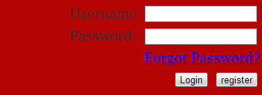
- He is then presented with a list of all the videos that are currently in the data base. This does not include videos listed as private.
- The nav bar has all the operation that can be performed by a registered user.
- The about button lets the user update his profile information
- The Discussions button takes you to a page where there are several ongoing discussions. You can either join an existing discussion or create your own discussion. You need to join a discussion if you want to comment on it.
- If you are the owner of the discussion you have the option to delete the group. If not then you can leave the group whenever you want.
- Once you join the discussion, you can comment on it. You can also reply to another user’s comment. You can delete your own comment.
- Contacts take you to view all the existing contacts. If a user is not already your friend you can give him a friend request. You also opt to block a user from your list. The contacts in your blocked list cannot view your uploaded media.
- The Metube systems also lets your message each other. You click on the message tab. This takes you to the message page. There you can compose a new mail, or check you inbox or outbox.
- Profile update lets you update your profile. You can update username, email, and password.
- Metube lets you upload files onto the site. You click on the upload button. You need to provide information such as filename, description, tags, category, media type, media access.
- The media can be listed as public and private. Private videos are not listed to everyone.
- A user has the privilege to create a playlist and organize his media under different playlist. The playlist tab lets you do that.
- Each user in the metube system has a separate channel. Anyone can subscribe to a channel.
- All the channel that I subscribed to appears under the “my subscription” tab.
- Additionally when you view a media, we can rate it and recommend it.
- You can also comment on a media.

SCREEN SHOTS

LOGIN

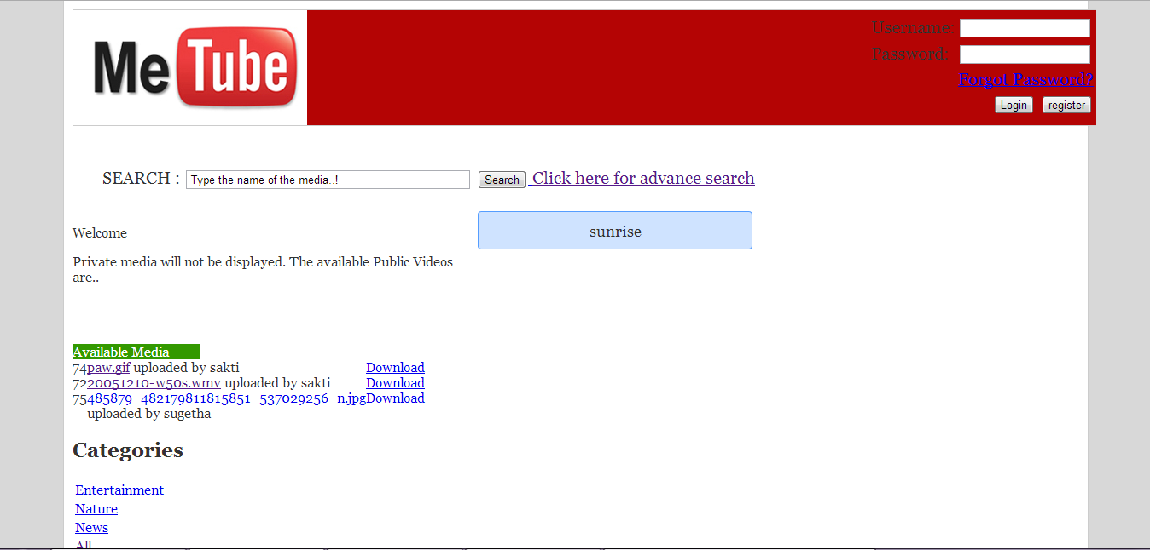

BROWSE
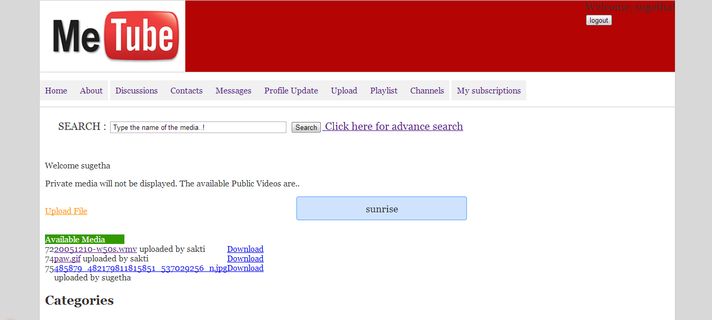

CONTACTS
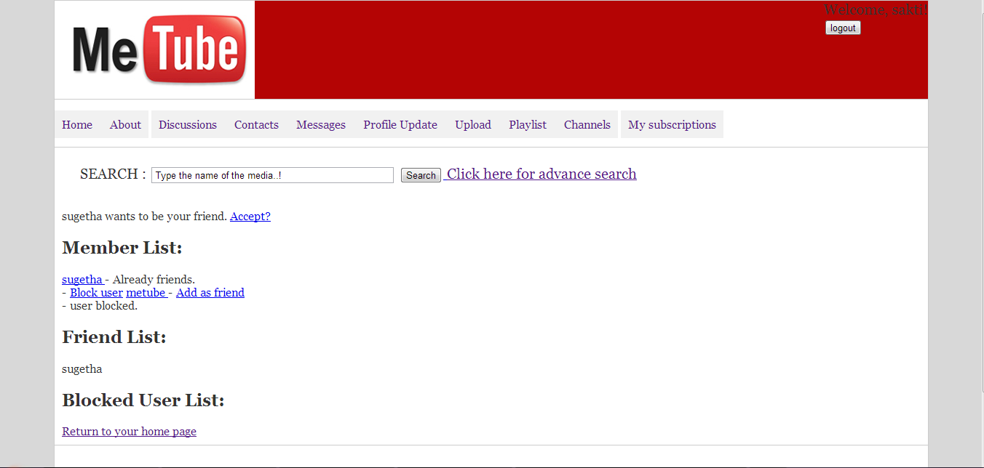

DISCUSSIONS
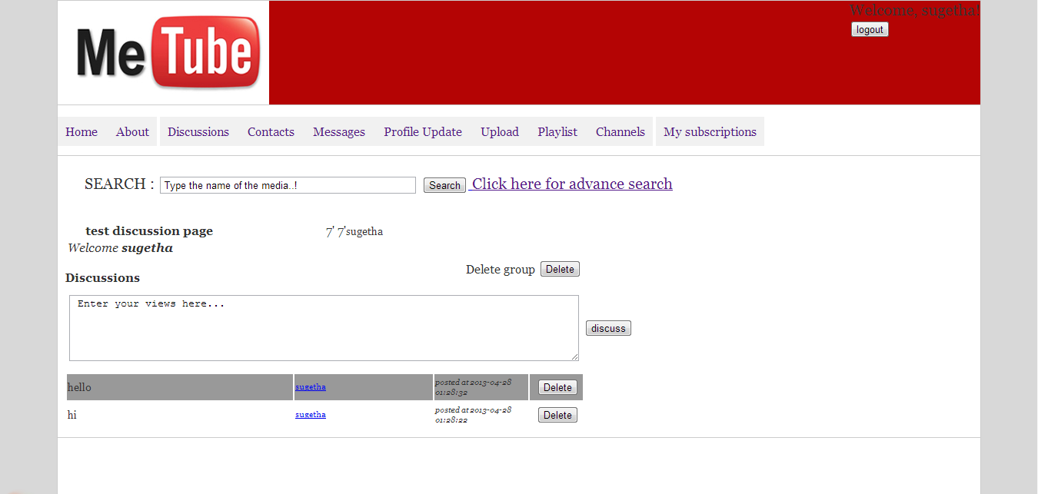

GROUPS
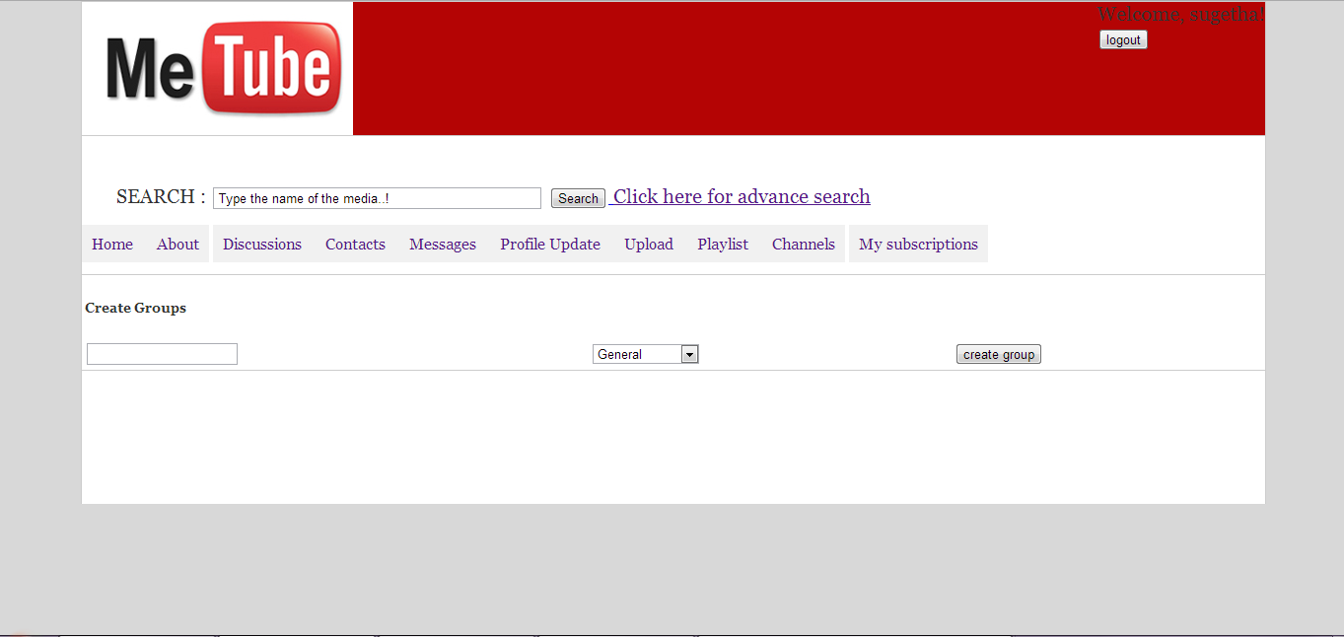

MESSAGES
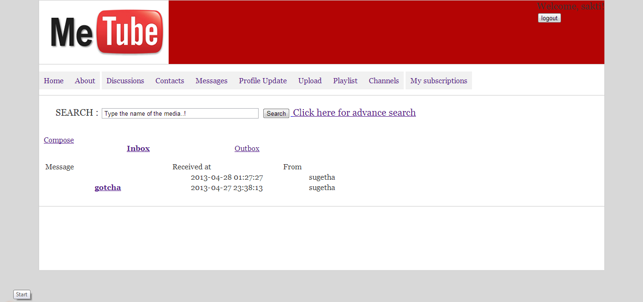

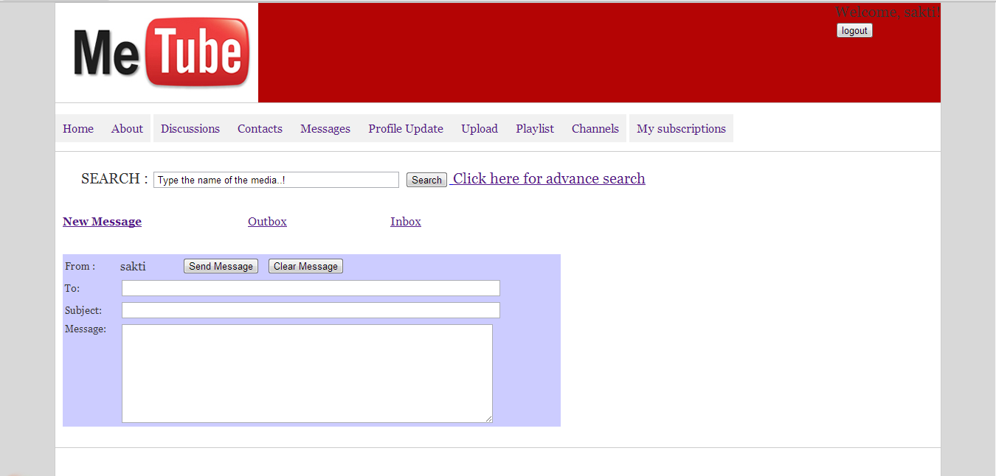

PLAYLIST
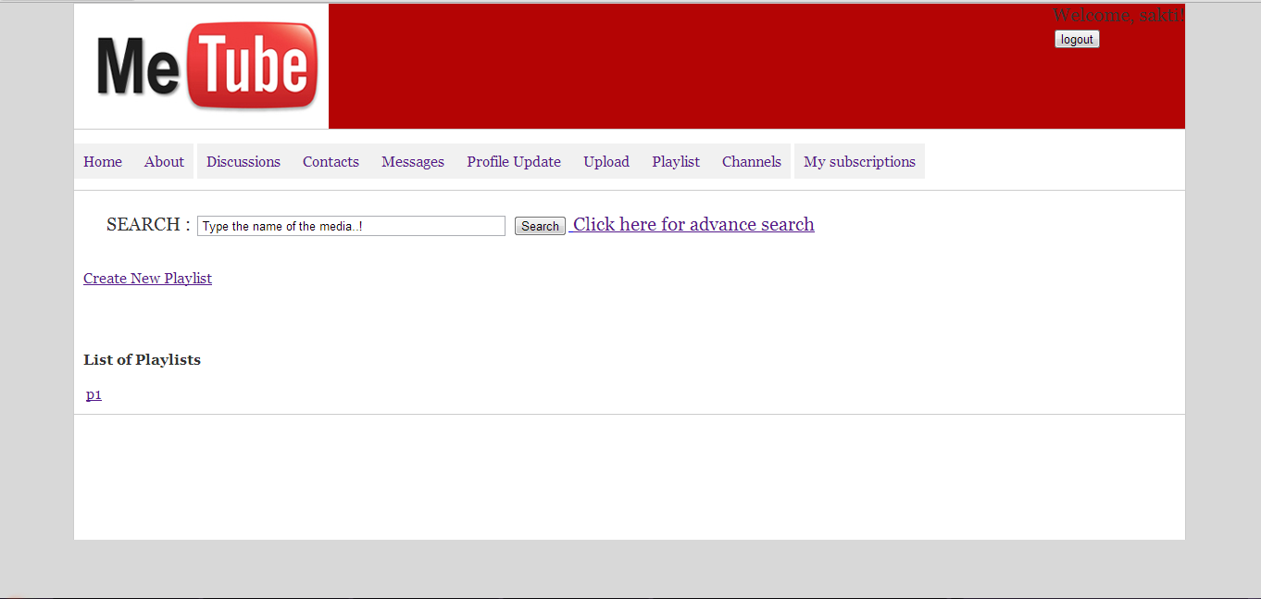

SUBSCIBE
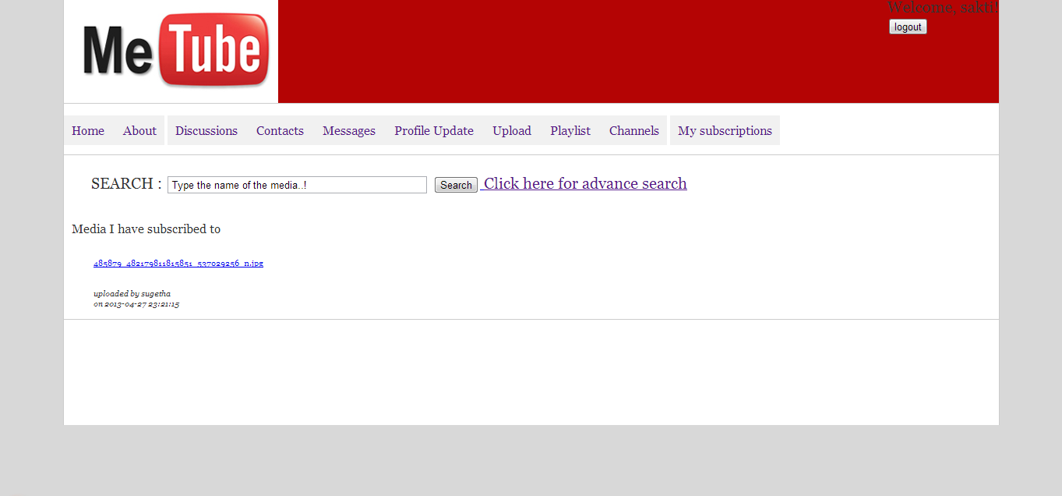

UPDATE PROFILE
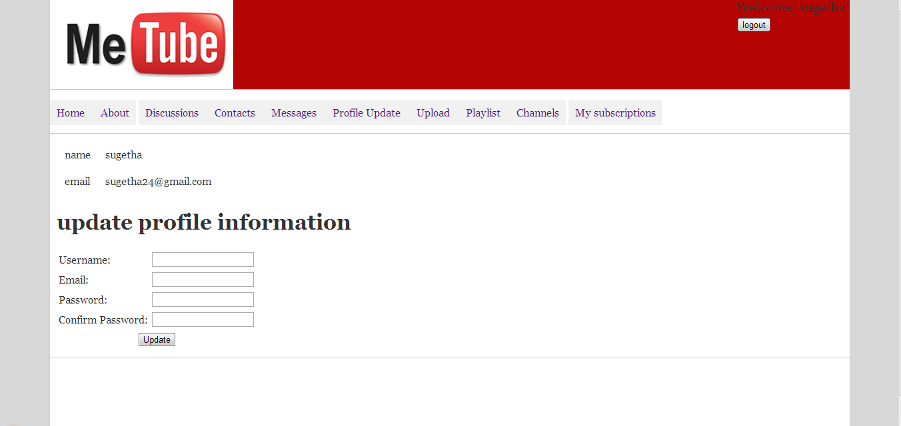

UPLOAD
