Design of pipeline-enabled SRAM-LUT using DFF
A Project Based Learning Report Submitted in partial fulfilment of the requirements for the award of the degree

of

Bachelor of Technology
in The Department of Electronics and Communications Engineering
24EC2211 with VLSI Design

Submitted by
2410040134: Sugguna Akhil
2410040123: PALGUNA RAO GURANA

Under the guidance of
Dr. Kayam Saikumar


Department of Electronics and Communication Engineering
Koneru Lakshmaiah Education Foundation, Aziz Nagar
Aziz Nagar – 500075
FEB - 2025.
Introduction

Brief introduction about your project area
In modern digital systems, speed and power efficiency are critical parameters that determine overall system performance. Field Programmable Gate Arrays (FPGAs) and digital integrated circuits widely use Look-Up Tables (LUTs) as fundamental building blocks for implementing combinational logic. A LUT stores truth table values in memory elements and produces outputs based on input address lines. Static Random Access Memory (SRAM) cells are commonly used to implement LUT storage because of their fast access time and non-destructive read capability.
However, as operating frequencies increase, propagation delay through combinational logic and memory elements becomes a major limitation. To overcome this, pipelining techniques are introduced. Pipelining improves system throughput by dividing operations into multiple stages separated by storage elements such as D Flip-Flops (DFFs). By introducing DFFs between SRAM-based LUT stages, timing constraints are relaxed, enabling higher clock frequencies and improved performance.
The proposed project focuses on designing a pipeline-enabled SRAM-based LUT architecture integrated with D Flip-Flops. The design enhances speed performance while maintaining logic flexibility. This architecture is especially useful in high-speed digital signal processing, embedded systems, and FPGA-based computation platforms. The project involves design analysis, architectural modeling, simulation, and performance comparison between conventional and pipelined LUT implementations.

Literature Review/ Application Survey

The rapid advancement of Very Large Scale Integration (VLSI) technology has significantly improved digital system performance. LUT-based architectures are extensively used in FPGAs such as those developed by Xilinx and Intel (formerly Altera). These architectures rely on SRAM cells to configure programmable logic blocks. Traditional SRAM-based LUT designs provide flexibility but may suffer from increased propagation delay when operating at high frequencies.
SRAM-based LUTs typically use 6T (six-transistor) SRAM cells for storing configuration bits. The output is selected using multiplexers controlled by input signals. Although efficient, the delay through SRAM cell access and multiplexing network limits maximum achievable clock frequency. To enhance performance, researchers have introduced pipelining techniques within FPGA logic blocks.
D Flip-Flops (DFFs) are fundamental sequential elements used for data storage and synchronization. In pipelined architectures, DFFs are inserted between combinational logic stages to reduce critical path delay. The use of edge-triggered DFFs ensures synchronized data transfer between pipeline stages, reducing timing violations.
Modern FPGA architectures, such as those in Xilinx Virtex-7 and Intel Stratix 10, integrate deeply pipelined logic blocks to support high-performance applications including artificial intelligence, digital signal processing, and real-time communication systems. These devices employ optimized SRAM-LUT configurations combined with embedded registers (DFFs) to enhance throughput.
Several research works have focused on optimizing LUT architecture. Studies show that pipelined LUT designs significantly reduce combinational delay, improve clock frequency, and lower dynamic power consumption due to shorter signal transitions. Additionally, timing-aware placement of DFFs helps in balancing logic depth across pipeline stages.
Applications of pipeline-enabled SRAM-LUT architectures include:
- Digital Signal Processing (DSP): High-speed filtering and FFT implementations.
- Communication Systems: Error correction coding and modulation techniques.
- Embedded Systems: Real-time control systems.
- Artificial Intelligence Accelerators: Matrix multiplications and activation functions.
Recent trends in VLSI emphasize low-power and high-speed design methodologies. By integrating DFF-based pipelining with SRAM-LUTs, designers achieve a trade-off between area overhead and speed enhancement. Although pipelining increases the number of registers (area and slight power increase), the overall system throughput improves significantly.
In comparison with non-pipelined LUT designs, the proposed architecture:
- Reduces critical path delay
- Increases maximum clock frequency
- Improves timing stability
- Supports scalable logic design
Therefore, pipeline-enabled SRAM-LUT using DFF represents a practical solution for high-performance programmable logic systems.

Block Diagram

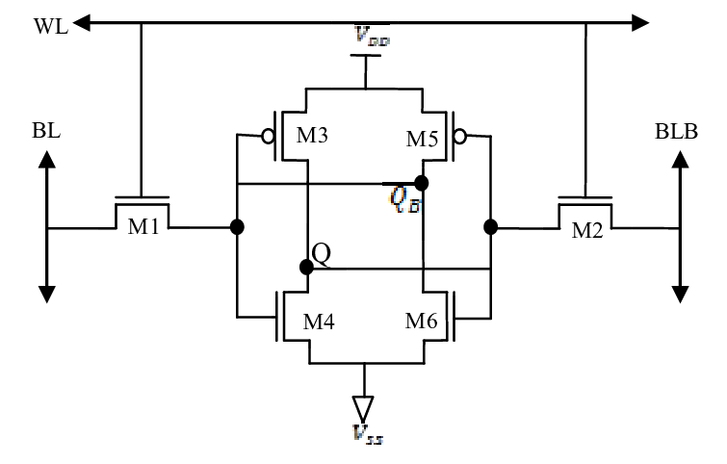

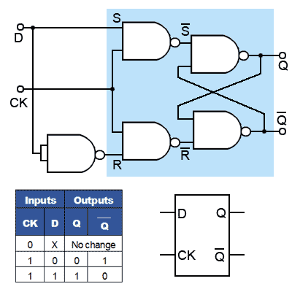

Advantages
- Higher operating frequency
- Reduced propagation delay
- Improved throughput
- Better timing reliability
- Suitable for FPGA implementation

Conclusion
The design of a pipeline-enabled SRAM-LUT using DFF significantly enhances digital system performance by improving timing efficiency and increasing clock frequency. By inserting D Flip-Flops between SRAM-LUT stages, the critical path delay is reduced, allowing higher throughput in high-speed applications. Though pipelining introduces slight area overhead, the performance gain outweighs the additional cost.
This architecture is highly suitable for modern FPGA and VLSI systems where speed and efficiency are primary design goals. Future work can focus on low-power optimization techniques and ASIC-level implementation to further enhance efficiency.

References
- B. Bandyopadhyay, O. Ismail, and R. Gorez, “Routh pade approximation for interval systems,” IEEE Trans. Autom. Contr, Vol. 39, no. 12, pp. 2454–6, Dec. 1994.
- C. Hwang, and S. F. Yang, “Comments on the computation of interval Routh approximants,” IEEE Trans. Autom. Control, Vol. 44, no. 9, pp. 1782–7, Sep. 1999.
- Y. Dolgin, and E. Zeheb, “On Routh-pade model reduction of interval systems,” IEEE Trans. Autom. Control, Vol. 48,no. 9, pp. 1610–2, Sep. 2003.
- S. F. Yang, “Comments on on Routh–pade model reduction of interval systems,” IEEE Trans. Autom. Control, Vol. 50, no. 2, pp. 273–74 Feb. 2005.

