Week-02-Operators and Expressions, Managing Input and Output Operations

[Week-02-02-Practice Session-Coding](http://www.rajalakshmicolleges.org/moodle/mod/quiz/view.php?id=35)

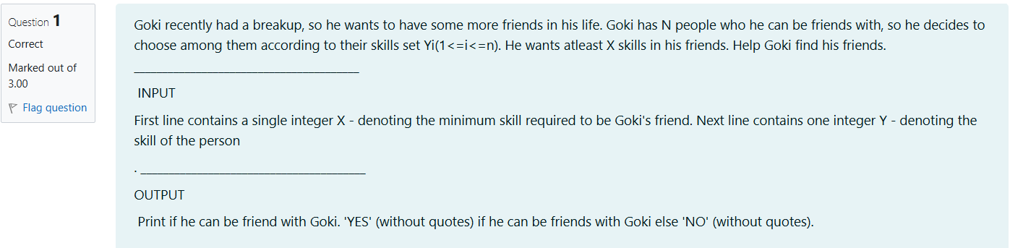

Source code

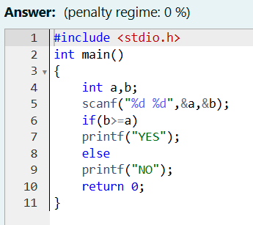

Result

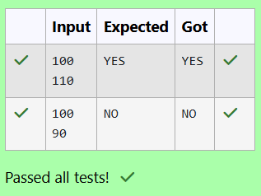

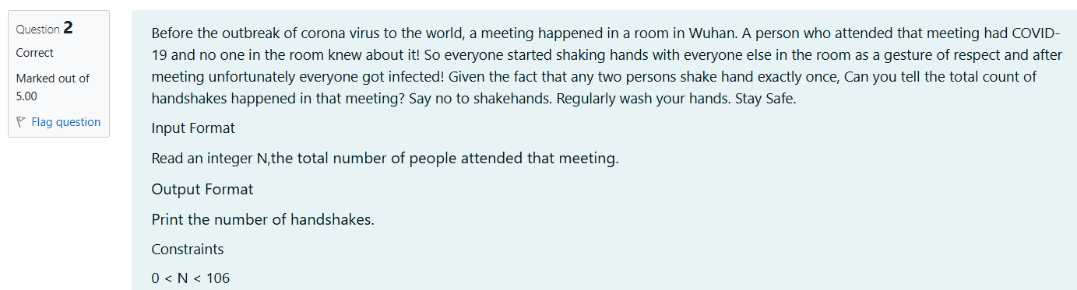

Source code

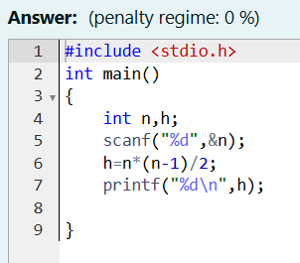

Result

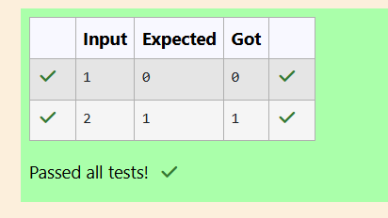

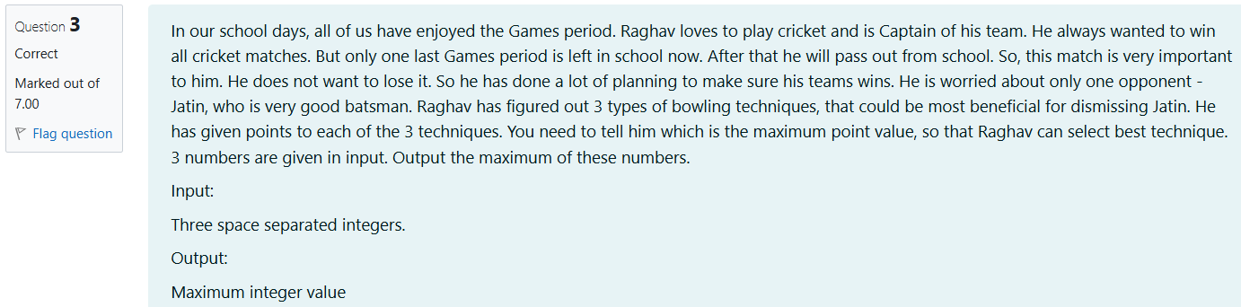 Source code

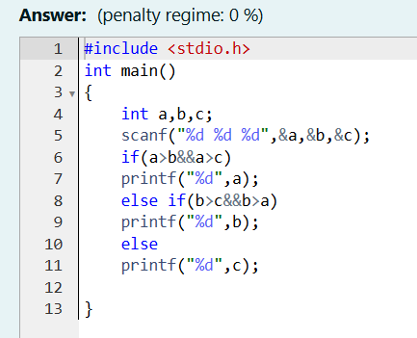

Result

