Week-03-Decision Making and Branching-if, if…else and nested if…else, if…else if and switch…case

[Week-03-01-Practice Session-Coding](http://www.rajalakshmicolleges.org/moodle/mod/quiz/view.php?id=35)

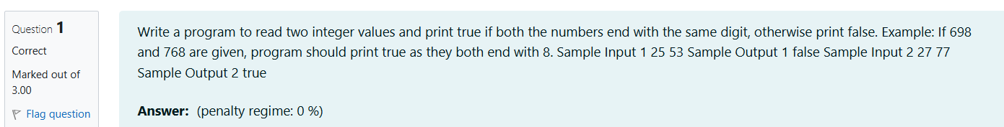

Source code

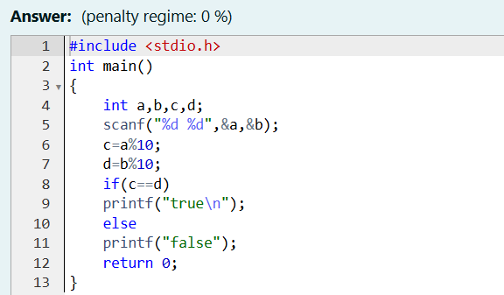

Result

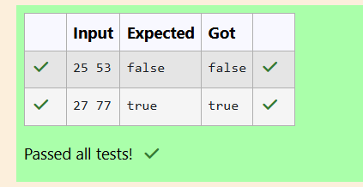

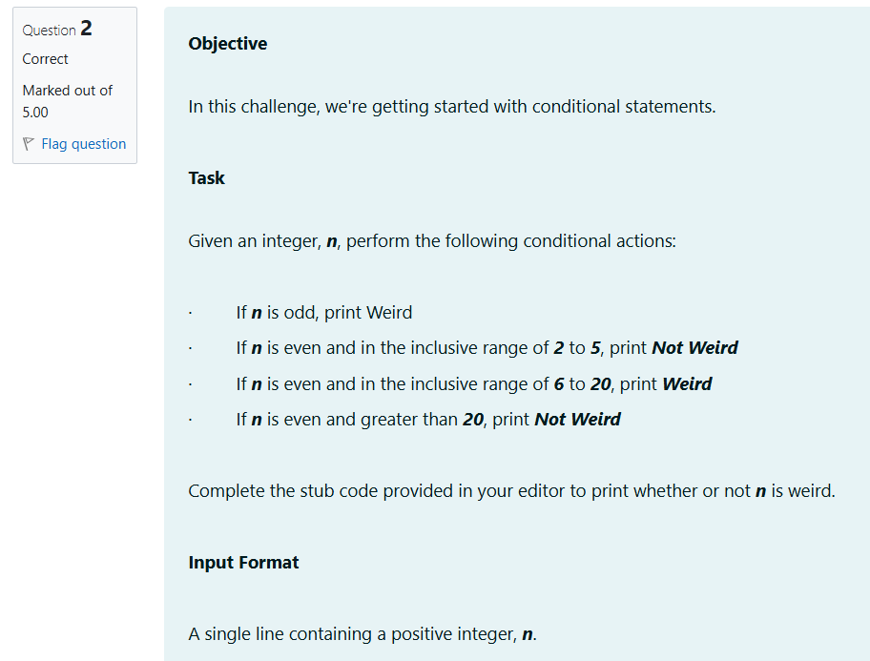

Source code

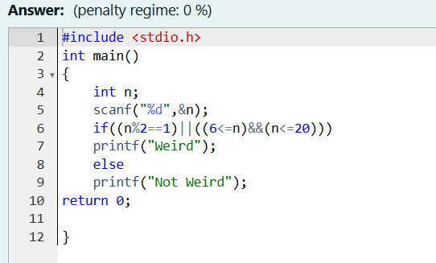

Result

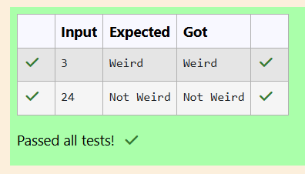

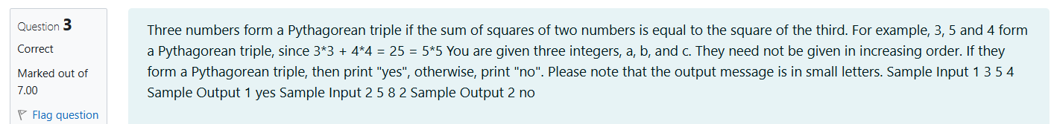

Source code

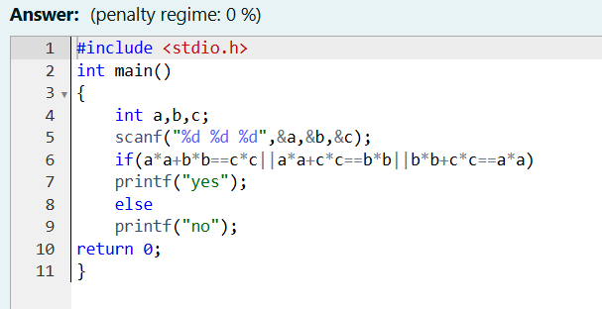

Result

