Problem Definition of Smart Parking

## Smart Parking is a parking solution that can include in-ground Smart Parking sensors, cameras or counting sensors. These devices are usually embedded into parking spots or positioned next to them to detect whether parking bays are free or occupied.  This happens through real-time data collection. The data is then transmitted to a smart parking mobile application or website, which communicates the availability to its users. Some companies also offer other in-app information, such as parking prices and locations. This gives you the possibility to explore every parking option available to you.

## Smart Parking and its Smart Parking Sensors can be seen as a part of smart cities. These smart cities are cities that are driven by an IT infrastructure and by using this infrastructure, cities can enhance the quality of life and improve economic development for its inhabitants. Becoming a smart city can be a good way to collect historical data in a relatively easy way. By collecting this data, cities can analyze how processes, like parking can be optimized.

## As a result of using Smart Parking, people who are looking to find a parking spot will find it in the most efficient way possible and companies or municipalities can optimize their parking territories. It also makes cities more livable, safer and less congested.

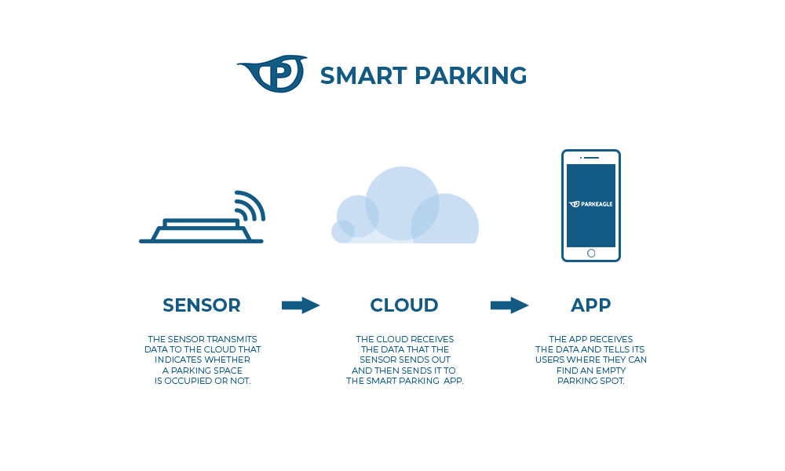

Advantages of Smart Parking for Drivers

## Optimizing the driving experience: using a Smart Parking system [saves a lot of time for drivers](https://www.parkeagle.com/2019/03/19/what-are-the-benefits-of-smart-parking-for-drivers/) since they know where to find a vacant parking spot. The amount of time you spend while looking for a parking spot will be minimized. By using the [Parkeagle technology](https://www.parkeagle.com/2018/05/12/what-is-smart-parking/www.parkeagle.com/our-technology) of the Smart Parking sensors, you will be able to find the parking spot you are looking for, without having to browse through the streets.

Advantages for Cities

## Less pollution:

## Smart Parking contributes to a cleaner environment. Reducing the time that is necessary to find a parking spot will reduce the amount of fuel that is used when looking for a parking space. This makes the process of finding a parking spot contribute to less pollution, which is beneficial for everyone.

## The space of a municipality will be utilized more efficiently:

## because Smart Parking sensors transmit live-data, drivers will have a real-time overview of the occupancy of parking bays. This means that free spots can be filled quicker, which will reduce the time that a parking spot is empty.

## Safety:

## The use of Smart Parking Sensors can optimize safety within cities. As a result of placing, for instance, on-ground sensors on parking bays, people will not be as stressed as when they are looking for parking spaces. Because these people will know where they are going, they can simply navigate to their parking spot and they will not have to stress out about it.

## Real-time parking analytics for cities:

## Parking space will become intelligent by use of the smart parking sensors on the parking bays. This means that as a city you’re able to see historical data which is stored and you’re able to make data driven decision and predictions based on the parking sensor data.

# ****SMART PARKING OF DESIGN THINKING****

# ****What is Design Thinking?****

Design thinking is essentially an approach to deeply understanding and defining a user’s problems, leading to a possible set of solutions and then to a prototype. Followed by testing and refining the prototype developed, to the point of implementation. It’s a non-linear, iterative process that involves five Stages— **Empathize**, **Define**, **Ideate**, **Prototype**and **Test**.

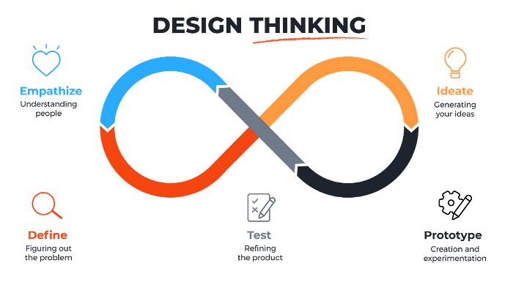

*Before moving on to the stages, it was important for me to remember that****I am NOT the user****and that I must keep my own perspectives to a minimum so that the insights I gain from my users are not biased.*

Smart parking and design thinking are two concepts that are related to each other. Here is a possible answer based on the current web page context:

* **Smart parking** is a parking solution that uses technology to optimize the use of parking spaces. It involves the use of sensors, cameras, and other devices to monitor parking availability and provide real-time information to drivers.
* **Design thinking** is a problem-solving approach that involves understanding the needs of users and designing solutions that meet those needs. It can help create user-friendly and efficient parking systems.
* **Benefits of smart parking and design thinking**: Smart parking and design thinking can offer various benefits, such as:
  + Saving time and money for drivers by reducing the search for parking spots
  + Reducing pollution and congestion by minimizing the fuel consumption and emissions of vehicles
  + Utilizing the space of a municipality more efficiently by filling vacant parking spots faster
  + Enhancing the safety and livability of cities by reducing stress and frustration of drivers
  + Providing real-time parking analytics for cities to optimize their parking policies and strategies