Report
Of

AI Innovation for Business: Strategic Planning, Algorithm Selection,
Implementation Roadmap and Evaluation

Submitted
To

School of Computer Science and Engineering
IILM University, Greater Noida, U.P.

In partial fulfilment of the requirement of degree of
B.Tech CSE

By

Roll Number of Student: CS2341217
Name of Student: SUGUN RANA
Batch: 2026-27

CANDIDATE'S DECLARATION
I, Sugun Rana, Roll No. CS2341217, do hereby declare that the internship report titled “AI Innovation for Business: Strategic Planning, Algorithm Selection, Implementation Roadmap and Evaluation” has been completed by me to fulfil the requirement for the award of the degree of Bachelor of Technology in CSE. All the references have been quoted and I have not taken as such any material from any other source. I affirm that this report is my own and has not been submitted to any other institute for any degree/diploma requirement, and I shall be solely responsible for any kind of copyright violation in this regard.
Signature
Student Name: Sugun Rana
Roll No.: CS2341217

ACKNOWLEDGEMENT
I am using this opportunity to express my gratitude to everyone who supported me throughout the Internship Program at YuvaIntern. I am thankful for their aspiring guidance, invaluably constructive criticism, and friendly advice during this work. I am sincerely grateful to Mr. Kounal Gupta, Founder of YuvaIntern, and the entire mentoring team for their support during the course of the Virtual AI Innovation Internship, which gave me the opportunity to apply theoretical knowledge of Artificial Intelligence to practical, real-world inspired tasks.
I would also like to thank the School of Computer Science and Engineering, IILM University, Greater Noida, for providing me the platform and encouragement to undertake this internship as part of my B.Tech CSE curriculum.
I express my gratitude to my parents for their blessings.
Signature
Student Name: Sugun Rana
Roll No.: CS2341217

TABLE OF CONTENTS
Cover Page
1. Candidate's Declaration
2. Acknowledgement
3. Internship Completion Certificate
4. Project Description
4.1 Introduction
4.2 Organization Profile
4.3 Problem Statement
4.4 Project Objectives
4.5 Scope of the Project
4.6 Technologies and Tools Used
4.7 System Architecture
4.8 Methodology
4.9 Expected Outcomes
4.10 Certificates of Completion and Communication Proof
5. Bibliography / References

3. INTERNSHIP COMPLETION CERTIFICATE
The Certificate of Experience issued by YuvaIntern (in association with Henry Harvin Education) confirming successful completion of the Virtual AI Innovation Internship is presented below.
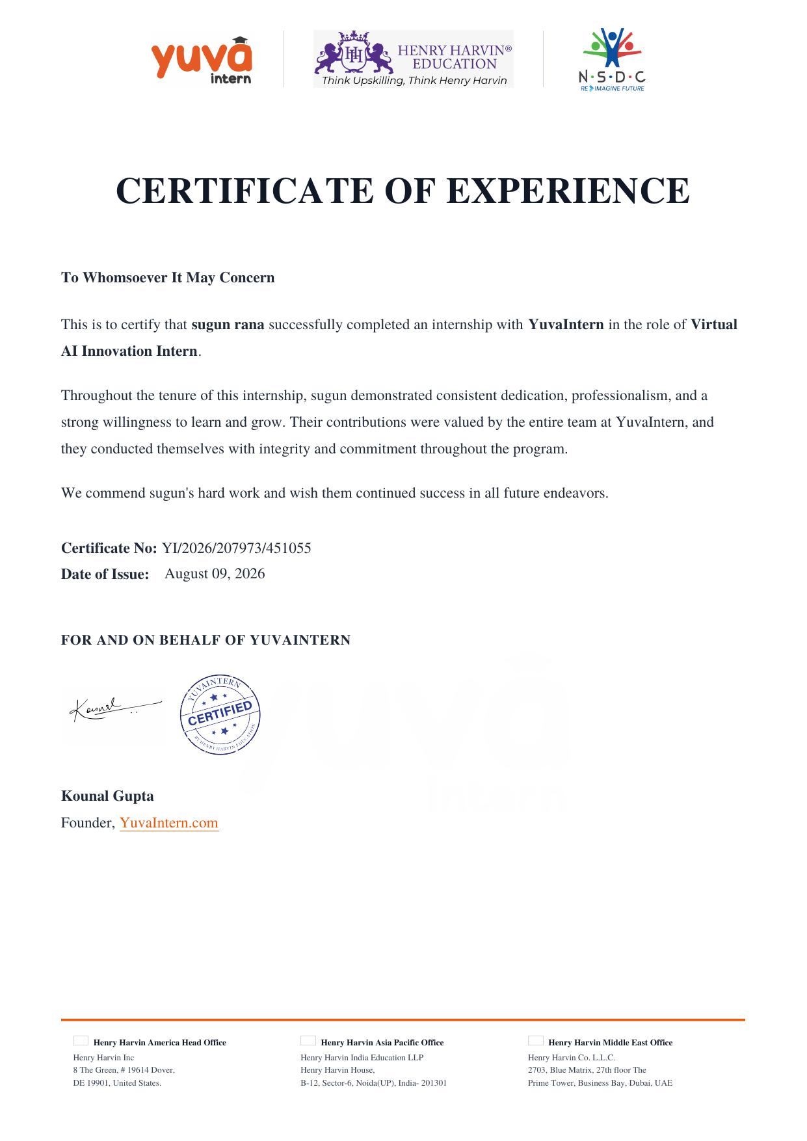

4. PROJECT DESCRIPTION
4.1 Introduction
Artificial Intelligence (AI) has emerged as one of the most transformative technologies of the present era, reshaping how organisations plan, build, and evaluate digital solutions. As part of the B.Tech CSE curriculum, I undertook a four-week Virtual AI Innovation Internship with YuvaIntern, where I was engaged in a structured, hands-on program centred on the core concepts of Artificial Intelligence. The internship was organised around four progressive tasks: strategic AI project planning, AI algorithm selection and methodology formulation, AI implementation roadmap and prototype design, and AI solution evaluation with future enhancement proposals. This report documents the work carried out during each of these stages, the research and analysis performed, and the outcomes achieved.
4.2 Organization Profile
YuvaIntern is a virtual internship platform, operating in association with Henry Harvin Education, that provides students and early-career learners with guided, project-based internship experiences across emerging technology domains. Henry Harvin Education is a recognised skilling and training organisation, empanelled with the National Skill Development Corporation (NSDC), with a presence across offices in the United States, India (Noida, Uttar Pradesh), and the Middle East (Dubai). Through YuvaIntern, the organisation offers remote internship roles such as the Virtual AI Innovation Intern position, designed for students new to the field of Artificial Intelligence, allowing them to apply machine learning concepts and data analysis techniques to simulated business challenges under the guidance of experienced mentors.
4.3 Problem Statement
Many organisations today recognise the potential of Artificial Intelligence but struggle to translate that potential into a structured, executable plan. The absence of a clear methodology for identifying suitable AI use cases, selecting the right algorithms, designing an implementation roadmap, and evaluating outcomes often results in AI initiatives that are poorly scoped, under-resourced, or difficult to scale. The core problem addressed during this internship was: how can an organisation systematically identify a viable AI opportunity, choose an appropriate technical approach, plan its implementation in phases, and evaluate and improve the resulting solution over time, using only publicly available research and industry knowledge?
4.4 Project Objectives
- To research contemporary AI trends and identify feasible AI application opportunities within an innovative business context.
- To perform a SWOT-based feasibility analysis of a chosen AI use case and translate it into a strategic roadmap with clear milestones and timelines.
- To study and compare multiple AI/ML algorithms on accuracy, efficiency, scalability, and interpretability, and to justify the selection of an algorithm for a given scenario.
- To design a conceptual implementation roadmap and prototype blueprint covering development, testing, and deployment phases.
- To evaluate a hypothetical AI solution against defined performance metrics and propose realistic, technically sound future enhancements.
4.5 Scope of the Project
The scope of the internship spanned the complete lifecycle of an AI initiative at a conceptual and strategic level, rather than full-scale software development. It covered opportunity identification, feasibility analysis, algorithm selection methodology, implementation roadmap design, prototype conceptualisation, and post-implementation evaluation. All research and analysis were carried out using publicly available resources, academic references, and industry case studies, without access to proprietary organisational data, since the tasks were designed around simulated, generic business scenarios suitable for a beginner-level AI internship.
4.6 Technologies and Tools Used
- Machine Learning and Deep Learning concepts (supervised, unsupervised, and ensemble methods).
- Analytical frameworks: SWOT analysis, comparative evaluation matrices, and risk-assessment matrices.
- Documentation and diagramming tools for flowcharts, wireframes, and system architecture representation.
- Publicly available AI research papers, industry reports, and case studies used for literature review.
- Microsoft Word / DOC-based reporting for structured documentation of each weekly deliverable.
4.7 System Architecture
As part of the Week 3 task, a conceptual prototype architecture was designed for the proposed AI solution. The architecture followed a layered structure: (i) a Data Layer responsible for data collection, cleaning, and preprocessing; (ii) a Model Layer where the selected machine learning algorithm is trained, validated, and tuned; (iii) an Application Layer that exposes the model's predictions through an interface for end users or downstream systems; and (iv) a Monitoring Layer that tracks model performance, data drift, and system health over time. Data flows from ingestion through preprocessing into the model layer, with predictions surfaced to the application layer and continuously monitored, forming a feedback loop that supports retraining and future enhancement.
4.8 Methodology
The methodology followed a phased approach aligned with the four weekly tasks of the internship:
- Week 1 - Research and Strategic Analysis: Investigated current AI trends and case studies, identified a specific business opportunity, and evaluated its feasibility using a SWOT framework before drafting a strategic roadmap with objectives, resources, timelines, and risks.
- Week 2 - Algorithm Selection: Conducted a literature review of multiple AI algorithms, developed a comparative evaluation matrix based on accuracy, efficiency, scalability, and interpretability, and justified the selected algorithm(s) with a step-by-step implementation methodology covering data handling, training, and validation.
- Week 3 - Implementation Roadmap and Prototype Design: Defined the project scope, broke the implementation into phases (research, prototype development, testing, and deployment), and produced a conceptual prototype design describing system architecture, data flow, and component interaction, along with identified risks and mitigation strategies.
- Week 4 - Evaluation and Enhancement: Defined performance metrics (accuracy, efficiency, user experience, and scalability), conducted a critical evaluation of the hypothetical AI solution's strengths and weaknesses, and proposed future enhancements involving updated technologies and scalability improvements.
4.9 Expected Outcomes
- A clear, well-documented strategic plan connecting research findings to an executable AI roadmap.
- A defensible, criteria-based methodology for selecting AI algorithms suited to a given problem.
- A conceptual prototype blueprint that can guide an actual development effort, along with identified risks and mitigation strategies.
- An evaluation framework and enhancement proposal that supports continuous improvement of an AI solution after deployment.
- Strengthened personal understanding of AI concepts, strategic thinking, and professional documentation practices.
4.10 Certificates of Completion and Other Communication/Proof
The Internship Offer Letter issued by YuvaIntern, confirming the internship role, duration, and terms, is presented below as proof of engagement. The Internship Completion Certificate has already been presented in Chapter 3.
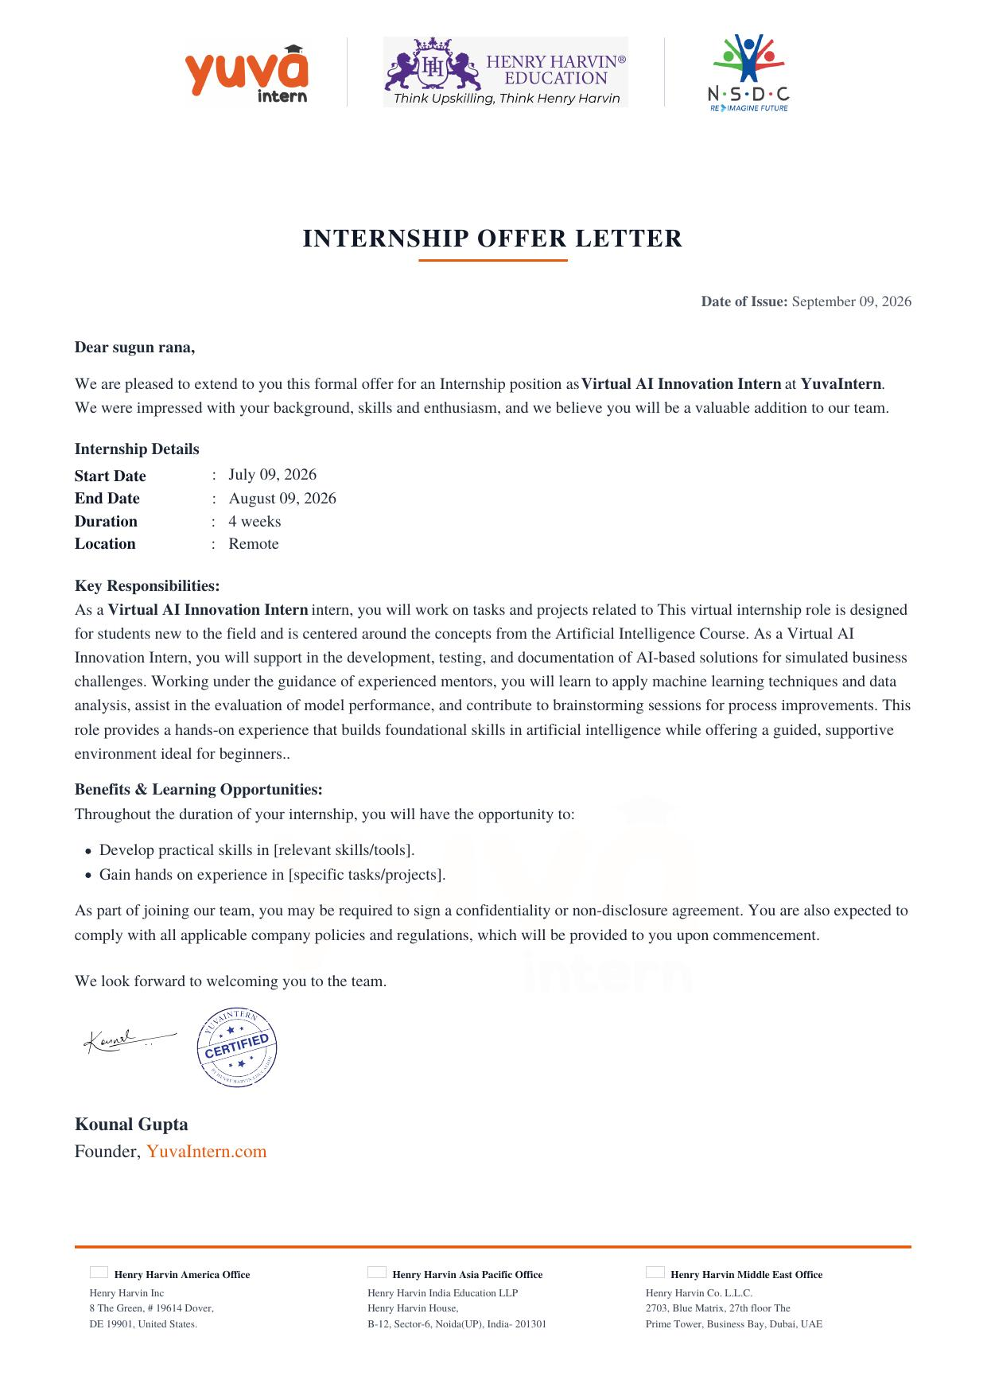

5. BIBLIOGRAPHY / REFERENCES
1. YuvaIntern. Internship Task Sheet - AI Innovation Track, YuvaIntern.com, 2026.
2. Henry Harvin Education. About Henry Harvin, henryharvin.com, accessed 2026.
3. Russell, S., & Norvig, P. Artificial Intelligence: A Modern Approach. Pearson Education.
4. Various publicly available AI research articles, industry blogs, and case studies referenced during literature review for Weeks 1-4 tasks.

