Abstract--We overview the current distribution automation system in Korea and point out the limitations of the distribution services which can be provided by the current system. In this paper we propose a new distribution system architecture which is based on the peer-to-peer communication model. In this decentralized architecture the intelligent FRTUs can initiate data transmission without any intervention of a central server, and can exchange data with other FRTUs as peers. In order to support the peer-based distribution system, we specify the requirements for new communication network and suggest a way of improving the current distribution network where we adapt an intelligent module for protection and restoration, called MASX, and utilize the open communication network protocols. We also show how the new architecture can enhance major distribution services such as protection, automatic restoration, and facility management.
Evolution of communication networks for distribution automation system in Korea
Sugwon Hong, Il Hyung Lim, Myeon-Song Choi, Seung-Jae Lee, Chang Hoon Shin, Sung Woo Lee, Bok Nam Ha

Index Terms—distribution automation, distribution communication network, distributed structure, peer model, automatic restoration, protection coordination

Introduction
The distribution automation system (DAS) provides capabilities for a central server to collect operation data such as voltage and current, to monitor and control feeder remote terminal units (FRTU) which are scattered in the distant area, and to detect and restore faults automatically [1].
The important service elements for operating the distribution system are protection coordination, fault restoration, and facility management. The current system in Korea is based on a centralized architecture to provide these services. A central server gathers data from FRTUs periodically by polling and sends control commands to them. FRTUs can not initiate any control, being dependent on the server in every action.
Due to the centralized architecture the current distribution system does not offer protection coordination which can be achieved by exchanging information between FRTUs. Moreover, it takes a few minutes to restore faults because a central server should collect fault information from FRTUs and analyze it to send control commands to them. Even though facility management is based on real-time monitoring, a little delay can not be avoidable due to its center-oriented characteristics.
In order to provide efficient services for protection coordination, fault recovery, and facility management, a decentralized architecture is required for the distribution automation where FRTUs can exchange information each other without any help of a central server [2]-[3]. In this paper we look into the current communication architecture and technology for the distribution automation in Korea and analyze the requirements for the communication infrastructure, and finally propose the evolutionary stages of the communication network architecture to satisfy these requirements.

Distribution automation system in Korea

System components
Two integral components of the distribution automation system are FRTUs and a DAS server. An independent distribution system consists of approximately 100 to 500 FRTUs depending on the geographic size. A local distribution system has an area of at most 20km. Fig. 1 shows the basic structure of the distribution system. This system has DAS servers located in a central control station which collect data from FRTUs and send control commands to FRTUs.

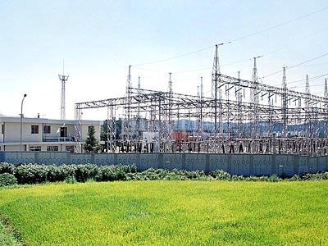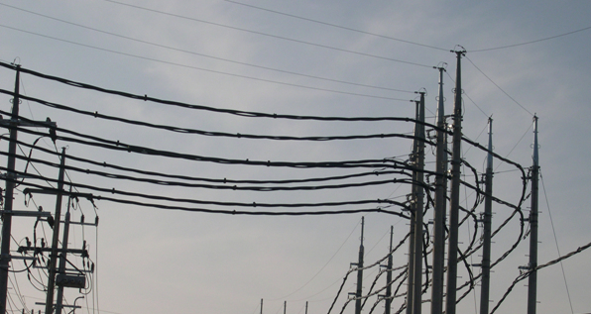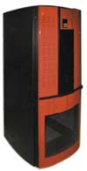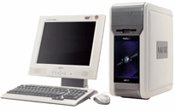
Substation
Distribution
Network
RTU
Branch
DAS
Communication Wire
Customer

Fig. 1 The DAS Structure

Communication network architecture
In addition to these power system components, the information infrastructure is necessary to exchange data between them. The distribution communication network in Korea is currently constructed using various transmission media and technology. Table 1 shows the composition of various transmission media currently installed in the distribution communication network in Korea. As shown in this table, optical fiber consists of more than 40%, and its share will be increasing.


Modem
FRTU
FRTU
Distribution Automation System
Optical Network (E1)
RS-232
FRTU
:Optical Cable

: RS-232 (1200 Bps)

Fig 2. DAS network architecture based on the optical ring in KOREA

Fig. 2 shows the current fiber-based communication network. As shown in this figure, a DAS server and FRTUs are connected to optical ring via modems which have a speed of E1 (2Mbps). A DAS server is connected to a modem via Ethernet while FRTUs are connected to RS-232 serial ports of modems. In this communication architecture each FRTU cannot exchange information directly each other. Instead the DAS server in the middle delivers data between FRTUs. Thus in order to improve performance and provide enhanced services in the distribution system, we need to have a communication architecture to offer capability that each FRTU can exchange information each other without any intervention of a DAS server.

TABLE 1. Promotion status of DAS communication nerwork in korea

SECTION | WIRED |  | WIRELESS |  |  | TOTAL
SECTION | OPTICAL | POTS | TRS | WIRELESS DATA | CDMA | TOTAL
Network Provider | Powercom | KT | KEPCO | Air media | SKT | -
Numbers | 11,101 | 6,735 | 4,125 | 3,804 | 290 | 26,055
Share(%) | 41.9 | 26.1 | 16.2 | 14.6 | 1.2 | 100
Modem Price | 272,480 | 473,000 | 1,284,600 | 553,488 | 900,637 | -
Pricing | Flat rate | Flat rate | - | Flat rate | Meter rate | -
Monthly charge | 54,000 | 49,400 | 0 | 18,000 | 17,000 | -
Yearly charge(bil) | 71.9 | 39.9 | 0 | 8.2 | 0.6 | 120.6

Communication technology

Ethernet as an access network technology
Ethernet has long been considered a flagship LAN technology. With a widespread use of gigabit Ethernet and an advent of 10 gigabit Ethernet, Ethernet reassures its position as a high-speed data transmission technology. Recently the use of switches makes Ethernet technology one of the most competitive technologies for metropolitan area network (MAN), pushing Ethernet beyond its traditional geographical boundary [4]-[5].
The traditional subscriber network is based on the telephone infrastructure. These days customer's needs for high-speed data service brought about new high-speed access technologies. Digital subscriber lines (DSL) and hybrid fiber coaxial (HFC) networks are the most popular technologies among them. While the wired networks become faster with the increasing deployment of optical fibers, wireless access network has its own edge over the wired forerunners with the emerging new generation wireless technology.
Metro Ethernet which utilizes 10G Ethernet and switch technology is recognized one of the most promising technology in the metropolitan area because it can cope with the voice-oriented traditional transmission channel usage and provide the high utilization of communication channels for data traffic [6].
The reasons that Ethernet keeps having competitive edge over other technologies are pointed out as follows. First Ethernet, based on the packet switching technology, can make the most of link utilization by link sharing, consequently reducing the cost per bandwidth. Second, since Ethernet has long been used widely, its products including chips and switches are relatively cheaper than any other competing technologies. Third, Ethernet has long been verified by network managers as stable and ease-to-use technology.

IP-based integrated services
With the widespread use of Internet, the IP-centric integration will be gaining momentum. The IP-based integration can be mentioned from two perspectives. One is the evolution toward IP-centric networks. The access networks as well as the core networks will progress toward networks that favor the delivery of Internet traffic. The other is the IP-centric service integration. Every service will be provided based on the IP networks. Not only data traffic but also voice traffic and video traffic will be delivered on the IP networks in the future.
Considering the trend of IP-based integration, it is desirable that the distribution networks will be based on the TCP/IP protocols. This will help the distribution system benefit from the use of the Internet technology. More importantly, the future power system networks including the SCADA system will be moving toward the networks based on the open standard protocols, especially TCP/IP protocols [7]. Thus power systems networks can be built on the common network protocols and provide services based on the integrated networks.

Power Line Communication
In the power system Ethernet technology is applied to the high-end system including EMS and SCADA, while serial communication is common in the low-end system. Currently the power line communication (PLC) is emerging as new communication technology. Recently PLC technology begins to be deployed in real networks and shows its possibility as a potential competitor in the market [8]-[9]. One of advantages of PLC technology is its low investing cost and operating cost.
The application of PLC technology is divided into three parts: 22.9kV high voltage section, 220V low-voltage section, and indoor section. In the first two sections, PLC technology can be used as access network technology, and in the indoor section, it can be used for home automation and networking. In particular, in the low-voltage section PLC can be used for communication between FRTUs.
The disadvantage of PLC use in the distribution network is its inability at a stoppage of power supply. For this reason it is not possible to use PLC for fault detection and restoration. The most promising application in the high and low-voltage section is the automatic meter reading and Internet access network technology.

Requirements for new distribution Network architecture

Distributed architecture
In the advanced power distribution system, more intelligent devices will be introduced. They are indispensable to maximize the efficiency of the system and provide new services. These devices will be functioned as nodes of the distribution communication network. The model of the future distribution network should accommodate the functions of the nodes as intelligent devices in the following way.
First, direct communication between nodes should be supported. To do this, each node should act as a server as well as a client as needed basis. Each node can request information that it needs to other nodes directly, and receive the information from other nodes directly as well. Each node acts as a peer to other nodes and their communication is achieved without any intervention of a DAS server. The peer model will offer the distribution system more capability to provide new services and to increase its efficiency.
Second, each node should have its unique network address to be identified in the network. To have a unique address is indispensable element for the peer model service. The new address structure can be introduced for this purpose, but alternatively the existing address such as IP address can be applied. Not only having its own address is necessary for acting as a peer, but it also provides the network platform which can treat and control all nodes in the integrated domain.

Communication protocol
One of the purposes of the distribution automation system is real-time control of the whole system which encompasses substations and residential areas as well as the distribution system. To achieve this goal, the distribution network should be designed to integrate the whole system.
We need to consider the following factor to construct the integrated network. The network should be based on a common network protocol so that services can be provided transparently regardless of underlying communication technology and transmission media. The common network protocol should be not a closed one which is used in a particular system or group, but be an open network protocol which can be accepted and accessed easily by all users.
In this respect the TCP/IP protocol is the most promising candidate to incorporate all the heterogeneous elements in the current distribution network. The TCP/IP protocol is widely used in most networks, and it will be more and more accepted as the universal network protocol, in particular with the increase of web-based application and the transition to IPv6.
The TCP/IP protocol is already adapted in the SCADA system. The use of this protocol in the distribution network will expedite seamless integration with the SCADA system and boost the service expansion with the compatibility with other existing networks including corporate networks.
Figure 3 shows the protocol stack when the TCP/IP protocol is adapted in the system. The DNP 3.0 protocol can be replaced by other IEC protocols and application over DNP 3.0 will be provided regardless of any underlying communication infrastructure and network protocols [10][]11].

DNP 3.0
TCP/IP
DNP 3.0
TCP/IP
Ethernet
Ethernet

Fig 3. Protocol stack based on TCP/IP and Ethernet

Security
Until now, the distribution network is closed from any access outside, and is unlikely to experience from any cyber attacks. The security approach is also focused on the physical protection, so called “security by obscurity.”
However, network security will become a critical issue if the distribution network is moving toward integrating with other networks which naturally are based on the open standard network protocols [12]-[13].
Many security measures and protocols have been developed and applied in the current network, especially the TCP/IP-based network. Not all security measures can be applied to the distribution network. The important thing in the security issues is to define the proper requirements peculiar to the distribution network. What we need to consider in the distribution network are as follows. First communication nodes, that is, FRTUs, are located in the metropolitan area of at most 20km as mentioned in section II. This is in contrast to the SCADA system which is intrinsically a LAN environment. Second, the communication node is an embedded system, which means that it is unmanned and may have limited computing power. Third, response to command should be immediate, especially even more when the command is related to fault indication and restoration [14].

Quality-of-service (QoS)
In the current distribution network application, the exchange of information between a DAS server and FRTUs is sporadic and generates light traffic. For this reason even though the current network is based on serial communication, the quality of network service is not a problem. However, as the installment of FRTUs is increasing, and new services are introduced, traffic between nodes will be increasing. In this case the quality of network services will become a critical issue.
We define the term, QoS, as the network capabilities to satisfy the service requirements of customers. By this definition, the first requirement of customers is network stability and reliability. To meet this requirement, network should operate robustly, and has a self-healing function when it has any fault. The network protocol should guarantee the error-free data delivery.
The second requirement is to guarantee data latency in order to perform tele-control in real-time. The exchange of control commands should be done within a required time. This is related to the network performance.

Evolution toward new distribution NETWORK architecture

Need for evolutionary approach
We explained the current distribution network in Korea in section II. The first direction to enhance the distribution network is to replace the serial communication by Ethernet. Ethernet provides high-speed data transfer in a economical way as mentioned in section III-A.
But the migration to Ethernet is not easy task. Now approximately 30,000 FRTUs which support only serial communication have been deployed. Thus transition to Ethernet can not be done at one moment because of the cost, but will take time. Another obstacle to move to Ethernet is that the optical fiber ring in the transmission network is owned by a network provider, not by a power company. Currently the transmission is based on the plesiochronous or synchronous transfer mode (PDH/SDH) over the fiber. The migration to Ethernet is dependent of the transmission technique and installment in this optical fiber transmission network.
Taking into these restrictions, we propose the stepwise migration plan for the distribution network.

MASX-based communication architecture
We introduce a device which is called Multi-Agent Service Device (MASX) as an interim solution for distribution automation system. MASX is a device which can perform protection coordination, automatic fault recovery, and facility management in the distribution system [1]. It also has Ethernet port through which it is connected to modem, and subsequently FRTUs with MASX can be connected to the modem through Ethernet. MASXs have also other communication ports such as CDMA, which can be used to exchange data between MASXs by using other technology than Ethernet.
Figure 4 shows the network configuration when MASX is applied to the current distribution network. As shown in this figure, FRTUs can communicate each other in the Ethernet-PDH/SDH-Ethernet way. The network with MASXs does not change the current interface with optical transmission ring. But this configuration enables FRTUs to act as peer nodes each other, and the distribution system to provide new services on this basis.

Modem
FRTU
(+MASX)
DAS
Ethernet
Optical Network
E1(PDH/SDH)
: Optical Cable

: LAN Cable
Modem
FRTU
(+MASX)

Fig 4. DAS Network Architecture with MASX

Ethernet-based network
As long as FRTUs are connected to the optical transmission ring based on the time-division multiplexing (TDM) transmission mode, we can not make the most of the strengths of Ethernet. In order to cope with this limitation, the transmission network to which all FRTU and DAS servers are connected should be replaced by Ethernet-based access or metropolitan network. Ethernet-based network can be realized with the 10G Ethernet and Ethernet switch technology, which can cover metropolitan area. Then FRTUs can enjoy full speed and merits of Ethernet technology.
With Ethernet as an underlying communication infrastructure, the future distribution network will be progressed to accommodate the TCP/IP protocol as an open standard network protocol. In this way the distribution network can be integrated with the SCADA system and also other networks, providing enhanced services.

New Distribution automation services

Cooperation and protection efficiency elevation
In the current distribution network, correction and cooperation course with protective equipments of a high electric current corrects considering maximum load of terminal protective equipments and the protective equipments of a high rank and a low rank will be cooperation when it provides a tap which is an electric current of the minimum action and choose T-C (time-current) curve which get an action time difference.
For example, the No.2 equipments and the No.3 equipments cooperate with each others in Fig.5. When the protective section of No.3 equipments is out of order, a load with sources of electricity in No.3 equipments give power without impediment as No.3 equipments which are the fast with action time act as main protection.

1
2
3
4
: Protection equipment
t1
Δ
t2
Δ
t3
Δ
t4
Δ
tn
Δ
: Different time of protection device n

Fig 5. Protection and cooperation method among the protective equipment

However, If No.3 equipments are out of order, back up protection, which act No.2 equipments after minimum time △t2 protect power utilities such as a transformer from a break down of an electric current. △t2, time of active cooperation, is against time to protection and relay method with a system in here.
But it is possible that protection and cooperation method can not completely protect or △t can get several minute, not several second. Nevertheless, if among protective equipments exchange information using P2P communication, some problems is easily solved.
If among No.3 and No.4 protective equipments are out of order in Fig 5, information of the fault indicator detects from No.1, 2, 3 protective equipments with fault occurrence. If protective equipments detecting fault current with P2P communication have judgment ability to find a fault section with asking existence and nonexistence of fault indicator to low protective equipments to do protection and cooperation, it can easily find a section of fault occurrence, and then it can do a function of main and back up protection.
In Fig 5, it confirms acting information of a fault indicator from No.1 to No.2 and from No.2 to No.3. When No.3 occur information of a fault indicator, it should prepare back up protection because No.1 and No.2 should act main protection. However, when it asks a information of a fault indicator from No.3 to No.4, if it does not answer or answer is “it does not detect fault current”, No.3 should immediately control something fault carry out main protection and send some signal to No.4 for opening. After removing fault, it can restrain carry out of back up protection to the high level protective equipments. If it design and use specific protection and cooperation algorithms, the same with existing, it gets protection and cooperation with acting time at occurring a difficulty communication. The algorithms include existing time cooperation method and occurring protection at the many faults in a difficulty communication or protective equipments. If communication time is faster then existing time cooperation without a difficulty communication for protection and cooperation, performance of protection and cooperation will be improvement because it can more fast performance of main and back up protection.

Restoration automation efficiency elevation

DAS
Reporting
Fault
DAS
Restoration
Command
Decision of
Restoration
Solution
Operator
Fig 6. Restoration process of DAS

Currently, distribution automation system method is the same Fig 6. After it receives and judges all information form, control instructions send that is related one by one. But at network, showed the Fig 7, if current distribution automation system becomes restoration that is like to result of Fig 8, it must have communication with all nodes to consider communication delay or loss from the net work to the center for correct fault section detecting. Therefore, after communicating the node of 14 units for each acquisition of information, the number of communication calculate restoration solution. And it should be communicating of 8 times because the nodes of 8 units carry out switching to act restoration. It needs using time of communication of 22 times because using time of communication is showed communication structure of one to one
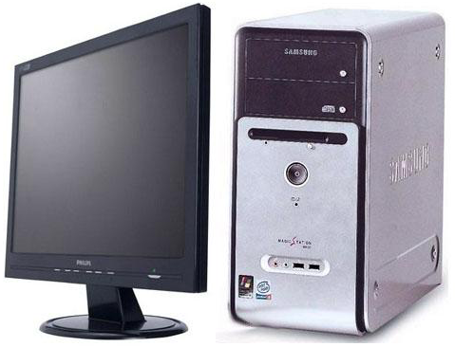
Substation
: Close
: Open
Central Agent
1
2
3
4
5
6
7
8
9
10
11
12
13
14
Fig 7. Example distribution network

But distributed restoration system that is showed Fig8 is different side of efficiency or time. Communication of the number of 14 which transfer to its center interchange of information mutually using distributed communication networks and surrounding node in accordance with naturally occurring F1 in each node. It expeditiously detects and divides a fault section so it is delayed the order of priority. Accordingly, at restoration action, communication of the number of 14 can reduce a couple of max for interchange of information mutually. When each node detects fault section, each node also transfers power failure restoration due to distributed communication structure. Node that should be switching is the number of 8 because of the possibility of multi communication and the paratactic communication. The time required communication becomes the time required three times from eight times. It completes the power failure restoration. It display like table2.
: Close
: Open
1
2
3
4
5
6
7
8
9
10
11
12
13
14
Substation

Fig 8. Distributed restoration process

Restoration order should open order according to priority because if all times connection point which divides connection section do close order, it occurs dual power in restoration motion. A result that Restoration system of distributed type and required restoration time using Visual C++ in base of PC notify that LAN need about 1 second and CDMA need about 43 seconds excepting required circuit breaker time. This give proof using domo system like Fig 9 that is reduced within 1 minute as compared with restoration time of temporary fault (5 minutes) in KEPCO.

TABLE 2. Comparison of the nessary time number for restoration of centeral and distributed type
 |  | Central Type | Distributed Type
Number of  switching act |  | 8 | 8
Number of communi-cation | 1 | D-2 Open | 2-1 : Close, 3-5 : Open
Number of communi-cation | 2 | D-3 Open | 3-11 : Open, 5-8 : Close
Number of communi-cation | 3 | D-1 Close | 3-14 : Close, 11-9 : Close
Number of communi-cation | 4 | D-5 Open
Number of communi-cation | 5 | D-11 Open
Number of communi-cation | 6 | D-8 Close
Number of communi-cation | 7 | D-9 Close
Number of communi-cation | 8 | D-14 Close

conclusion
Due to its centralized structure, the current distribution automation system in Korea has the limitation to provide the most important services such as protection coordination, fault restoration, and facility management. To overcome this limitation we propose a distributed architecture where FRTUs can communicate each other as peer-to-peer mode. We also investigate the current distribution network and communication technology, and define the requirements to provide the capability to the distribution network. In order to accommodate these requirements, the distribution network needs to migrate to Ethernet-based network based on the TCP/IP protocol as an open standard protocol. Taking the current situation into consideration, we propose a MASX-based network as an interim solution.

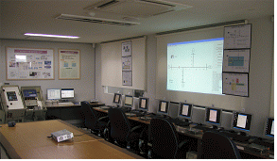

Fig 9. Distributed restoration demo system by example distribution network

Acknowledgment
Authors would like to thank Ministry of Commerce, Industry and Energy for their support through development program of Intelligent Distribution Management System.

References
- Il Hyung Lim, Myeon Song Choi, Seung Jae Lee, Bok Nam Ha, Sung Chul Kwon, “Distributed restoration system based on Multi-Agent”, KIEE Summer conference, pp. 52-53, 2006
- Kwang-Ho Jung, Myeon-Song Choi, et, al, "A Service Restoration Algorithm for Power Distribution Networks Applying the Multi-Agent System", KIEE International Trans., Vol. 5-2, pp. 125-131, 2005
- Murty Yalla, Mark Adamiak, et. al, "Application of Peer-to-Peer Communication for Protective Relaying", IEEE Transactions on Power Delivery, Vol, 17, No. 2, 2002
- Ralph Santitoro, "Metro Ethernet Services-A Technical Overview," Metro Ethernet Froum, www.metroethernetforum.org/metro-ethernet-services.pdf, Dec. 2003
- Sam Halabi, Metro Ethernet, Cisco Press 2003
- Ralph Santitoro, "Bandwidth Profiles for Ethernet Services," Metro Ethernet Froum, “www.metroethernetforum.org/PDFs/WhitePapers/ Bandwidth-Profiles-for-Ethernet-Services.pdf, 2004
- K.-H. Mak and B. Holland, "Migrating electrical power network SCADA systems to TCP/IP and Ethernet networking," Power Engineering Journal, Dec. pp. 305-311, Dec. 2002
- www.powerlinecommunications.net
- www.plcforum.org
- DNP Users Group, "DNP3 Basic 4 Documentations", www.dnp.org, 1998
- DNP Users Group, "Transporting DNP V3.00 over Local and Wide Area Networks", www.dnp.org, 1998
- A. Creery and E. J. Byres, "Industrial cybersecurity for power system and SCADA networks," Petroleum and Chemical Industry Conference, pp. 303-309, 2005
- IEC, "Power system control and associated communications - data and communication security," TR 62210, 2003
- Sugwon Hong, Il Hyung Lim, Myeon-Song Choi, Seung-Jae Lee, Chang Hoon Shin, Sung Woo Lee, Bok Nam Ha, “Security measures in distributed communication networks,” to be published

Biographies
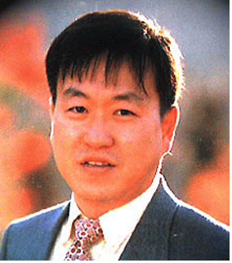
Sugwon Hong was born in Incheon in Korea, on January 7, 1957. He earned BS in physics at Seoul National Univ. in 1979, MS and Ph.D. in computer Science at North Carolina State Univ. in 1988, 1992 respectively.
His employment experience included Korea Institute of Science and Technology(KIST), Korea Energy Economics Institute, SK inc. and Electronic and Telecommunication Research Institute(ETRI). Currently he is a professor at Dept. of Computer Software, Myongji University since 1995.


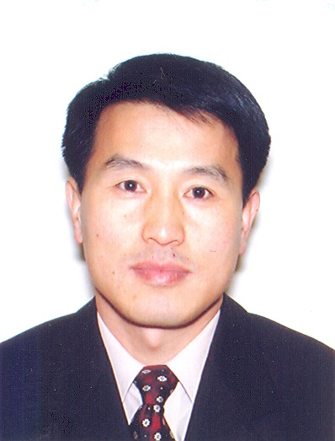
Il Hyung Lim was born in Seoul, Korea, in 1979. He received his B.E., and M.S. degrees in Electrical Engineering from Myongji University, Yongin, Korea in 2007. He is now working for his Ph.D. in Myongji University. His research interests are power system control and protective relaying, including artificial intelligence application..

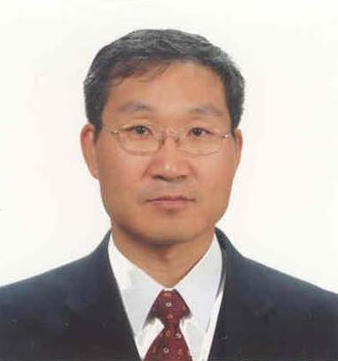
Myeon-Song Choi was born in Chungju, Korea, in 1967. He received his B.E., M.S., and Ph.D. degrees in Electrical Engineering from Seoul National University, Korea, in 1989, 1991, and 1996, respectively. He was a Visiting Scholar at the University of Pennsylvania State in 1995. Currently, he is an Associate Professor at Myongji University. His major research fields are power system control and protection, including artificial intelligence application

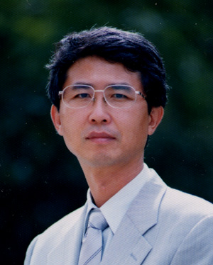Seung-Jae Lee was born in Seoul, Korea, in 1955. He received his B.E. and M.S. degrees in Electrical Engineering from Seoul National University, Korea, in 1979 and 1981, respectively. He received his Ph.D. degree in Electrical Engineering from the University of Washington, Seattle, USA in 1988. Currently, he is a Professor at Myongji University and a Director at NPTC (Next-Generation Power Technology Center). His major research fields are protective relaying, distribution automation and AI applications to power systems.


Chang-hoon Shin was born in Daegu, Korea in 1968. He studied at Kyungpook National University and revieved a master’s degree in electronics engineering in 1994. He entered Korea Electric Power Research Institute (KEPRI), KEPCO research center in 1994. As a researcher he contributed on developing digital control systems for power plants and had specialty in nuclear instrumentation. He joined the power distribution sector in 2005 and now he is performing research projects related on distribution automation and distribution IT systems.

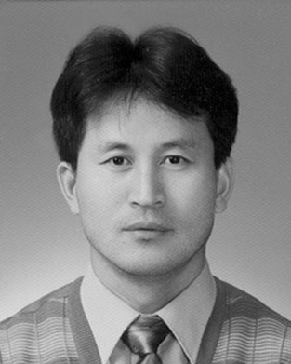
Sung-Woo Lee received the Ph.D. degree in electrical engineering from Kun Kook University, Seoul, in 1999. He entered Korea Electric Power Research Institute(KEPRI) representative research center of Korea Electric Power Corporation(KEPCO) in 1992. As a researcher belong to the power generation laboratory he contributed on developing distributed control systems for power plant more than fourteen years and had specialty in nuclear instrumentation. He joined the distribution laboratory in 2006 and now he is performing research projects related on distribution automation and distribution IT systems.

Bok-Nam Ha was born in Daejon, Korea in 1958. He received M.S.E.E degree and Ph.D. from the Chungnam National University, Korea. He is currently working in Korea Electric Power Research Institute of Korea Electric Power Corporation since he joined in 1978. He is a deputy researcher and the leader of distribution automation group to develop intelligent distribution automation system since 1990. His research interests are the application programs of distribution automation and its field application.

 This work was supported by the development program of Intelligent Distribution Management System of Ministri of Commerce, Industry and Energy. Sug Won Hong, Il Hyung Lim, Myeon-Song Choi, , Seung-Jae Lee are with the Next-generation Power Technology Center, Department of Electrical Engineering, Myongji University, Yongin 449-728, Korea (e-mail: swhong@mju.ac.kr, sojoo2jan@mju.ac.kr, mschoi@mju.ac.kr, sjlee@mju.ac.kr). Chang Hoon Shin, Sung Woo Lee, Bok Nam Ha are with the KEPRI, Daejeon Korea (e-mail : hoony@kepri.re.kr, swlee@kepri.re.kr, bnha@kepri.re.kr).

