AI Invoice Builder - Architecture

System Overview
Concept: "PO 던지면 인보이스 나오는 상자" (Throw in a PO, get an invoice out)
User Flow: Upload PO → Select Type → AI Analyze → Review → Generate Invoice

System Architecture Diagram
전체 시스템의 계층 구조와 컴포넌트 간 연결을 보여줍니다.
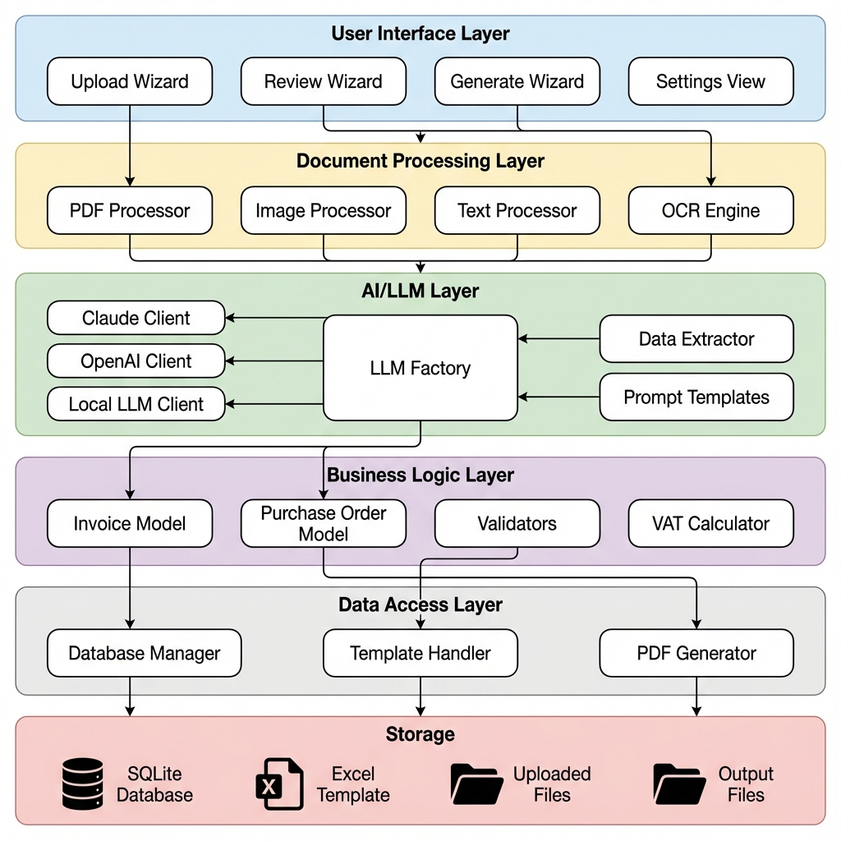

User Flow Sequence
사용자가 PO를 업로드하고 인보이스를 생성하는 전체 흐름입니다.
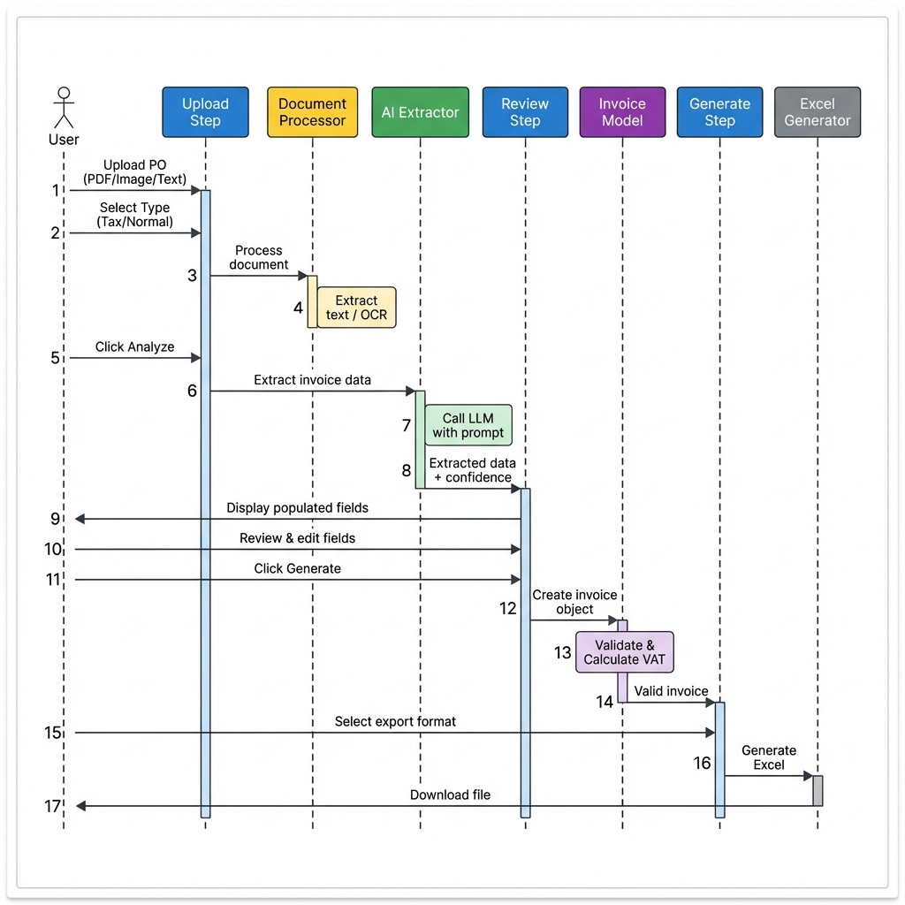

Database Schema (ERD)
데이터베이스 테이블 구조와 관계를 보여줍니다.
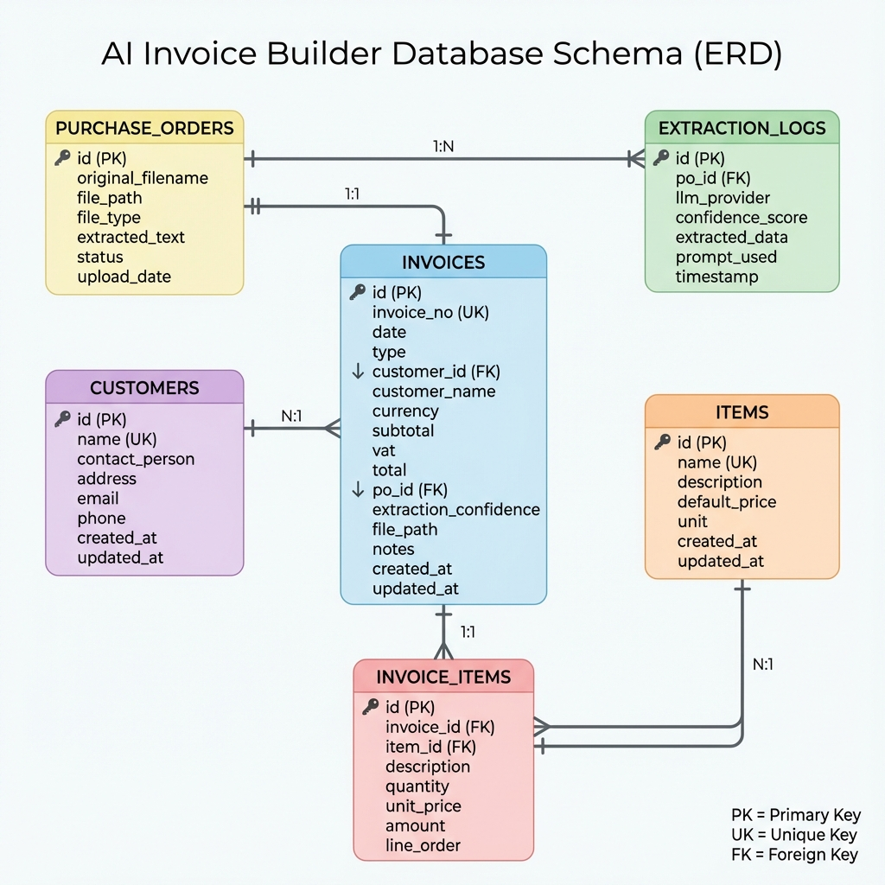

Technology Stack
Layer | Technology | Purpose
GUI Framework | PySide6 (Qt6) | Native Windows interface
AI/LLM | Anthropic Claude API | Primary AI extraction
AI/LLM | OpenAI API | Alternative AI provider
AI/LLM | LM Studio / Ollama | Local LLM support
PDF Processing | pdfplumber | PDF text extraction
OCR | pytesseract / EasyOCR | Image text extraction
Image Processing | Pillow | Image manipulation
Database | SQLite3 | Data storage
Excel Processing | openpyxl | Excel generation
Language | Python 3.11+ | Application logic

Key Features
- Multi-Provider LLM Support: Claude API, OpenAI API, Local LLM (LM Studio/Ollama)
- Intelligent Document Processing: PDF text extraction, OCR for scanned documents, Image processing
- Confidence Scoring: Per-field confidence indicators, Visual highlighting of low-confidence fields
- Flexible Review: Side-by-side PO viewer, Editable fields, Quick corrections
- JSON Metadata Storage: Flexible schema for varying PO fields, AI-extracted data preservation

File Organization
invoice_studio/
├── ai/ # NEW: AI/LLM integration
├── llm_client.py # LLM client factory & implementations
├── prompts.py # Prompt templates
├── extractor.py # Main extraction orchestrator
├── document/ # NEW: Document processing
├── pdf_processor.py # PDF handling
├── image_processor.py # Image & OCR
├── text_processor.py # Text cleaning
├── gui/wizard/ # NEW: Wizard UI
├── upload_step.py # Step 1: Upload PO
├── review_step.py # Step 2: Review extracted data
├── generate_step.py # Step 3: Generate invoice
├── models/ # MODIFIED: Business models
├── invoice.py # Add from_extracted_data()
├── purchase_order.py # NEW: PO model
├── database/ # MODIFIED: Database layer
├── models.py # Add PO and extraction_logs tables
├── config.py # NEW: Configuration management

Configuration (.env)
# LLM Provider Selection
LLM_PROVIDER=claude # Options: claude, openai, lm_studio
# API Keys
CLAUDE_API_KEY=sk-ant-xxxxx
OPENAI_API_KEY=sk-xxxxx
# LM Studio Configuration
LM_STUDIO_URL=http://localhost:1234
LM_STUDIO_MODEL=local-model
# Application Defaults
DEFAULT_CURRENCY=KRW
DEFAULT_INVOICE_TYPE=tax

