

**Arab American University**

**Faculty of Engineering and Information Technology**

**Assembly lab**

**Shift, Rotate, Multiplication and Division Instructions**

**Prepared by:Suha Waleed Alardah**

**ID:201811033**

**To:Dr.Tareq Zanoon**

**To:Mrs.NOOR**

**Introduction :**

The MUL and DIV instructions take much longer to execute than the Shift instructions. Therefore, when multiplying/dividing an operand by a small number it is better to use Shift instructions than to use the MUL/DIV instructions.

Objective:

• To know more about Assembly language, such Shift, Rotate, Multiplication and Division Instructions.

ϖ Shift and Rotate Instructions

• Shifting means to move bits right and left inside an operand.

• The following table provides Shift and Rotate Instructions.

• All affecting the Overflow and Carry flag

• MUL sets the Carry and Overflow flags if the upper half of the product is not equal to zero.

Task1: Allow the user to enter 3 digit number and convert to binary

dosseg

.model small

.data

num equ 10

.code

main:

mov ax,@data

mov ds,ax

mov dl,num

mov ah,1

int 21h

sub al,30h

mul dl

mov bx,ax

mov ah,1

int 21h

sub al,30h

add al,bl

mul dl

mov bx,ax

mov ah,1

int 21h

sub al,30h

add bl,al

mov ah,4ch

int 21h

end main

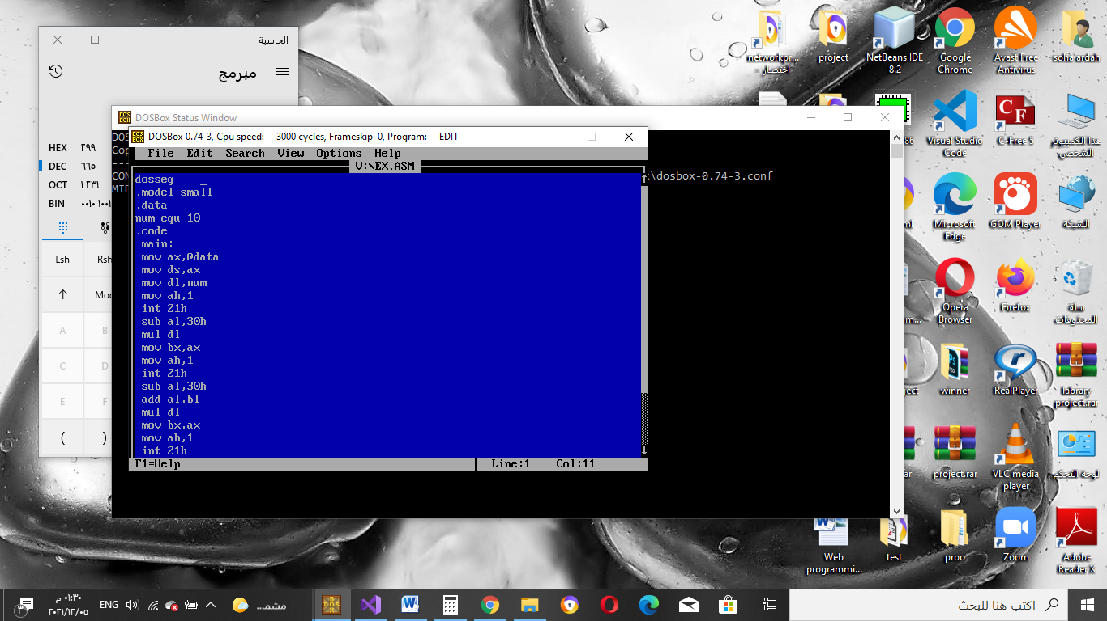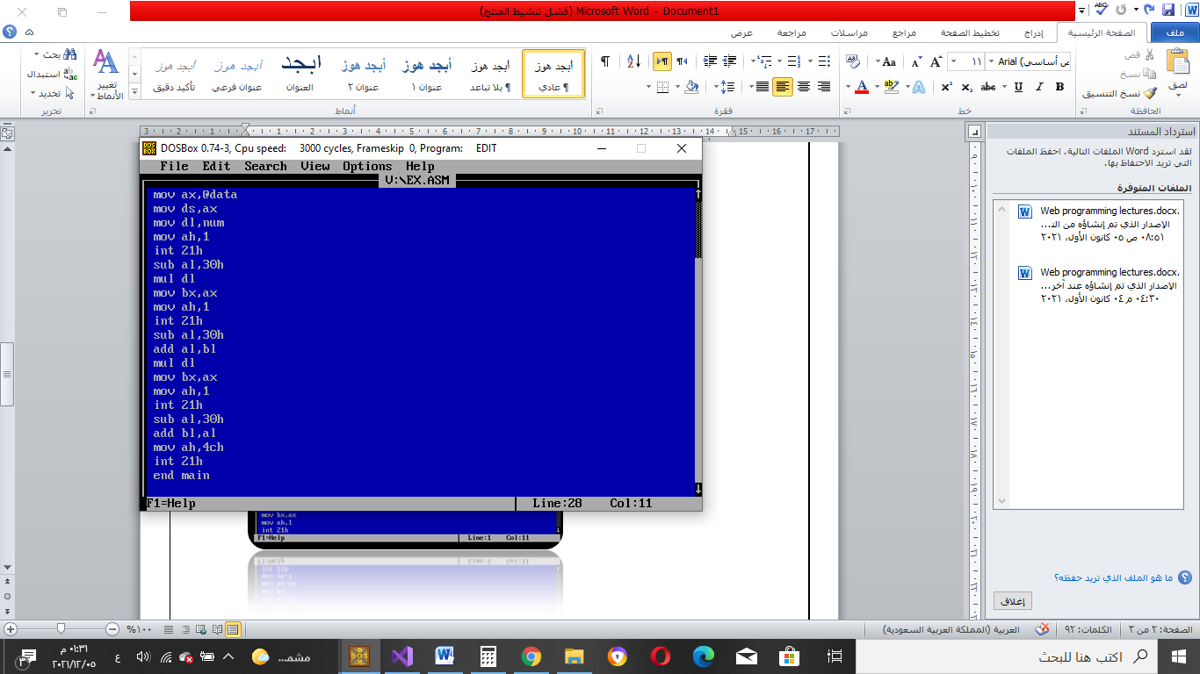

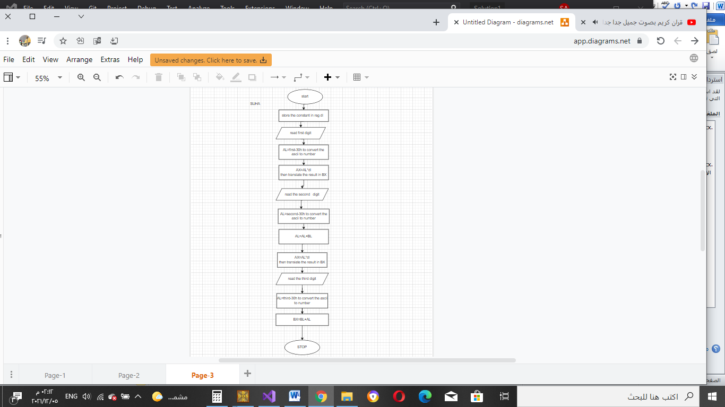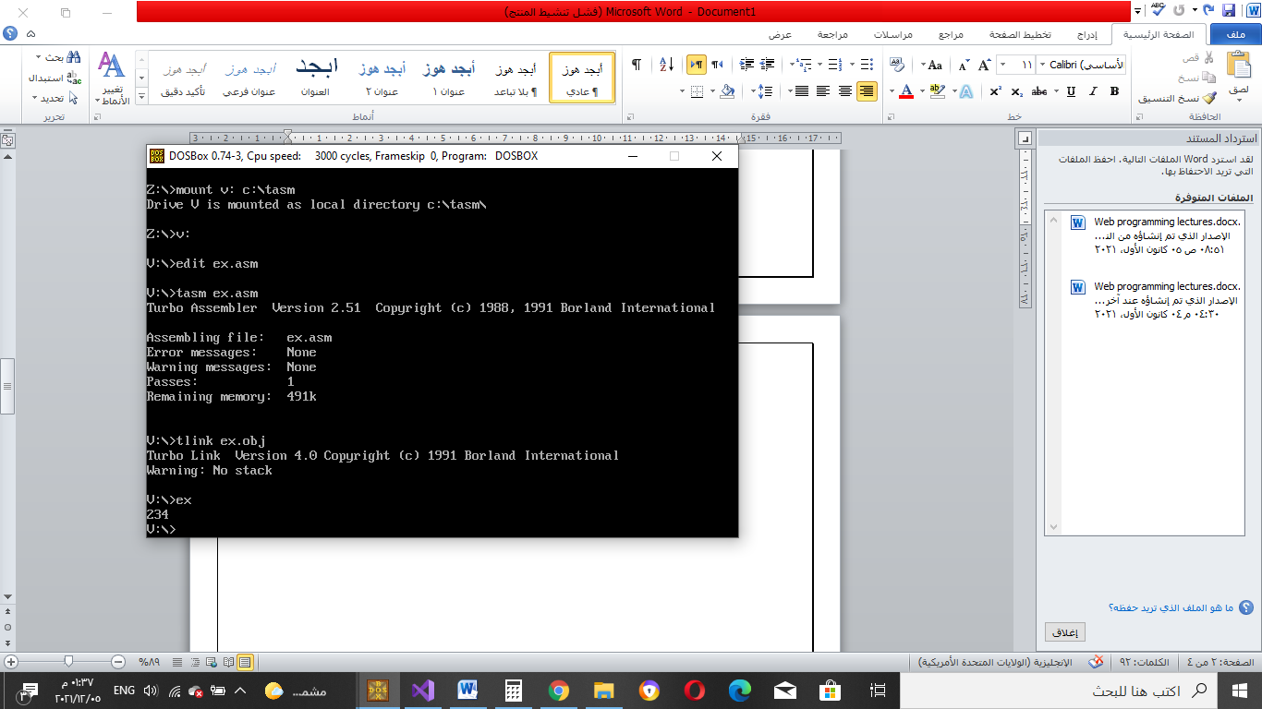

Task2:Using TD check if the binary value matches the entered number

EXAMPLE :IF WE ENTER 889 THE BX WILL DISPLAY 379 BECOUSE THE NUM.CONVERT FROM DEC TO HEX

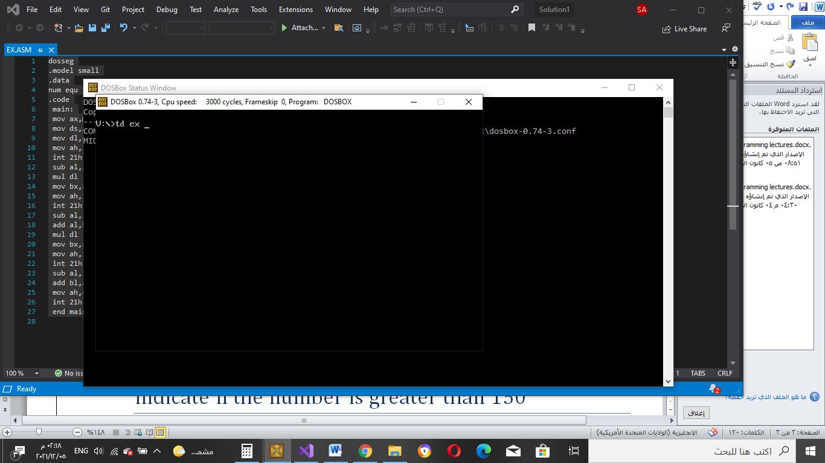

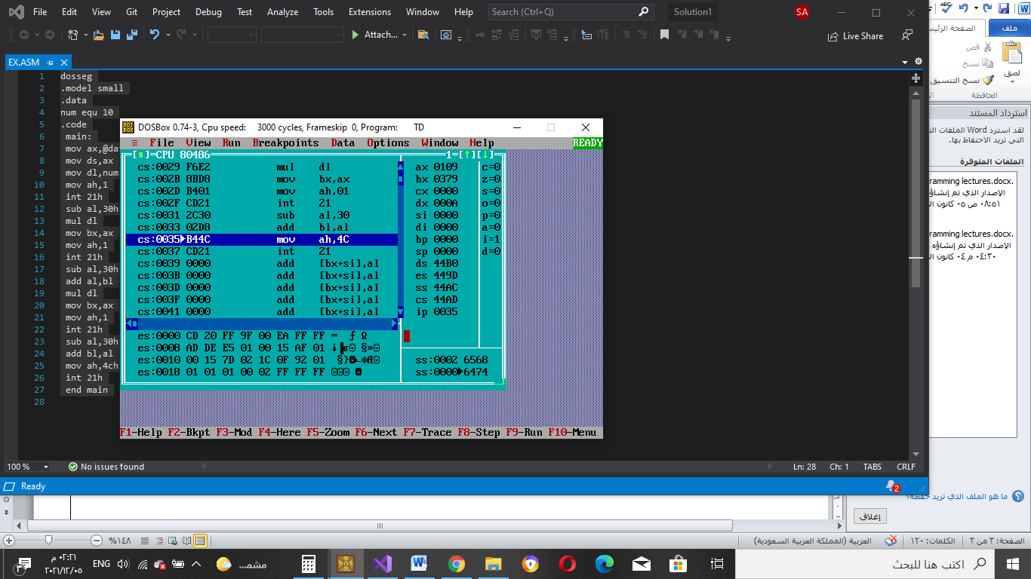

Task3:

indicate if the number is greater than 150

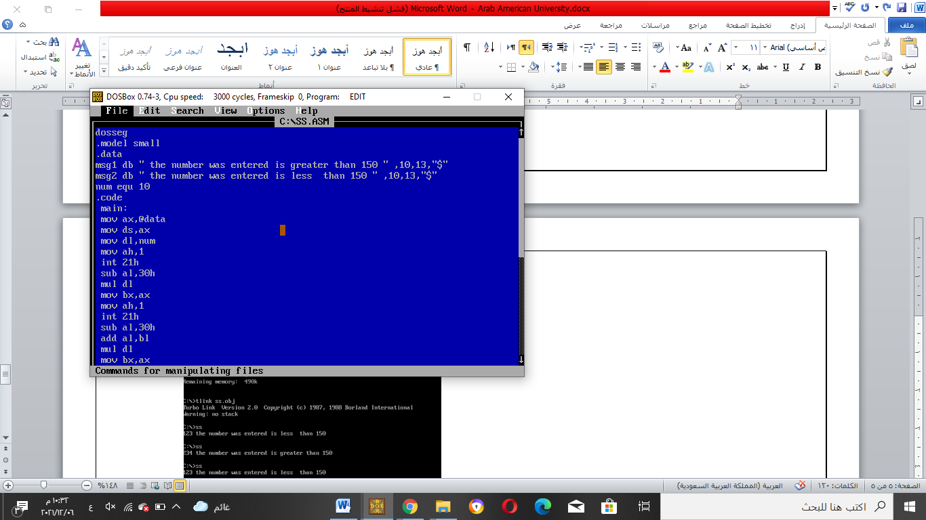

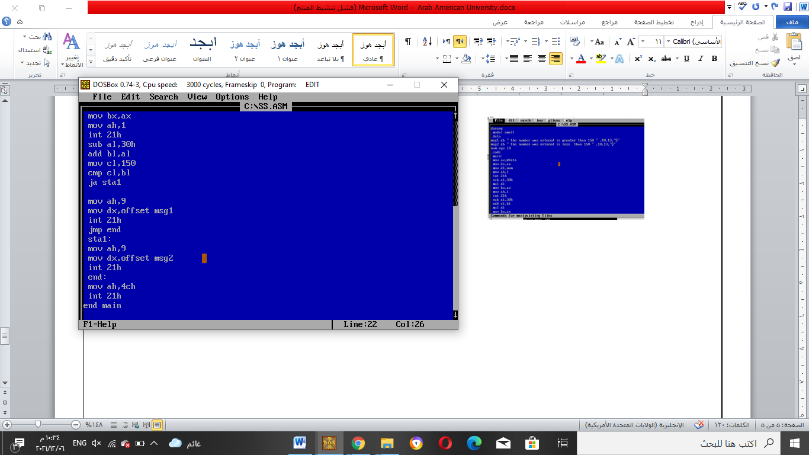

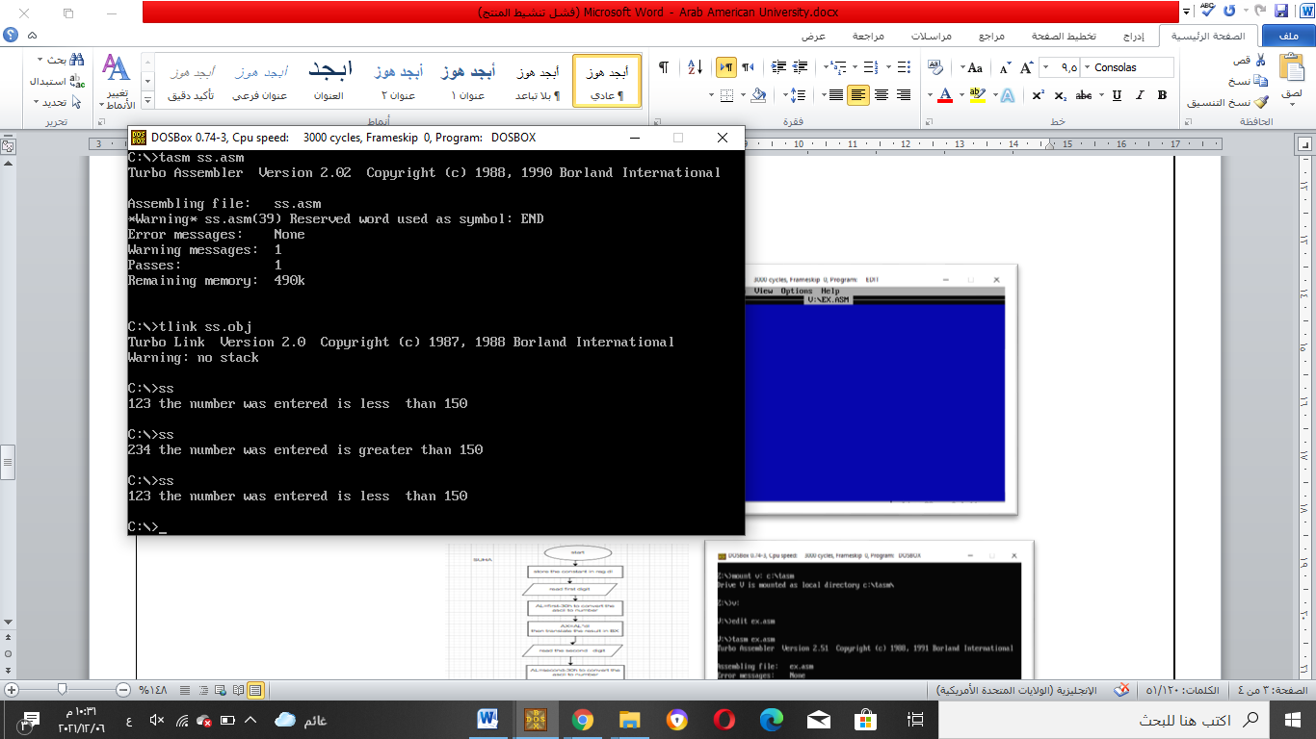

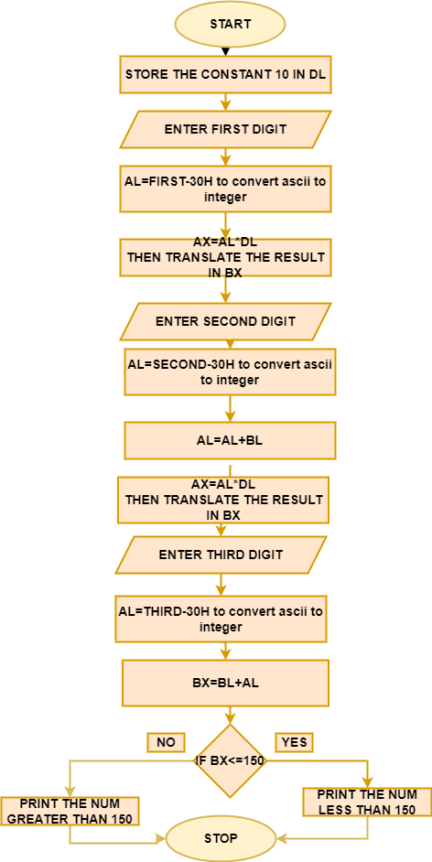

TASK4: Ask the user to enter 2 number each is three digit and print their sum , if the sum is greater than 255 print error.

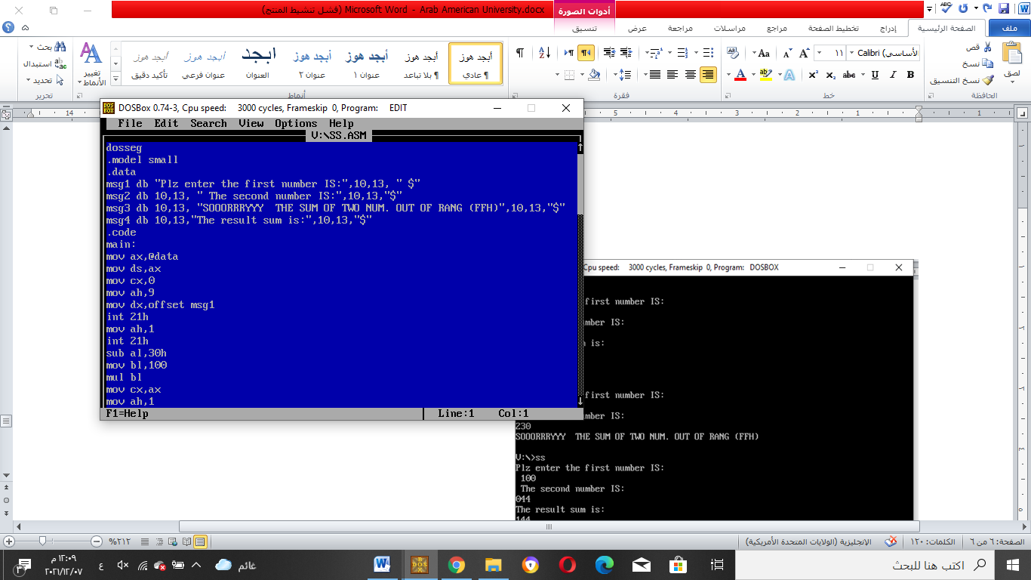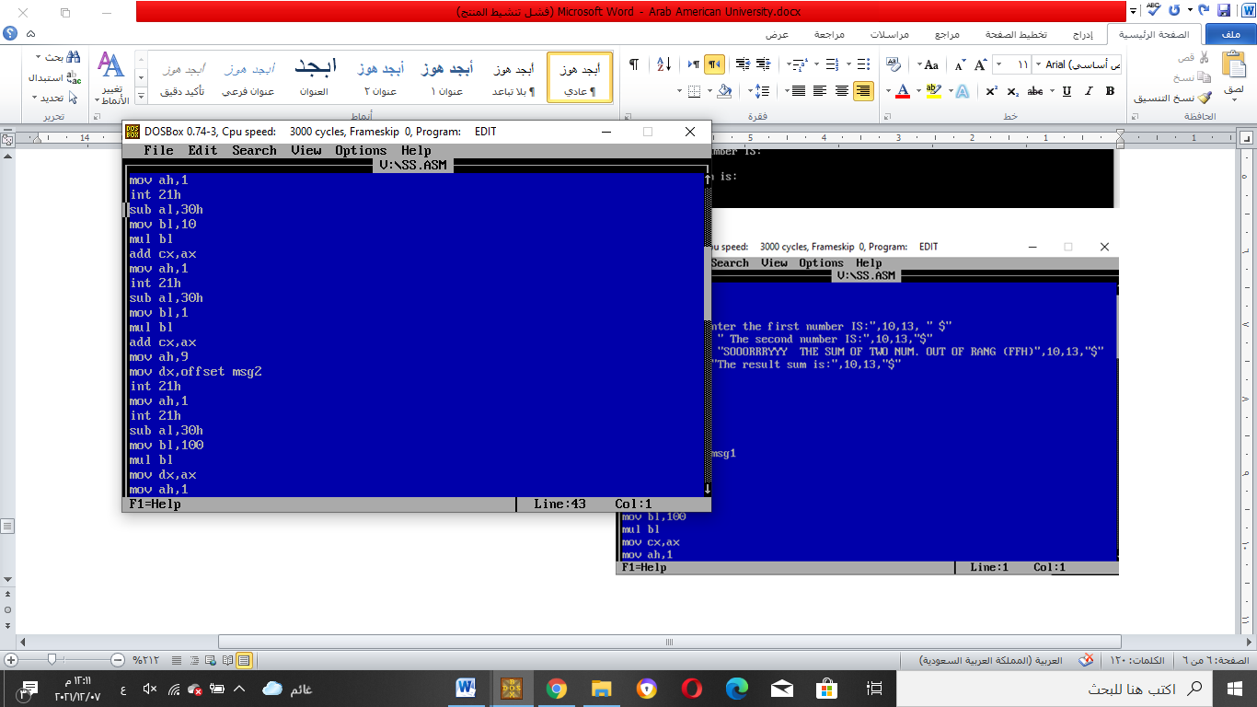

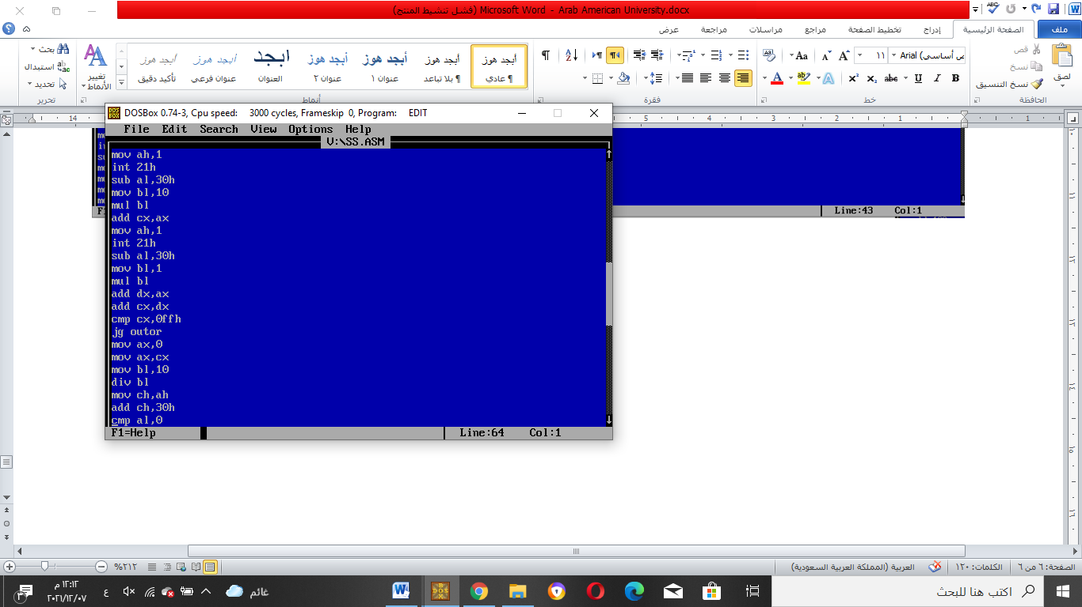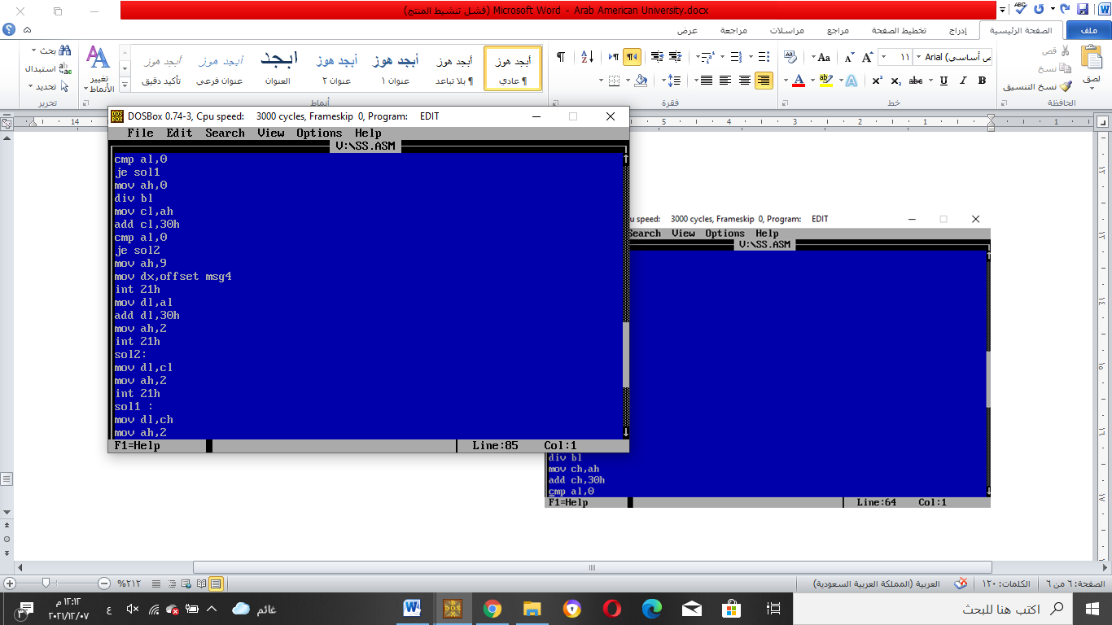

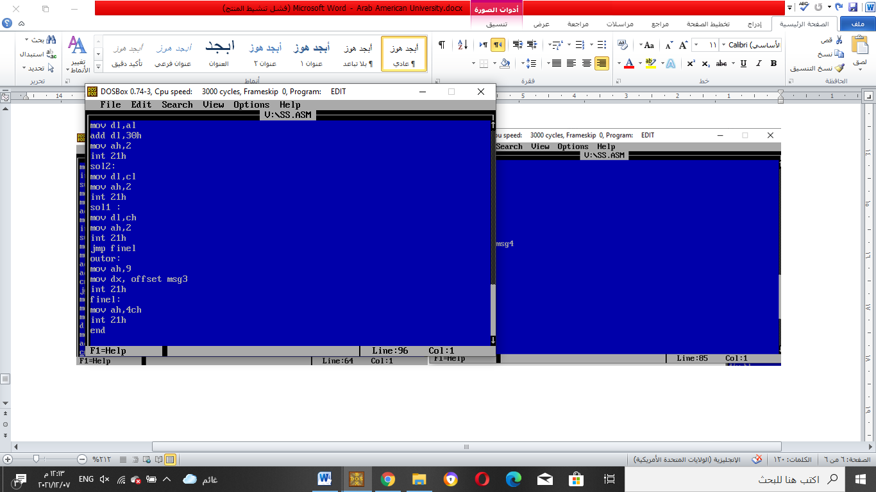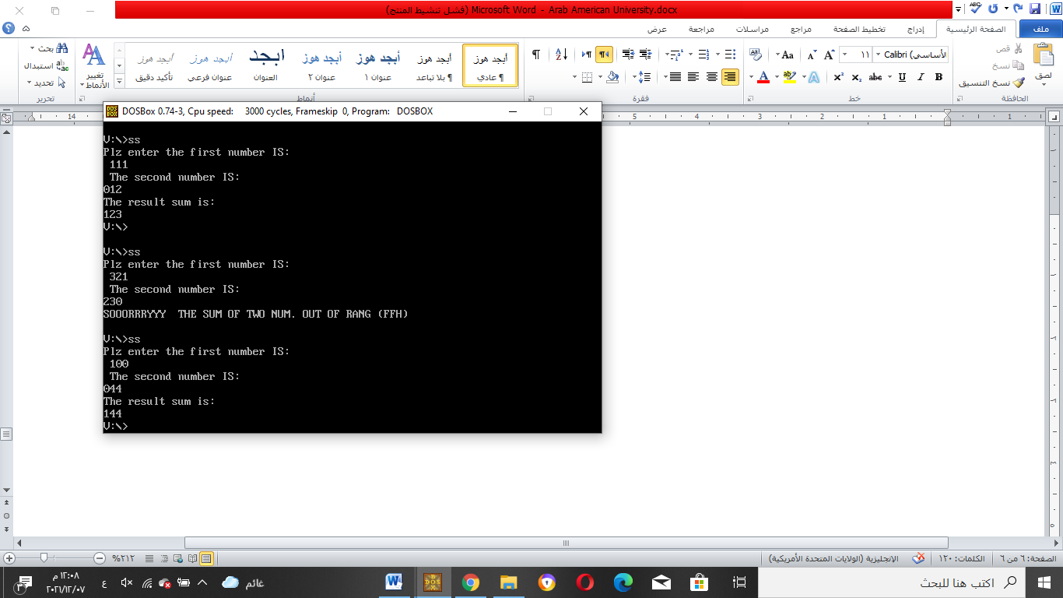

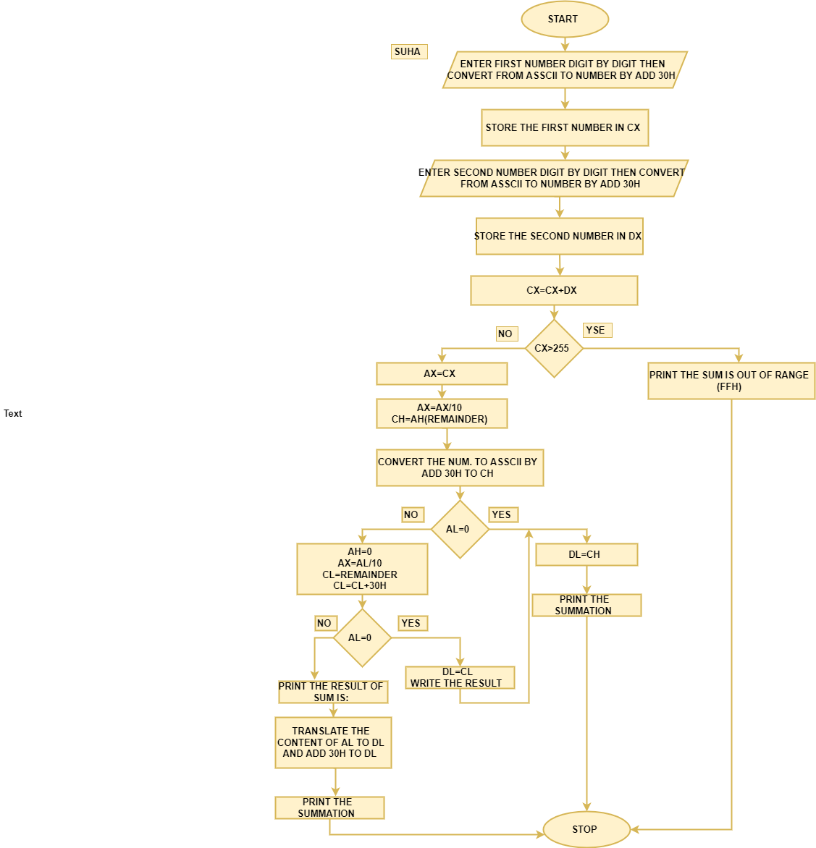

**Conclusion:**

In this lab we learn how to multiplication and convert the number we are enter from asscii to integer and add 2 number from 3 digit and compare to FFH

We learn what is div and mul and where the result stored

**DIV Instruction**

The DIV (unsigned divide) instruction performs 8-bit, 16-bit, and 32-bit unsigned integer division.

The single register or memory operand is the divisor

**MUL Instruction**

The MUL (unsigned multiply) instruction comes in three versions:

1. The first version multiplies an 8-bit operand by the AL register.
2. The second version multiplies a 16-bit operand by the AX register.
3. The third version multiplies a 32-bit operand by the EAX register.