

Arab American University

Faculty of Engineering and Information Technology

Assemply lab

Prepared by:Suha Waleed Alardah

ID:201811033

To:Dr.Tareq Zanoon

To:Mrs.Yousar

Inroduction:

We can define the of assembly language isa low-level programming language that consists of instructions that are mnemonic codes for corresponding machine language instructions , and we can go up level to loops and IF statements by using microprocessor flags in order to jump from line to another in the code. So How do the flags help to build loops and IF statements? how can we do that?

Objectives:

1. Review some arithmetic operation : ADD, SUB,MUL,..
2. Review CPU flags  CF, PF,SF,OF
3. Learn how to create loops using both JMP inst and LOOP inst.
4. Learn the different between  conditional jump and non-conditional jump.
5. Solve the task.

## Task1:

Apply code one and code two.

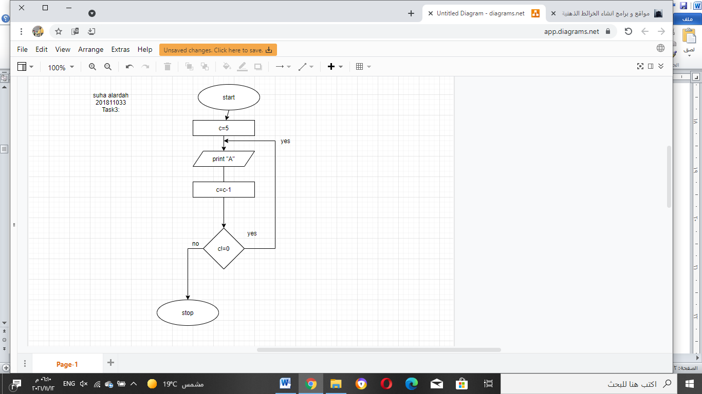

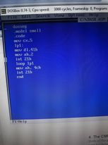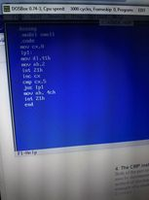 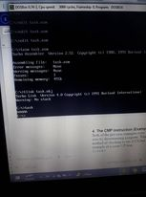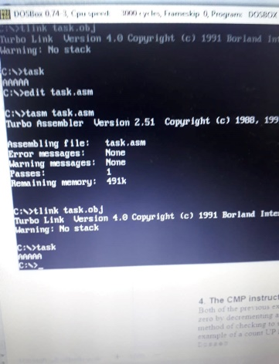

## Task2:

Modify the code such that the character is repeated as indicated by the user by reading a key(0-9)

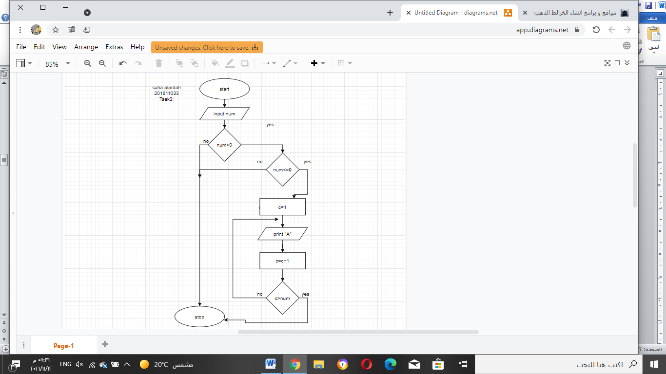

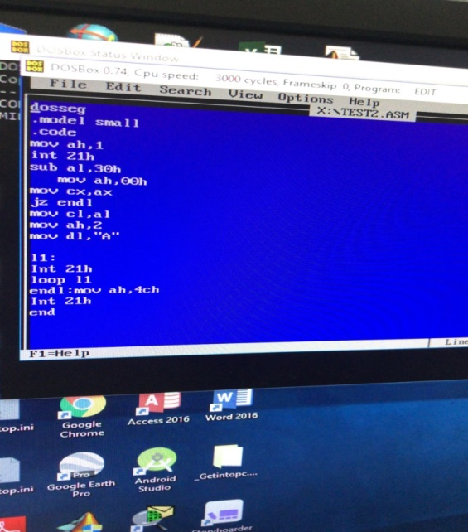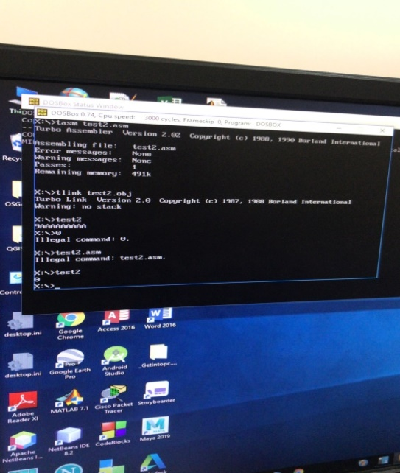

## Task3:

Ask the user to enter 2 numbers

Number1

Number2

Tell the user which number is greater?

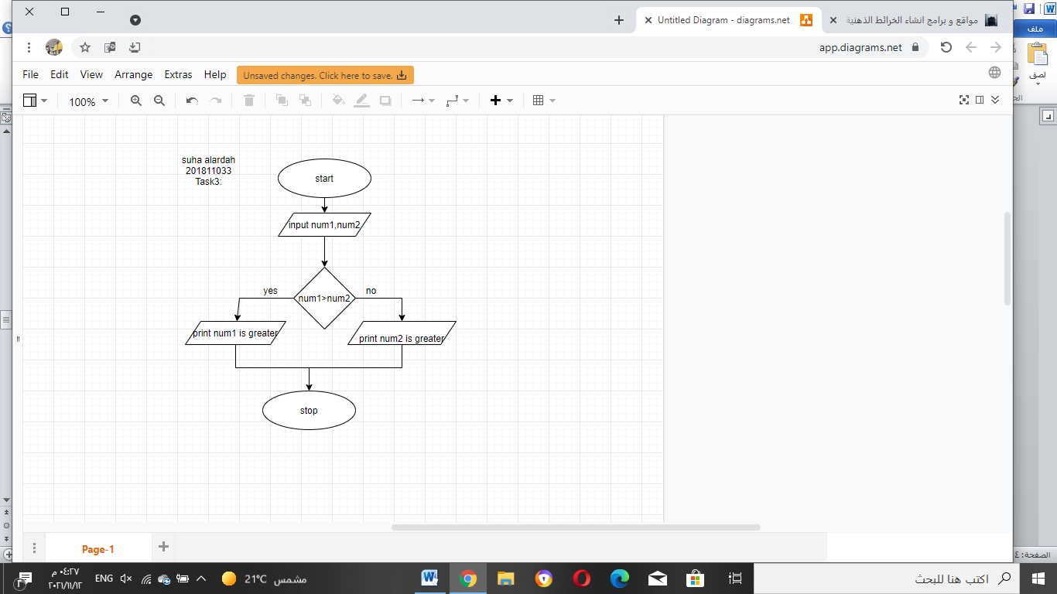

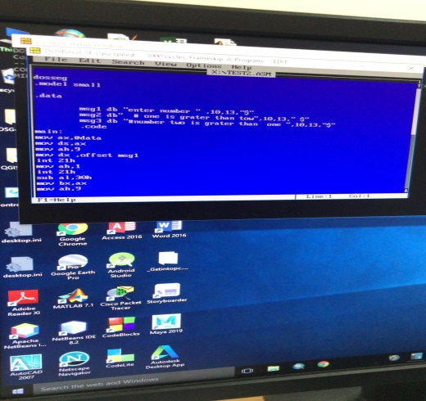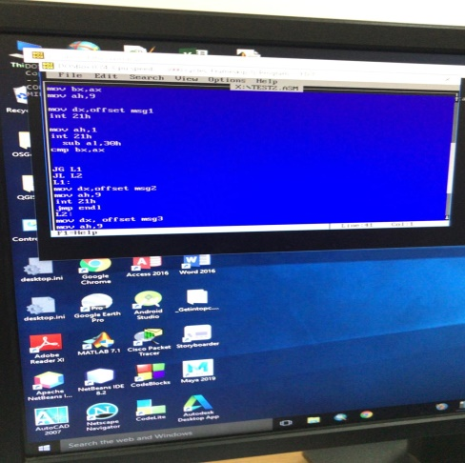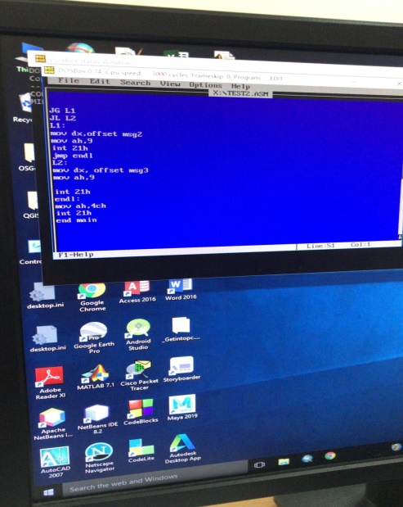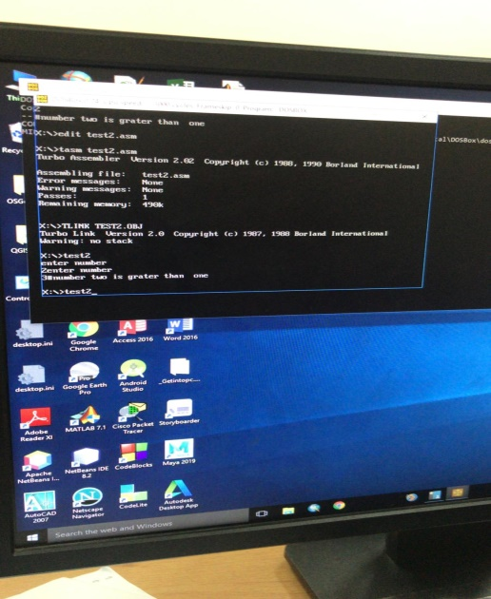

## Task4:

## Ask the user to enter any number tell the user if this number is odd or even?

## 

## 

## 

## Task5:

Validate that only numbers can entered in 4 print error otherwise(30-39H)

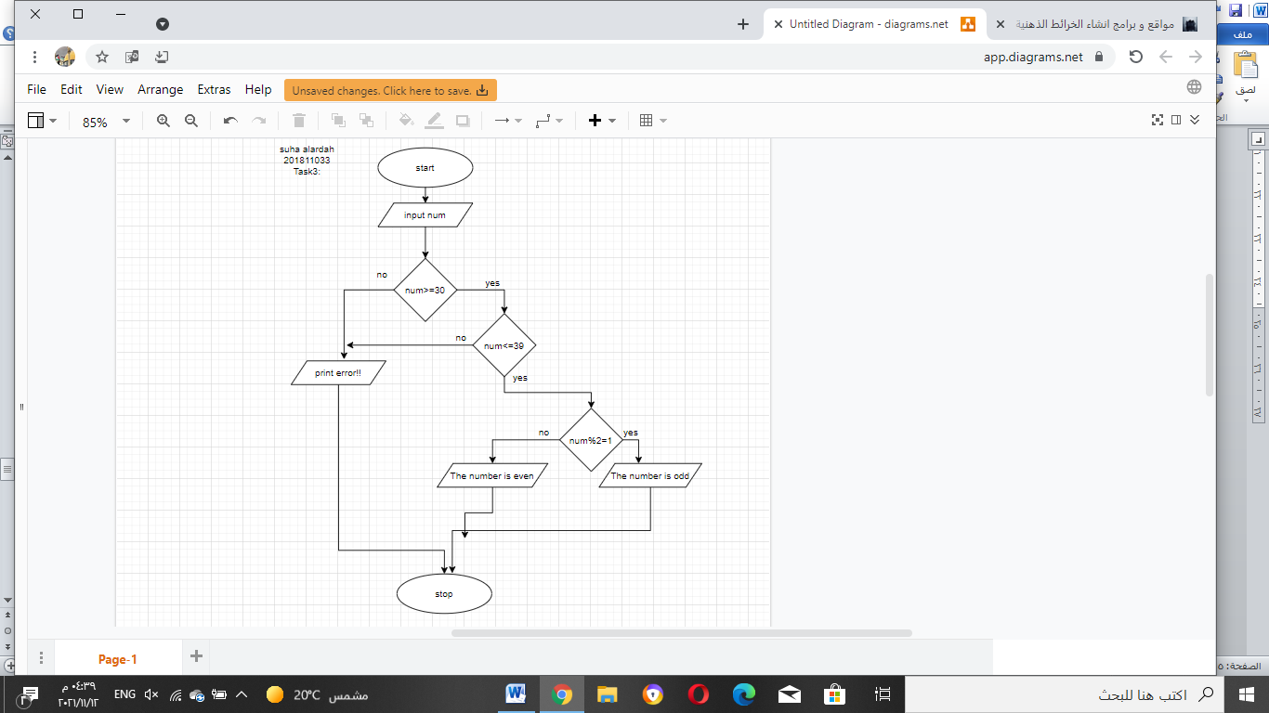

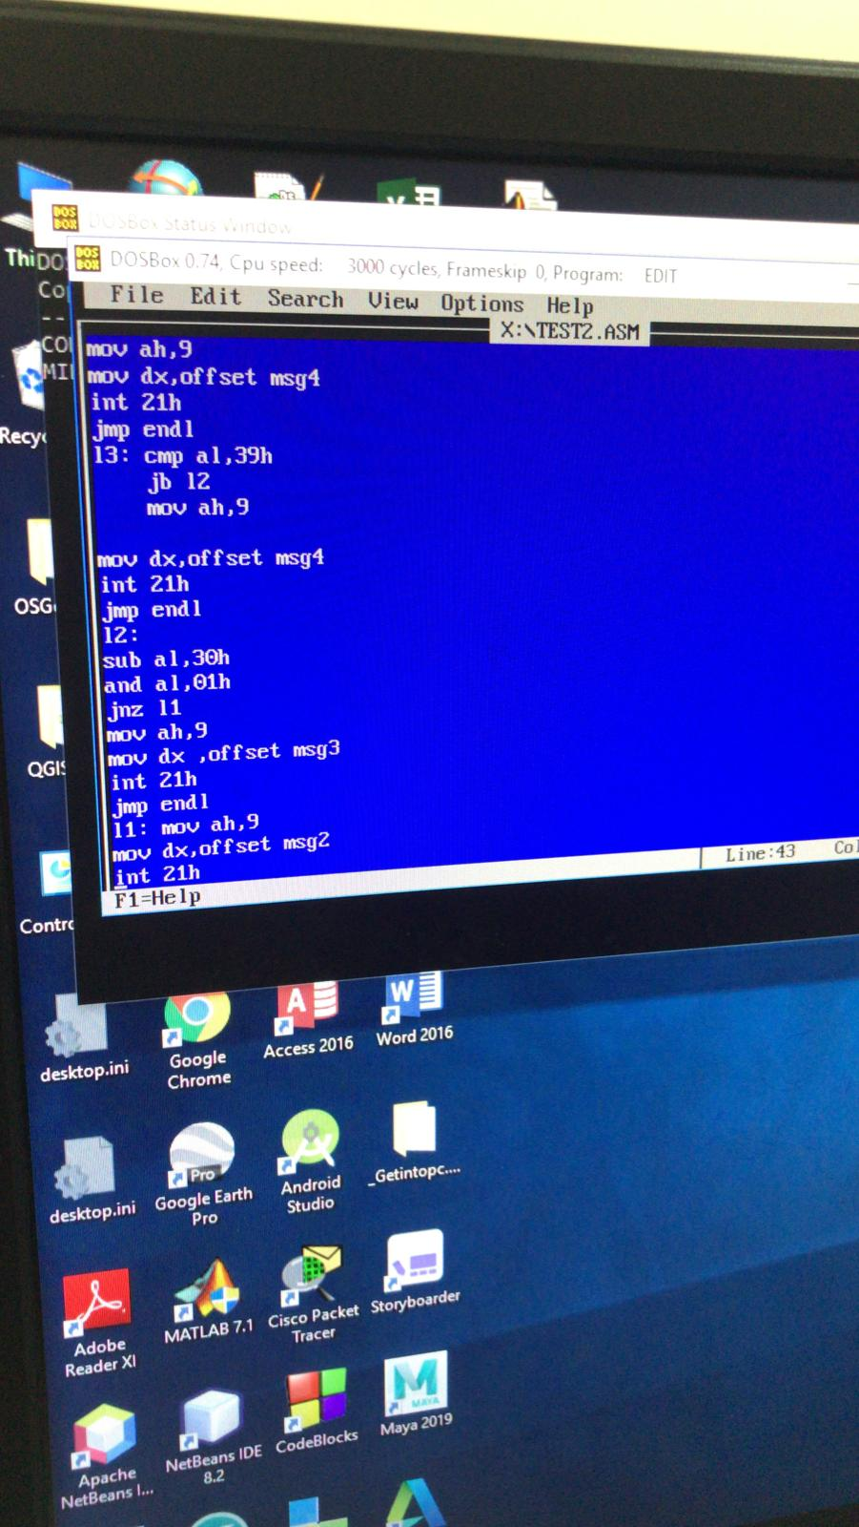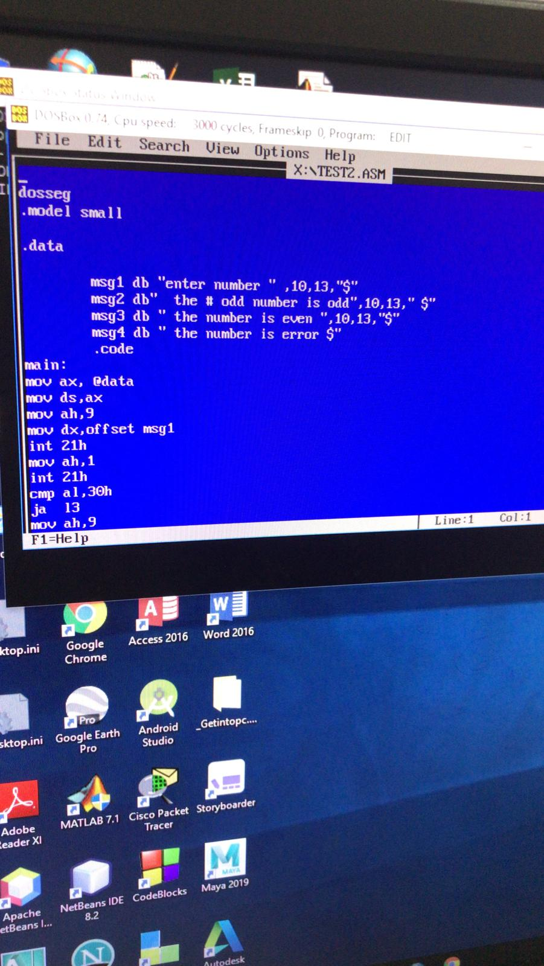

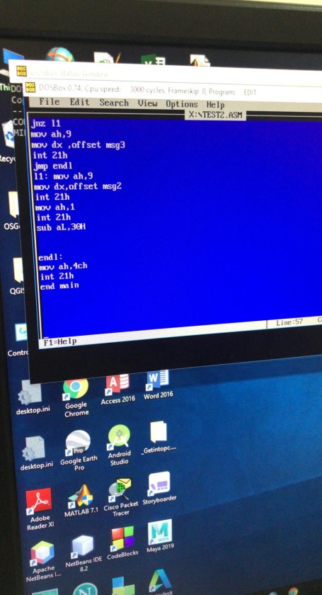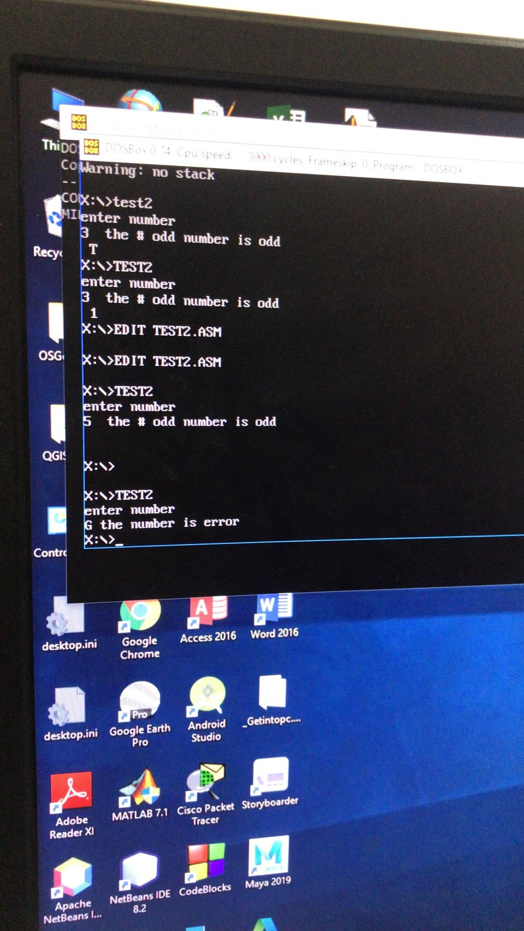

## Result:

We learn how to implement a loop in many ways for example jnz +dec counter or loop

Also,we learn how to use different types of jumps JNZ ,JG ,JL..etc.

Finally, we learn how to read from keyboard and using condition to solve many case proplem..

*Conclusions:*

The assembly language uses JMP instruction to implement loops,

using flag register to indicate the result of instruction , Flags help assembly  programmer to build loops and to satisfy all conditions.