

**Arab American University**

**Faculty of Engineering and Information Technology**

**Microprosser lab**

**Prepared by:Suha Waleed Alardah**

**ID:201811033**

**To:Dr.Mamoud obaid**

**Miss: Noor Kmail**

**Introduction**

8255 is a programmable peripheral interface. It is used to interface microprocessor with I/O devices via three ports: PORTA, PORB and PORTC,And MDA_win8086 kit contains a lot of ICs, in this experiment we will used the 4-colored led some activities and tasks by assembly code.

**explain**

A1 and A0 are connected with A2 and A1 of 8086 to selection mode.They can have 4 options, selecting PA, PB, PC or the control word. The ports are selected to transfer data. The Control word is selected to send commands.

And light emitting diode controller interface module is designed to simulate the function of four way light controller. Combinations of red, yellow green and red2 LED’s control turn on or off led using lower nibble of PORTB for ex. When lower nibble is 0001 the red1 is on ,0010 the green is on,0100 yellow is on ,1000 red2 is on.

The LED has a positive anode and a negative cathode that must have a potential difference for the light to work. 

**In this paper show how find the CWR And address of ports and how connect th MP to PPI\***

## 

## Task1:

Write assembly code that make led red is light.

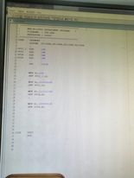

## Task2:

Write assembly code that work as following red ,yellow, green 3 times

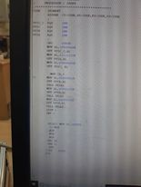

## Task3:

Write assembly code that work as following yellow long time ,green short time .

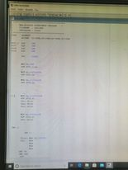

Task4:

Write assembly code that work traffic light red ,yellow, green -->red,yellow ,green.

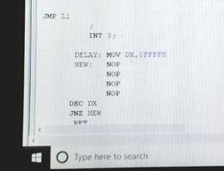

**Conclusion:**

We learn use the the 4-colored led in kit and do some activities by using it

and this experiment that used port B to make to do a traffic light and other activities and its active high.