**JEPPIAAR COLLEGE OF ARTS AND SCIENCE**



**NAAN MUDHALVAN – GROUP PROJECT**



**FRONTEND DEVELOPMENT WITH REACT.JS**

**CRYPTOVERSE: A CRYPTOCURRENCY DASHBOARD**

**2025**

**PROJECT TEAM INFORMATION**

|  |  |
| --- | --- |
| **TEAM ID** | SWTID1741158168 |
| **TEAM SIZE** | 4 |
| **TEAM LEADER** | SUHAANA KHAN Z.  (*Project Architect*) |
| **TEAM MEMBER** | AKSHAYAA S. J.  (*Frontend Developer*) |
| **TEAM MEMBER** | VISHNU VARTHAN L.  (*Backend Developer & API Integration Specialist*) |
| **TEAM MEMBER** | MUKUL KUMAR P.  (*Testing & Quality Assurance Engineer*) |

**INDEX**

|  |  |  |
| --- | --- | --- |
| **S.NO.** | **TABLE OF CONTENT** | **PAGE NO.** |
| 1. | INTRODUCTION | 1 |
| 2. | POJECT OVERVIEW | 2 |
| 3. | ARCHITECTURE | 3 |
| 4. | SETUP INSTRUCTIONS | 5 |
| 5. | FOLDER STRUCTURE | 6 |
| 6. | RUNNING THE APPLICATION | 8 |
| 7. | COMPONENT DOCUMENTATION | 9 |
| 8. | STATE MANAGEMENT | 11 |
| 9. | USER INTERFACE | 13 |
| 10. | STYLING | 14 |
| 11. | TESTING | 15 |
| 12. | OUTPUT | 17 |
| 13. | KNOWN ISSUES | 20 |
| 14. | FUTURE ENHANCEMENTS | 20 |

**INTRODUCTION**

The Cryptocurrency Dashboard is a web application designed to provide real-time data and insights into the cryptocurrency market. With the rapid growth and volatility in the digital currency landscape, this platform aims to deliver accurate and up-to-date information to help users make informed financial decisions.

Built using React.js with Vite for enhanced performance, the dashboard efficiently retrieves data from an external cryptocurrency API. The project's architecture follows a modular structure, ensuring scalability, ease of maintenance, and improved development flow.

The dashboard is designed to cater to both novice investors seeking simple insights and experienced traders requiring comprehensive analysis. Its intuitive interface ensures that users can access essential data points such as cryptocurrency prices, market trends, and percentage changes with minimal effort.

By integrating dynamic visual elements and responsive design principles, the Cryptocurrency Dashboard delivers a seamless and engaging user experience. The project also emphasizes error handling, ensuring stability and reliability even during API failures.

This documentation outlines the project's architecture, features, and setup instructions, guiding developers and users alike through its functionality and design.

**PROJECT OVERVIEW**

**PURPOSE**

The Cryptocurrency Dashboard aims to provide users with real-time insights into cryptocurrency trends, prices, and market data. Its primary goal is to simplify cryptocurrency tracking by presenting comprehensive data in a user-friendly format. By integrating API-driven data, the dashboard ensures timely updates, helping both novice investors and experienced traders make informed decisions. The project prioritizes clarity, performance, and ease of navigation to enhance the overall user experience.

**FEATURES**

The Cryptocurrency Dashboard offers a wide range of features that improve functionality and user engagement:

1. **Live Cryptocurrency Data:** Real-time data on cryptocurrency prices, market caps, and trends are fetched via the cryptoApi.js service, ensuring users access the latest information.
2. **Search Functionality:** Users can quickly find detailed insights on specific cryptocurrencies using the integrated search bar.
3. **Trend Analysis:** The dashboard displays clear visual indicators of percentage changes, assisting users in understanding market fluctuations at a glance.
4. **Interactive UI Components:** Leveraging modular components like App.jsx, the dashboard provides a clean and intuitive interface for seamless interaction.
5. **Responsive Design:** Ensuring compatibility across various devices, the dashboard offers a consistent experience for desktop, tablet, and mobile users.
6. **API Integration with Error Handling:** The cryptoApi.js service effectively manages API requests, ensuring stable performance even during connection failures or data retrieval issues.
7. **Custom Visuals:** The use of assets such as cryptocurrency.png enhances the dashboard's aesthetic appeal, improving user engagement.

This feature set ensures the Cryptocurrency Dashboard is not only functional but also reliable and visually appealing.

**ARCHITECTURE**

**COMPONENT STRUCTURE**

The **Cryptocurrency Dashboard** follows a well-defined React component architecture designed to enhance modularity, scalability, and ease of maintenance. The structure is as follows:

* **App.jsx** – The primary component that serves as the core of the application. It:
  + Integrates all major sections of the dashboard.
  + Manages state and props distribution to child components.
  + Handles conditional rendering to display different views based on user interaction.
* **main.jsx** – The application's entry point that:
  + Imports the App component and renders it into the root element in index.html.
  + Ensures proper initialization of the application.
* **components/** – This directory houses individual UI elements designed for reusability. Key examples may include:
  + **CryptoCard.jsx** – Displays individual cryptocurrency details such as name, price, and percentage change.
  + **SearchBar.jsx** – Provides functionality for users to search for specific cryptocurrencies.
  + **Header.jsx** – Contains navigation links and branding elements.
  + **Footer.jsx** – Displays important information such as data sources or credits.
* **services/cryptoApi.js** – This file is responsible for managing all API interactions. It:
  + Uses fetch or axios to retrieve cryptocurrency data from a third-party API.
  + Implements functions that support various data endpoints, ensuring flexibility for additional features like trending coins or market stats.
* **assets/** – Contains media files such as cryptocurrency.png, icons, and other visual elements to enhance the UI design.

**STATE MANAGEMENT**

State management is achieved using a **Redux-like pattern** via the store.js file located in the app/ directory. This approach offers several advantages:

* Centralized state management ensures data consistency across all components.
* The store.js file defines key application states such as selected currency, market data, and UI behavior.
* Actions and reducers are structured to streamline updates to the state.
* This pattern efficiently manages asynchronous data fetching using the cryptoApi.js service, ensuring smooth API integration.

**ROUTING**

While the current project does not include a dedicated routing library like react-router, conditional rendering logic is implemented within App.jsx to handle navigation between views.

Key routing concepts include:

* Conditional rendering logic to toggle between dashboard views, search results, or detailed cryptocurrency information.
* Future enhancements may incorporate react-router to improve navigation structure with path-based URLs for seamless user experience.

**SETUP INSTRUCTIONS**

**PREREQUISITES**

To successfully run this project, ensure you have the following installed:

* **Node.js** (version 16.x or later)
* **npm** or **yarn** (for dependency management)
* **Vite** (for building and running the project)

**INSTALLATION**

Follow these steps to set up the project on your local machine:

1. **Clone the Repository:**



1. **Install Dependencies:** Run the following command to install the required dependencies:



1. **Configure Environment Variables:**
   * Create a .env file in the root directory.
   * Add the following variable inside the .env file:



1. **Run the Application:** Use the following command to start the development server:



1. **Access the Application**: Once the server starts, the application will be available at [http://localhost:5173](http://localhost:5173/) by default.

**FOLDER STRUCTURE**

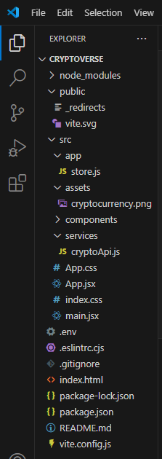

**CLIENT**

The React application's folder structure is organized as follows:

* **public/**
  + Contains static files such as the _redirects file for Netlify and vite.svg for the app logo.
* **src/**
  + **app/**
    - Contains store.js, which manages the global state for the application.
  + **assets/**
    - Includes static images like cryptocurrency.png for visual elements.
  + **components/**
    - Houses reusable UI components used throughout the project.
  + **services/**
    - Contains cryptoApi.js, responsible for making API calls to fetch cryptocurrency data.
  + **Root Files:**
    - App.jsx – Main entry point that integrates components and routes.
    - main.jsx – Renders the root React application and integrates Vite for development.
    - .env – Stores environment variables for API keys and configurations.

**UTILITIES**

* **API Handling**: The cryptoApi.js file inside the services folder centralizes API requests, improving code modularity and maintainability.
* **State Management**: The store.js file in the app folder is designed to manage the application's global state.
* **CSS Files**: App.css, index.css, and main.jsx provide styling and ensure a consistent visual theme across the application.

**RUNNING THE APPLICATION**

To run the **Cryptoverse** application locally, follow these steps:

1. **Install Dependencies**  
   Run the following command in the project root directory to install all necessary packages:



1. **Run the Development Server:** To start the frontend server, execute this command:



1. **Access the Application:** Once the server is running, open your browser and navigate to:



We have to ensure that the .env file is properly configured before running the application for successful API integration.

**COMPONENT DOCUMENTATION**

**KEY COMPONENTS**

The Cryptoverse application is structured with key components that manage core functionalities. Below are the major components, their purpose, and key props they receive:

1. **App.jsx** (Located in /src/App.jsx):
   * **Purpose:** Acts as the root component that sets up routing and organizes the layout.
   * **Props:** None (Uses internal state management and React Router for navigation).
2. **Main.jsx** (Located in /src/main.jsx):
   * **Purpose:** Entry point for the React application, rendering the root component into the DOM.
   * **Props:** None
3. **cryptoApi.js** (Located in /src/services/cryptoApi.js):
   * **Purpose:** Fetches cryptocurrency data using createApi from reduxjs/toolkit.
   * **Props:** Accepts baseUrl and API endpoints as configuration.
4. **Store.js** (Located in /src/app/store.js):
   * **Purpose:** Centralized Redux store setup for state management.
   * **Props:** None

**RESUABLE COMPOENTS**

The application also includes reusable components to ensure code efficiency and maintainability.

1. **Navbar.jsx** (Example Location: /src/components/Navbar.jsx):
   * **Purpose:** Provides a navigation bar for the application.
   * **Props:**
     + links: An array of navigation links to render.
     + onLinkClick: Function to handle link clicks.
2. **CryptoCard.jsx** (Example Location: /src/components/CryptoCard.jsx):
   * **Purpose:** Displays cryptocurrency details like price, rank, and market cap.
   * **Props:**
     + coin: Object containing coin details like name, symbol, and current value.
3. **Loader.jsx** (Example Location: /src/components/Loader.jsx):
   * **Purpose:** Displays a loading spinner when data is being fetched.
   * **Props:**
     + message: A string to indicate what data is loading (e.g., "Fetching cryptocurrency data").

Each component follows the best practices of React, ensuring modularization, maintainability, and scalability. Let me know if you’d like code snippets or additional details for specific components.

**STATE MANAGEMENT**

**GLOBAL STATE**

The Cryptoverse project uses **Redux Toolkit** for efficient global state management. This ensures consistent data flow, better scalability, and improved maintainability for the application. The global state is managed in the store.js file located in the /src/app/ folder.

**Key Features of Global State in Cryptoverse:**

* Centralized data handling for cryptocurrency details, market stats, and trending coins.
* Utilizes **Redux Toolkit's** createSlice() for state slicing and logic management.
* Middleware is employed for handling API requests and asynchronous operations.

**Key File Location:**

* **src/app/store.js**: This file sets up the Redux store and integrates the reducers.

**Code from store.js:**

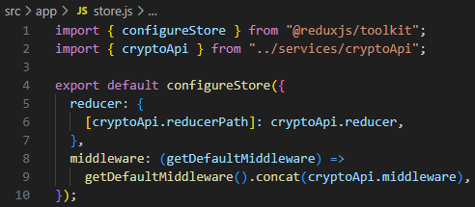

**Flow of Data in Global State:**

* The cryptoApi service fetches cryptocurrency data from an API.
* This data is stored in Redux state via reducers and accessed across multiple components for rendering detailed coin information, trending prices, etc.

**LOCAL STATE MANAGEMENT**

For local state management within individual components, React's **useState** hook is utilized to manage component-specific data. Although no dedicated file exists for complex local state management, simple useState implementations are scattered throughout the project.

**Example in CryptoDetails.jsx (Location: /src/components/CryptoDetails.jsx)**

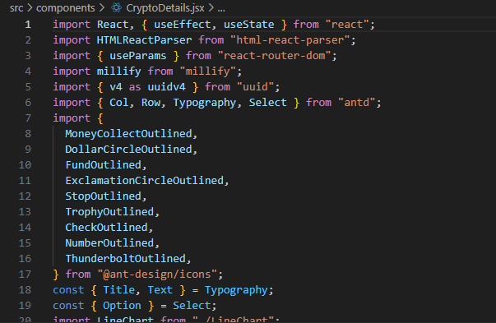

This implementation effectively controls UI elements requiring dynamic state updates within individual components.

**USER INTERFACE**

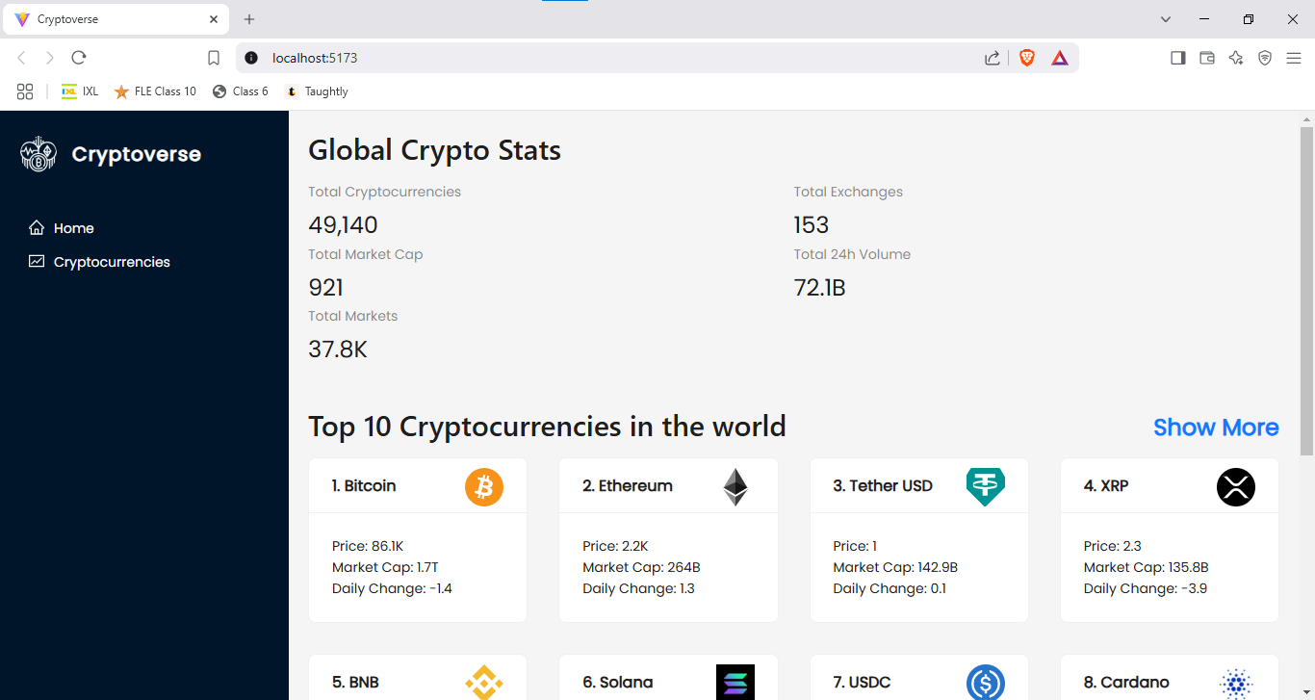

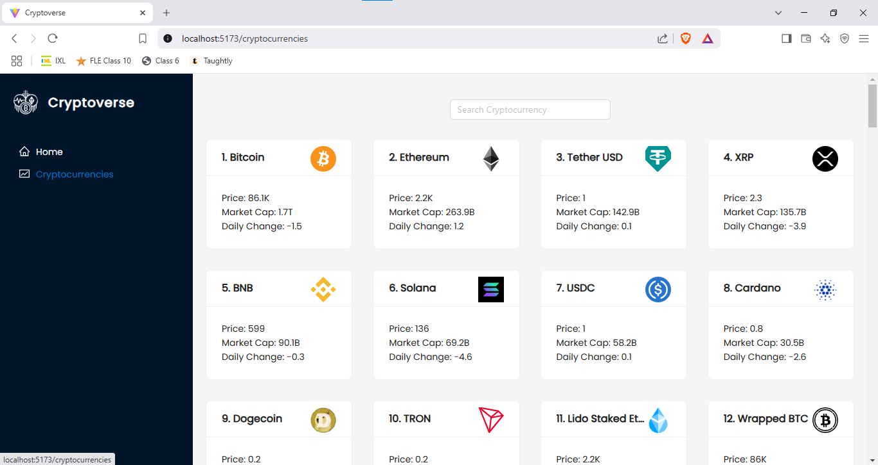

**STYLING**

**CSS FRAMEWORKS/LIBRARIES**

The project primarily utilizes **plain CSS** for styling. The following key CSS files are used throughout the application:

* **App.css** — Contains global styles, including layout, spacing, and typography.
  + **File Reference:** /src/App.css
* **index.css** — Handles root-level styling configurations such as body styles, font imports, and basic resets.
  + **File Reference:** /src/index.css

**THEMING**

* While the project does not implement a dedicated **theming system** or **CSS pre-processor**, the CSS files adopt a consistent design pattern with well-structured class names for easy customization.
* The styling approach focuses on:
  + **Consistent color schemes** (likely hardcoded values in CSS files).
  + **Reusable class names** across components for maintaining uniform spacing, text styling, and responsive design.
  + Ensuring **flexible layouts** using CSS flexbox/grid strategies for dynamic UI behavior.

**Key Styling Highlights:**

* The **Navbar** has responsive styling to adapt across various screen sizes.
  + **File Reference:** /src/components/Navbar.jsx with styles in App.css.
* The **LineChart** component integrates dynamic chart visuals with appropriate margins, padding, and color styles to enhance data visibility.
  + **File Reference:** /src/components/LineChart.jsx.

**TESTING**

**TESTING STRATEGY**

The provided project does not include dedicated test files or configurations. However, to implement an effective testing strategy for this application, the following methods are recommended:

1. **Unit Testing:**
   * Tools: **Jest** with **React Testing Library** for testing individual components.
   * Focus Areas:
     + Component rendering.
     + Prop validation and default values.
     + UI behavior based on user interactions.
   * Example Targets:
     + **Navbar.jsx** — Test if the navigation links render correctly.
     + **Loader.jsx** — Verify the loader animation appears during data fetching.
2. **Integration Testing**:
   * Tools: **React Testing Library** or **Enzyme**.
   * Focus Areas:
     + Testing interaction between multiple components.
     + Ensuring correct data flow between services and UI components.
   * Example Targets:
     + Verify that the **CryptoDetails.jsx** component fetches and displays the correct cryptocurrency data.
3. **End-to-End (E2E) Testing:**
   * Tools: **Cypress** or **Playwright**.
   * Focus Areas:
     + Test full user flows, such as navigating between pages, submitting forms, and validating data display.
   * Example Targets:
     + Test the overall workflow from homepage navigation to cryptocurrency detail display.

**CODE COVERAGE**

* To ensure comprehensive test coverage:
  + **Jest** includes built-in code coverage reports using the --coverage flag.
  + Recommended Configuration in package.json:

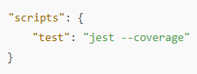

Code coverage should target:

* **Critical UI elements** (e.g., Navbar, CryptoDetails).
* **Key business logic** (e.g., cryptoApi.js functions for data fetching).

**OUTPUT**

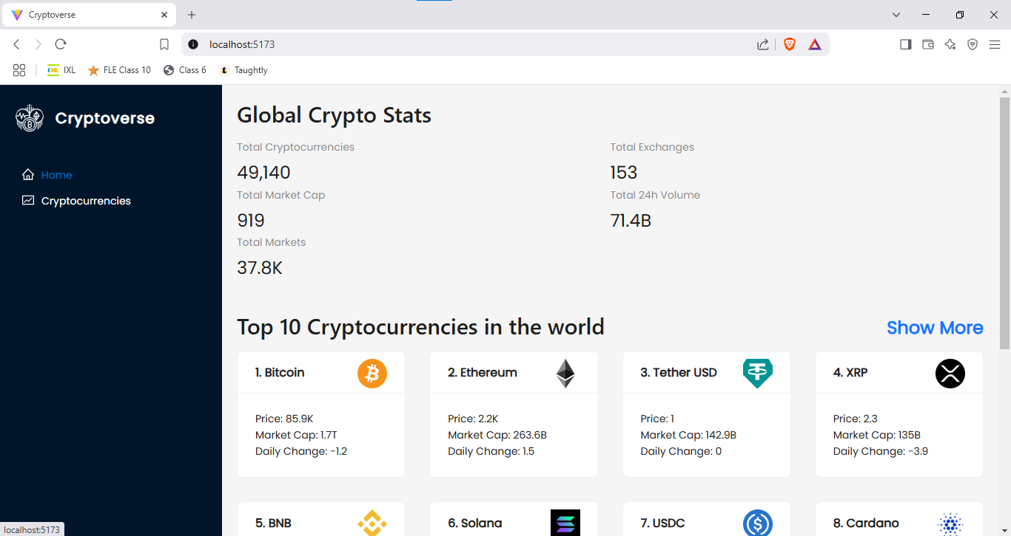

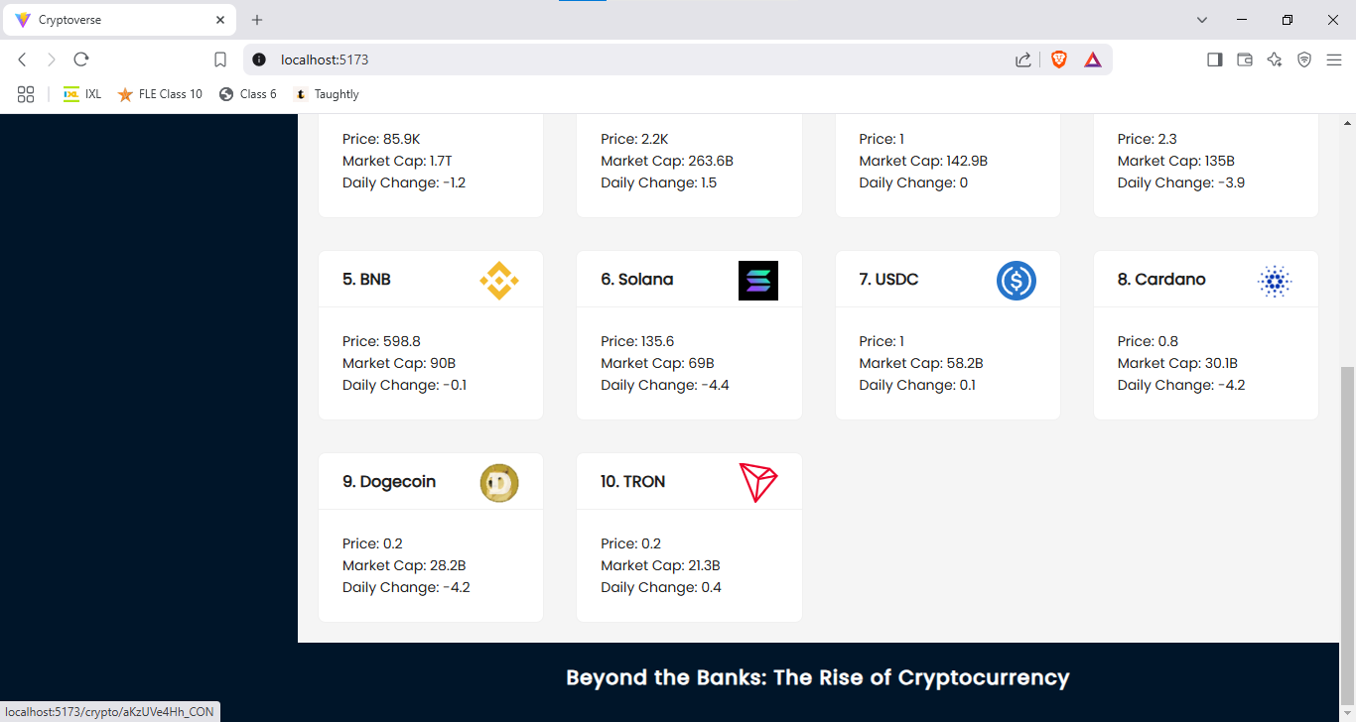

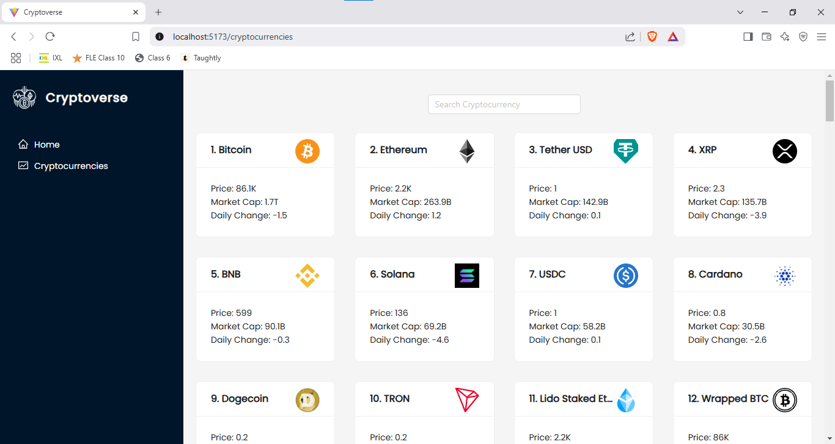

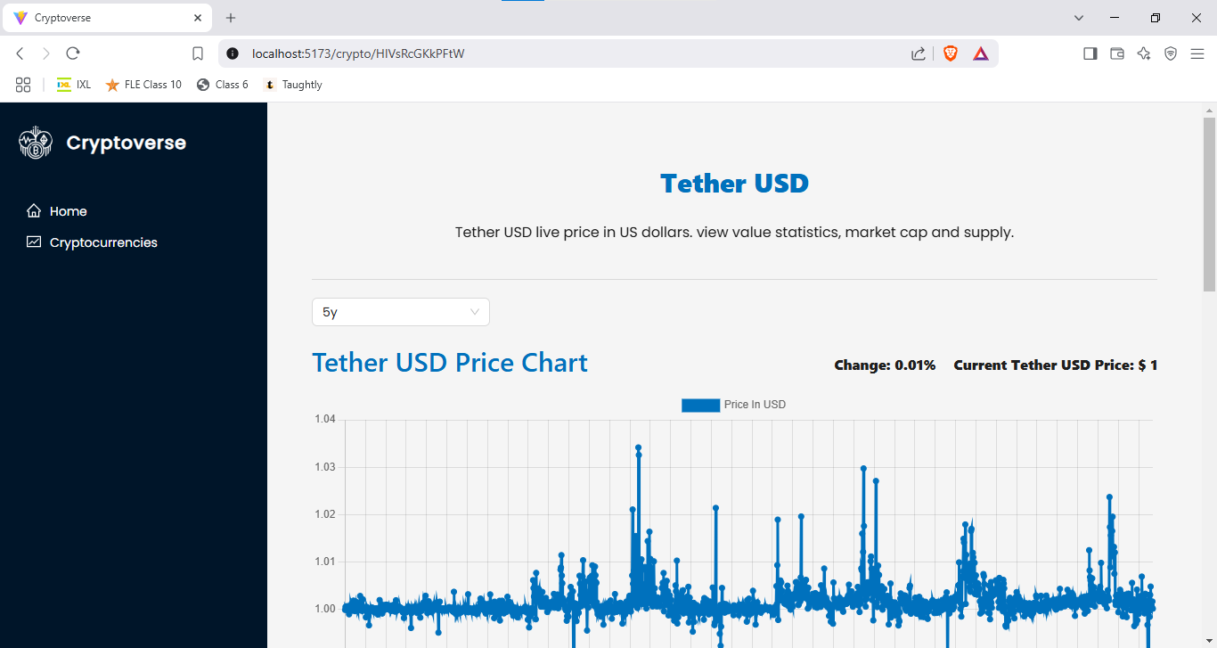

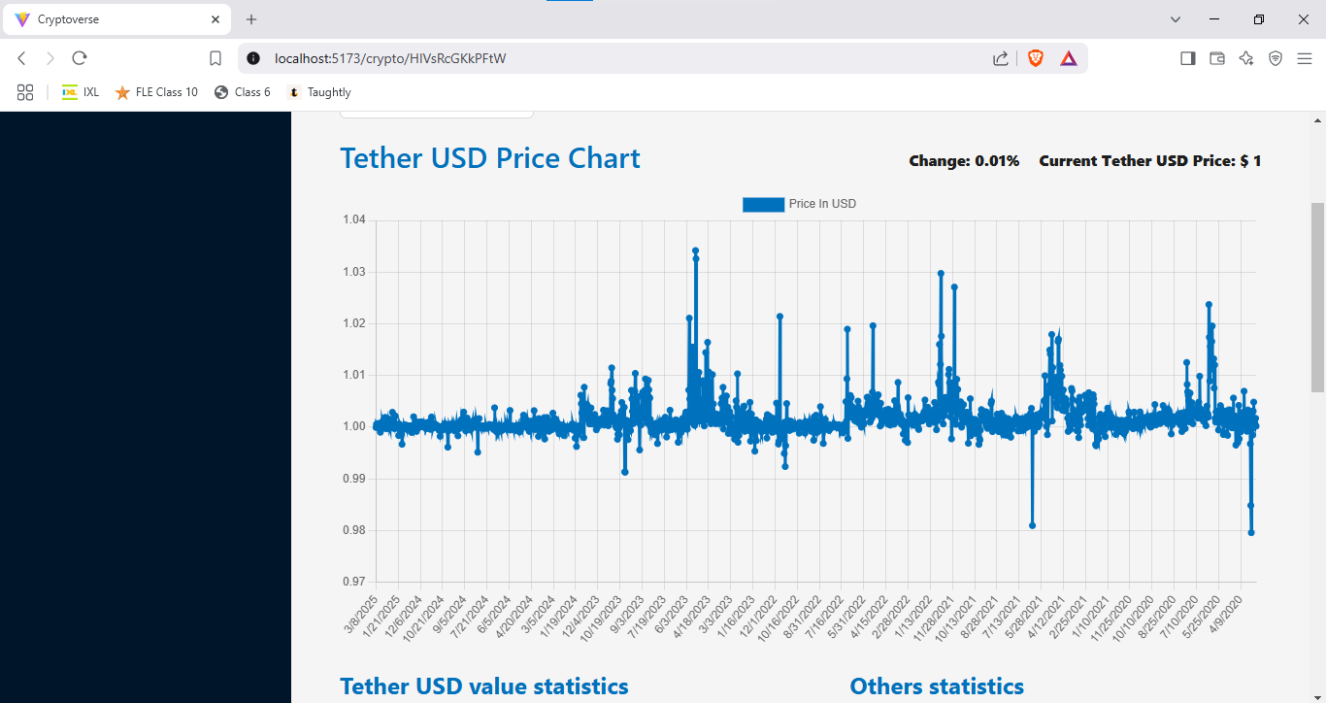

**KNOWN ISSUES**

The Cryptoverse project currently faces a few known issues that developers should be aware of. These include an API rate limiting error, which may cause disruptions during frequent data fetch requests, and incorrect data display in the CryptoDetails.jsx component if the API response format changes. Additionally, users might encounter UI flickering in the Loader.jsx component, broken navigation links in Navbar.jsx, and occasional Vite configuration warnings during server startup. The project also exhibits responsive design issues on smaller screens and experiences search functionality delays when handling large datasets. Addressing these issues with caching strategies, improved conditional rendering, optimized search logic, and enhanced media queries will significantly improve the application's stability and performance.

**FUTURE ENHANCEMENTS**

For future enhancements, the Cryptoverse project can incorporate several improvements to enhance user experience and functionality. Potential additions include implementing real-time price updates using WebSocket connections for faster data synchronization, improving the search functionality with predictive text and autocomplete features, and integrating dark mode support for enhanced visual comfort. Introducing interactive data visualizations with libraries like Chart.js or Recharts can provide users with dynamic insights into cryptocurrency trends. Enhanced styling improvements, such as adding micro-interactions and page transition animations, can create a smoother browsing experience. Furthermore, implementing a watchlist feature to track selected cryptocurrencies and adding multi-language support will significantly expand the application's accessibility and user engagement.