SUHAANI KEDAR
23BCB0030
Exno 1 c) Develop a web page to display your profile using basic html tags.
Aim: Develop a web page to display your profile using basic html tags. The tentative profile page template is given below. Your page should include,
- Use image, text as hyperlink reference.
- Apply internal navigation (Hyperlinking to your E-Mail Address)
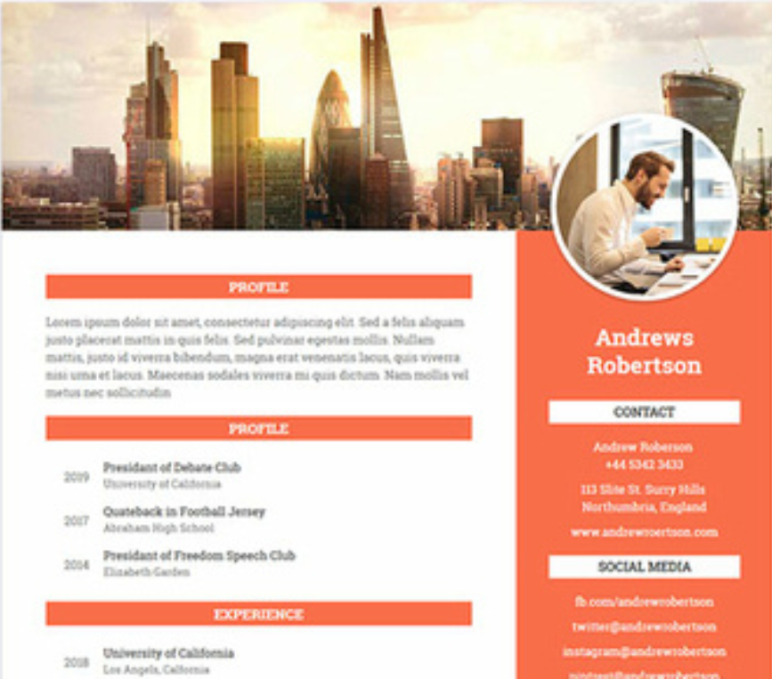
(Reference: dribbble)
HTML Tags need to be used:
Tags used | Attributes
<br>
<h1>
<p>
<img> | src, height, width, alt, caption
<a> | href, target (_blank,_parent,_self,_top) [Note: Use Hyperlinking to your E-Mail Address]
<li>
<ul>
<font>

Procedure:
- Create an html file named as home.html to design a page as per the above-mentioned template. It may have the following
  - Name, Address, Telephone number, Email-id, Photo
  - Educational Details (X, XII, I Year, Second Year – Institute name, Max mark, scored mark, percentage or CGPA, class) (Use table)
  - Co-curricular activity details (Use List)
  - Extracurricular activity details (Use List)
  - Technical skill set details (Use List)
  - Hobbies, Personal details
- Multiple pages can also be created and connected together using links.
- In notepad or any editor or IDE type the necessary code & save with the file name mentioned with .html extension display your time table.
- To view your web page, simply double click your html file.
<Paste your code>
<!DOCTYPE html>
<html lang="en">
<head>
<meta charset="UTF-8">
<meta name="viewport" content="width=device-width, initial-scale=1.0">
<title>My Profile</title>
<style>
body {
font-family: Arial, sans-serif;
margin: 0;
padding: 0;
background: linear-gradient(to bottom, #99b9d5, #002331);
color: #333;
}
header {
position: relative;
text-align: center;
color: white;
}
header img {
width: 100%;
height: 300px;
object-fit: cover;
}
header h1 {
position: absolute;
top: 50%;
left: 50%;
transform: translate(-50%, -50%);
font-size: 3em;
background-color: rgba(0, 0, 0, 0.5);
padding: 10px 20px;
border-radius: 10px;
}
.container {
margin: 20px auto;
max-width: 900px;
background: #ffffff;
padding: 20px;
border-radius: 8px;
box-shadow: 0px 4px 8px rgba(0, 0, 0, 0.2);
}
.profile {
display: flex;
align-items: center;
margin-bottom: 20px;
}
.profile-image {
flex: 0 0 150px;
margin-right: 20px;
overflow: hidden;
border-radius: 50%;
width: 150px;
height: 150px;
}
.profile-image img {
width: 180px;
height: 195px;
object-fit: cover;
transform: translate(-15px, -15px);
}
.content {
flex: 1;
}
h2 {
color: #4caf50;
margin-bottom: 10px;
}
table {
width: 100%;
border-collapse: collapse;
margin-bottom: 20px;
}
th, td {
border: 1px solid #ddd;
padding: 8px;
text-align: left;
}
th {
background-color: #4caf50;
color: white;
}
ul {
list-style-type: circle;
padding-left: 20px;
}
a {
color: #4caf50;
text-decoration: none;
}
footer {
text-align: center;
margin-top: 20px;
padding: 10px 0;
background-color: #132243;
color: white;
}
footer a {
color: #4caf50;
text-decoration: none;
margin: 0 10px;
}
</style>
</head>
<body>
<header>
<img src="headerimage.webp" alt="Header Image">
<h1><font color="pink" size="10" face="Helvetica">My Profile</font></h1>
</header>
<div class="container">
<div class="profile">
<div class="profile-image">
<img src="profile.jpg" alt="Profile Photo">
</div>
<div class="content">
<h2>Contact Information</h2>
<p>
Name: <b>Suhaani Kedar</b><br>
Address: LH E Block, VIT Vellore, Katpadi, Tamil Nadu, India<br>
Telephone: 9449015257<br>
Email: <a href="mailto:suhaanikedar@gmail.com">suhaanikedar@gmail.com</a>
</p>
</div>
</div>
</div>
<div class="container">
<h2>Educational Details</h2>
<table>
<tr>
<th>Year</th>
<th>Institution</th>
<th>Max Marks</th>
<th>Scored Marks</th>
<th>Percentage/CGPA</th>
<th>Class</th>
</tr>
<tr>
<td>2010-2022</td>
<td>Kendriya Vidyalaya DRDO</td>
<td>500</td>
<td>488</td>
<td>95%</td>
<td>First</td>
</tr>
<tr>
<td>I Sem</td>
<td>Vellore Institute Of Technology</td>
<td>10</td>
<td>8.88</td>
<td>8.88</td>
<td>First</td>
</tr>
<tr>
<td>II Sem</td>
<td>Vellore Institute Of Technology</td>
<td>10</td>
<td>9.49</td>
<td>9.49</td>
<td>First</td>
</tr>
</table>

<h2>Co-Curricular Activities</h2>
<ul>
<li>President of Debate Club</li>
<li>National level roller skater</li>
<li>Kathak dancer</li>
<li>Member of Robotics Club</li>
<li>Volunteer at Community Tech Workshops</li>
</ul>

<h2>Technical Skills</h2>
<ul>
<li>HTML, CSS, JavaScript</li>
<li>Python, Java</li>
<li>Machine Learning Basics</li>
<li>Motion graphics</li>
</ul>

<h2>Hobbies</h2>
<ul>
<li>Traveling</li>
<li>Reading Novels</li>
<li>Playing Guitar</li>
</ul>

<h2>Personal Details</h2>
<p>
Date of Birth: 11th October 2004<br>
Nationality: Indian<br>
Languages: English, Hindi, Sanskrit
</p>
</div>
<footer>
<p>&copy; 2024 Suhaani Kedar | <a href="https://www.linkedin.com/in/skedar2004/" target="_blank">LinkedIn</a> | <a href="https://github.com/SuhaaniK" target="_blank">GitHub</a> | <a href="#">Portfolio</a></p>
</footer>
</body>
</html>
<Paste cropped output>
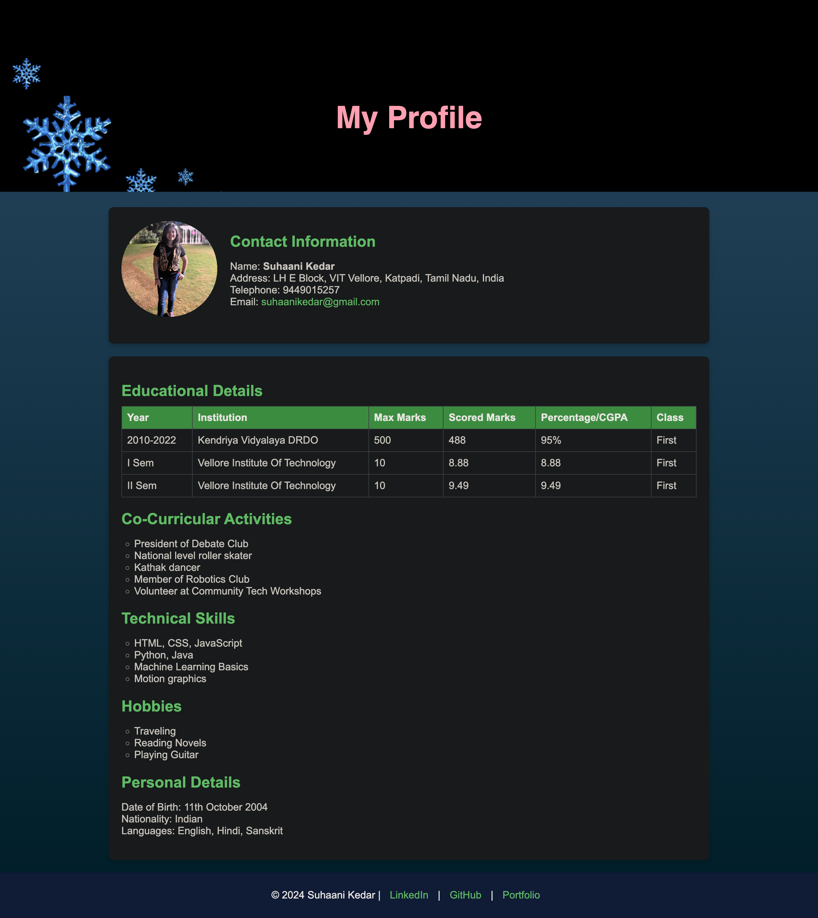
<Paste output screenshot with timestamp>
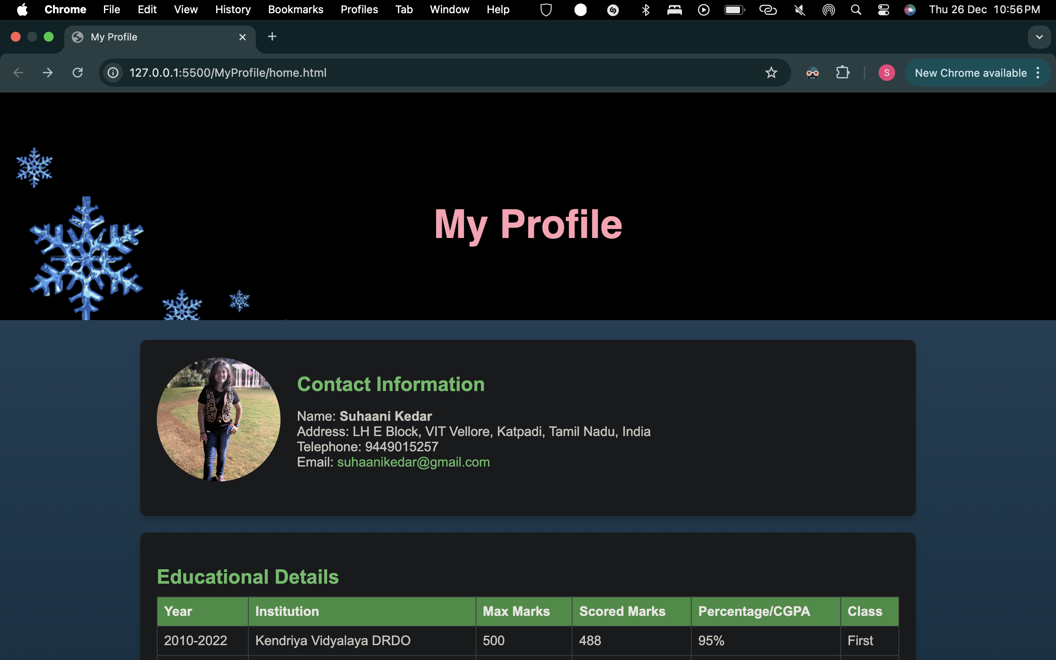
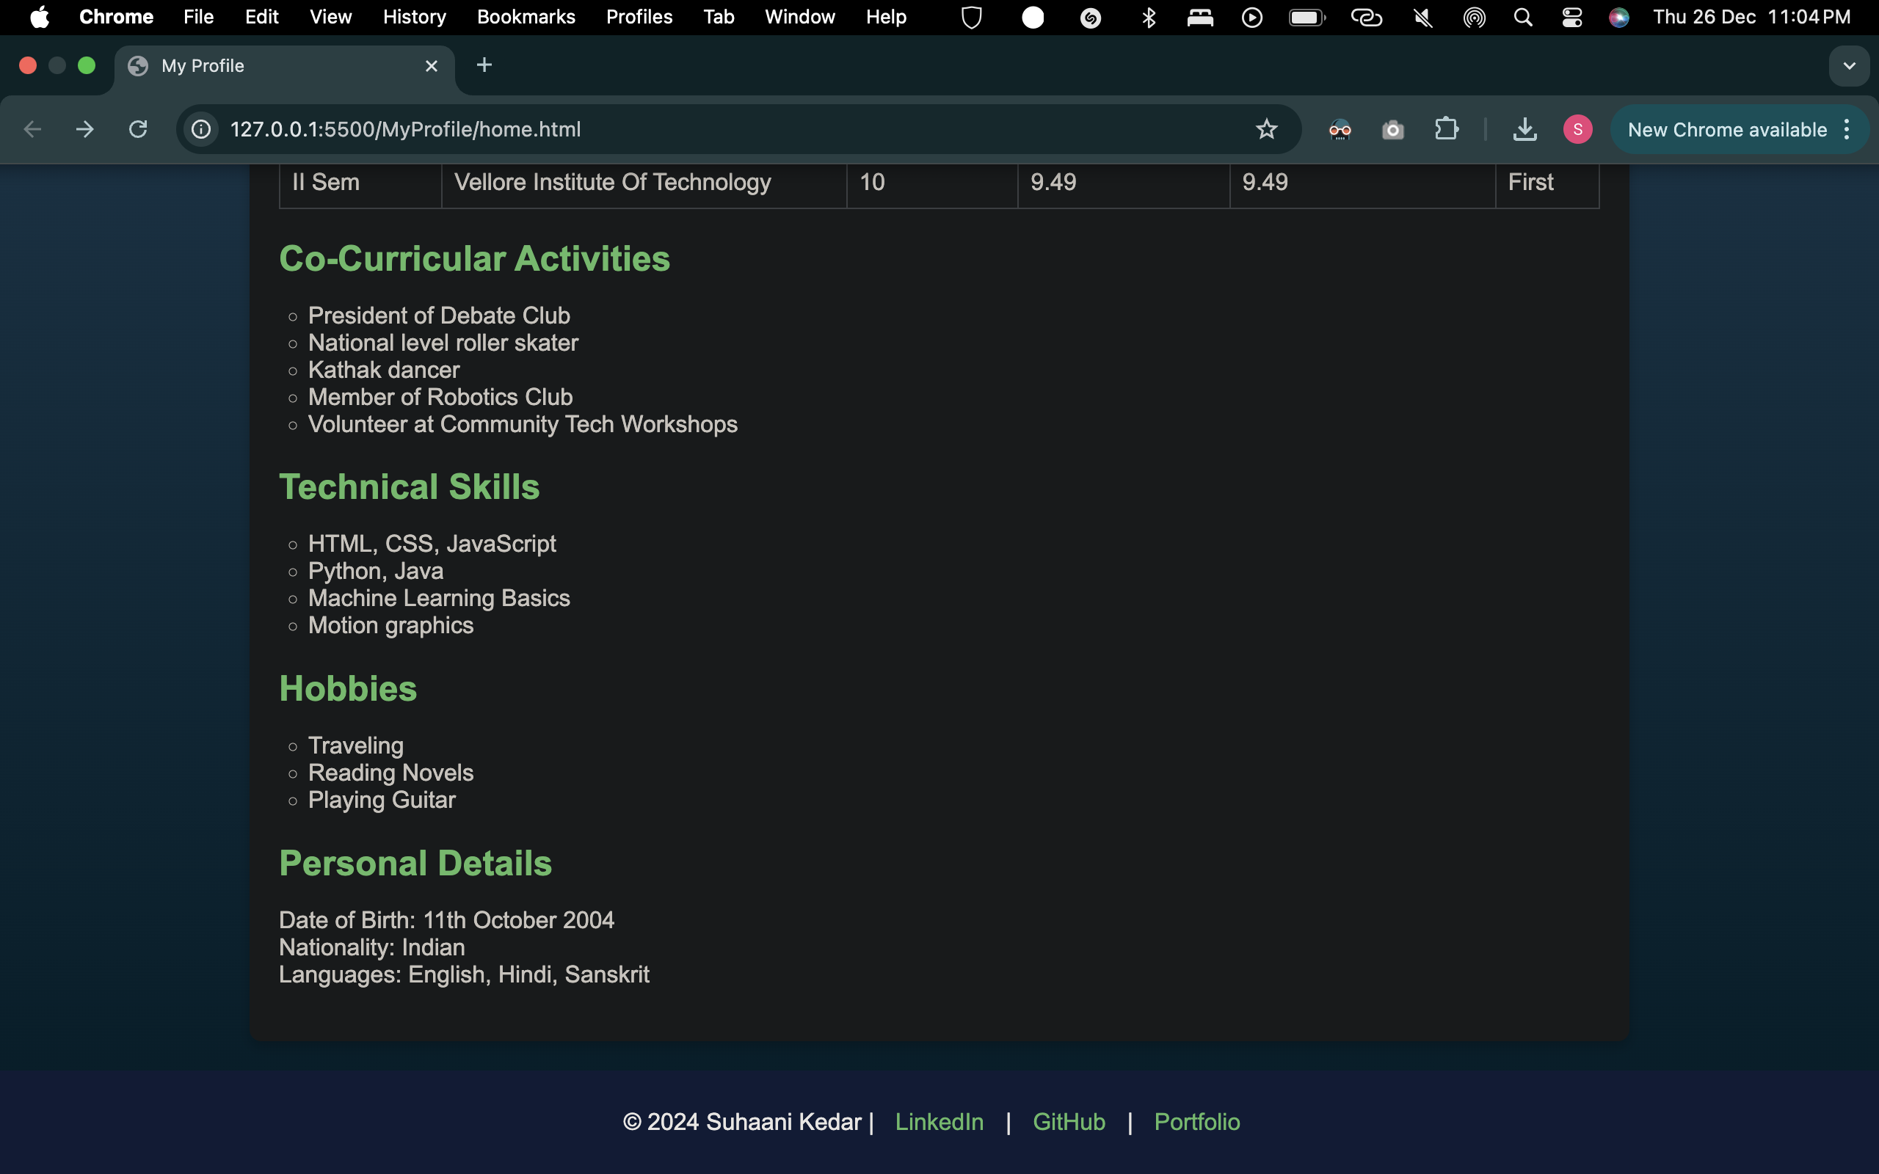
Result:
Thus a web page was created to display my profile using basic html tags. The output was verified.

