SUHAANI KEDAR
23BCB0030
Aim: Develop a web page to replicate your VTOP Timetable of Winter Semester 2024 – 2025 using basic html tags. The timetable should be exactly same as VTOP format.
HTML Tags need to be used:
Tags used | Attributes
<br>
<h1>
<table> | border, rowspan, colspan, align=center/left/right, cellpadding=, cellspacing=
<tr>
<td> | bg-color
<th>
<caption>
<font> | color, face, size

Procedure:
- In notepad or any editor or IDE type the necessary code & save with the file name mentioned with .html extension display your time table.
- To view your web page, simply double click your html file.
<Paste your code>
<!DOCTYPE html>
<html>
<head>SUHAANI KEDAR <br>
23BCB0030
</head>
<body>
<h1> Time Table </h1>
<table border="3" cellpadding="5" cellspacing="0" align="center">
<caption>Weekly TimeTable</caption>
<tr>
<th rowspan="2">THEORY</th>
<th>Start</th>
<th>8:00</th>
<th>9:00</th>
<th>10:00</th>
<th>11:00</th>
<th>12:00</th>
<th>-</th>
<th>Lunch</th>
<th>14:00</th>
<th>15:00</th>
<th>16:00</th>
<th>17:00</th>
<th>18:00</th>
<th>18:51</th>
<th>19:01</th>
</tr>
<tr>
<th>End</th>
<th>8:50</th>
<th>9:50</th>
<th>10:50</th>
<th>11:50</th>
<th>12:50</th>
<th>-</th>
<th>Lunch</th>
<th>14:50</th>
<th>15:50</th>
<th>16:50</th>
<th>17:50</th>
<th>18:50</th>
<th>19:00</th>
<th>19:50</th>
</tr>
<tr>
<th rowspan="2">LAB</th>
<th>Start</th>
<th>8:00</th>
<th>8:51</th>
<th>9:51</th>
<th>10:51</th>
<th>11:40</th>
<th>12:31</th>
<th>Lunch</th>
<th>14:00</th>
<th>14:51</th>
<th>15:51</th>
<th>16:41</th>
<th>17:40</th>
<th>18:31</th>
<th>-</th>
</tr>
<tr>
<th>End</th>
<th>8:50</th>
<th>9:40</th>
<th>10:40</th>
<th>11:30</th>
<th>12:30</th>
<th>13:20</th>
<th>Lunch</th>
<th>14:50</th>
<th>15:40</th>
<th>16:40</th>
<th>17:30</th>
<th>18:30</th>
<th>19:20</th>
<th>-</th>
</tr>
<tr>
<th rowspan="2">MON</th>
<th>THEORY</th>
<th style = "background-color: red;">A1-BCSE204L-TH-SJT324-ALL</th>
<th style = "background-color: red;">F1-BCSE304L-TH-SJT421-ALL</th>
<th>D1</th>
<th style = "background-color: red;">TB1-BECE204L-TH-SJT315-ALL</th>
<th style = "background-color: red;">TG1-BCSE203E-ETH-SJT401-ALL</th>
<th>-</th>
<th>Lunch</th>
<th>A2</th>
<th style = "background-color: red;">F2-BSTS102P-SS-TT504-ALL</th>
<th>D2</th>
<th>TB2</th>
<th style = "background-color: red;">TG2-BMAT202L-TH-SMV122-ALL</th>
<th>-</th>
<th>V3</th>
</tr>
<tr>
<th>LAB</th>
<th>L1</th>
<th>L2</th>
<th>L3</th>
<th>L4</th>
<th>L5</th>
<th>L6</th>
<th>Lunch</th>
<th>L31</th>
<th>L32</th>
<th>L33</th>
<th>L34</th>
<th>L35</th>
<th>L36</th>
<th>-</th>
</tr>
<tr>
<th rowspan="2">TUE</th>
<th>THEORY</th>
<th style = "background-color: red;">B1-BECE204L-TH-SJT315-ALL</th>
<th> G1</th>
<th>E1</th>
<th style = "background-color: red;">TC1-BCSE205L-TH-SJT405-ALL</th>
<th>TAA1</th>
<th>-</th>
<th>Lunch</th>
<th>B2</th>
<th style = "background-color: red;">G2-BMAT202L-TH-SMV122-ALL</th>
<th>E2</th>
<th>TC2</th>
<th>TAA2</th>
<th>-</th>
<th>V4</th>
</tr>
<tr>
<th>LAB</th>
<th>L7</th>
<th>L8</th>
<th>L9</th>
<th>L10</th>
<th>L11</th>
<th>L12</th>
<th>Lunch</th>
<th>L37</th>
<th>L38</th>
<th>L39</th>
<th>L40</th>
<th>L41</th>
<th>L42</th>
<th>-</th>
</tr>
<tr>
<th rowspan="2">WED</th>
<th>THEORY</th>
<th style = "background-color: red;">C1-BCSE205L-TH-SJT405-ALL</th>
<th style = "background-color: red;">A1-BCSE204L-TH-SJT324-ALL</th>
<th style = "background-color: red;">F1-BCSE304L-TH-SJT421-ALL</th>
<th>V1</th>
<th>V2</th>
<th>-</th>
<th>Lunch</th>
<th>C2</th>
<th>A2</th>
<th style = "background-color: red;">F2-BSTS102P-SS-TT504-ALL</th>
<th>TD2</th>
<th>TBB2</th>
<th>-</th>
<th>V5</th>
</tr>
<tr>
<th>LAB</th>
<th>L13</th>
<th>L14</th>
<th>L15</th>
<th>L16</th>
<th>L17</th>
<th>L18</th>
<th>Lunch</th>
<th>L43</th>
<th>L44</th>
<th>L45</th>
<th>L46</th>
<th style = "background-color: red;">L47-BCSE203E-ELA-SJT515-ALL</th>
<th style = "background-color: red;">L48-BCSE203E-ELA-SJT515-ALL</th>
<th>-</th>
</tr>
<tr>
<th rowspan="2">THU</th>
<th>THEORY</th>
<th>D1</th>
<th style = "background-color: red;">B1-BECE204L-TH-SJT315-ALL</th>
<th>G1</th>
<th>TE1</th>
<th>TCC1</th>
<th>-</th>
<th>Lunch</th>
<th>D2</th>
<th>B2</th>
<th style = "background-color: red;">G2-BMAT202L-TH-SMV122-ALL</th>
<th>TE2</th>
<th>TCC2</th>
<th>-</th>
<th>V6</th>
</tr>
<tr>
<th>LAB</th>
<th>L19</th>
<th>L20</th>
<th>L21</th>
<th>L22</th>
<th style = "background-color: red;">L23-BMAT202P-LO-SMVG15-ALL</th>
<th style = "background-color: red;">L24-BMAT202P-LO-SMVG15-ALL</th>
<th>Lunch</th>
<th style = "background-color: red;">L49-BCSE204P-LO-SJT621-ALL</th>
<th style = "background-color: red;">L50-BCSE204P-LO-SJT621-ALL</th>
<th>L51</th>
<th>L52</th>
<th style = "background-color: red;">L53-BECE204P-LO-PRP136-ALL</th>
<th style = "background-color: red;">L54-BECE204P-LO-PRP136-ALL</th>
<th>-</th>
</tr>
<tr>
<th rowspan="2">FRI</th>
<th>THEORY</th>
<th>E1</th>
<th style = "background-color: red;">C1-BCSE205L-TH-SJT405-ALL</th>
<th style = "background-color: red;">TA1-BCSE204L-TH-SJT324-ALL</th>
<th style = "background-color: red;">TF1-BCSE304L-TH-SJT421-ALL</th>
<th>TD1</th>
<th>-</th>
<th>Lunch</th>
<th>E2</th>
<th>C2</th>
<th>TA2</th>
<th style = "background-color: red;">TF2-BSTS102P-SS-TT504-ALL</th>
<th>TDD2</th>
<th>-</th>
<th>V7</th>
</tr>
<tr>
<th>LAB</th>
<th>L25</th>
<th>L26</th>
<th>L27</th>
<th>L28</th>
<th>L29</th>
<th>L30</th>
<th>Lunch</th>
<th style = "background-color: red;">L55-BCSE203E-ELA-SJT515-ALL</th>
<th style = "background-color: red;">L56-BCSE203E-ELA-SJT515-ALL</th>
<th>L57</th>
<th>L58</th>
<th>L59</th>
<th>L60</th>
<th>-</th>
</tr>
<tr>
<th rowspan="2">SAT</th>
<th>THEORY</th>
<th>V8</th>
<th>X11</th>
<th>X12</th>
<th>Y11</th>
<th>Y12</th>
<th>-</th>
<th>Lunch</th>
<th>X21</th>
<th>Z21</th>
<th>Y21</th>
<th>W21</th>
<th>W22</th>
<th>-</th>
<th>V9</th>
</tr>
<tr>
<th>LAB</th>
<th>L71</th>
<th>L72</th>
<th>L73</th>
<th>L74</th>
<th>L75</th>
<th>L76</th>
<th>Lunch</th>
<th>L77</th>
<th>L78</th>
<th>L79</th>
<th>L80</th>
<th>L81</th>
<th>L82</th>
<th>-</th>
</tr>
<tr>
<th rowspan="2">SUN</th>
<th>THEORY</th>
<th>V10</th>
<th>Y11</th>
<th>Y12</th>
<th>X11</th>
<th>X12</th>
<th>-</th>
<th>Lunch</th>
<th>Y21</th>
<th>Z21</th>
<th>X21</th>
<th>W21</th>
<th>W22</th>
<th>-</th>
<th>V11</th>
</tr>
<tr>
<th>LAB</th>
<th>L83</th>
<th>L84</th>
<th>L85</th>
<th>L86</th>
<th>L87</th>
<th>L88</th>
<th>Lunch</th>
<th>L89</th>
<th>L90</th>
<th>L91</th>
<th>L92</th>
<th>L93</th>
<th>L94</th>
<th>-</th>
</tr>
</table>

</body>

</html>

<Paste cropped output>
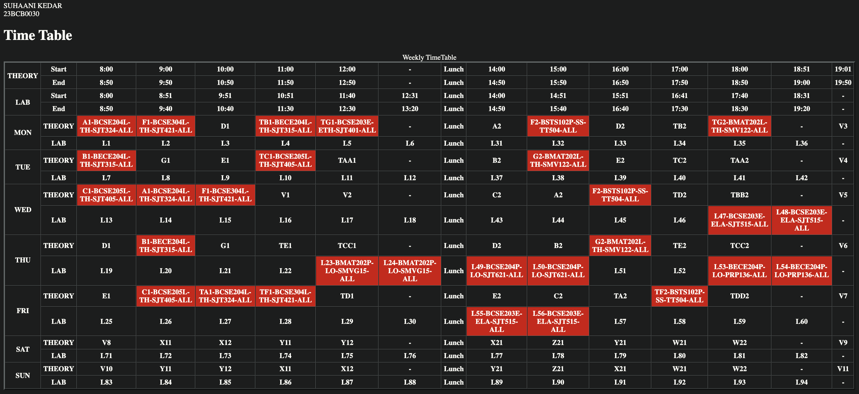

<Paste output screenshot with timestamp>
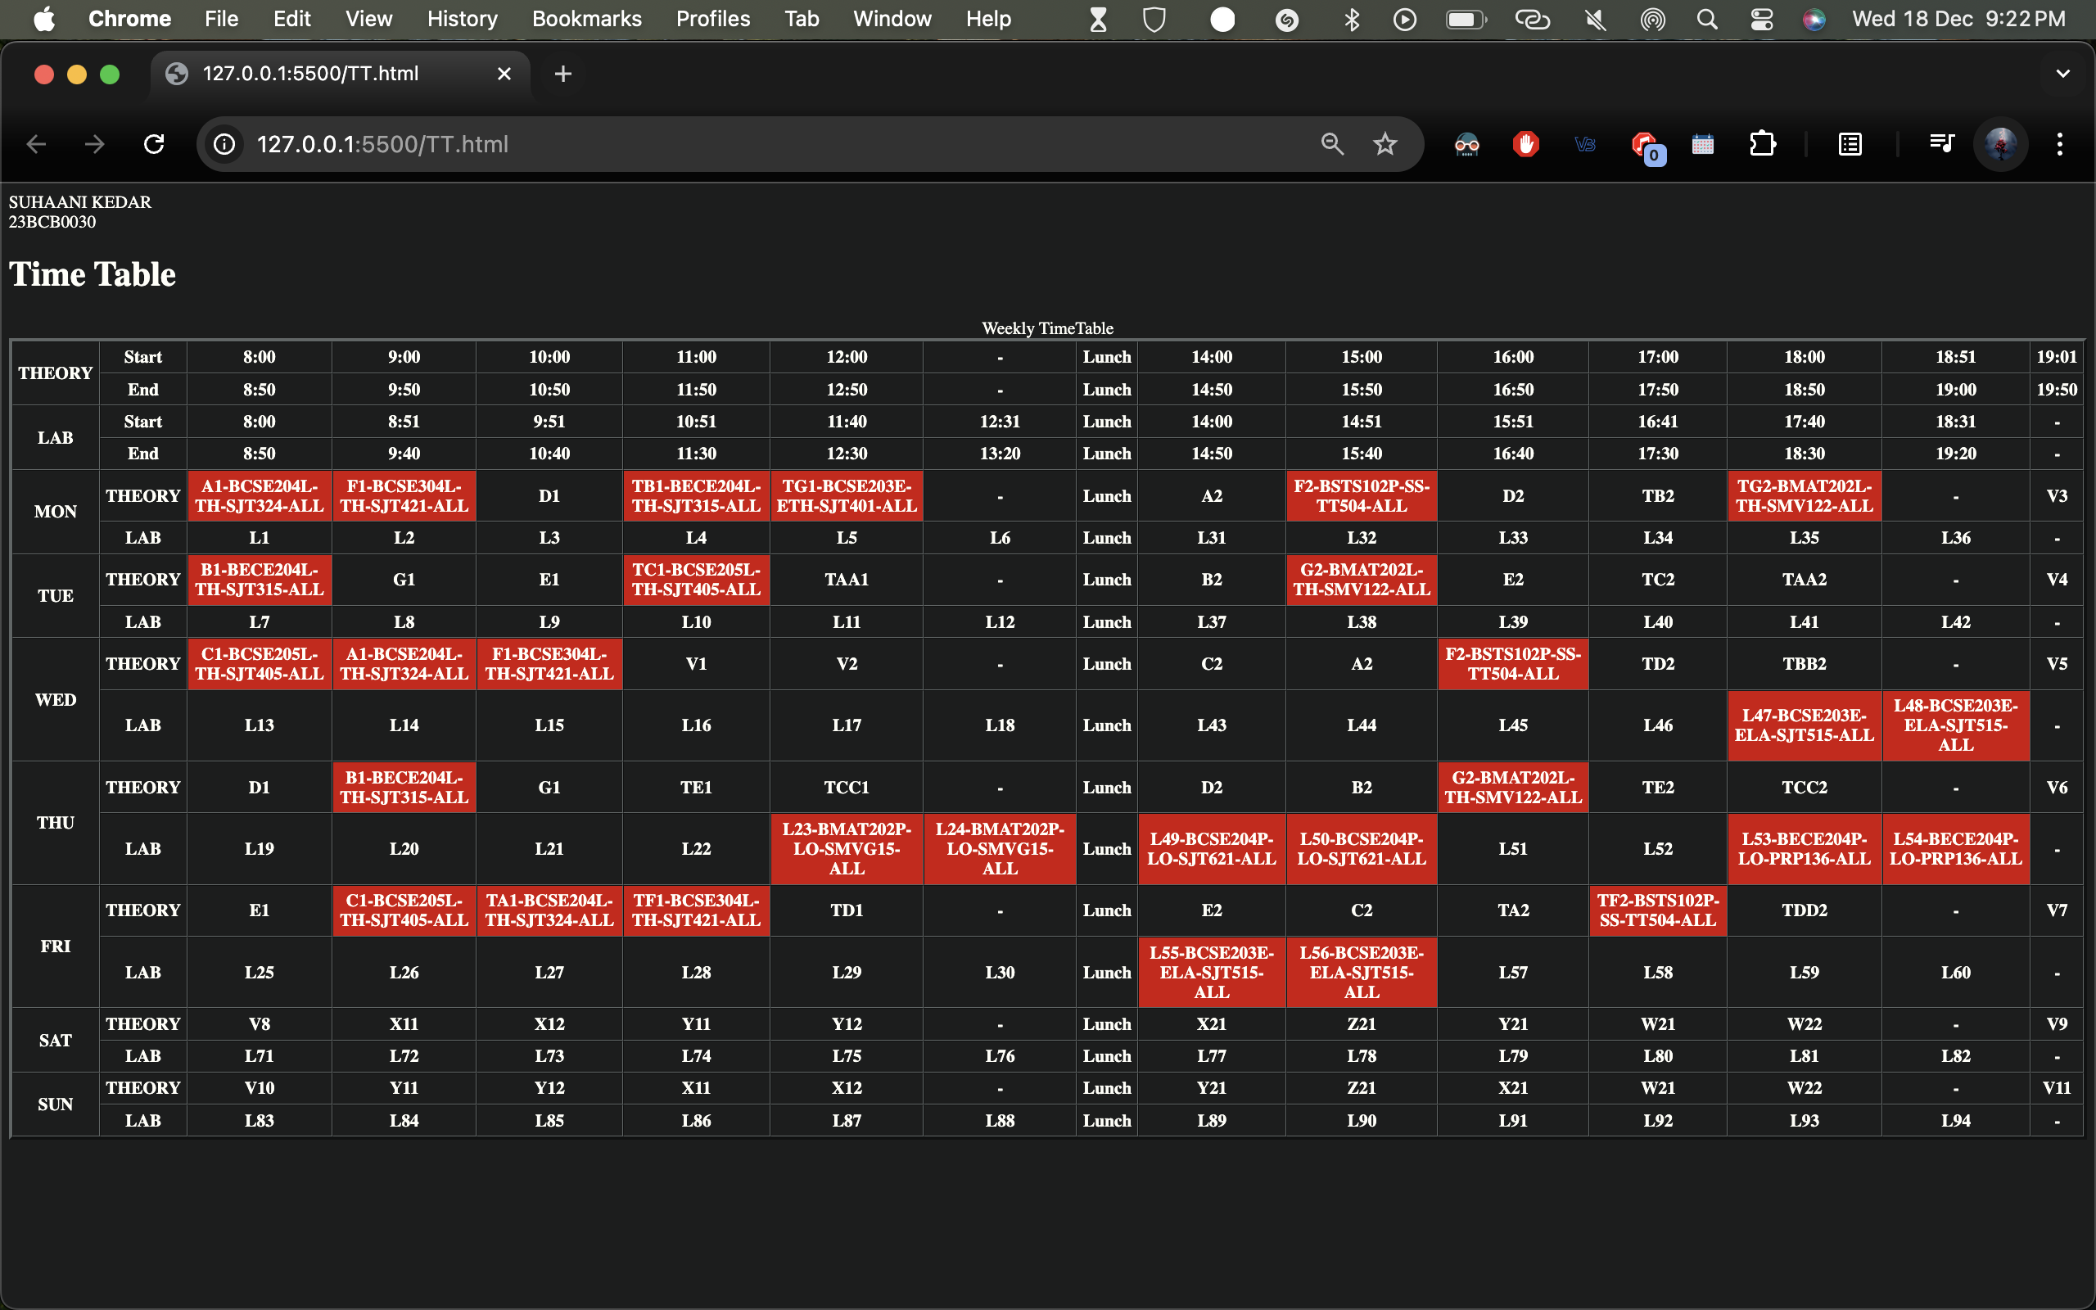
Result:
Thus the web page to replicate your VTOP Timetable of Winter Semester 2024 – 2025 was created using basic html tags. The output was verified.

