SUHAANI KEDAR
23BCB0030
Exno 1 d) Develop a web page to create registration page using html form tags.
Aim: Develop a web page to create registration page using html form tags. The tentative registration page template is given below. Your page should include,
- Use table to create forms with proper alignment.
- Apply different html input types (text, number, checkbox, radio and so on)
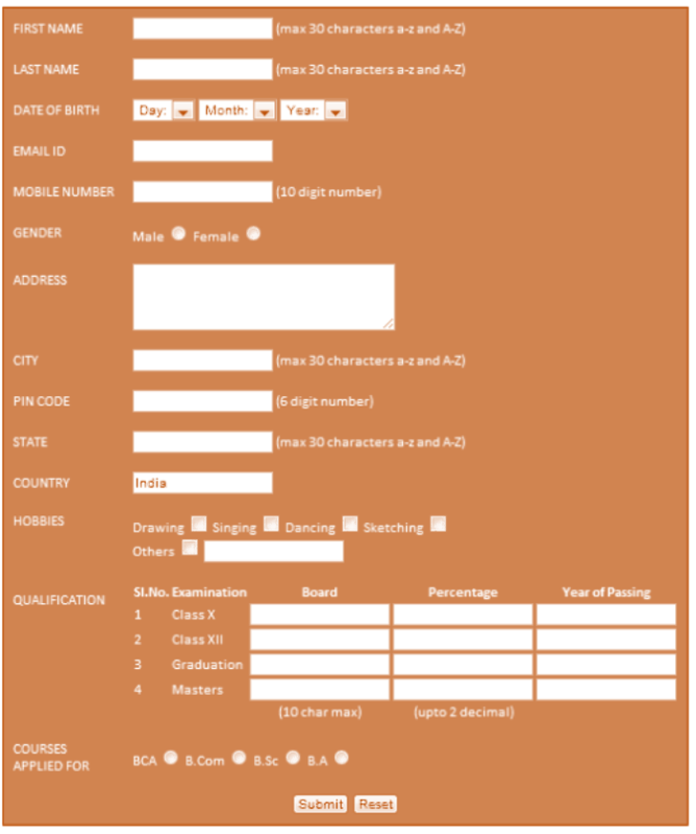
(Reference: progmgpalace)
HTML Tags need to be used:
Tags/elements/methods used | Attributes
<br>
<h1>
<p>
<table> | Use rowspan and colspan
<form>
<input> | Use different types
HTTP methods | get, post
<label>

Procedure:
- Create an html file named as registration.html to design a page as per the above-mentioned template.
- Multiple pages can also be created and connected together using form actions.
- Use HTTP methods (get and post) to understand the differences between them.
- In notepad or any editor or IDE type the necessary code & save with the file name mentioned with .html extension display your time table.
- To view your web page, simply double click your html file.

<Paste your code>
Registration.html
<!DOCTYPE html>
<html lang="en">
<head>
<meta charset="UTF-8">
<meta name="viewport" content="width=device-width, initial-scale=1.0">
<title>Registration Page</title>
<style>
body {
font-family: Arial, sans-serif;
background-color: #d4a373;
margin: 0;
padding: 0;
}
h1 {
text-align: center;
margin-top: 20px;
}
.form-container {
width: 60%;
margin: 20px auto;
background-color: #fff;
padding: 20px;
border-radius: 8px;
box-shadow: 0 0 10px rgba(0, 0, 0, 0.1);
}
table {
width: 100%;
border-collapse: collapse;
}
td {
padding: 10px;
}
label {
font-weight: bold;
}
input[type="text"], input[type="email"], input[type="number"], select, textarea {
width: 100%;
padding: 8px;
margin: 5px 0;
box-sizing: border-box;
}
textarea {
resize: none;
}
.hobbies input {
margin-right: 5px;
}
.buttons {
text-align: center;
margin-top: 20px;
}
input[type="submit"], input[type="reset"], button {
padding: 10px 20px;
border: none;
background-color: #6b705c;
color: white;
border-radius: 5px;
cursor: pointer;
}
input[type="submit"]:hover, input[type="reset"]:hover, button:hover {
background-color: #40513b;
}
</style>
</head>
<body>
<h1>Registration Form</h1>
<div class="form-container">
<form method="post" action="success.html">
<table border="0">
<tr>
<td><label for="first-name">First Name:</label></td>
<td><input type="text" id="first-name" name="first-name" maxlength="30" required></td>
</tr>
<tr>
<td><label for="last-name">Last Name:</label></td>
<td><input type="text" id="last-name" name="last-name" maxlength="30" required></td>
</tr>
<tr>
<td><label for="dob">Date of Birth:</label></td>
<td><input type="date" id="dob" name="dob" required></td>
</tr>
<tr>
<td><label for="email">Email ID:</label></td>
<td><input type="email" id="email" name="email" required></td>
</tr>
<tr>
<td><label for="mobile">Mobile Number:</label></td>
<td><input type="number" id="mobile" name="mobile" maxlength="10" required></td>
</tr>
<tr>
<td><label>Gender:</label></td>
<td>
<input type="radio" id="male" name="gender" value="Male" required>
<label for="male">Male</label>
<input type="radio" id="female" name="gender" value="Female">
<label for="female">Female</label>
</td>
</tr>
<tr>
<td><label for="address">Address:</label></td>
<td><textarea id="address" name="address" rows="3" required></textarea></td>
</tr>
<tr>
<td><label for="city">City:</label></td>
<td><input type="text" id="city" name="city" maxlength="30" required></td>
</tr>
<tr>
<td><label for="pincode">Pin Code:</label></td>
<td><input type="number" id="pincode" name="pincode" maxlength="6" required></td>
</tr>
<tr>
<td><label for="state">State:</label></td>
<td><input type="text" id="state" name="state" maxlength="30" required></td>
</tr>
<tr>
<td><label for="country">Country:</label></td>
<td><input type="text" id="country" name="country" value="India" readonly></td>
</tr>
<tr>
<td><label>Hobbies:</label></td>
<td class="hobbies">
<input type="checkbox" name="hobbies" value="Drawing">Drawing
<input type="checkbox" name="hobbies" value="Singing">Singing
<input type="checkbox" name="hobbies" value="Dancing">Dancing
<input type="checkbox" name="hobbies" value="Sketching">Sketching
<input type="checkbox" name="hobbies" value="Others">Others
</td>
</tr>
<tr>
<td colspan="2"><label>Qualification:</label></td>
</tr>
<tr>
<td colspan="2">
<table border="1" width="100%">
<tr>
<th>Sl.No.</th>
<th>Examination</th>
<th>Board</th>
<th>Percentage</th>
<th>Year of Passing</th>
</tr>
<tr>
<td>1</td>
<td>Class X</td>
<td><input type="text" name="board_x"></td>
<td><input type="number" step="0.01" name="percentage_x"></td>
<td><input type="number" name="year_x"></td>
</tr>
<tr>
<td>2</td>
<td>Class XII</td>
<td><input type="text" name="board_xii"></td>
<td><input type="number" step="0.01" name="percentage_xii"></td>
<td><input type="number" name="year_xii"></td>
</tr>
<tr>
<td>3</td>
<td>Graduation</td>
<td><input type="text" name="board_grad"></td>
<td><input type="number" step="0.01" name="percentage_grad"></td>
<td><input type="number" name="year_grad"></td>
</tr>
<tr>
<td>4</td>
<td>Masters</td>
<td><input type="text" name="board_masters"></td>
<td><input type="number" step="0.01" name="percentage_masters"></td>
<td><input type="number" name="year_masters"></td>
</tr>
</table>
</td>
</tr>
<tr>
<td><label>Courses Applied For:</label></td>
<td>
<input type="checkbox" name="course" value="BCA">BCA
<input type="checkbox" name="course" value="B.Com">B.Com
<input type="checkbox" name="course" value="B.Sc">B.Sc
<input type="checkbox" name="course" value="B.A">B.A
<input type="checkbox" name="course" value="B.Tech">B.Tech
</td>
</tr>
</table>
<div class="buttons">
<button type="button" onclick="window.location.href='success.html'"> Submit </button>
<input type="reset" value="Reset">
<button type="button" onclick="window.location.href='success.html'">Already Registered</button>
</div>
</form>
</div>
</body>
</html>

success.html
<!DOCTYPE html>
<html lang="en">
<head>
<meta charset="UTF-8">
<meta name="viewport" content="width=device-width, initial-scale=1.0">
<title>Registration Successful</title>
<style>
body {
font-family: Arial, sans-serif;
background-color: #d4a373;
margin: 0;
padding: 0;
}
.success-container {
text-align: center;
margin-top: 20%;
color: #40513b;
}
a {
display: inline-block;
margin-top: 20px;
text-decoration: none;
color: #6b705c;
font-weight: bold;
padding: 10px 20px;
border: 2px solid #6b705c;
border-radius: 5px;
transition: background-color 0.3s, color 0.3s;
}
a:hover {
background-color: #6b705c;
color: white;
}
</style>
</head>
<body>
<div class="success-container">
<h1>Registration Successful!</h1>
<p>Thank you for registering. Your information has been recorded successfully.</p>
<a href="index.html">Go Back to Home</a>
</div>
</body>
</html>

index.html
<!DOCTYPE html>
<html lang="en">
<head>
<meta charset="UTF-8">
<meta name="viewport" content="width=device-width, initial-scale=1.0">
<title>Home Page</title>
<style>
body {
font-family: Arial, sans-serif;
background-color: #d4a373;
margin: 0;
padding: 0;
}
header {
background-color: #6b705c;
color: white;
padding: 10px 20px;
text-align: center;
}
nav {
background-color: #40513b;
display: flex;
justify-content: center;
padding: 10px 0;
}
nav a {
text-decoration: none;
color: white;
padding: 10px 20px;
margin: 0 10px;
border-radius: 5px;
transition: background-color 0.3s;
}
nav a:hover {
background-color: #d4a373;
color: #40513b;
}
.content {
text-align: center;
margin: 50px auto;
width: 80%;
}
h1 {
color: #6b705c;
}
p {
color: #333;
}
.buttons {
margin-top: 20px;
}
.buttons a {
text-decoration: none;
color: white;
padding: 10px 20px;
background-color: #6b705c;
border-radius: 5px;
transition: background-color 0.3s, color 0.3s;
}
.buttons a:hover {
background-color: #40513b;
}
</style>
</head>
<body>
<header>
<h1>Welcome to Our Website</h1>
</header>
<nav>
<a href="index.html">Home</a>
<a href="registration.html">Register</a>
<a href="success.html">Success Page</a>
</nav>
<div class="content">
<h1>Welcome!</h1>
<p>Thank you for visiting our website. Use the navigation menu to explore different sections.</p>
<div class="buttons">
<a href="registration.html">Go to Registration Form</a>
</div>
</div>
</body>
</html>

<Paste cropped output>
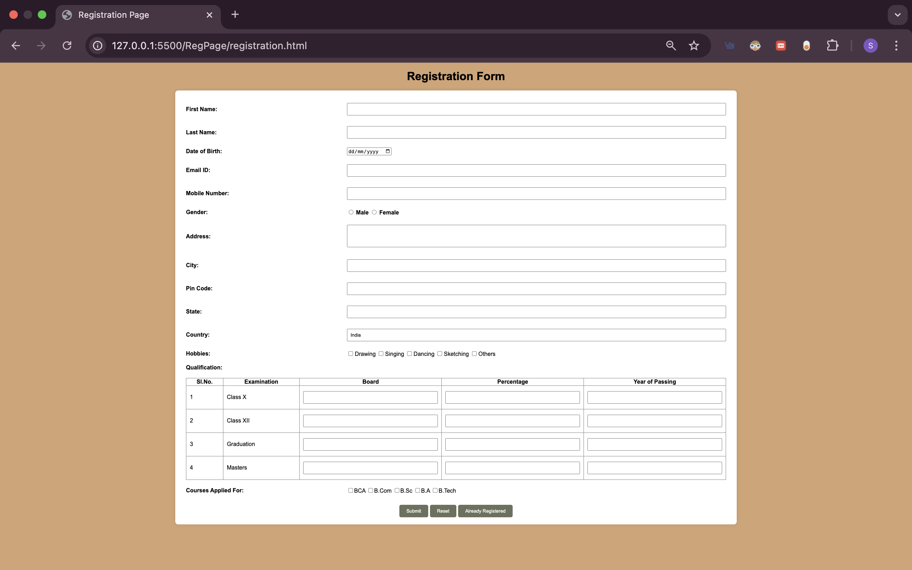
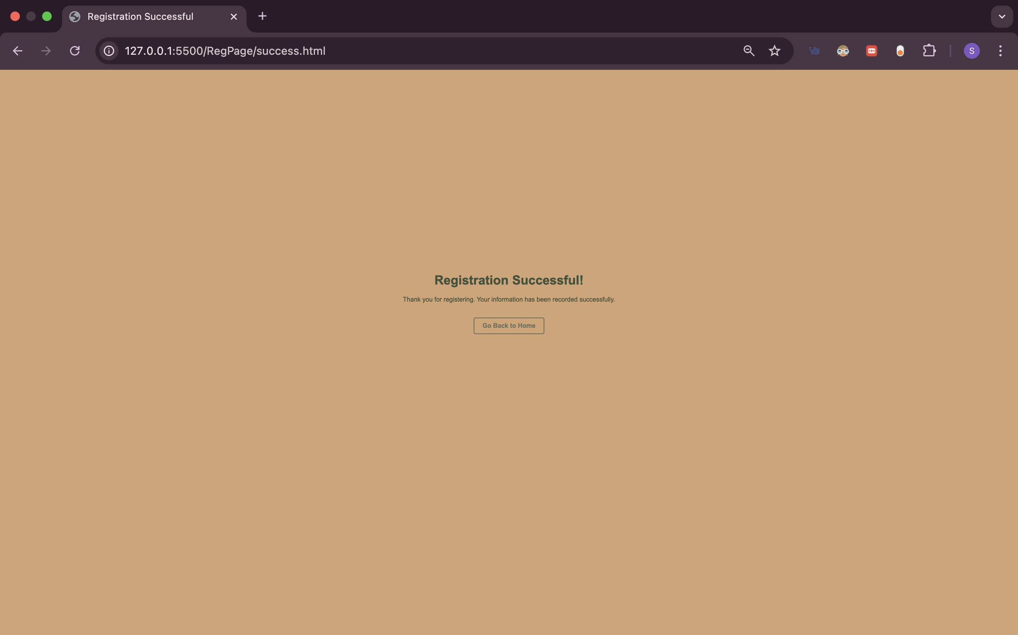
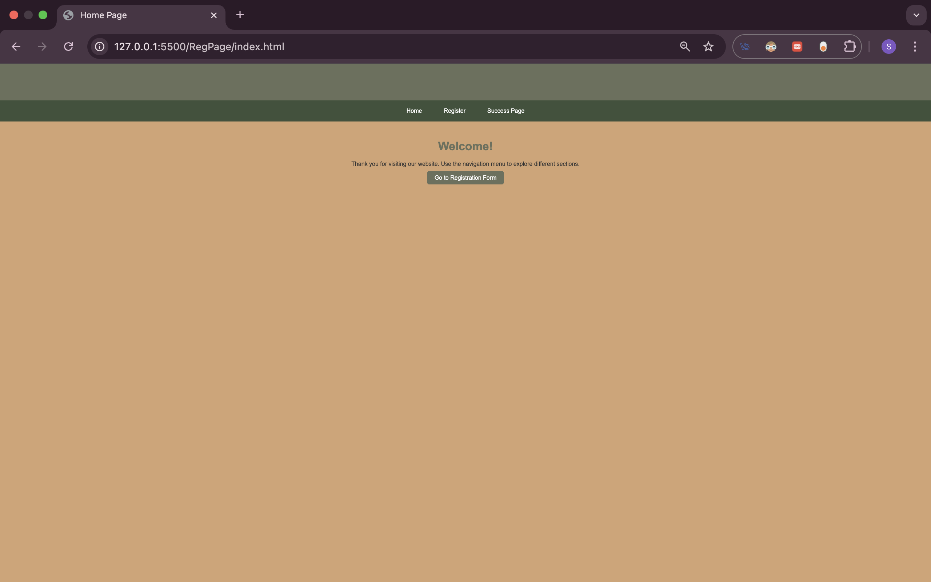

<Paste output screenshot with timestamp>
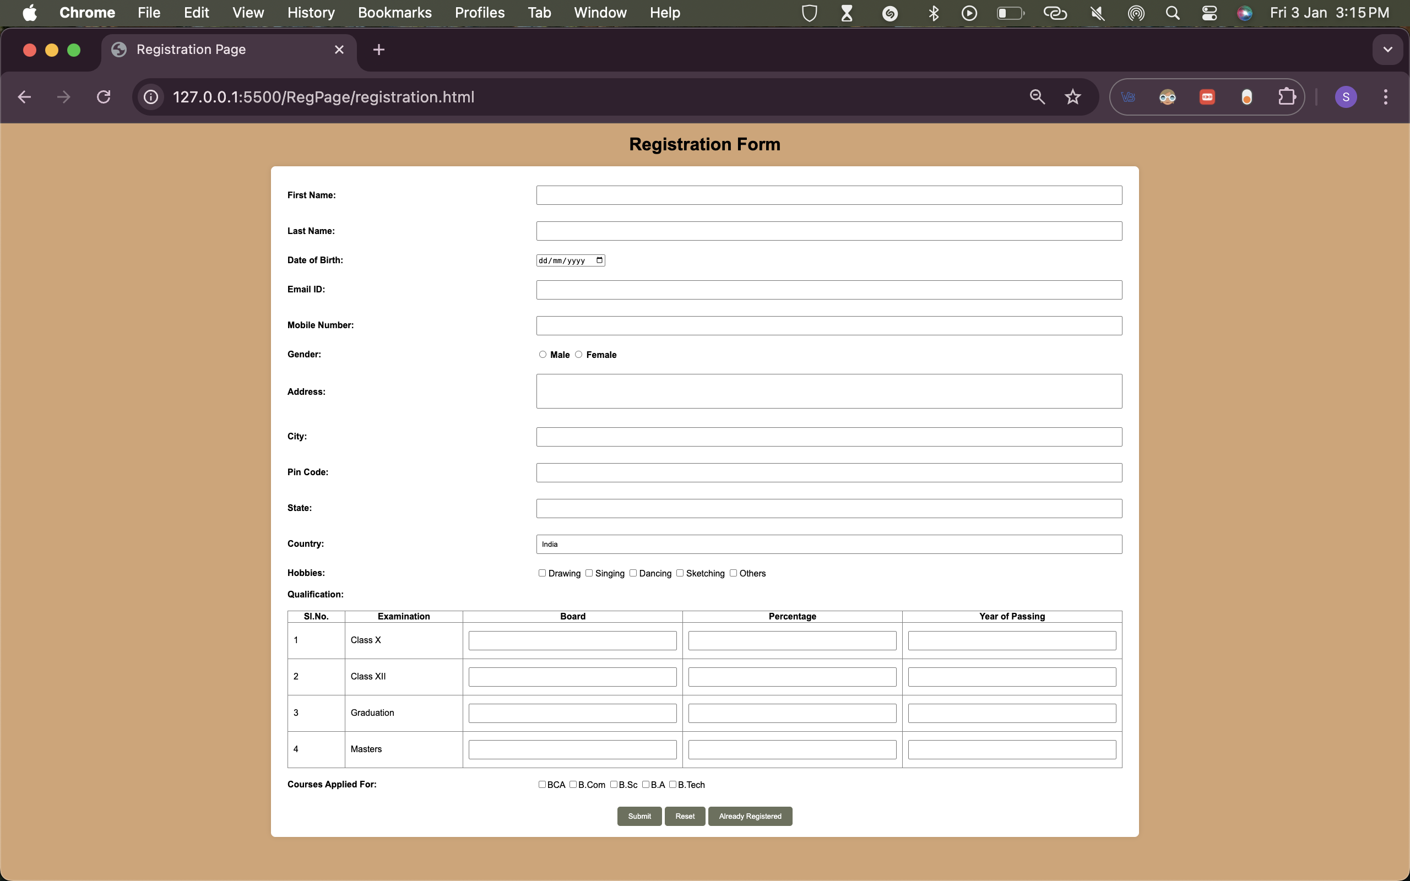

Result:
Thus a registration web page was created using basic html form and table tags. The output was verified.

