

**BCSE203E- Web Programming**

**Assignment**

*Topics –, HTML Block and Inline Elements <div> and <span> and Semantic HTML.*

**Activity 1:**

* A description of yourself in minimum 3 paragraphs and justify the text content
* Highlight the most important word(s) and infer the differences of bold, strong, emphasize.
* Use background colours and text colours appropriately for a good design.
* Add your image in left corner of the first paragraph

**Note: Incorporate HTML Block <*div>* and Inline Elements *<span>***

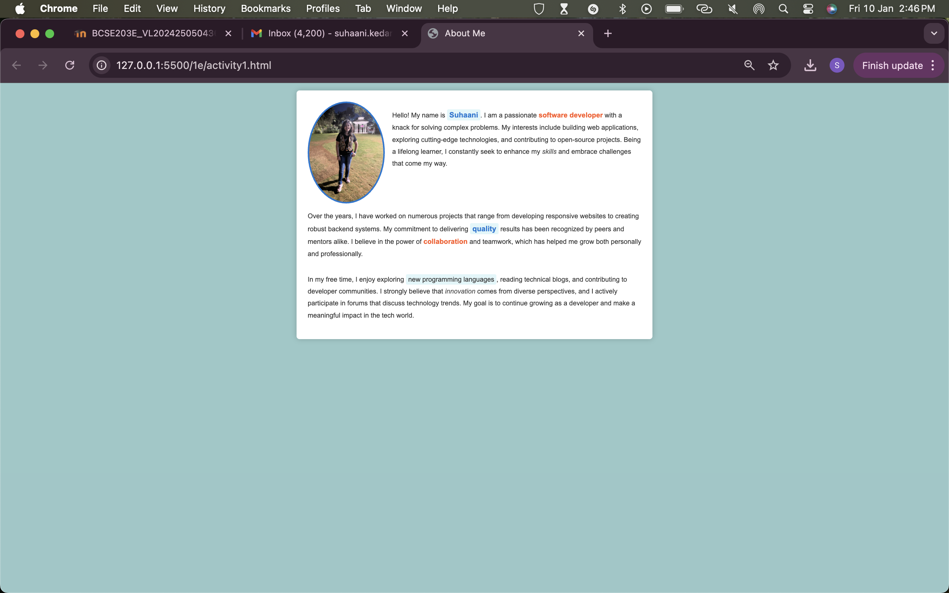

<!DOCTYPE html>

<html lang="en">

<head>

<meta charset="UTF-8">

<meta name="viewport" content="width=device-width, initial-scale=1.0">

<title>About Me</title>

<style>

body {

font-family: Arial, sans-serif;

line-height: 1.8;

background-color: #98c8c8;

color: #333;

margin: 20px;

font-size: 18px; /* Increased font size */

}

.container {

display: flex;

flex-direction: column;

align-items: flex-start;

max-width: 900px; /* Adjusted for larger content */

margin: auto;

background-color: #ffffff;

padding: 30px;

border-radius: 8px;

box-shadow: 0 0 15px rgba(0, 0, 0, 0.2);

}

.image {

float: left;

margin-right: 20px;

width: 200px; /* Increased image size */

border-radius: 50%;

border: 4px solid #0078d4;

}

.highlight {

font-weight: bold;

color: #0078d4;

font-size: 20px; /* Slightly larger for emphasis */

}

strong {

color: #ff5722;

font-size: 19px; /* Larger for visibility */

}

em {

font-style: italic;

color: #555;

font-size: 18px; /* Match text size */

}

span {

background-color: #e0f7fa;

padding: 4px 6px;

border-radius: 4px;

font-size: 18px; /* Match text size */

}

</style>

</head>

<body>

<div class="container">

<div>

<img src="profile.jpg" alt="My Image" class="image">

<p>

Hello! My name is <span class="highlight">Suhaani</span>. I am a passionate <strong>software developer</strong> with a knack for solving complex problems. My interests include building web applications, exploring cutting-edge technologies, and contributing to open-source projects. Being a lifelong learner, I constantly seek to enhance my <em>skills</em> and embrace challenges that come my way.

</p>

</div>

<p>

Over the years, I have worked on numerous projects that range from developing responsive websites to creating robust backend systems. My commitment to delivering <span class="highlight">quality</span> results has been recognized by peers and mentors alike. I believe in the power of <strong>collaboration</strong> and teamwork, which has helped me grow both personally and professionally.

</p>

<p>

In my free time, I enjoy exploring <span>new programming languages</span>, reading technical blogs, and contributing to developer communities. I strongly believe that <em>innovation</em> comes from diverse perspectives, and I actively participate in forums that discuss technology trends. My goal is to continue growing as a developer and make a meaningful impact in the tech world.

</p>

</div>

</body>

</html>

**Activity 2:**

* Create a GitHub repository and upload all your web pages.
* Prepare a video report about **Hosting Website** on **GitHub (Max 3 Mins)**

Note: Use the video in the **Activity 3** and embed the same in your blog page

**Activity 3: Semantic html**

Design a web page of your choice “*myindex.html*” and include the following information as follows.

* Home Page - Short Descriptions about your theme.
* Navigation page- include all the activity listed as per module 2 (all html documents)
* Blog Page – Photos/ videos/ hyperlinks
* Contact us – Use your intuitive approach and add the form fields for a contact us page in the footer.

**Note: Choose the layout design of your choice**

|  |  |
| --- | --- |
| <Header> | |
| <Navigation > | |
| <article >  <section> | <aside> |
| <footer> | |

**Evaluation Scheme:**

|  |  |
| --- | --- |
| **Description** | **Marks** |
| Design and Creativity | 3 |
| Usage of HTML elements and attribute | 3 |
| Video Creation | 2 |
| Output | 2 |
| Total | 10 |