**INTRODUCTION TO PROJECT**

Eating a home cooked meal is one of the pleasures of the world, but having it cooked is one of the biggest nightmares one is bound to experience. Sometimes you will want to sit on your couch and enjoy a simple or even complex warm cooked meal without the hustle of lifting a finger to cook it yourself and without the worry of having to wash dishes and cleaning up after. With the economy on a dip people often have to work extra hours or extra shifts to make ends meet and by doing so leave no time to cook and enjoy their home-cooked meal. Hiring a chef or a house-help that can always be at home to cook has become a luxury that is no longer affordable making pizza and Chinese take outs the only viable meal for individuals after having a long day at work.

**TECHNOLOGY**

1. **HTML**

HTML is a hypertext markup language. The word markup was used by editors who marked up manuscripts (usually with a blue pencil) when giving instructions for revisions. "Markup" now means something slightly different: a language with specific syntax that instructs a Web browser how to display a page.

Once again, HTML separates "content" (words, images, audio, video, and so on) from "presentation" (instructions for displaying each type of content). HTML uses a pre-defined set of elements to define content types. Elements contain one or more "tags" that contain or express content. Tags are enclosed by angle brackets, and the closing tag begins with a forward slash.

Tim Berners-Lee, physicist at CERN (the European Organization for Nuclear Research), devised a way in the late 1980s for scientists to share documents over the Internet. Before that, Internet communication had been limited to plain text, using technologies such as email, FTP (File Transfer Protocol), and Usenet-based discussion boards. HTML used a content model stored on a central server but transferrable to a local workstation and viewable in a browser, simplifying access to content and making "rich" content possible (such as sophisticated text formatting and images). HTML is derived from SGML, which is a complex syntax for marking up or binding of content (text or graphics) in documents; as of HTML5, HTML no longer attempts to adhere to SGML syntax.

1. **JavaScript**

JavaScript only execute on the page(s) that are on your browser window at any set time. When the user stops viewing that page, any scripts that were running on it are immediately stopped. The only exceptions are cookies or various client side storage APIs, which can be used by many pages to store and pass information between them, even after the pages have been closed.

JavaScript is a programming language that can be included on web pages to make them more interactive. You can use it to check or modify the contents of forms, change images, open new windows and write dynamic page content. You can even use it with CSS to make DHTML (Dynamic Hyper Text Markup Language).

JavaScript is a client side, interpreted, object oriented, high level scripting language, while Java is a client side, compiled, object oriented high level language. Now after that mouthful, here's what it.

1. **CSS**

CSS stands for Cascading Style Sheets.CSS describes how HTML elements are to be displayed on screen, paper or in to other media.CSS saves a lot of work. It can control the layout of multiple web pages all at ones. External style sheets are stored in CSS files.CSS is a style sheet used to define styles for your web pages.

The most common way to add styling is to keep the style in separate CSS files.CSS is a style sheet language used for describing the presentation of the document written in markup language. CSS describes how elements must be rendered on screen, on paper, on in other media. The style defines are normally saved in external.css files.

**EXISTING SYSTEM**

Throughout the system analysis, an in-depth, study of end-user information is conducted, for producing functional requirement of the proposed system. Data about the existing ordering system is collected through several fact-finding techniques such as website visit and document review, at the beginning of this stage. The data collected facilities information required during detailed analysis. A study on the current system is performed based on the collected data. As a result, user requirement of the proposed system is determined. At the end of this stage, requirement specification is produced as deliverable. The existing system happens to be a non-computerized operating system were all operations are done manually by the waiter carrying paper and to take down the order of the customer or making an order over the counter. This leads to mistakes because the waiter might not understand what the customer had ordered therefore serving him/her a different menu. This could be so embarrassing because the customer might not take it lightly with the waiter which may lead to misunderstanding.

**Fast Food Disadvantages**

**Obesity**

One of the most obvious fast food disadvantages is obesity. Obesity is a common medical condition in most countries with a fast food culture. The high levels of sugar and fat in fast food can lead to an increased risk of obesity. Studies show that over the past twenty years, the number of obese children has doubled and the number of obese teens has tripled. This is because of the high-calorie contents of fast food. Extra sugar and food dye are put into fast food to make it more appealing. These addicting ingredients contribute to the increasing number of obesity cases. Obesity is not only bad for your physical appearance, it can also lead to health problems including heart disease and reduced life expectancy.

**Unhealthy Food Choice**

Even though many fast food joints are now offering healthier food choices, most of the fast food is still quite unhealthy. In addition to the fast food disadvantages, is the fact that fast food ingredients are mostly artificial? They are high in sugar and fat and are not meant to be eaten on a regular basis. Consuming these ingredients regularly can lead to health issues including heart disease, diabetes, and cancers.

**Kidney and Cardiovascular Diseases**

Most fast foods like French fries, burgers, pizzas have high salt and cholesterol content which when consumed excessively can cause problems with kidney or cardiovascular system. High levels of sodium from fast food will increase your blood pressure, which can also increase the risk of heart attack or stroke over time. Cholesterol can also clog the arteries, increasing the risk of having a heart attack or stroke. In addition, the high level of salt in fast food contributes to the probability of developing kidney diseases.

**Adverse Effects of Additives and Preservatives**

Most fast food products contain food additives and preservatives. A lot of these additives and preservatives are harmful to the human body.  Some of the preservatives have been known to contain carcinogenic materials which can cause cell damage and may lead to certain types of cancer if taken in excessive amount or frequency.

**Effects to the Environment**

To add to the list of fast food disadvantages is the effects of fast food on the environment. The production and selling of junk food put a significant negative impact on the environment. The environmental consequences are another rather large disadvantage of fast food that one has to consider. Excess packaging, excess processing of food, not to mention the chemical waste that occurs, not only from the preservatives for the fast food but also from the factory farms that house the millions of chickens and cows used in fast food production.

Overall, disadvantages of fast food are now beginning to outweigh the convenience it offers. Fast food may be the fastest way to satisfy your hunger, but it is not healthy at all. Fast food is now a fast way to increase your risk of heart attacks and other health-related issues, including cancer. You should learn to choose fast food carefully and limit your intake. So before you go order a happy meal, take a moment to think about the bigger consequences.

**NEED AND SCOPE**

1. **You Need a Digital Business Card**

Americans spend, on average, 23.6 hours online each week and nearly 5 hours every day on their mobile devices. So, if you want to be discovered where people are spending their time, it’s essential to have accurate information about your company accessible in that space.

A website acts like a digital business card for a company: people can reference it again and again for things like contact information, names of employees, services offered and more.

1. **You Need to Be Discoverable in Search Engine Results**

People don’t just browse the Internet to discover companies they want to do businesses with; more specifically, they visit search engines. 93% of online experiences start with a search engine. And nearly half of these searches are for local businesses.

So, you need to have a search-optimized company website that can rank well in search engine results. This will ensure consumers are able to find, and connect with, your business.

1. **It Can Help You Build Credibility**

When it comes to convincing consumers to buy, first impressions are important. Fifty-seven percent of people won’t recommend a business with a poorly designed mobile site. That’s right consumers make judgments about your business based on the appearance of your website.

Having a professionally designed, thorough and easy-to-use website can help you to more easily convey to potential customers that you are a reputable organization, one they want to do business with.

1. **SEO Is a Cost Effective Marketing Strategy**

Every company wants to optimize the dollars in their budget, ultimately getting the most amount of bang for the least amount of buck. When it comes to marketing, having a website that is optimized for search can be one of the most cost-effective marketing strategies.

Are you thinking about tackling SEO yourself? We wouldn’t suggest it, after all you have a business to run. But there are some basic tactics that you can take to position yourself to be discovered through search.

1. **Google Ranks Local Businesses Higher When Searchers Use Mobile Devices**

Google assumes that a user doing a search on their mobile phone is most likely on the go, and, in turn, looking for a business in close proximity. Thus, the search engine favors local businesses when people do mobile searches.

Having a company website that is optimized for mobile gives you the chance to take advantage of Google’s preferential treatment and appear higher up on the results page. This ups your chances of consumers discovering your company in the moment that they’re looking for it and means they’re more likely to get in touch.

1. **Your Website Stays Open 24 Hours Per Day**

Unlike your business, which most likely does not operate or communicate with customers after-hours, your website stays open 24 hours per day, 7 days per week. This means that even when your staff is not available to interact with people looking to do business with you, your website is accessible and able to provide helpful information, serve as a point of contact or even allow customers to make purchases or submit orders.

1. **Your Competitors Probably Have One**

While 36 percent of small businesses don’t have their own website, 64 percent of them do. This means that the majority of small businesses DO have a presence online, and it’s likely that your competitors have a website that is appealing to people in your area.

If you want to stay relevant and competitive within your field, it’s important that your business have a footprint online it not only helps you stay competitive, but it also helps cement your role as a forward-thinking, tech-savvy business.

1. **It Can Help Your Business Grow**

If you’re hoping to expand your business and bring in new customers, having a website is an important strategy. Small businesses who’ve experimented with launching a website report being happy with their success. Surveys on small business’ websites show that 81 percent of companies that launched sites saw their business grow, and 97 percent of small business owners would recommend having a website to other small business owners.

1. **It Allows You to Hone Your Company’s Brand and Image**

A website is a good place to hone your brand using your specific aesthetic, vocabulary, and more it’s the ideal forum for you to shape the narrative about your company.

Social media pages (like Facebook) and peer review sites (like Yelp) on the other hand, allow your company’s image to be shaped via input from the public—this can be helpful but doesn’t always paint the picture you would prefer to see. By creating and managing your own company site and content, you get to paint the picture of your business.

**PROPOSED SYSTEM**

1. When you prepare your own meals, you have more control over the ingredients. By cooking for yourself, you can ensure that you and your family eat fresh, wholesome meals. This can help you to look and feel healthier, boost your energy, stabilize your weight and mood, and improve your sleep and resilience to stress. Saves money. Eating homemade foods is usually much cheaper than eating at a restaurant or buying processed foods from the market.
2. Saves time.
3. Healthier ingredients.
4. Avoid food allergies and sensitivities.
5. Portion control.
6. Brings family together.

A food is something that provides nutrients. Nutrients are substances that provide: energy for activity, growth, and all functions of the body such as breathing, digesting food, and keeping warm; materials for the growth and repair of the body, and for keeping the immune system healthy.

So here from our website anyone can **order traditional home made foods**. You don’t need to prepare the food also which will save your extra time.

As today everyone is accustomed to order food online from websites, our food website can be useful in that case.

**Scope of the website**

At Home Foods, we dream big. Our future plans, therefore, cover almost every area of our existence.

The other areas of future focus are our food range and geographical reach. We have concrete plans of bringing in various new food items into the market in near future. In addition, we are expanding our network and exploring new geographical areas.

The Proposed system is web based application. The computerized system records all information. This system is used by internet. All information is given through proposed system. In this project the user can gives the feedback to the system. Our system gets the information about various arts which is used in conducting people.

**Advantages of Proposed system**

1. User can choose best option for get knowledge.
2. The user can give the feedback to the system.
3. The information is available to be accessed by anyone, anywhere, anytime.
4. The information within a site can be quickly accessed.
5. The site can be updated to always provide the latest information

**Limitations of Proposed System**

1. Viewing problem

When technical issues occur system loss the opportunity to broadcast advertisements for their services .

1. Do not cover all the types that should be present for Art gallery
2. Threat to security level.

**REQUIREMENT GATHERING**

**Waterfall Model design**

Waterfall approach was first SDLC Model to be used widely in Software Engineering to ensure success of the project. In "The Waterfall" approach, the whole process of software development is divided into separate phases. In Waterfall model, typically, the outcome of one phase acts as the input for the next phase sequentially.

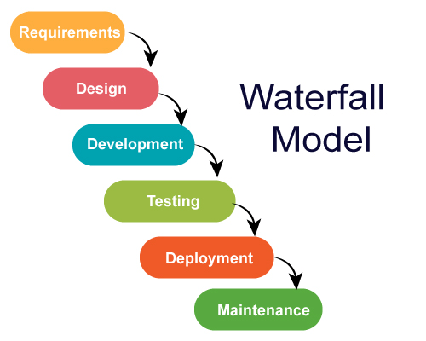

Fig. Waterfall model

**The sequential phases in Waterfall model are:**

1. **Requirement Gathering and analysis:** All possible requirements of the system tobe developed are captured in this phase and documented in a requirement specification doc.
2. **System Design:** The requirement specifications from first phase are studied in thisphase and system design is prepared. System Design helps in specifying hardware and system requirements and also helps in defining overall system architecture.
3. **Development:** With inputs from system design, the system is first developed insmall programs called units, which are integrated in the next phase. Each unit is developed and tested for its functionality which is referred to as Unit Testing.
4. **Testing:** All the units developed in the implementation phase areintegrated into a system after testing of each unit. Post integration the entire system is tested for any faults and failures.
5. **Deployment of system:** Once the functional and non-functional testing is done, theproduct is deployed in the customer environment or released into the market.
6. **Maintenance:** There are some issues which come up in the client environment. Tofix those issues patches are released. Also to enhance the product some better versions are released. Maintenance is done to deliver these changes in the customer environment.

**SYSTEM ANALYSIS**

**Site Map**

The following diagram shows layout of website

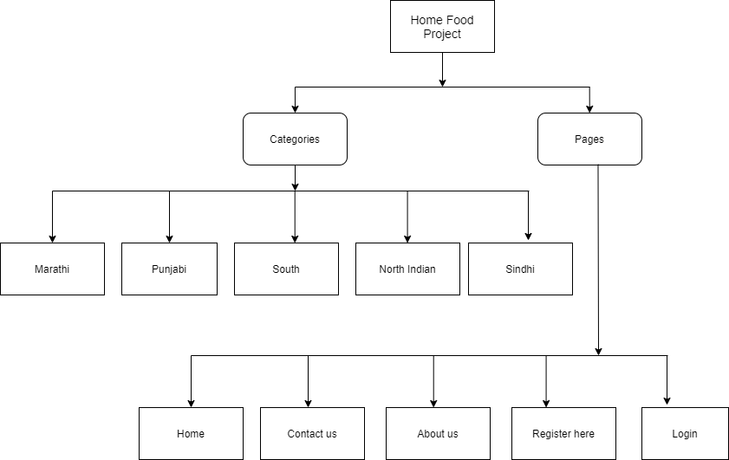

Fig SiteMap

**CODE**

**Home Page**

**index.html**

<html>

<head>

    <title> Home Foods</title>

    <link rel="stylesheet" type="" href="./assests/bootstrap.min.css">

    <link rel="stylesheet" type="" href="./assests/font-awesome.min.css">

    <script src="./assests/jquery-3.6.0.min.js"></script>

    <script src="./assests/bootstrap.min.js"></script>

    <link rel="stylesheet" type="" href="style/styles.css">

    <link rel="shortcut icon" href="image/lunch-box.png">

    <script>var $;</script>

</head>

<body class="w-1280">

    <div class="container">

        <a class="navbar-brand proj-title" href="#">Home Food Best Food</a>

    </div>

    <nav class="navbar navbar-default navbar-fixed-top" role="navigation">

        <a class="navbar-brand back-drop" href="index.html">Home Foods</a>

        <ul class="nav navbar-nav">

            <li class="back-drop">

                <a href="marathi.html">Marathi</a>

            </li>

            <li class="back-drop">

                <a href="punjabi.html">Punjabi</a>

            </li>

            <li class="back-drop">

                <a href="south.html">South</a>

            </li>

            <li class="back-drop">

                <a href="north.html">North Indidan</a>

            </li>

            <li class="back-drop">

                <a href="sindhi.html">Sindhi</a>

            </li>

            <!-- <li class="back-drop"><a href="brands.html">Categories</a></li> -->

        </ul>

        <ul class="nav navbar-nav" style="margin-right: 0%; float: right;">

            <li class="back-drop"><a href="contact.html">Contact Us</a></li>

            <li class="back-drop"><a href="about.html">About Us</a></li>

            <li class="back-drop"><a href="register.html">Register Here</a></li>

            <li class="back-drop"><a href="orders.html">Orders</a></li>

            <li class="back-drop" class="login-btn"><a href="login.html">Log In</a></li>

        </ul>

    </nav>

    <div class="h1">

        <h1>

            <marquee WIDTH=400 HEIGHT=50 BEHAVIOR=ALTERNATE>NEW ARRIVALS!! </marquee>

        </h1>

        <form action="marathi.html">

            <input class="ro-b" id="topimgmh1" type="image" width="500px" height="450px"

                src="image/maharashtra/modak1.webp" alt="Submit">

            <input class="ro-b" id="topimgmh2" type="image" width="500px" height="450px"

                src="image/maharashtra/pithale.jpg" alt="Submit">

        </form>

        <div class="h2">

            <form action="marathi.html">

                <input class="ro-b" type="image" width="500px" height="500px" src="image/maharashtra/thalipeeth.jpg"

                    alt="Submit" title="Eat marathi food!">

                <input class="ro-b" type="image" width="500px" height="500px" src="image/maharashtra/pav-bhaji.jpg"

                    alt="Submit" title="Eat marathi food!">

                <input class="ro-b" type="image" width="600px" height="500px"

                    src="image/maharashtra/sabudana-khichdi.jpg" alt="Submit" title="Eat marathi food!">

            </form>

        </div>

        <div class="h2">

            <form action="south.html">

                <input class="ro-b" type="image" width="500px" height="500px" src="image/south/akki-roti.jpg"

                    alt="Submit" title="Eat south food!">

                <input class="ro-b" type="image" width="500px" height="500px" src="image/south/dosa.jpeg" alt="Submit"

                    title="Eat south food!">

                <input class="ro-b" id="topimgst2" type="image" width="500px" height="500px"

                    src="image/south/holige.jpg" alt="Submit" title="Eat south food!">

            </form>

        </div>

    </div>

    <div class="h3">

        <h3> <br> Punjabi Food </br></h3>

        <form action="punjabi.html">

            <input class="ro-b" id="topimgpu3" width="1000px" type="image" src="image/punjabi/aloo-ka-parantha.jpg "

                alt="Submit" title="Eat punjabi food!">

            <input class="ro-b" width="1000px" type="image" src="image/punjabi/bharwa-bhindi.jpg" alt="Submit"

                title="Eat punjabi food!">

            <input class="ro-b" width="500px" height="450px" type="image" src="image/punjabi/dal-makhni.webp "

                alt="Submit" title="Eat punjabi food!">

            <input class="ro-b" width="500px" height="450px" type="image" src="image/punjabi/paneer-tikka.webp "

                alt="Submit" title="Eat punjabi food!">

        </form>

    </div>

    <div class="h4">

        <h4><br>

            <marquee WIDTH=1000 BEHAVIOR=ALTERNATE>

                <span style="color: #ff9900;">Tambda</span>

                <span style="color: #f3e3b0;">Pandhara</span>

                <span style="color: cadetblue;">Rassa</span>

            </marquee></br>

        </h4>

    </div>

    <form action="marathi.html">

        <input class="ro-b" type="image" class="w-99" src="image/thecha.png" alt="Submit"

            title="Eat marathi food!" />

    </form>

    <script src="scripts/slider.js"> </script>

    <div class="fix">

        <footer>

            <p>&copy; 2021 homefoods.com</p>

        </footer>

    </div>

</body>

</html>

**marathi.html**

<html>

<head>

    <title> Home Foods Marathi</title>

    <link rel="stylesheet" type="" href="./assests/bootstrap.min.css">

    <link rel="stylesheet" type="" href="./assests/font-awesome.min.css">

    <script src="./assests/jquery-3.6.0.min.js"></script>

    <script src="./assests/bootstrap.min.js"></script>

    <link rel="stylesheet" type="" href="style/styles.css">

    <link rel="shortcut icon" href="image/lunch-box.png">

    <script>var $;</script>

    <script src="scripts/orders.js"></script>

    <script src="scripts/load-images.js"></script>

</head>

<body class="w-1280">

    <div class="container">

        <a class="navbar-brand proj-title" href="#">Home Food Best Food</a>

    </div>

    <nav class="navbar navbar-default navbar-fixed-top" role="navigation">

        <a class="navbar-brand back-drop" href="index.html">Home Foods</a>

        <ul class="nav navbar-nav">

            <li class="back-drop">

                <a href="marathi.html">Marathi</a>

            </li>

            <li class="back-drop">

                <a href="punjabi.html">Punjabi</a>

            </li>

            <li class="back-drop">

                <a href="south.html">South</a>

            </li>

            <li class="back-drop">

                <a href="north.html">North Indidan</a>

            </li>

            <li class="back-drop">

                <a href="sindhi.html">Sindhi</a>

            </li>

            <!-- <li class="back-drop"><a href="brands.html">Categories</a></li> -->

        </ul>

        <ul class="nav navbar-nav" style="margin-right: 0%; float: right;">

            <li class="back-drop"><a href="contact.html">Contact Us</a></li>

            <li class="back-drop"><a href="about.html">About Us</a></li>

            <li class="back-drop"><a href="register.html">Register Here</a></li>

            <li class="back-drop"><a href="orders.html">Orders</a></li>

            <li class="back-drop" class="login-btn"><a href="login.html">Log In</a></li>

        </ul>

    </nav>

    <!--  -->

    <span id="appendHere"></span>

    <script>

        loadImages('maharashtra');

        $(document).ready(() => {

            if (localStorage.getItem('username')) {

                console.log($('.login-btn'));

            }

        });

    </script>

    <!--  -->

    <div class="fix">

        <footer>

            <p>&copy; 2021 homefoods.com </p>

        </footer>

    </div>

</body>

</html>

**Common style sheet**

**styles.css**

body {

    font-family: cursive;

    padding: 30px;

    /* width: 1500px; */

    text-align: center;

    background-color: #f7f2df;

}

.proj-title {

    margin: auto;

    font-size: 50px;

    text-decoration: underline;

}

.navbar {

    background-color: #f7f2df;

}

.navbar-nav {

    margin-right: auto;

    display: flex;

    flex-direction: row;

}

.navbar-nav a {

    color: green;

}

.navbar-brand {

    color: green;

}

.navbar-nav li {

    margin-right: 5px;

}

.back-drop {

    padding-right: 10px;

    padding-left: 10px;

    background-color: honeydew;

    border-radius: 50px;

}

.t-c {

    text-align: center;

}

.w-1280 {

    width: 1280px;

}

.ro-b {

    border-radius: 30px;

}

.food-list {

    display: inline-block;

    width: 40%;

}

.food-item-con {

    margin: 30px;

    /* display: flex;

    flex-direction: row; */

}

.food-image-con {

    border-radius: 10px;

    display: inline-block;

    box-shadow: 0 4px 8px 0 rgba(0, 0, 0, 0.2), 0 6px 20px 0 rgba(0, 0, 0, 0.19);

    height: 300px;

    width: 300px;

    overflow: hidden;

}

.food-image {

    border-radius: 10px;

    object-fit: fill;

    height: 300px;

    width: 300px;

}

.food-details {

    margin-left: 30px;

    display: flex;

    flex-direction: column;

}

.food-name {

}

.food-price {

}

.food-price .order-now {

}

.food-price .price {

}

.progress {

    margin-bottom: 5px;

    border-radius: 50px;

}

.progress-bar {

    background-color: greenyellow;

    text-align: left;

    justify-content: normal;

    border-radius: 50px;

}

.rating-desc .col-md-3 {

    padding-right: 0px;

}

.sr-only {

    color: indianred;

    font-size: 13px;

    margin-left: 10px;

    overflow: visible;

    clip: auto;

}

.contact-about-us {

    background-color: aliceblue;

    margin: auto;

    width: 350px;

    height: 350px;

    border-radius: 30px;

    box-shadow: 0 0 10px;

}

.login-form {

    margin: auto;

    background-color: azure;

    border-radius: 10px;

    padding: 10px;

}

.t-l {

    text-align: left;

}

.c-p {

    cursor: pointer;

}

/* orders */

.order-list {

    /* display: flex; */

    /* flex-direction: row;

    flex-wrap: wrap; */

    width: 100%;

    background-color: lavender;

}

.order-item-con {

    display: flex;

    flex-direction: row;

    margin: 30px;

    padding: 20px;

    justify-content: center;

}

.order-image-con {

    border-radius: 3px;

    /* display: inline-block; */

    box-shadow: 0 4px 8px 0 rgba(0, 0, 0, 0.2), 0 6px 20px 0 rgba(0, 0, 0, 0.19);

    height: 100px;

    width: 100px;

    overflow: hidden;

}

.order-image {

    border-radius: 3px;

    object-fit: fill;

    height: 100px;

    width: 100px;

}

.order-details {

    margin-left: 30px;

    /* display: inline-block; */

    /* flex-direction: column; */

}

.food-name {

}

.food-price {

}

.food-price .order-now {

}

.food-price .price {

}

**Scripts**

**load-images.js**

function loadImages(folderName) {

    let foods = products.filter((item) => item.category == folderName)

    let pName;

    for (let food of foods) {

        pName = getItemName(food.name);

        rating = getRating();

        ratPerc = (rating / 5) * 100;

        let eles = `

        <div class="food-list">

            <div class="food-item-con">

                <div class="food-image-con">

                    <img class="food-image" src="image/${folderName}/${food.name}" />

                </div>

                <div class="food-details">

                    <div class="food-name">

                        <span>${pName}</span>

                    </div>

                    <div class="food-price">

                        <span class="order-now c-p" onclick='addToCart(${JSON.stringify(food)})'> Order Now </span>

                        <span class="price">${food.price}/-</span>

                    </div>

                    <div>

                        <div class="progress progress-striped">

                            <div class="progress-bar progress-bar-success" role="progressbar" aria-valuenow="20"

                                aria-valuemin="0" aria-valuemax="100" style="width: ${ratPerc}%">

                                <span class="sr-only">Rating ${rating}</span>

                            </div>

                        </div>

                    </div>

                </div>

            </div>

        </div>

        `;

        $('#appendHere').append(eles);

    }

}

function getItemName(imageName) {

    return imageName.split('.')[0].split('-').map(e => e.charAt(0).toUpperCase() + e.substring(1)).join(' ');

}

function getRating() {

    let min = 4;

    let max = 5;

    return Math.round((Math.random() * (max - min) + min) * 10) / 10;

}

**login.js**

if (localStorage.getItem('username') && window.location.href.indexOf('login.html') != -1) {

    window.location = "index.html";

}

var creds = [

    { u: 'seema', p: 'seema' },

    { u: 'abhishek', p: 'abhishek' },

    { u: 'varsha', p: 'varsha' },

    { u: 'gauri', p: 'gauri' },

    { u: 'tanvi', p: 'tanvi' },

    { u: 'rohit', p: 'rohit' },

];

var maxTry = 3;

function validate() {

    const cred = { u: '', p: '' };

    cred.u = document.getElementById("username").value;

    cred.p = document.getElementById("password").value;

    if (cred.u == "") { alert("User Name Should not be empty"); return }

    if (cred.p == "") { alert("Password should not be empty"); return }

    if (creds.some((c) => c.u == cred.u && c.p == cred.p)) {

        document.getElementById("error").innerHTML = "Log in sucessfull";

        localStorage.setItem('username', cred.u);

        window.location = "index.html";

        return false;

    }

    else {

        maxTry--;

        document.getElementById("error").innerHTML = "<br>Incrorrect username or password" + "<br>You have left" + maxTry + " attempt.";

        if (maxTry == 0) {

            document.getElementById("username").disabled = true;

            document.getElementById("password").disabled = true;

            document.getElementById("submit").disabled = true;

            return false;

        }

    }

}

**IMPLEMENTATION**

**System Requirement**

**Hardware:**

* Monitor
* RAM=256MB
* Key board
* Mouse
* Hard disk=500GB
* CPU

**Software:**

* Internet Explorer
* Google chrome

**USER GUIDELINE**

When we open a website following menus are shown in every page of our web page:

* + Home
  + About us
  + Contact Us
  + Food Categories
  + Feedback

1. **Home:**

This is our main web page. Here we display detail information about home food menus online. You can go home page on clicking home menu

**2. About Us:**

In about us page, we are display information about our mission, vision, infrastructure & quality. You can go about us page on clicking about us menu.

**3. Contact Us:**

In contact page we can display information about the Name, Phone no, . You can go Contact us page on clicking Contact us menu.

**4. Food Menus:**

In food menu page we can display food menus which we provides to customer.

**OUTPUT**

**Login Page**

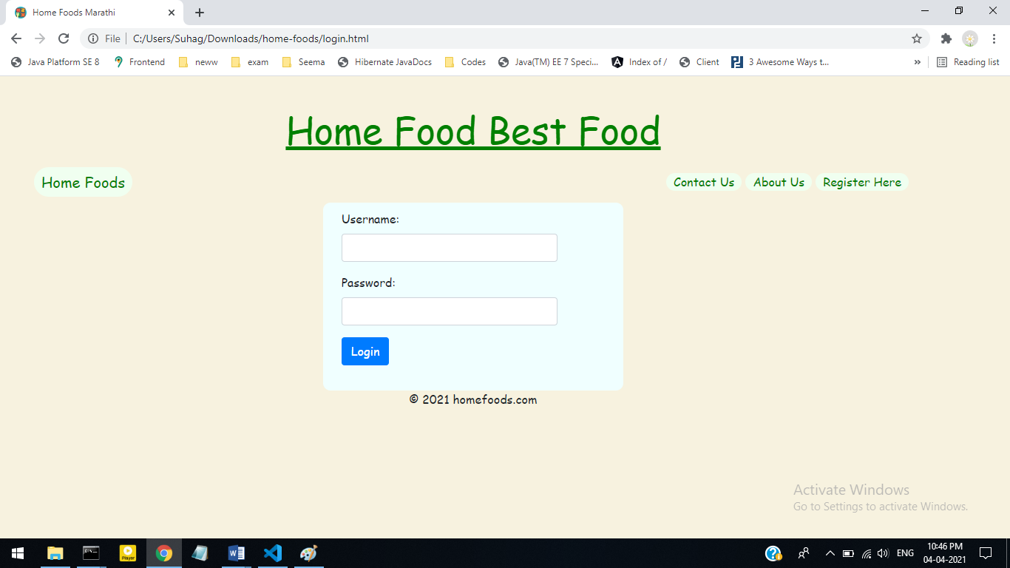

**Home page**

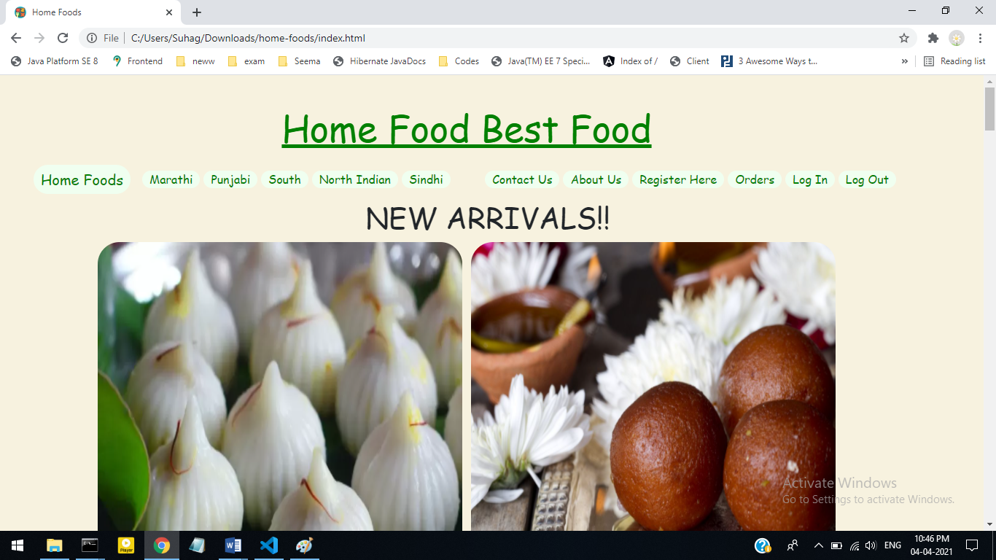

**Maharashtra food**

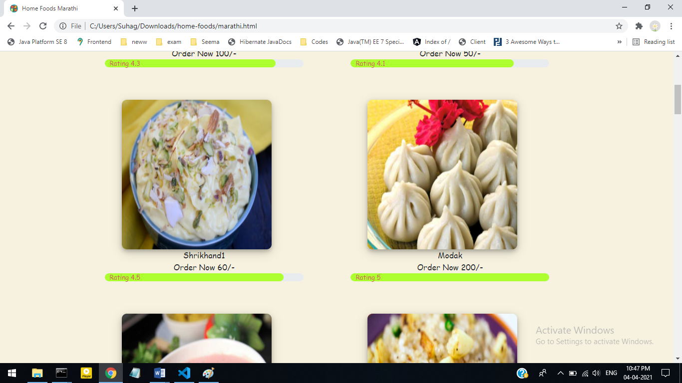

**Punjabi food**

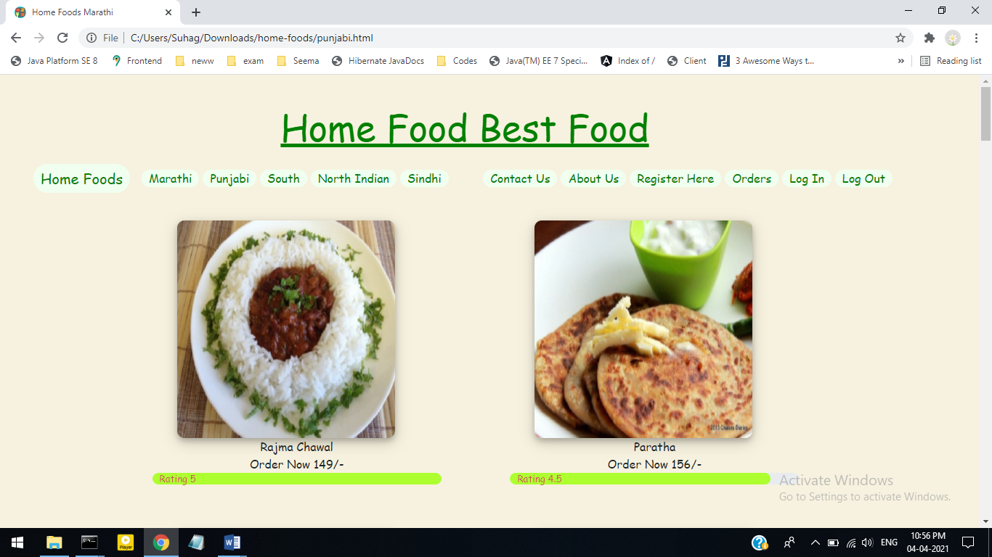

**About Us**

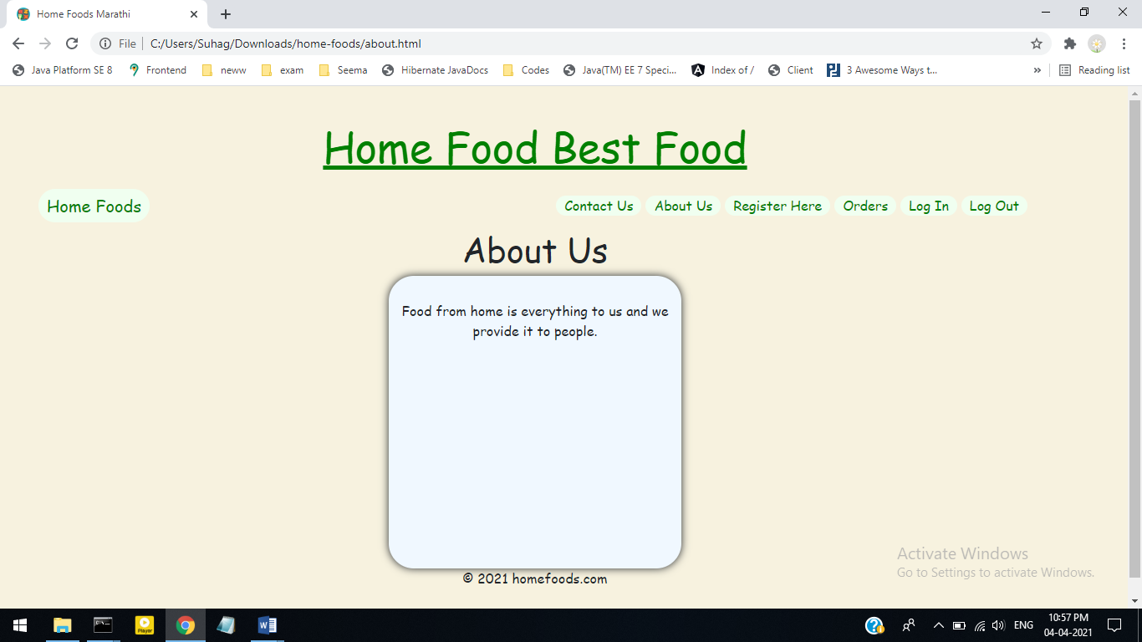

**Contact Us**

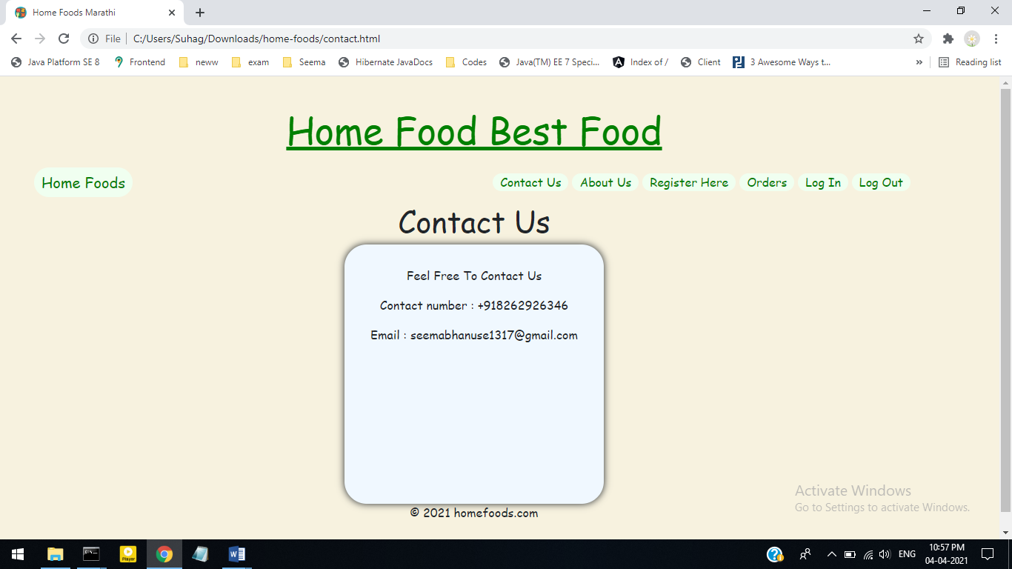

**CONCLUSION**

1. The present computerized system “Home Foods” is helpful for creating up to website through “Home Foods” information details. Through this information, user can easily choose the home made food to eat.
2. User can choose best option for get food. The project include all the information & description of the Home Foods.
3. As you can see, there are many possibilities for creating a website for yourself or someone else. No matter what your reason might be for creating a site, the objectives are essentially the same to share information and offer products, services.
4. The system satisfies most of its objectives.
5. It perform desired task with speed and accuracy.
6. It helps in managing the data in a much better way.
7. It helps in retrieving information more easily to many different users.
8. It provides more information to user with in short period.