**/*Roll No : 3001**

**Program Name : Write a program to demonstrate the view state,application**

**state,session state. */**

**Defualt.aspx :-**

<%@ Page Language="C#" AutoEventWireup="true" CodeFile="Default.aspx.cs" Inherits="_Default" %>

<!DOCTYPE html PUBLIC "-//W3C//DTD XHTML 1.0 Transitional//EN" "http://www.w3.org/TR/xhtml1/DTD/xhtml1-transitional.dtd">

<html xmlns="http://www.w3.org/1999/xhtml">

<head runat="server">

<title>Untitled Page</title>

</head>

<body>

<form id="form1" runat="server">

<div>

<span style="text-decoration:underline">view state</span><br/>

Enter your name:

<asp:TextBox ID="txtName" runat="server" />

<br/>

&nbsp;&nbsp;&nbsp;&nbsp;&nbsp;&nbsp;&nbsp;&nbsp;&nbsp;&nbsp;&nbsp;&nbsp;&nbsp;&nbsp;&nbsp;&nbsp;&nbsp;&nbsp;

<br/>

&nbsp;&nbsp;&nbsp;&nbsp;&nbsp;&nbsp;&nbsp;&nbsp;&nbsp;&nbsp;&nbsp;&nbsp;&nbsp;&nbsp;&nbsp;&nbsp;&nbsp;&nbsp;

<asp:Button ID="btnSubmit" Text="submit" OnClick="btnSubmit_Click" runat="server" />

<br />

<asp:Label ID="Label1" runat="server" Text="Label"></asp:Label><br />

&nbsp;

<br />

<br />

<br />

<span style="Text-decoration: underline"><strong>Application State<br />

<br />

</strong></span>Number of Last visits:

<asp:Label ID="Label2" runat="server" Text="Label"></asp:Label><br />

<br />

<br />

<strong><span style="text-decoration:underline">Session state <br />

</span></strong>

<br />

<asp:Label ID="Label3" runat="server" Text="Label"></asp:Label><br />

</div>

</form>

</body>

</html>

**Defualt.aspx.cs :-**

using System;

using System.Configuration;

using System.Data;

using System.Linq;

using System.Web;

using System.Web.Security;

using System.Web.UI;

using System.Web.UI.HtmlControls;

using System.Web.UI.WebControls;

using System.Web.UI.WebControls.WebParts;

using System.Xml.Linq;

public partial class _Default : System.Web.UI.Page

{

protected void Page_Load(object sender, EventArgs e)

{

Application["visits"] = (int)Application["visits"] + 1;

Label2.Text = Application["visits"].ToString();

Label3.Text = (string)Session["mytext"];

}

protected void btnSubmit_Click(object sender, EventArgs e)

{

string txtvalue = txtName.Text;

ViewState.Add("item", txtvalue);

string item = (string)ViewState["item"];

Label1.Text = item;

}

}

**Global .asax:-**

<%@ Application Language="C#" %>

<script runat="server">

void Application_Start(object sender, EventArgs e)

{

Application["visits"] = 0;

}

void Application_End(object sender, EventArgs e)

{

// Code that runs on application shutdown

}

void Application_Error(object sender, EventArgs e)

{

// Code that runs when an unhandled error occurs

}

void Session_Start(object sender, EventArgs e)

{

Session["mytext"] = "I am the user!!";

}

void Session_End(object sender, EventArgs e)

{

// Code that runs when a session ends.

// Note: The Session_End event is raised only when the sessionstate mode

// is set to InProc in the Web.config file. If session mode is set to StateServer

// or SQLServer, the event is not raised.

}

</script>

**Output:-**

**1}Starting Page:-**

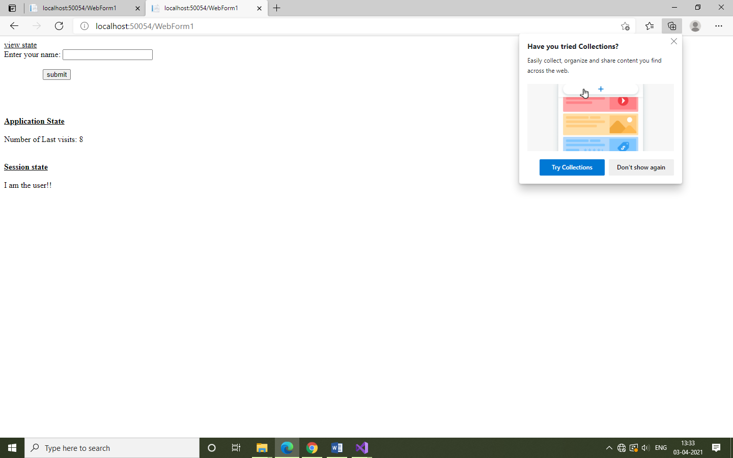

**2} Visited User :-**

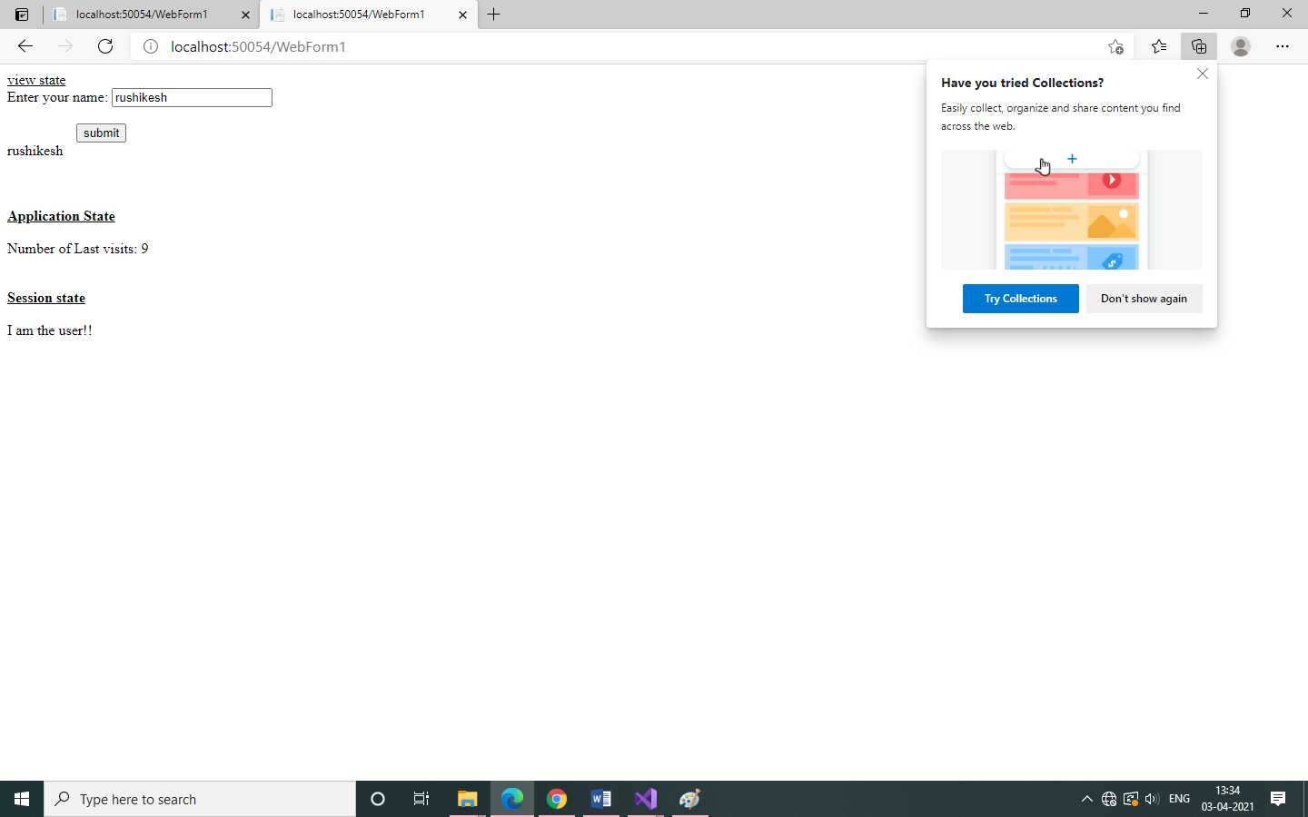

**/*Roll No : 3001**

**Program Name : Write a program to demonstrate the simple interest. */**

**Defualt.aspx :-**

<%@ Page Language="C#" AutoEventWireup="true" CodeFile="Default.aspx.cs" Inherits="_Default" %>

<!DOCTYPE html PUBLIC "-//W3C//DTD XHTML 1.0 Transitional//EN" "http://www.w3.org/TR/xhtml1/DTD/xhtml1-transitional.dtd">

<html xmlns="http://www.w3.org/1999/xhtml">

<head id="Head1" runat="server">

<title>Untitled Page</title>

</head>

<body>

<form id="form1" runat="server">

<div>

<asp:Label ID="Label1" runat="server" Text="Enter Amount:"></asp:Label>

<asp:TextBox ID="TextBox1" runat="server" ></asp:TextBox>

<br />

<asp:Label ID="Label2" runat="server" Text="Enter Rate:"></asp:Label>

<asp:TextBox ID="TextBox2" runat="server"></asp:TextBox>

<br />

<asp:Label ID="Label3" runat="server" Text="Enter Year:"></asp:Label>

<asp:TextBox ID="TextBox3" runat="server"></asp:TextBox>

<br />

<br />

<asp:Button ID="Button1" runat="server" Text="Simple Interest" OnClick="ButtonClick" />

<br />

<br />

<asp:Label ID="Label5" runat="server" Text="Simple Interest"></asp:Label>

<asp:TextBox ID="TextBox5" runat="server"></asp:TextBox>

</div>

</form>

</body>

</html>

**Defualt.aspx.cs :-**

using System;

using System.Configuration;

using System.Data;

using System.Linq;

using System.Web;

using System.Web.Security;

using System.Web.UI;

using System.Web.UI.HtmlControls;

using System.Web.UI.WebControls;

using System.Web.UI.WebControls.WebParts;

using System.Xml.Linq;

public partial class _Default : System.Web.UI.Page

{

protected void Page_Load(object sender, EventArgs e)

{

}

protected void ButtonClick(object sender, EventArgs e)

{

int a = Convert.ToInt32(TextBox1.Text);

int r = Convert.ToInt32(TextBox2.Text);

int n = Convert.ToInt32(TextBox3.Text);

int si = ((a * r * n) / 100);

TextBox5.Text = si.ToString();

}

}

**Output:-**

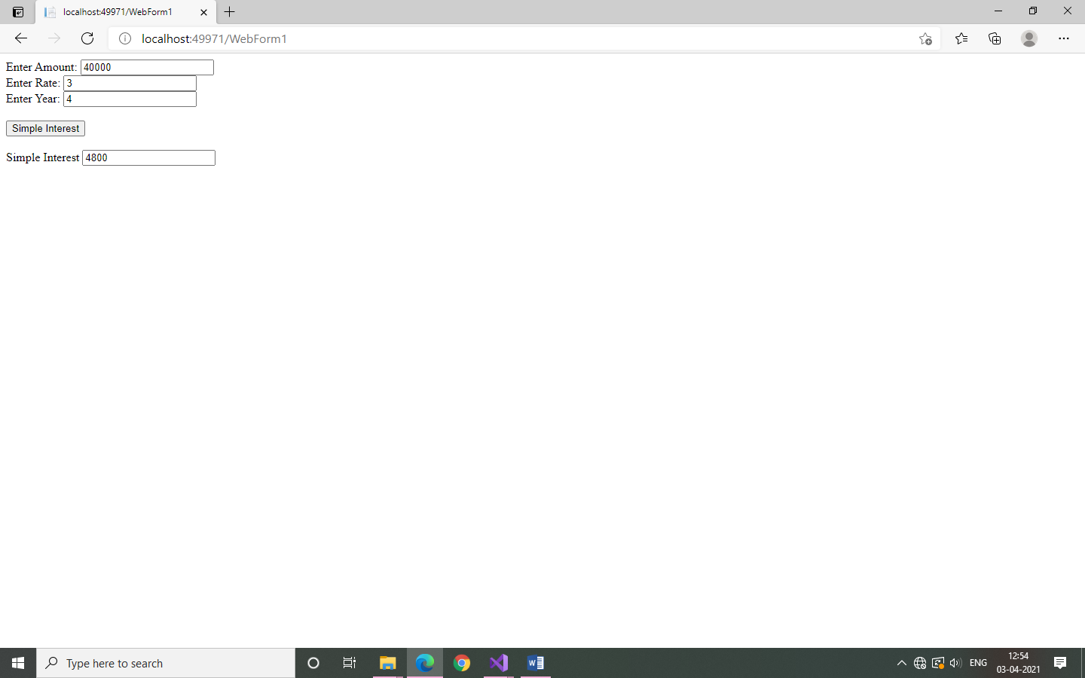

**/*Roll No : 3001**

**Program Name : Write a program to display the date & time */**

**Defualt.aspx :-**

<%@ Page Language="C#" AutoEventWireup="true" CodeFile="Default.aspx.cs" Inherits="_Default" %>

<!DOCTYPE html PUBLIC "-//W3C//DTD XHTML 1.0 Transitional//EN" "http://www.w3.org/TR/xhtml1/DTD/xhtml1-transitional.dtd">

<html xmlns="http://www.w3.org/1999/xhtml">

<head runat="server">

<title>Untitled Page</title>

</head>

<body>

<form id="form1" runat="server">

<div>

<asp:Label ID="Label2" runat="server" Text="This page exicuted on:"></asp:Label>

<asp:Label ID="Label1" runat="server" Text="Label"></asp:Label>

</div>

</form>

</body>

</html>

**Defualt.aspx.cs :-**

using System;

using System.Configuration;

using System.Data;

using System.Linq;

using System.Web;

using System.Web.Security;

using System.Web.UI;

using System.Web.UI.HtmlControls;

using System.Web.UI.WebControls;

using System.Web.UI.WebControls.WebParts;

using System.Xml.Linq;

public partial class _Default : System.Web.UI.Page

{

protected void Page_Load(object sender, EventArgs e)

{

Label1.Text = DateTime.Now.ToString();

}

}

**Output: 