Remindoo CRM
QA and product review report
Prepared for Waqas Sagar (owner, Remindoo.co) and the Remindoo development team
Testing date: 15 October 2026 | Environment: crm.remindoo.co (dummy account)

Before you read
This review was carried out on a dummy account. Some of the data seen during testing (clients, tasks, proposals, invoices and reminders) is test data, so a few counts and figures quoted here reflect that data rather than a real practice.
No load or stress testing was done on the live servers. Page timings in this report are what a single user experienced in the browser. They are indicative, not a performance benchmark.
Test records created during QA are listed in Appendix A so they can be removed.

How this review was done
The review looks at Remindoo from two angles: a QA engineer checking that each feature works, validates input and handles errors; and a UK chartered accountant asking whether the product supports the way a practice actually runs, including statutory deadlines, HMRC and Companies House data, and GDPR.
Testing covered a read-only tour of every screen, followed by hands-on tests in Leads, Proposals, Clients and onboarding, Companies House lookup, Tasks, Invoices, Documents, Emails, Knowledge Base, Financial Assistant, Dashboard and Settings. Each finding has an ID that is used throughout the report.

Severity scale
Severity | Meaning
Critical | Feature unusable, data or security exposure, or wrong output reaching clients. Fix now.
High | Wrong numbers, compliance risk or a core workflow broken. Fix in the next release.
Medium | Works, but with errors, poor validation or confusing behaviour. Schedule soon.
Low | Cosmetic or minor friction. Batch into a polish sprint.

Contents
1. Executive summary
2. Severity-ranked fix list
3. Module-by-module review
4. The accountant's view: compliance gaps
5. What to build on top: the AI layer roadmap
Appendix A. QA test records to clean up

1. Executive summary
Overall verdict: strong breadth, not yet dependable. Remindoo already covers most of what a UK practice needs in one place: leads to proposals to clients, Companies House import, accurate SA and CT deadlines, task checklists and timers, recurring work and VAT-correct invoices. The core task and invoice calculations held up well under test. However, three critical faults (exposed AWS details on every document upload, reminder emails sent to clients with "::Name::" in the subject, and a Financial Assistant that cannot be used) plus wrong dashboard KPIs, proposal pricing errors and 10-20 second page loads would quickly erode an accountant's trust. Fix the foundation first, then build the AI layer on top.
Findings by severity
Critical | High | Medium | Low | Total
3 | 26 | 40 | 13 | 82
Counts include missing features that matter to accountants (marked "Missing" in the fix list).
Top 10 fixes
# | Ref | Fix | Owner
1 | DOC-01 | Stop raw AWS S3 errors and fix uploads. Every upload fails and shows the AWS account ID, IAM user and bucket name. | Zain
2 | REM-01 | Block reminder emails with unfilled placeholders. Clients have already been sent "7th Reminder - ::Name:: ...". | Sami
3 | FA-01/02 | Make the Financial Assistant usable: the question box rejects input after a PDF, and CSVs return a raw OpenAI error. | Aftab
4 | IVC-01/02 | Remove duplicate recurring invoice schedules, stop paused schedules from billing, and create credit notes. | Aftab
5 | DSH-01/02 | Correct dashboard KPIs: 240% acceptance, 0% utilisation, £2,500 revenue vs £21k signed, completed tasks shown as overdue. | Hammad
6 | PRO-01-04 | Fix proposal pricing and templates: monthly fees counted as one-off, negative fees, PDF totals, wrong sole-trader wording and Harrods/Accotax footer. | Aftab / Umair
7 | GEN-01 | Speed: Clients, Tasks and Emails take 10-20 seconds to load. | Zain
8 | EML-01/02 | Show the email body when opened and fix AI Suggestion. | Sami
9 | CLI-01-06, 13 | Client tax data: UTR validation and checksum, SATR roll-forward, LOE date shift, negative fees, CT quarterly instalments, payments on account. | Abdul Rehman
10 | CH-01/02 | Companies House: show true status (Carillion shows Active while in Liquidation) and warn on overdue accounts and confirmation statements. | Abdul Rehman

2. Severity-ranked fix list
All 82 findings, ranked Critical to Low. Within each severity, items are grouped by module. "Missing" marks a feature gap rather than a defect. Owners are suggestions based on each team member's area.
Owners: Abdul Rehman (clients and Companies House), Sami (email and reminders), Hammad (dashboard), Muqaddas (frontend/UX), Aftab (invoices and integrations), Zain (backend performance and security), Umair (data and template cleanup).
ID | Module | Issue | Severity | Accountant / business impact | Owner
REM-01 | Reminders and automations | Planned Reminders sent with unfilled placeholder in subject: "7th Reminder - ::Name:: Personal Tax Return", marked Sent | Critical | Real clients receive broken emails under the practice's name; reputational damage and lost trust in automation | Sami
DOC-01 | Documents | Every upload fails with a raw AWS S3 AccessDenied error exposing AWS account ID, IAM user and bucket name | Critical | Document storage is unusable and internal infrastructure details are shown to any user | Zain
FA-01 | Financial Assistant | After a PDF is processed, the question box rejects all input | Critical | The feature cannot be used at all after upload | Aftab
GEN-01 | General | Slow page loads: Clients 10-20s, Tasks ~20s, Emails ~20s, Leads/Proposals 5-8s, dashboard tabs 3-5s | High | Staff lose minutes every hour; in deadline season this is the first thing users will complain about | Zain
REM-02 | Reminders and automations | Automation moves Archived leads back to New Lead after 1 hour | High | Dead or unsubscribed leads are re-contacted; possible GDPR/PECR complaints | Sami
DSH-01 | Dashboard | Proposal acceptance rate 240% (12 signed / 5 sent); leads 0 conversions but 54% rate; utilisation 0% despite logged time; client revenue £2,500 vs £21k signed | High | Owner cannot trust any headline KPI; management decisions made on wrong numbers | Hammad
DSH-02 | Dashboard | Overdue list includes a task that is Complete | High | Staff chase work already done; overdue figure overstated | Hammad
LEA-01 | Leads | Primary Contact panel shows the assigned staff member, not the lead | High | Emails and calls go to the wrong person; embarrassing with prospects | Abdul Rehman
PRO-01 | Proposals | Monthly fee added as a one-off; no annual value shown; recurring and one-off fees mixed in one total | High | Quotes understate annual fees (e.g. £150/month bookkeeping counted as £150); lost revenue or disputes | Aftab
PRO-02 | Proposals | Negative fee accepted | High | A proposal can go out with a credit instead of a fee | Aftab
PRO-03 | Proposals | PDF shows Total Exc. VAT before discount, no subtotal, yearly items under a "Fee/Month" column | High | The engagement document the client signs does not add up; weakens the contract | Aftab
PRO-04 | Proposals | Sole-trader template mentions Corporation Tax and obsolete P35/P14; footer carries Accotax/Harrods branding | High | Client-facing letter of engagement is technically wrong and carries another firm's branding | Umair
CH-01 | Companies House | Carillion PLC shows Active although it is in Liquidation | High | Practice may onboard or keep working for an insolvent company without noticing; AML and fee-recovery risk | Abdul Rehman
CH-02 | Companies House | No warnings for overdue accounts or confirmation statements | High | Misses the most valuable CH signal for an accountant: client already late | Abdul Rehman
CLI-01 | Clients | UTR field accepts letters; no UTR checksum | High | Invalid UTRs reach HMRC filings and agent authorisation requests | Abdul Rehman
CLI-02 | Clients | Letter of Engagement signed date saved one day early (timezone) | High | Engagement date on file is wrong; audit and professional-indemnity evidence weakened | Abdul Rehman
CLI-03 | Clients | CT payment date ignores quarterly instalment payments for large companies | High | Large-company clients get wrong payment reminders; interest exposure | Abdul Rehman
CLI-04 | Clients | Only one client-level fee; no fee per service | High | Cannot price or report profitability by service | Abdul Rehman
CLI-05 | Clients | Negative fee or hours silently saved as positive | High | Data changed without telling the user; fee records wrong | Abdul Rehman
CLI-06 | Clients | Next SATR date not editable, so the tax year cannot be rolled forward | High | Self Assessment cycle cannot move to next year without support help | Abdul Rehman
CLI-13 | Clients | Missing: payments on account (31 Jan / 31 Jul) | High | Core Self Assessment deadline not tracked; clients miss POA and pay interest | Abdul Rehman
IVC-01 | Invoices | Recurring schedules duplicated; a paused daily schedule raised 26 invoices | High | Double billing of clients; credit notes and apologies needed | Aftab
IVC-02 | Invoices | Credit of £100.60 applied but no credit note created | High | No audit trail for the reduction; VAT records incomplete | Aftab
IVC-03 | Invoices | Drafts tab does not filter | High | Draft and issued invoices mixed; risk of sending drafts | Aftab
IVC-04 | Invoices | Search by client name fails | High | Cannot find a client's invoices when they call about a bill | Aftab
DOC-02 | Documents | Double-clicking New Folder creates duplicate folders | High | Clients' files end up split across duplicate folders | Muqaddas
EML-01 | Emails | Email body not shown when an email is opened | High | The inbox cannot be used to read client emails | Sami
EML-02 | Emails | AI Suggestion fails: "Failed to retrieve email data" | High | Headline AI feature does not work | Sami
FA-02 | Financial Assistant | CSV upload rejected with a raw OpenAI error | High | Exposes the AI vendor and gives the user no way forward | Aftab
GEN-02 | General | Failed login shows no error message | Medium | Users cannot tell a wrong password from a system fault; more support calls | Muqaddas
GEN-03 | General | Employee role has 71 of 72 permissions | Medium | Junior staff can see or change almost everything; weak least-privilege control over client data | Zain
GEN-07 | General | AI sidebar says "connect a provider" while OpenAI is shown active in Settings | Medium | Users conclude the AI features are broken or not paid for | Aftab
DAT-01 | Data and templates | Duplicate service templates (CIS x3), duplicate client custom fields, "Service 1/2/3" placeholders, proposal categories all N/A | Medium | Messy setup for every new practice; wrong service picked, reporting split across duplicates | Umair
DSH-03 | Dashboard | Count mismatches: Tasks "All" 137 vs status chips summing to 234; leads table New 36 vs Kanban 30 | Medium | Undermines confidence in every count on screen | Hammad
DSH-04 | Dashboard | Duplicate ABC ABACUS tasks inflate overdue count | Medium | Overdue workload looks worse than it is | Hammad
DSH-05 | Dashboard | Task adherence and checklist metrics do not update after task activity | Medium | Performance reviews based on stale data | Hammad
DSH-07 | Dashboard | Missing: invoice and fee KPIs (billed, outstanding, WIP) | Medium | Owner has no cash view on the home screen | Hammad
LEA-02 | Leads | Notes display raw <p> HTML tags | Medium | Notes are hard to read and look broken | Muqaddas
LEA-03 | Leads | Notes modal X does not close; Save & Exit does not close the form | Medium | Users think the save failed and re-enter data | Muqaddas
LEA-04 | Leads | Negative turnover and invalid postcodes accepted; duplicate turnover fields | Medium | Bad data feeds proposals and fee quotes | Abdul Rehman
LEA-05 | Leads | Convert to Client has no confirmation; new client lands in Draft and is not searchable | Medium | Converted clients appear "lost"; risk of duplicate client records | Abdul Rehman
PRO-05 | Proposals | Discount larger than subtotal silently becomes 0 | Medium | User does not know the discount was dropped | Aftab
PRO-06 | Proposals | Proposal name locked to template; wrong error text shown | Medium | Hard to tell proposals apart; confusing validation | Muqaddas
PRO-07 | Proposals | Signature box overlaps the totals in the PDF | Medium | Totals unreadable on the signed copy | Muqaddas
PRO-08 | Proposals | BCC auto-filled with the client's email | Medium | Privacy risk and odd-looking emails; client sees themselves BCC'd | Sami
PRO-09 | Proposals | Missing: PDF download button | Medium | Accountant cannot save or attach the proposal outside Remindoo | Muqaddas
CH-03 | Companies House | Name search ~10s and 1 result per page | Medium | Slow onboarding of new companies | Abdul Rehman
CH-04 | Companies House | Dissolved companies greyed out with no reason; no PSC explanation | Medium | Users unsure why a company cannot be picked; PSC data unexplained for AML | Abdul Rehman
CH-05 | Companies House | Missing: automatic sync and change alerts | Medium | Officer, address and date changes at CH go unnoticed | Abdul Rehman
CLI-07 | Clients | NI number "XX123" truncated to "123" | Medium | Silent data loss on a key identifier | Abdul Rehman
CLI-08 | Clients | Marketing opt-in defaults to ON | Medium | Not valid consent under UK GDPR/PECR | Abdul Rehman
CLI-09 | Clients | Pending tasks shows 0 while 6 subtasks are open | Medium | Client looks up to date when it is not | Abdul Rehman
CLI-10 | Clients | Company UTR labelled "Personal UTR"; individual flow uses company wording and has no date of birth | Medium | Confusing for staff; DOB needed for ID/AML and HMRC | Muqaddas
CLI-11 | Clients | Duplicate client appears briefly after onboarding | Medium | Users may act on, or delete, the wrong record | Abdul Rehman
CLI-12 | Clients | No direct client URL (returns 404) | Medium | Cannot share or bookmark a client page with colleagues | Muqaddas
TSK-01 | Tasks | Timer can only be started inside a subtask; time differs between list and side panel | Medium | Time capture is awkward and inconsistent; WIP and billing disputes | Muqaddas
TSK-02 | Tasks | Task can be completed at 67% checklist with no warning | Medium | Work signed off with checklist steps still open; quality-control risk | Muqaddas
TSK-03 | Tasks | "All" count excludes completed tasks | Medium | Counts do not reconcile; users distrust the list | Hammad
TSK-04 | Tasks | External deadline not auto-filled from the service, despite help text saying it is | Medium | Statutory deadline can be missed if staff rely on the help text | Abdul Rehman
IVC-05 | Invoices | Inconsistent invoice numbering (INV-058, INV-1791590401656, INV-REC-...) | Medium | Non-sequential numbering is hard to defend in a VAT inspection | Aftab
IVC-06 | Invoices | HTML in item descriptions stripped silently | Medium | Invoice wording changes without warning | Aftab
IVC-07 | Invoices | Missing: VAT and invoice-numbering settings | Medium | Practice cannot set its own VAT defaults or number format | Aftab
IVC-08 | Invoices | To re-check: invoice lines possibly dropped on save | Medium | If confirmed, invoices under-bill; needs a focused retest | Aftab
DOC-03 | Documents | .exe files accepted despite the stated allowed types | Medium | Malware could be stored and shared with clients via the portal | Zain
DOC-04 | Documents | "Visible to client" ON by default; notification text persists between uploads | Medium | Internal working papers can be exposed to clients by accident | Muqaddas
EML-03 | Emails | Last sync 21 hours old; emails labelled "Unknown" | Medium | Client emails missed or not matched to the client | Sami
KB-01 | Knowledge Base | In-page search does not filter articles | Medium | Staff cannot find internal procedures | Muqaddas
FA-03 | Financial Assistant | Missing: general UK tax Q&A (allowances, thresholds, rates) | Medium | Assistant cannot answer the everyday questions accountants would ask first | Aftab
SET-01 | Settings and search | Global search is per-module only; invoice search for "QA Test" finds nothing | Medium | Users must know which module to search; slows everyday lookups | Muqaddas
GEN-04 | General | Pending invites shown as Active | Low | Owner cannot tell who has actually joined the practice account | Muqaddas
GEN-05 | General | Mixed US/UK date formats across the app | Low | Risk of misreading deadlines (e.g. 05/04 vs 04/05) in a deadline-driven product | Muqaddas
GEN-06 | General | Icon-only actions, 40+ client columns, row colours with no legend | Low | Steep learning curve; new staff guess what icons and colours mean | Muqaddas
DAT-02 | Data and templates | Typos in templates and UI: "Standardsss", "Statemnet", "Engagment", "Filling" | Low | Looks unprofessional in front of the accountant's own clients | Umair
DAT-03 | Data and templates | Campaigns section is empty | Low | Feature looks unfinished in demos | Umair
DSH-06 | Dashboard | Odd quick-metric deltas; revenue chart runs into future months | Low | Cosmetic, but adds to the sense numbers are unreliable | Hammad
LEA-06 | Leads | Created date shifted by timezone | Low | Lead age and response-time reporting slightly wrong | Abdul Rehman
PRO-10 | Proposals | Amounts like £2,520.6 (one decimal); US dates | Low | Looks unpolished on a client document | Muqaddas
TSK-05 | Tasks | Escape does not close popups; popups stack | Low | Minor friction | Muqaddas
TSK-06 | Tasks | "Weekly WIP" recurring template is actually monthly | Low | Recurring work generated at the wrong frequency | Umair
DOC-05 | Documents | Dialog stays open after action; US dates; rename hidden in Document Info | Low | Minor friction | Muqaddas
KB-02 | Knowledge Base | Typo in the Knowledge Base | Low | Cosmetic | Umair
SET-02 | Settings and search | Team member count reads "1 Members" | Low | Cosmetic | Muqaddas

Owner workload summary
Owner | Critical | High | Medium | Low | Total
Abdul Rehman | 0 | 10 | 10 | 1 | 21
Sami | 1 | 3 | 2 | 0 | 6
Hammad | 0 | 2 | 5 | 1 | 8
Muqaddas | 0 | 1 | 13 | 7 | 21
Aftab | 1 | 8 | 7 | 0 | 16
Zain | 1 | 1 | 2 | 0 | 4
Umair | 0 | 1 | 1 | 4 | 6

3. Module-by-module review
Each module lists what works, what is broken and what is missing. Finding IDs link back to the fix list.

3.1 Cross-cutting: performance, login, roles and data hygiene
Works
- Settings are organised into 15 logical sections.
Broken
- GEN-01 (High) Slow loads: Clients 10-20s, Tasks ~20s, Emails ~20s, Leads/Proposals 5-8s, dashboard tabs 3-5s.
- GEN-02 (Medium) Failed login shows no error message.
- GEN-03 (Medium) Employee role has 71 of 72 permissions.
- GEN-07 (Medium) AI sidebar asks to connect a provider while OpenAI is active in Settings.
- DAT-01 (Medium) Duplicate service templates (CIS x3), duplicate client custom fields, "Service 1/2/3" placeholders, proposal categories all N/A.
- GEN-04/05/06, DAT-02/03 (Low) Pending invites shown as Active; mixed US/UK dates; typos (Standardsss, Statemnet, Engagment, Filling); icon-only actions; 40+ client columns; row colours with no legend; Campaigns empty.
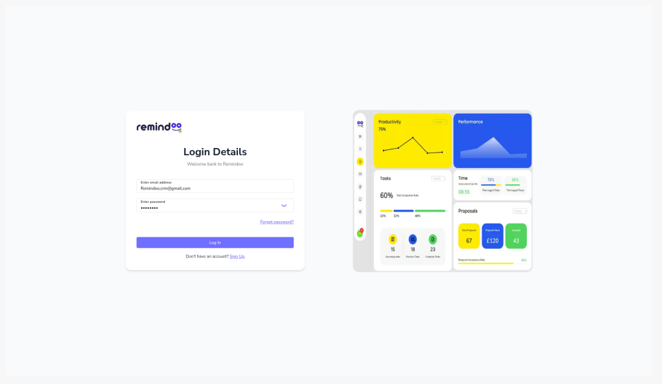
Figure 1: Failed login: no error message shown (GEN-02)

3.2 Reminders and automations
Works
- Planned Reminders log shows recipients, BCC, status and finish time for each email.
Broken
- REM-01 (Critical) Emails marked Sent with subject "7th Reminder - ::Name:: Personal Tax Return". The placeholder was never filled, so clients received it as written.
- REM-02 (High) An automation moves Archived leads back to New Lead after one hour.
Missing
- A send-time guard that blocks any email still containing "::" placeholders.
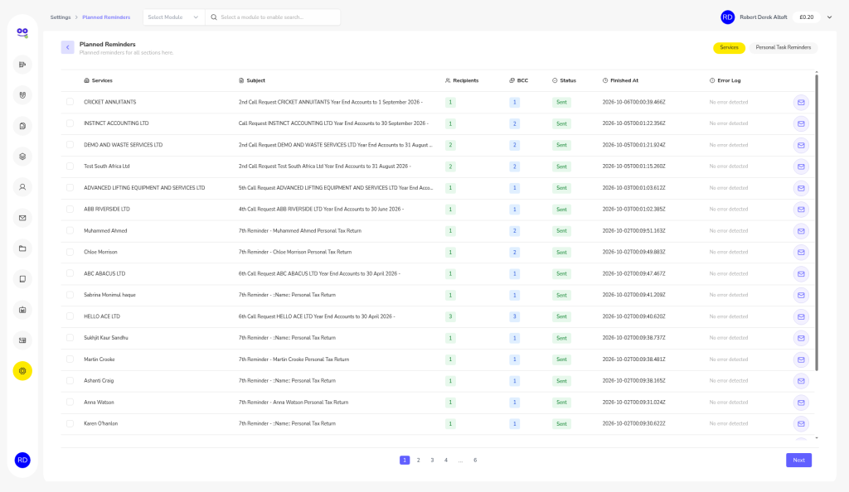
Figure 2: Planned Reminders: several "7th Reminder - ::Name:: Personal Tax Return" emails marked Sent (REM-01)
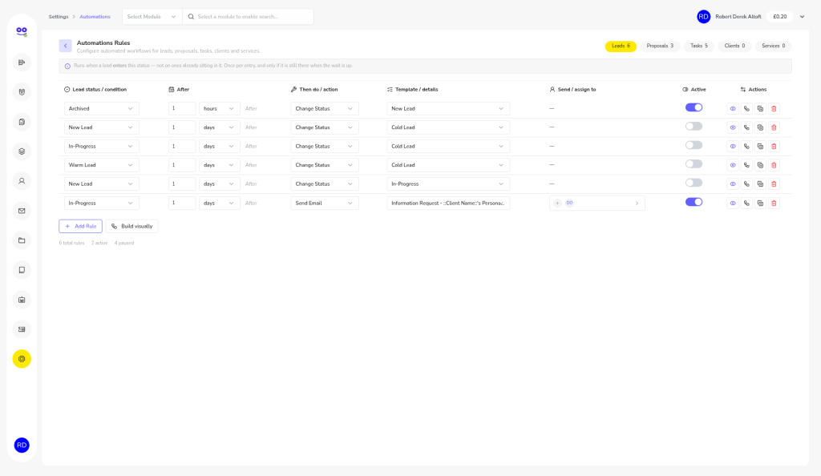
Figure 3: Automations, including the rule that re-opens archived leads (REM-02)

3.3 Dashboard
Works
- Service and status totals reconcile (53).
- VAT filter works.
- Overdue card count matches its list.
Broken
- DSH-01 (High) Proposal acceptance 240% (12 signed / 5 sent); leads show 0 conversions but a 54% rate; utilisation 0% despite logged time; client revenue £2,500 against £21k signed.
- DSH-02 (High) Overdue list includes a task marked Complete.
- DSH-03 (Medium) Tasks "All" 137 vs chips summing to 234; leads table New 36 vs Kanban 30.
- DSH-04 (Medium) Duplicate ABC ABACUS tasks inflate the overdue count.
- DSH-05 (Medium) Adherence and checklist metrics do not update after task activity.
- DSH-06 (Low) Odd quick-metric deltas; chart runs into future months.
Missing
- DSH-07 Invoice and fee KPIs.
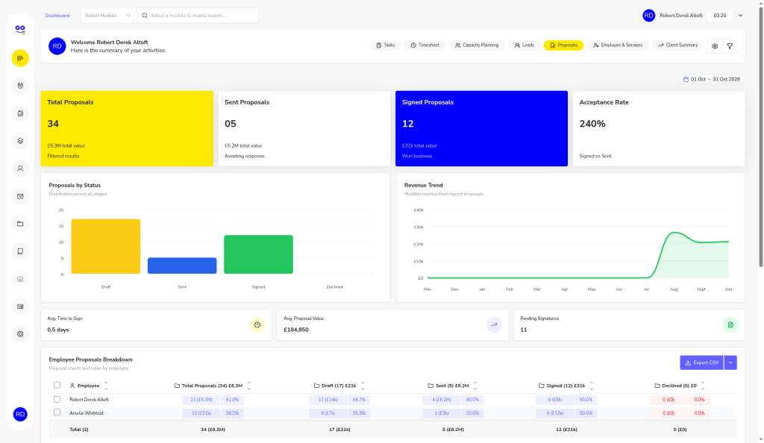
Figure 4: Proposals dashboard: 240% acceptance rate from 12 signed and 5 sent (DSH-01)
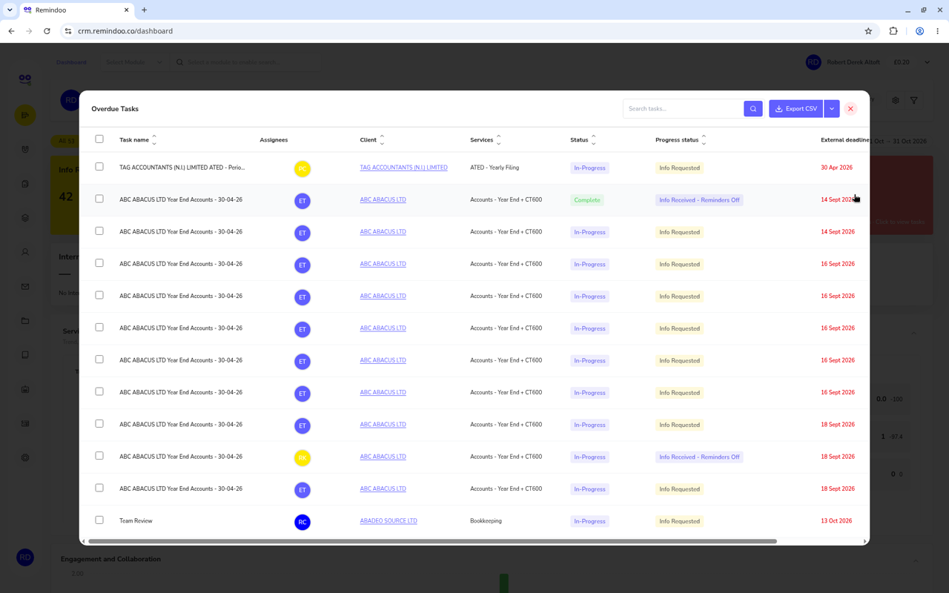
Figure 5: Overdue list includes a completed task (DSH-02)

3.4 Leads
Works
- Form validation.
- Timeline notes.
- Kanban drag-and-drop saves the new status.
- Conversion to client.
Broken
- LEA-01 (High) Primary Contact panel shows the assignee (Marcus Adeyemi) rather than the lead.
- LEA-02/03 (Medium) Notes show raw <p> HTML; notes modal X does not close; Save & Exit does not close.
- LEA-04 (Medium) Negative turnover and invalid postcode accepted; duplicate turnover fields.
- LEA-05 (Medium) Convert to Client has no confirmation; the client lands in Draft and is not searchable.
- LEA-06 (Low) Created date is timezone-shifted.
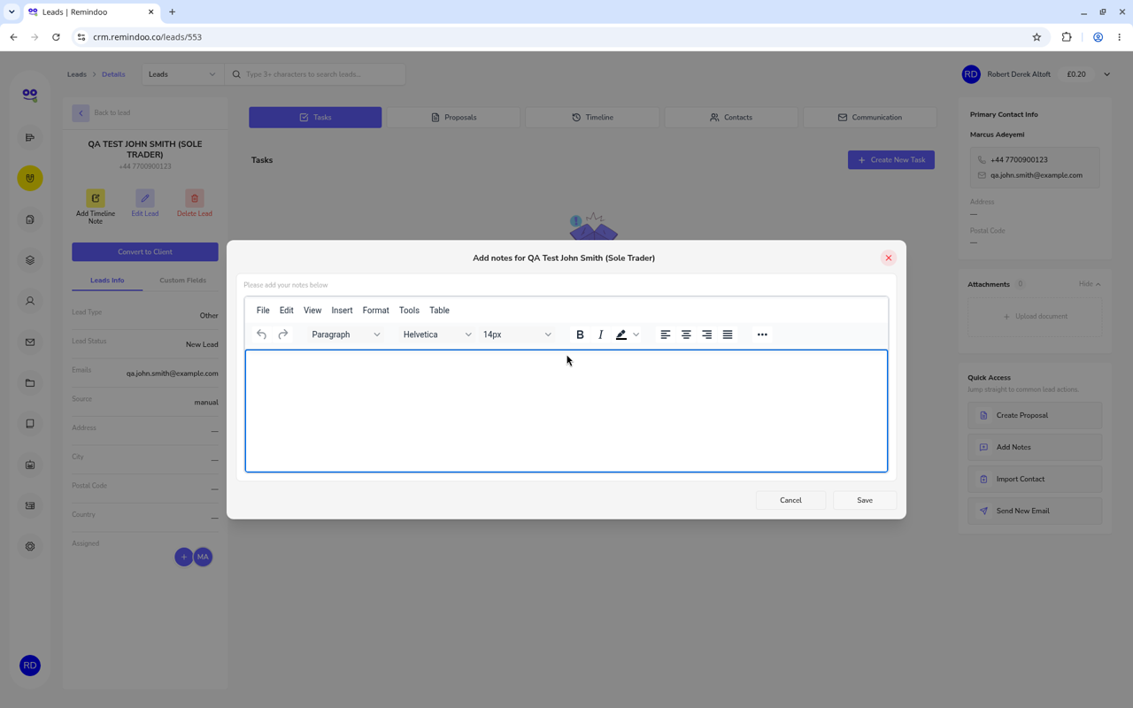
Figure 6: Lead "QA Test John Smith": Primary Contact shows the assigned staff member (LEA-01)

3.5 Proposals
Works
- VAT at 20% calculated correctly.
- Percentage discount applied.
- Preview renders.
Broken
- PRO-01 (High) Monthly fee added as a one-off; no annual value; recurring and one-off fees mixed in one total.
- PRO-02 (High) Negative fee accepted.
- PRO-03 (High) PDF shows Total Exc. VAT before discount, has no subtotal, and lists yearly items under "Fee/Month".
- PRO-04 (High) Sole-trader template mentions Corporation Tax and obsolete P35/P14 forms; footer carries Accotax/Harrods branding.
- PRO-05/06/07/08 (Medium) Discount above subtotal silently set to 0; name locked to template; wrong error text; signature box overlaps totals; BCC auto-filled with client email; typo.
- PRO-10 (Low) £2,520.6 shown with one decimal; US dates.
Missing
- PRO-09 PDF download button.
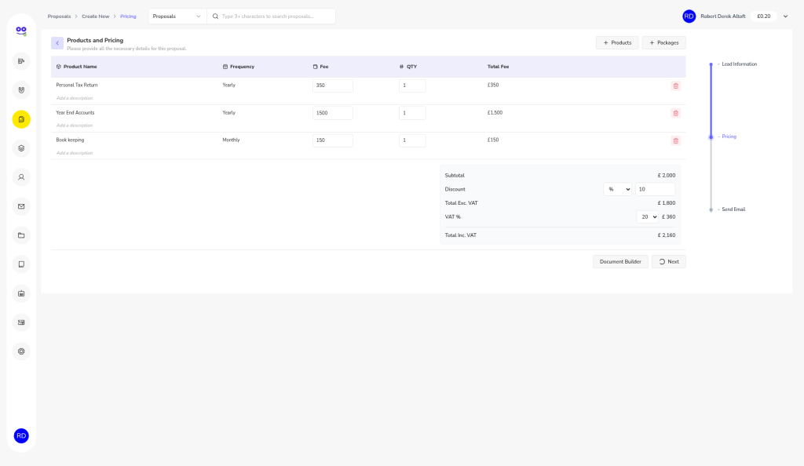
Figure 7: Pricing step: £150 monthly bookkeeping added to a one-off subtotal of £2,000 (PRO-01)
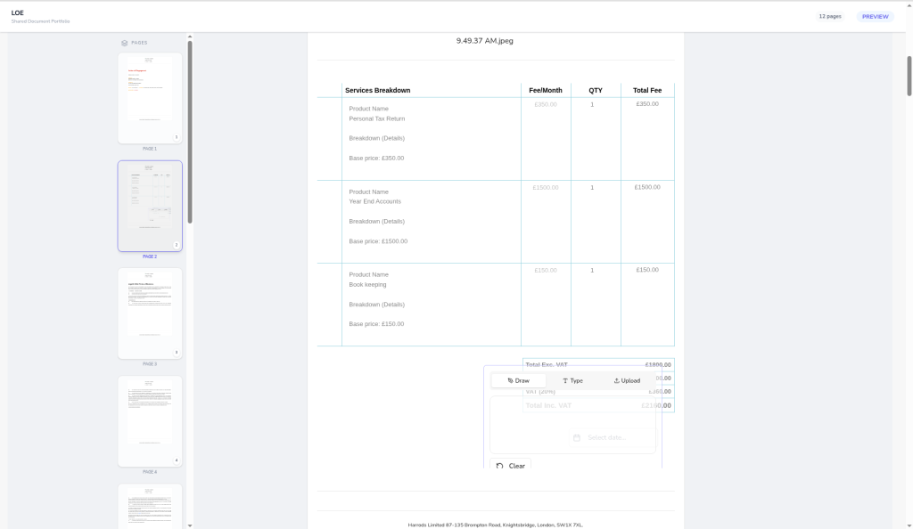
Figure 8: Proposal PDF: yearly fees under "Fee/Month", signature box over totals, Harrods footer (PRO-03, PRO-04, PRO-07)

3.6 Companies House
Works
- Lookup by company number and by name.
- Name, registered address, SIC codes, incorporation date, accounts and confirmation statement dates and officers all match Companies House.
Broken
- CH-01 (High) Carillion PLC shows Active although it is in Liquidation.
- CH-02 (High) No warnings for overdue accounts or confirmation statements.
- CH-03 (Medium) Name search takes about 10 seconds and shows one result per page.
- CH-04 (Medium) Dissolved companies greyed out with no reason; no PSC explanation.
Missing
- CH-05 Automatic sync and change alerts.
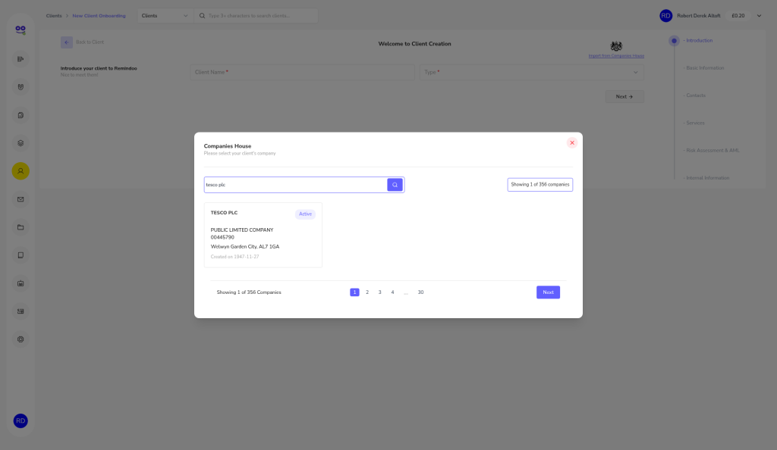
Figure 9: Companies House name search during onboarding (CH-03)

3.7 Clients and onboarding
Works
- CT600 filing and CT payment dates are correct for standard companies.
- Self Assessment deadlines correct: paper 31 October, online 31 January.
- AML questionnaire produces Low Risk as expected.
Broken
- CLI-01 (High) UTR accepts letters.
- CLI-02 (High) LOE signed date saved one day early (timezone).
- CLI-03 (High) CT payment ignores quarterly instalments for large companies.
- CLI-04 (High) Only one client-level fee; no fee per service.
- CLI-05 (High) Negative fee or hours saved as positive.
- CLI-06 (High) Next SATR date is read-only, so the year cannot be rolled forward.
- CLI-07/08/09 (Medium) NI "XX123" truncated to "123"; marketing opt-in default ON; pending tasks 0 while 6 subtasks are open.
- CLI-10/11/12 (Medium) Company UTR labelled Personal UTR; individual flow uses company wording and has no DOB; duplicate client briefly after onboarding; no direct client URL (404).
Missing
- CLI-13 Payments on account (31 January / 31 July).
- CLI-01 UTR checksum.
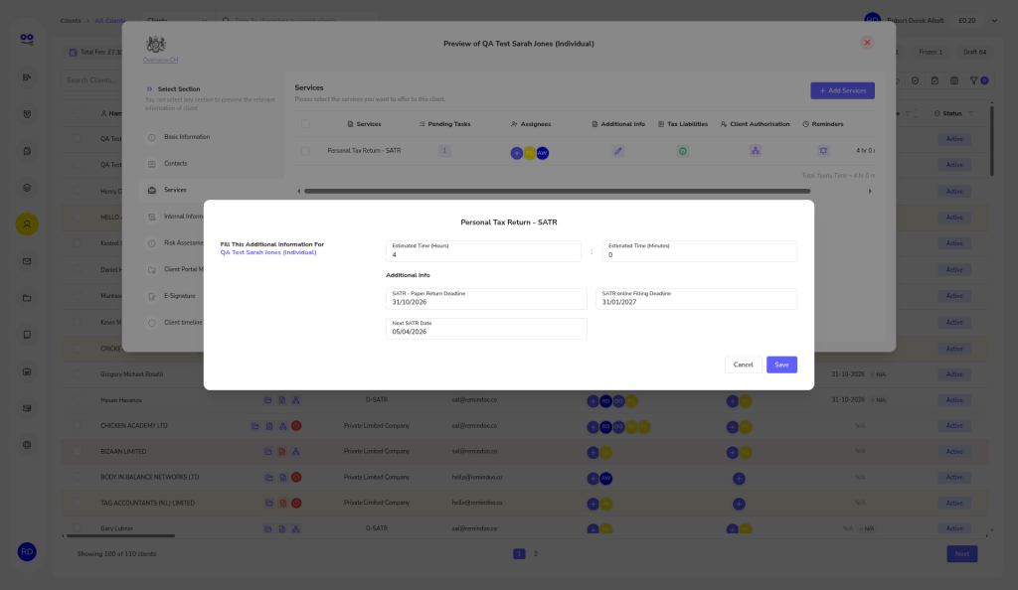
Figure 10: SATR dates: correct deadlines, but Next SATR Date cannot be edited (CLI-06)
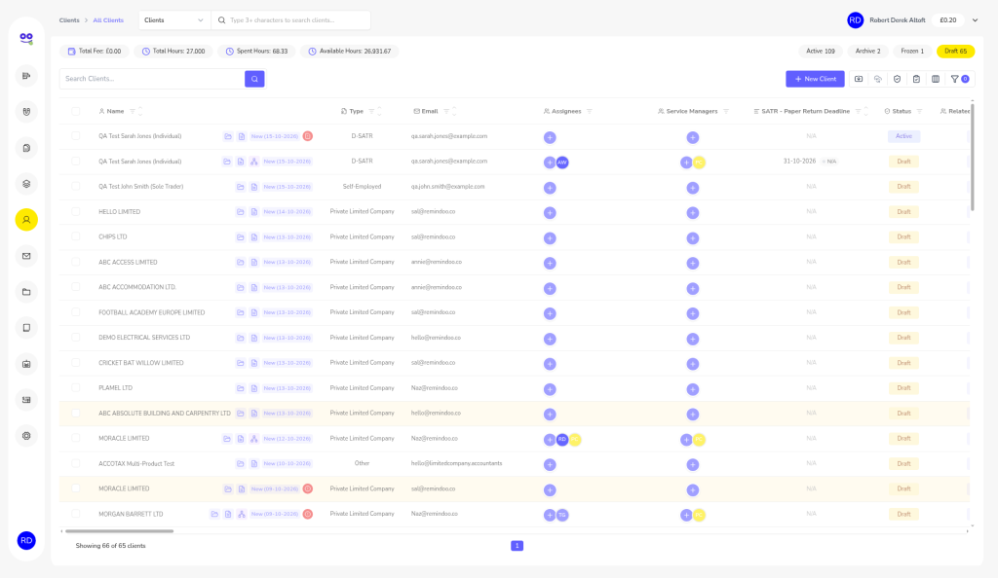
Figure 11: Duplicate client shown immediately after onboarding (CLI-11)

3.8 Tasks
Works
- Create task, with validation and past dates blocked.
- Timer logs time (1m 06s recorded).
- Comments.
- Checklist progress (67%).
- Status flow.
- Kanban view.
- Recurring task creation.
Broken
- TSK-01 (Medium) Timer only startable inside a subtask; time differs between list and panel.
- TSK-02 (Medium) Task can be completed at 67% checklist without a warning.
- TSK-03 (Medium) "All" count excludes completed tasks.
- TSK-04 (Medium) External deadline not auto-filled from the service, despite help text.
- Page load about 20 seconds (see GEN-01).
- TSK-05/06 (Low) Escape does not close popups, which stack; "Weekly WIP" recurring is monthly.
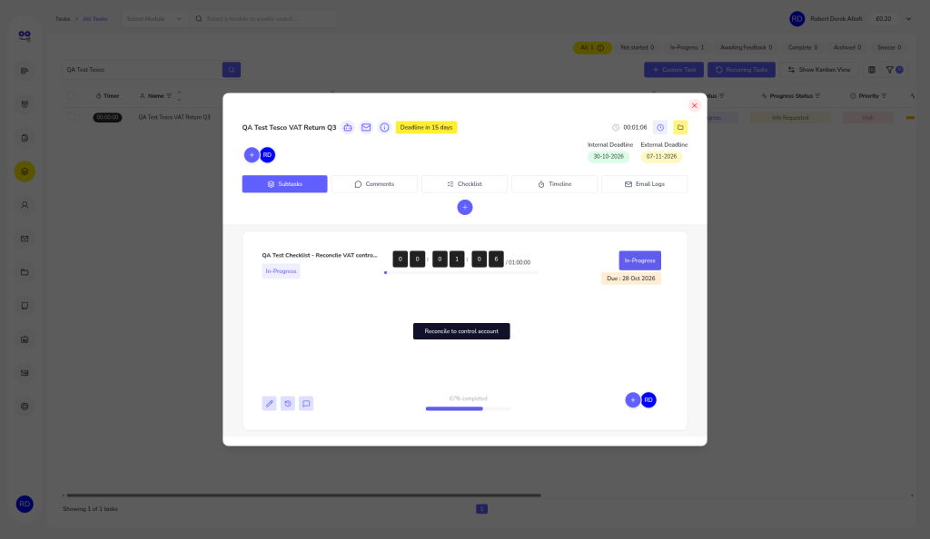
Figure 12: Checklist at 67% (TSK-02)
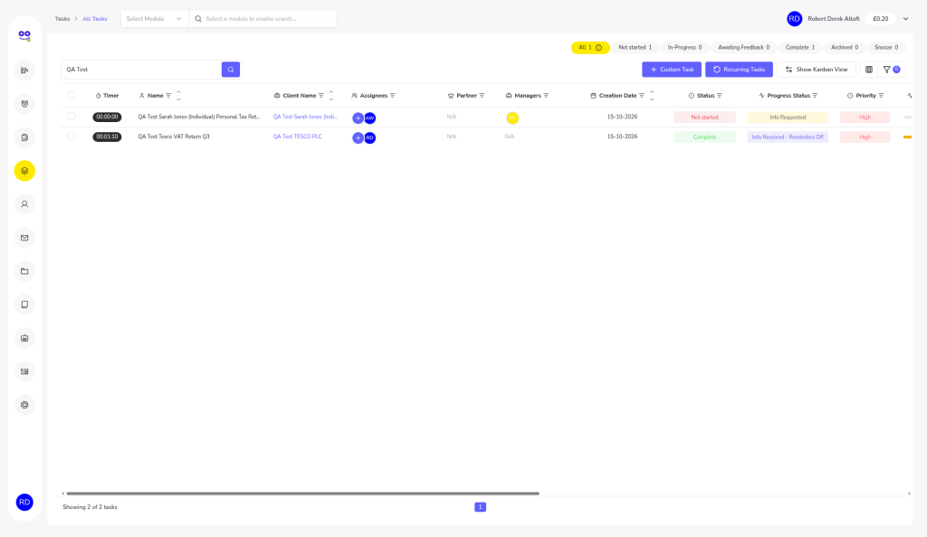
Figure 13: Task completed with checklist unfinished; "All" count drops (TSK-02, TSK-03)

3.9 Invoices
Works
- VAT at 20%, 5% and 0% correct, with correct rounding.
- Item required validation.
- Single save (no double-submit).
- Part-payment status.
- Clear recurring list.
Broken
- IVC-01 (High) Recurring schedules duplicated (double-billing risk); a paused daily schedule raised 26 invoices.
- IVC-02 (High) Credit of £100.60 applied but no credit note created.
- IVC-03 (High) Drafts tab does not filter.
- IVC-04 (High) Search by client name fails.
- IVC-05/06 (Medium) Inconsistent numbering (INV-058, INV-1791590401656, INV-REC-...); HTML stripped silently.
- IVC-08 (Medium, to re-check) Possible invoice lines dropped on save.
Missing
- IVC-07 VAT and invoice-numbering settings.
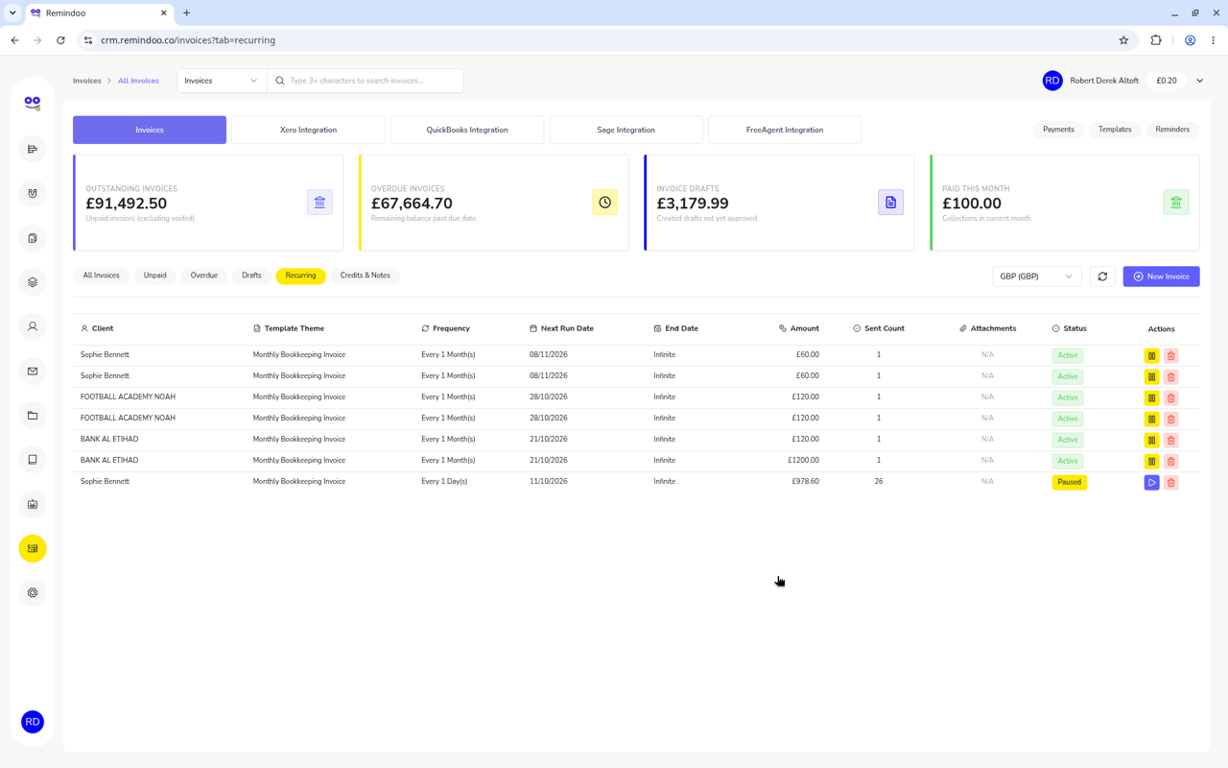
Figure 14: Duplicated recurring invoice schedules (IVC-01)
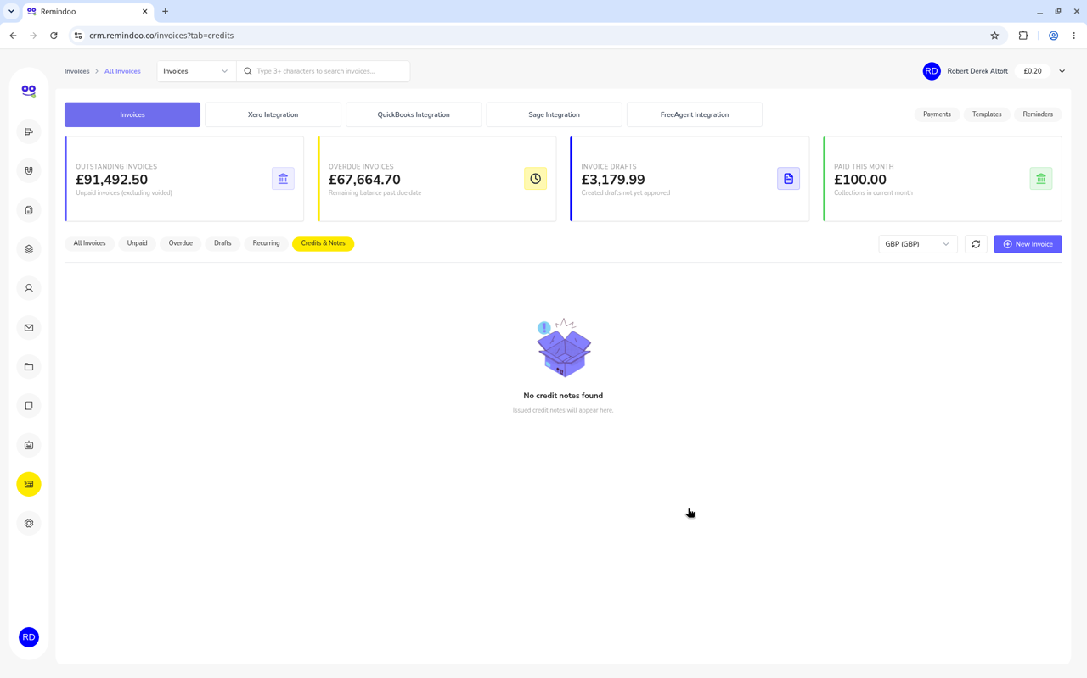
Figure 15: Credit Notes tab empty although a credit was applied (IVC-02)
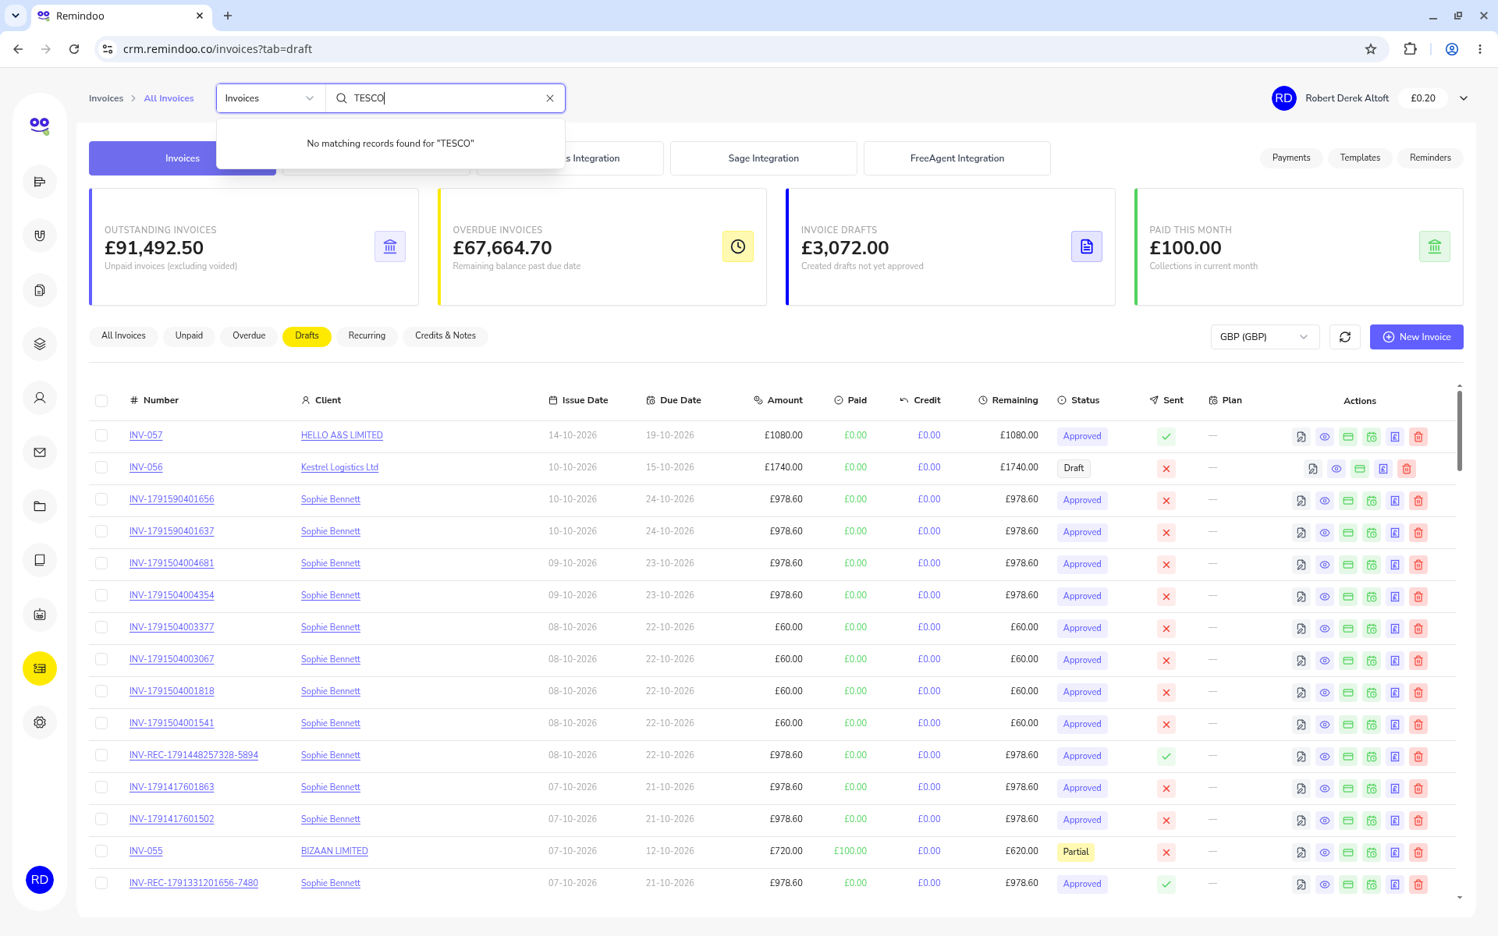
Figure 16: Drafts tab showing non-draft invoices (IVC-03)

3.10 Documents
Works
- Folders can be created and renamed (rename is hidden in Document Info).
Broken
- DOC-01 (Critical) Every upload fails with a raw AWS S3 AccessDenied message that exposes the AWS account ID, IAM user and bucket name.
- DOC-02 (High) Double-click creates duplicate folders.
- DOC-03 (Medium) .exe files accepted despite the stated allowed types.
- DOC-04 (Medium) "Visible to client" ON by default; notification text persists.
- DOC-05 (Low) Dialog stays open; US dates; rename hidden in Document Info.
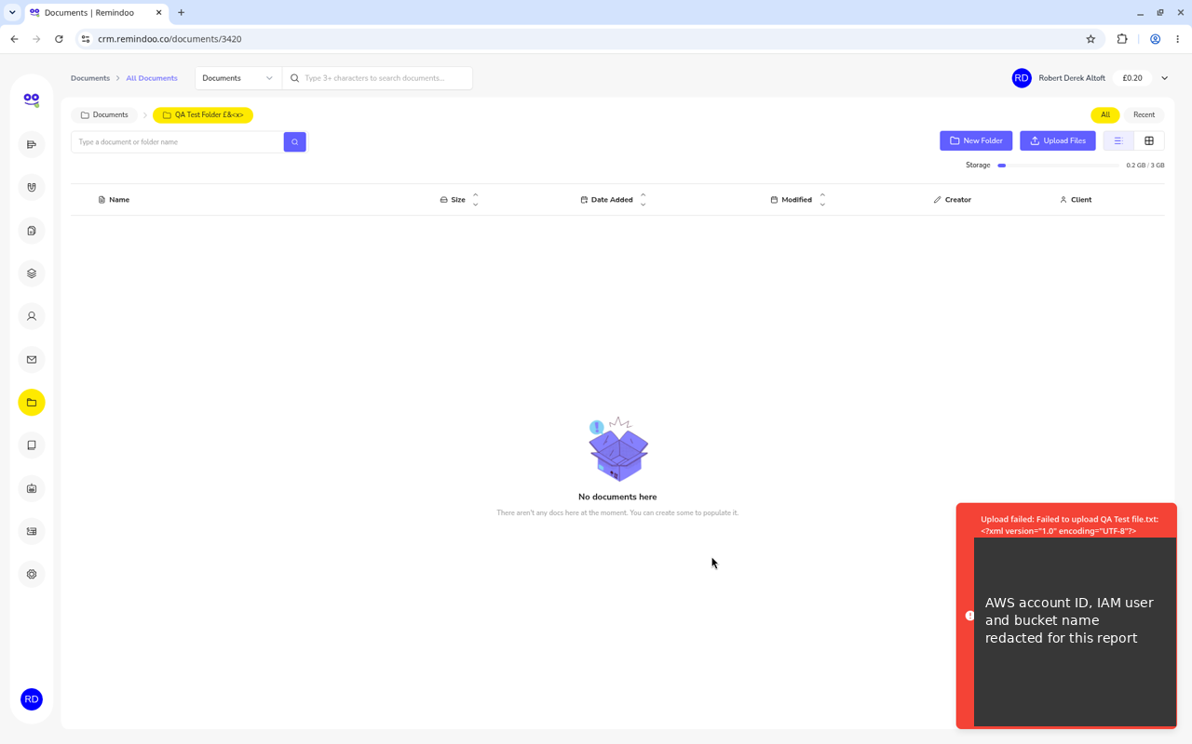
Figure 17: Upload failure exposing S3 details (DOC-01). Sensitive values redacted in this copy.
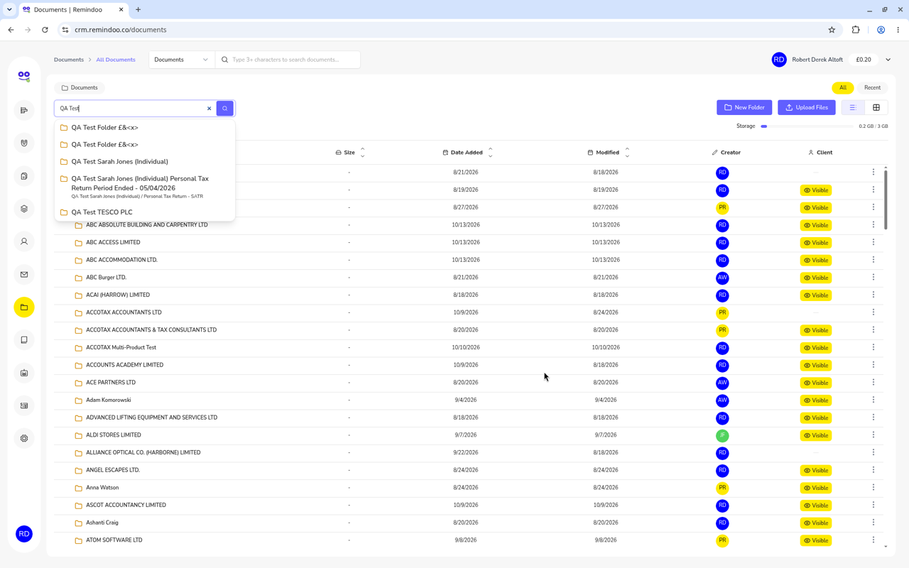
Figure 18: Duplicate folders from a double-click (DOC-02)

3.11 Emails
Works
- Compose editor loads.
- Link Client picker works.
Broken
- EML-01 (High) Email body not shown when an email is opened.
- EML-02 (High) AI Suggestion fails with "Failed to retrieve email data".
- EML-03 (Medium) Last sync 21 hours old; emails labelled "Unknown".
- Inbox load about 20 seconds (see GEN-01).
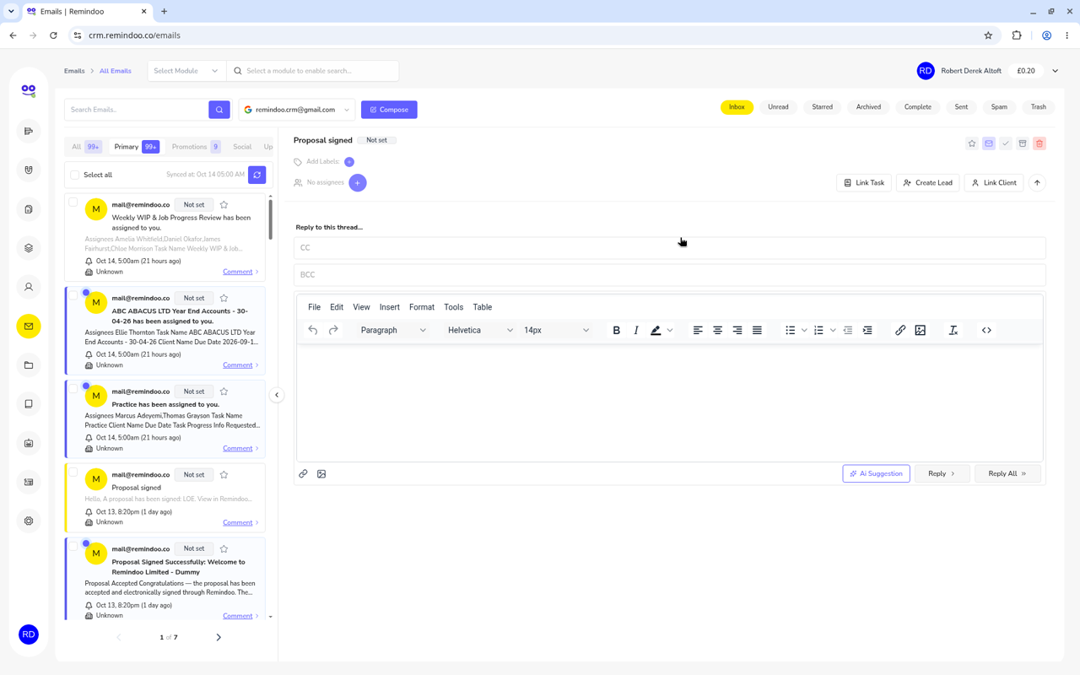
Figure 19: Opened email with no body shown (EML-01)
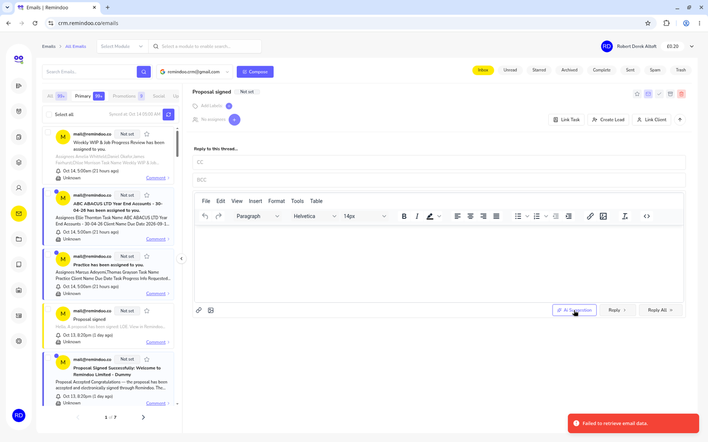
Figure 20: AI Suggestion error (EML-02)

3.12 Knowledge Base
Works
- Create a draft with emoji and long text.
- No double-save.
- Edit an article.
- Top search bar.
Broken
- KB-01 (Medium) In-page search does not filter.
- KB-02 (Low) Typo.
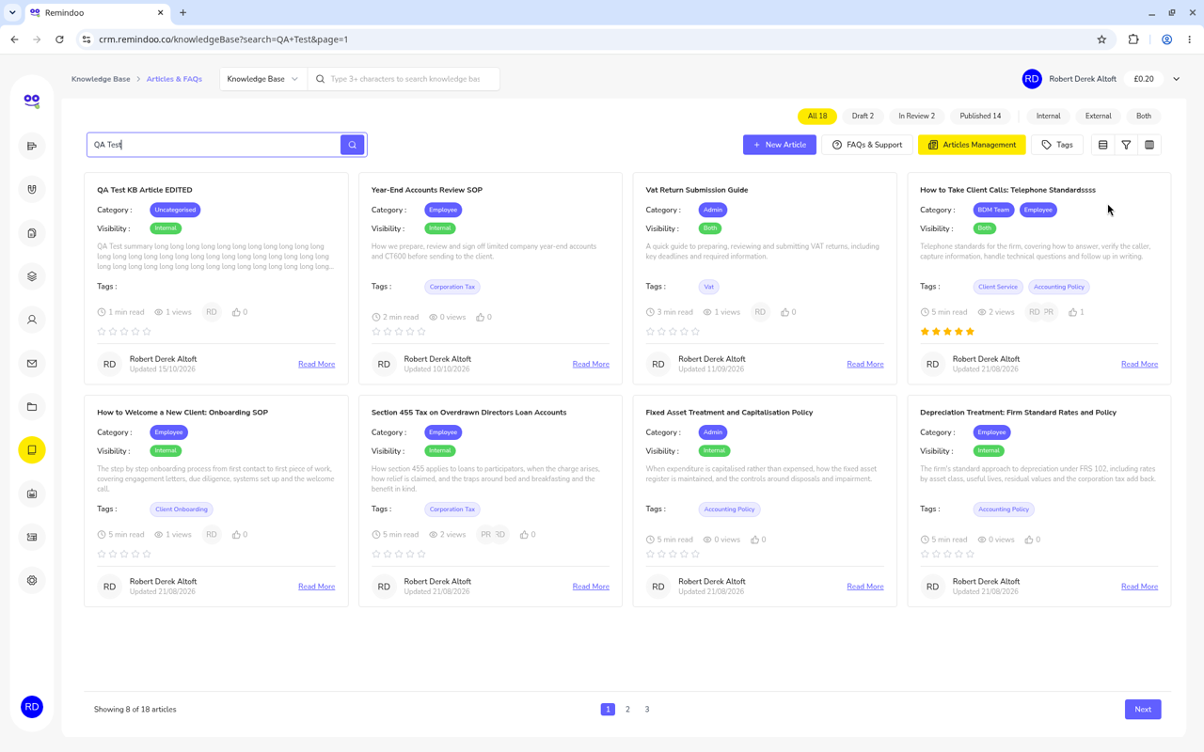
Figure 21: Knowledge Base in-page search not filtering (KB-01)

3.13 Financial Assistant
Works
- PDF upload processes to "ready".
Broken
- FA-01 (Critical) After the PDF is ready, the question box rejects all input.
- FA-02 (High) CSV rejected with a raw OpenAI error.
Missing
- FA-03 General UK tax Q&A. Answers expected for 2026/27: Personal Allowance £12,570; VAT registration threshold £90,000; Corporation Tax 25% main rate and 19% small profits rate, with marginal relief between £50,000 and £250,000.
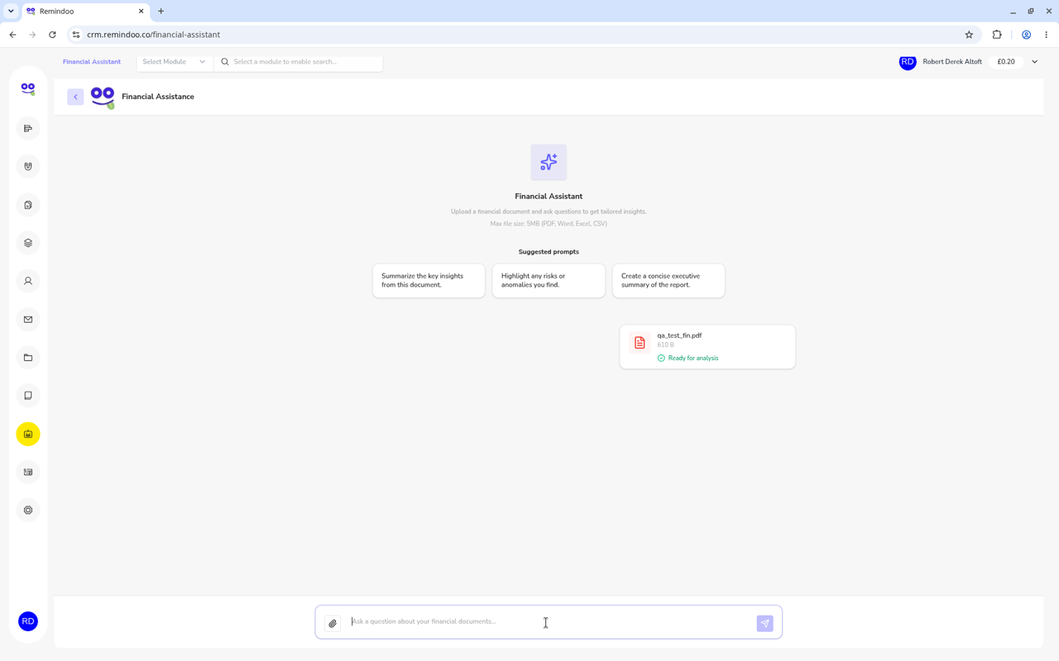
Figure 22: Question box rejecting input (FA-01)
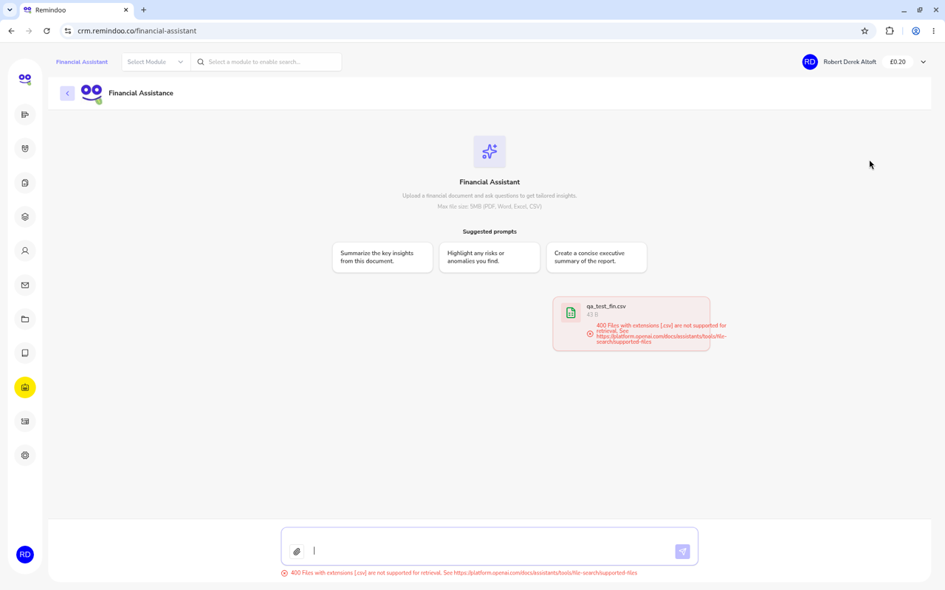
Figure 23: CSV upload returning a raw OpenAI error (FA-02)

3.14 Settings and global search
Works
- 15 settings sections, logically grouped.
- Team name length validation.
Broken
- SET-01 (Medium) Global search is per-module only; invoice search for "QA Test" finds nothing.
- SET-02 (Low) "1 Members".
Missing
- Invoice, VAT and numbering settings (see IVC-07).
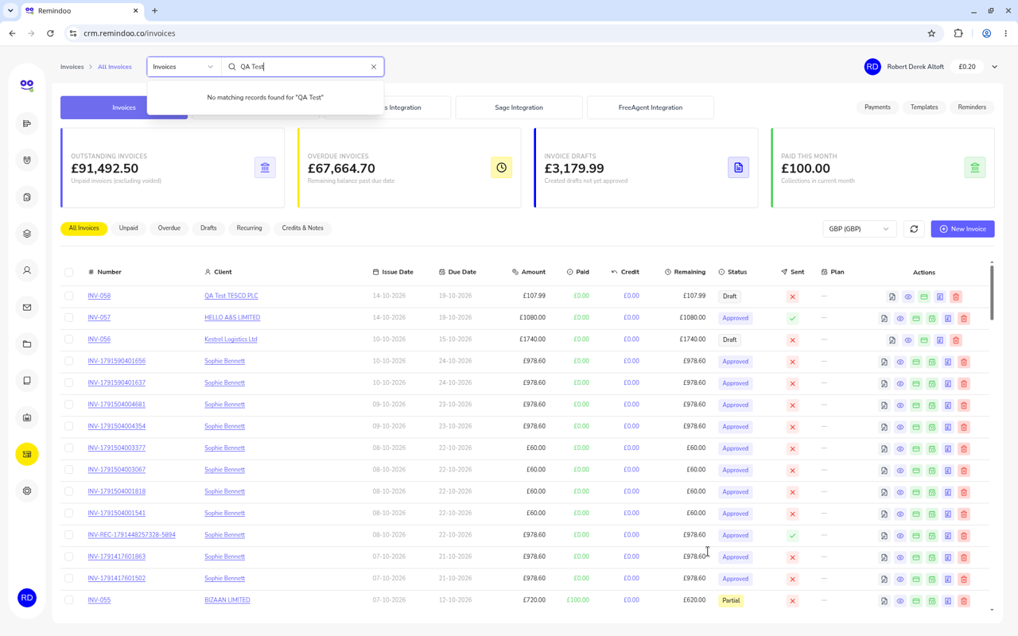
Figure 24: Global search returns no match for "QA Test" invoices (SET-01)

4. The accountant's view: compliance gaps
From a UK practice point of view, the deadline engine already gets the basics right: CT600 filing, the standard CT payment date and the Self Assessment paper (31 October) and online (31 January) deadlines were all correct, and Companies House data matched the register. The gaps below are the ones an accountant would notice in the first month, because they affect what is filed, what is paid and what can be evidenced later.

4.1 Tax deadlines and payments
Gap | What we found | Why it matters to a practice | Ref
Payments on account | No tracking of 31 January and 31 July payments on account. | POAs are among the deadlines clients most often miss. Without them, reminders only cover filing, not paying. | CLI-13
Quarterly CT instalments | CT payment date ignores quarterly instalment payments for large companies. | Large-company clients receive a single, wrong payment date; interest can arise on late instalments. | CLI-03
Rolling the SA year | Next SATR date cannot be edited. | The practice cannot move a client to the next tax year itself. | CLI-06
Service deadlines on tasks | External deadline not auto-filled from the service. | Staff may trust the help text and leave a statutory deadline blank. | TSK-04
Out-of-date template wording | Sole-trader LOE mentions Corporation Tax and P35/P14 forms, which no longer exist under RTI. | A letter of engagement with the wrong taxes in scope is weak evidence of what the firm agreed to do. | PRO-04

4.2 Identifiers and data quality
Gap | What we found | Why it matters to a practice | Ref
UTR checksum | UTR accepts letters; no checksum check. | A mistyped UTR is only caught when HMRC rejects a filing or authorisation. | CLI-01
NI number | "XX123" saved as "123". | Silent loss of a key identifier. | CLI-07
Wrong labels | Company UTR shown as "Personal UTR"; no DOB in the individual flow. | Staff enter data in the wrong place; DOB is needed for ID checks. | CLI-10
Companies House status | Carillion PLC shown Active while in Liquidation; no overdue accounts or CS warnings. | Insolvency and late filings are key AML and engagement risks. | CH-01, CH-02
Silent value changes | Negative fee/hours turned positive; discount above subtotal set to 0; HTML stripped. | Records no longer reflect what the user entered, without telling them. | CLI-05, PRO-05, IVC-06

4.3 GDPR and privacy defaults
Gap | What we found | Why it matters to a practice | Ref
Marketing consent | Marketing opt-in defaults to ON. | Under UK GDPR and PECR, consent must be an active opt-in. This should default to OFF. | CLI-08
Client document visibility | "Visible to client" ON by default on uploads. | Internal working papers could be shared with a client by mistake. Default should be OFF. | DOC-04
Email BCC | Client email auto-filled into BCC on proposals. | Unexpected recipients on client correspondence. | PRO-08
Archived leads re-opened | Automation returns archived leads to New Lead after an hour. | People who asked not to be contacted may be contacted again. | REM-02
Infrastructure exposure | AWS account ID, IAM user and bucket name shown in an error. | A security weakness in a system that will hold client ID and tax documents. | DOC-01
Access control | Employee role holds 71 of 72 permissions. | Limits on who sees client data are hard to demonstrate. | GEN-03

4.4 Audit trail and evidence
Gap | What we found | Why it matters to a practice | Ref
Credit notes | £100.60 credit applied with no credit note. | Every reduction to a VAT invoice should be backed by a credit note. | IVC-02
Invoice numbering | Three different number formats in use. | A clear, sequential series is expected for VAT records. | IVC-05
Duplicate billing | Duplicated recurring schedules; a paused schedule raised 26 invoices. | Each wrong invoice then needs a credit note and an explanation to the client. | IVC-01
Engagement date | LOE signed date saved one day early. | The engagement record should show the exact date the client signed. | CLI-02
Sent communications | Reminder emails with "::Name::" logged as Sent. | The log shows what was sent, but nothing stopped it being sent. | REM-01
Checklist sign-off | Task can be completed with checklist at 67%. | Review evidence is incomplete if steps can be skipped silently. | TSK-02

4.5 Reference answers for the Financial Assistant (2026/27)
Once FA-01 to FA-03 are fixed, the assistant should give these answers to basic questions as a minimum acceptance test:
Question | Expected answer
Personal Allowance | £12,570
VAT registration threshold | £90,000
Corporation Tax main rate | 25%
Corporation Tax small profits rate | 19%
Marginal relief band | £50,000 to £250,000

5. What to build on top: the AI layer roadmap
From an owner or CEO point of view, the AI layer is where Remindoo can stand out against other practice-management tools. But AI that summarises wrong KPIs, drafts emails with "::Name::" or cannot read the inbox would do more harm than good. The roadmap therefore starts with a foundation phase.

Phase 0: Foundation (do first)
- Speed: bring Clients, Tasks and Emails well under the current 10-20 seconds (GEN-01).
- Correct metrics: fix dashboard KPIs and counts so AI summaries rest on true numbers (DSH-01 to DSH-05).
- Placeholder guard: block any outgoing email or document that still contains an unfilled placeholder (REM-01).
- Clean data: remove duplicate services, fields and tasks, and fix templates (DAT-01, DSH-04, PRO-04).
- Also needed by the AI features: working email body retrieval (EML-01), document upload (DOC-01) and a consistent AI provider connection (GEN-07, FA-01).

Prioritised AI features
Priority | Feature | What it does for the practice | Depends on
1 | Deadline and penalty guard | Watches every client deadline and payment date and warns before penalties arise. | CLI-03, CLI-13, CH-02
2 | AI inbox triage | Tags the client, creates a task, drafts a reply, flags HMRC and urgent emails. | EML-01/02/03
3 | Morning brief per person | Each team member starts the day with their deadlines, overdue tasks and emails needing a reply. | DSH-01/02, GEN-01
4 | Automatic document chase | Chases clients for missing records, without placeholder errors. | REM-01, DOC-01
5 | Instant lead reply | Replies to new enquiries within minutes with the right next step. | LEA-01, REM-02
6 | AI proposal builder | Builds a proposal from lead details with correct monthly, annual and one-off fees. | PRO-01 to PRO-04
7 | Smart document intake and extraction | Reads uploaded documents, files them to the right client and extracts key figures. | DOC-01, DOC-03, FA-01/02
8 | Ask-your-practice chat | Plain-English questions across clients, tasks, invoices and the Knowledge Base, plus UK tax Q&A. | FA-03, KB-01, SET-01
9 | Client health score | Combines overdue work, late filings, unpaid invoices and engagement status into one score. | IVC-01/02, CH-01
10 | Profitability per client and service | Compares time logged with fees charged for each client and service. | CLI-04, TSK-01
11 | Capacity forecast | Predicts workload peaks from deadlines and estimated hours. | DSH-01 (utilisation), TSK-01
12 | Review assistant | Checks work against the checklist before sign-off and highlights gaps. | TSK-02
13 | Upsell finder | Spots clients who may need extra services (for example VAT or payroll) from their data. | CLI-04, DAT-01

The order reflects a mix of accountant value (avoiding penalties and missed client emails), how much existing data each feature needs to be trustworthy, and how soon it can ship after Phase 0. Features 1 to 5 build on modules that mostly work already once their High and Critical issues are fixed; 9 to 13 need clean fee, time and service data first.

Appendix A. QA test records created on the dummy account
The following records were created during testing on 15 October 2026 and can be deleted. Most are prefixed "QA Test" for easy searching.
# | Module | Record | Notes
1 | Leads | Lead: QA Test John Smith | Converted to client; the client sits in Draft
2 | Proposals | Proposal: LOE, £2,160 | Not sent
3 | Clients | Client: QA Test TESCO PLC | Company client
4 | Clients | Client: QA Test Sarah Jones | Individual; Personal Tax Return - SATR service
5 | Tasks | Task: QA Test Tesco VAT Return Q3 | Includes test comments, checklist and timer entries
6 | Tasks | Recurring task: QA Test Monthly Bookkeeping Tesco | Recurring schedule
7 | Invoices | Draft invoice: INV-058 | Draft
8 | Documents | 2 QA document folders | One is a duplicate from the double-click test (DOC-02)
9 | Knowledge Base | Draft article 67 | Draft
10 | Settings | Team: QA Test Team £& | Created to test validation

Also check the converted Draft client from item 1 and the duplicate client shown after onboarding (CLI-11).

