**Task 1**

The quantization error with 3 code vectors is 269.99 and quantization error with 5 code vectors is 183.52, so 5 code vectors are suitable as quantization error are low. Clusters with 3 code vectors represent classes almost accurately while clusters with 5 code vectors are dividing class 2 and 3 into 4 clusters because in this case, the number of clusters is more than the number of classes.

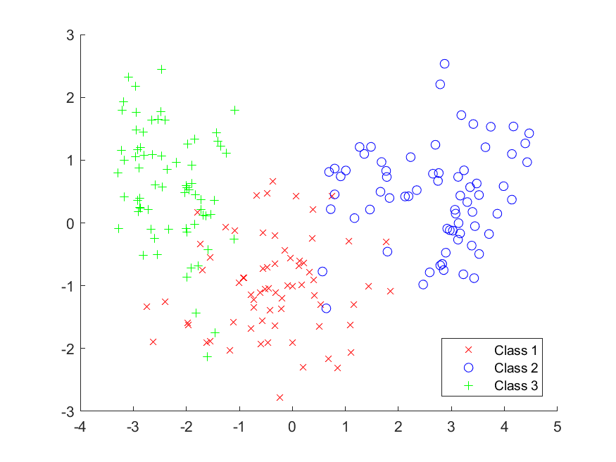

Figure :Laballed Data in PC1 and PC2 projection

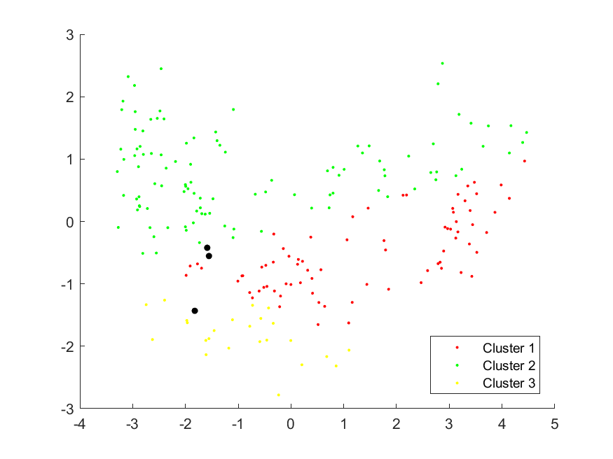

Figure : Un-clustered Data with 3 Code Vectors

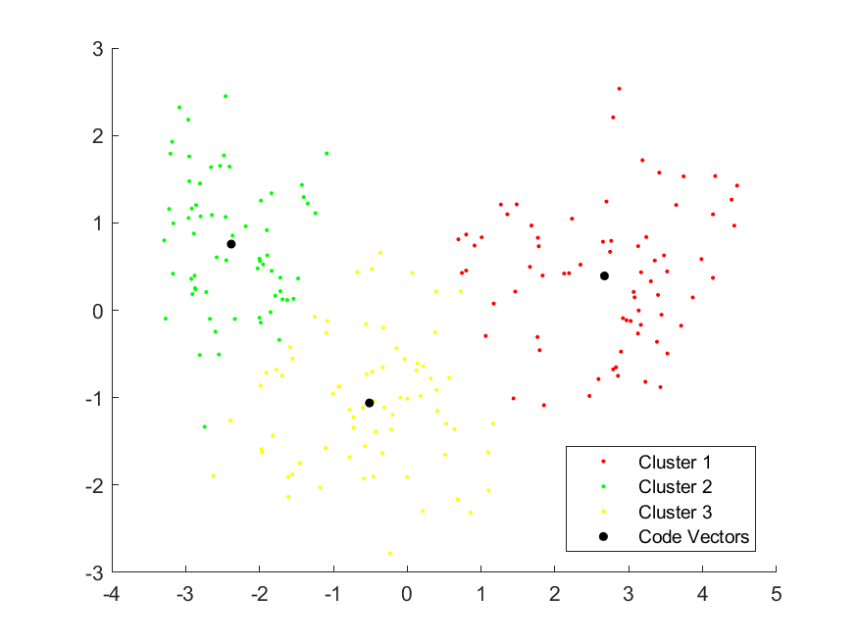

Figure : Clustered Data with 3 Code Vectors

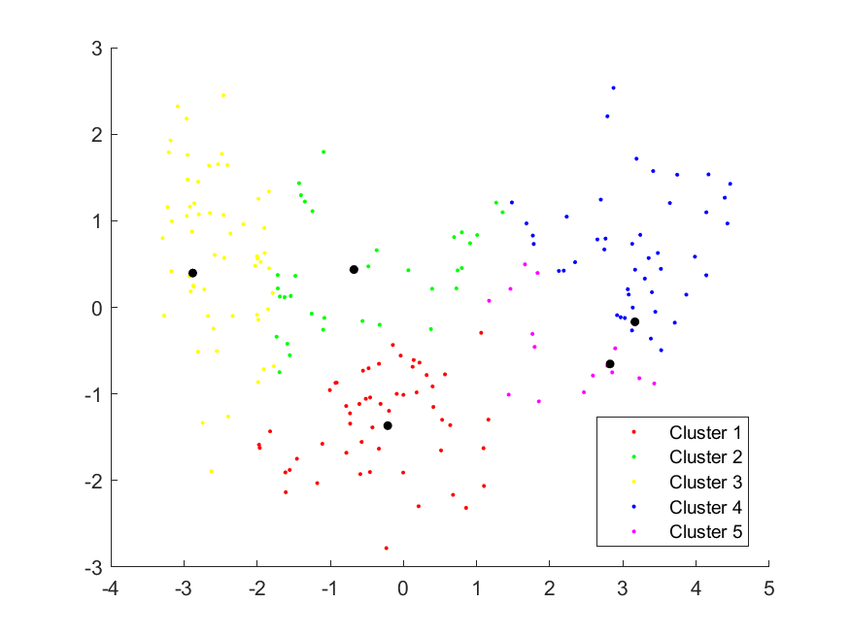

Figure : Un-clustered Data with 5 Code Vectors

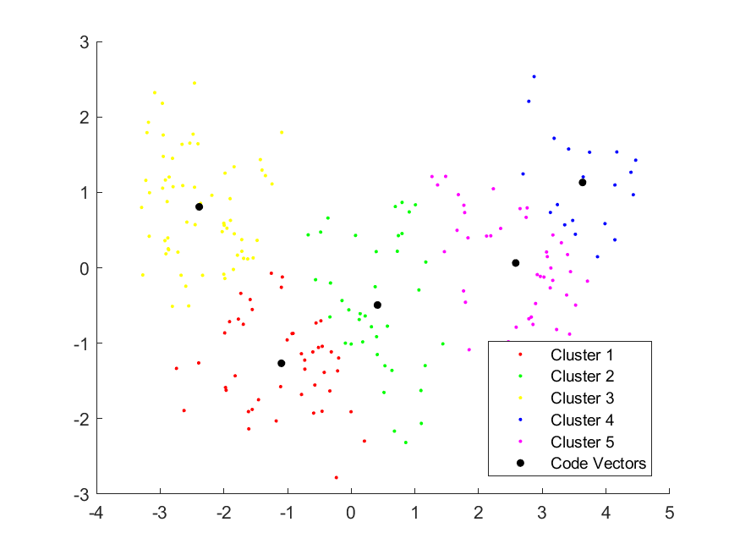

Figure : Clustered Data with 3 Code Vectors