**Task 2**

More the principal component we take more the image recovers. To decide how many principal components, you should use to compress the image, you’ll compare the original image with a recovered compressed image that if you get a compressed image with the minimum amount of loss in data.

Most of the data are in starting principal components and there is mostly noise in last principal components.



Figure 1: Original Image (256K)

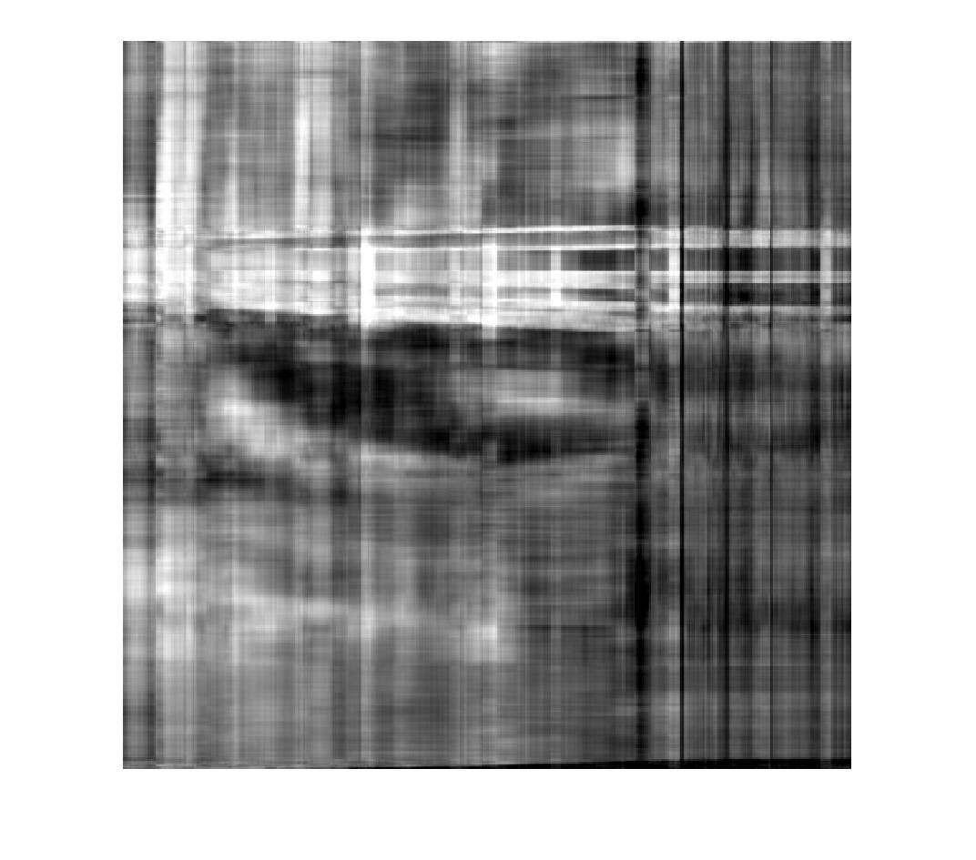

Figure 2: Compressed Image with 1st 10 PC (86.4k)

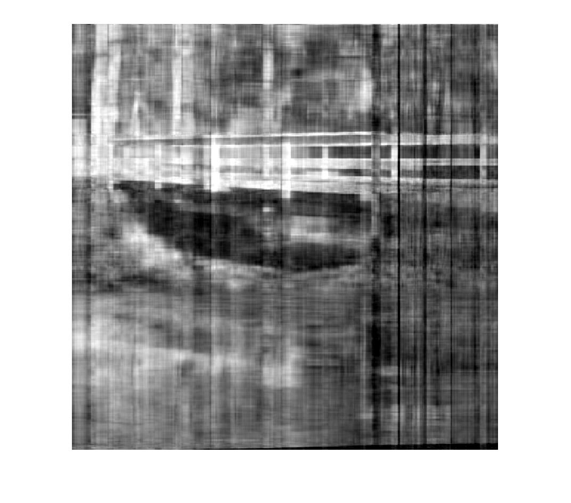

Figure 3: Compressed Image with 1st 20 PC (97.5k)

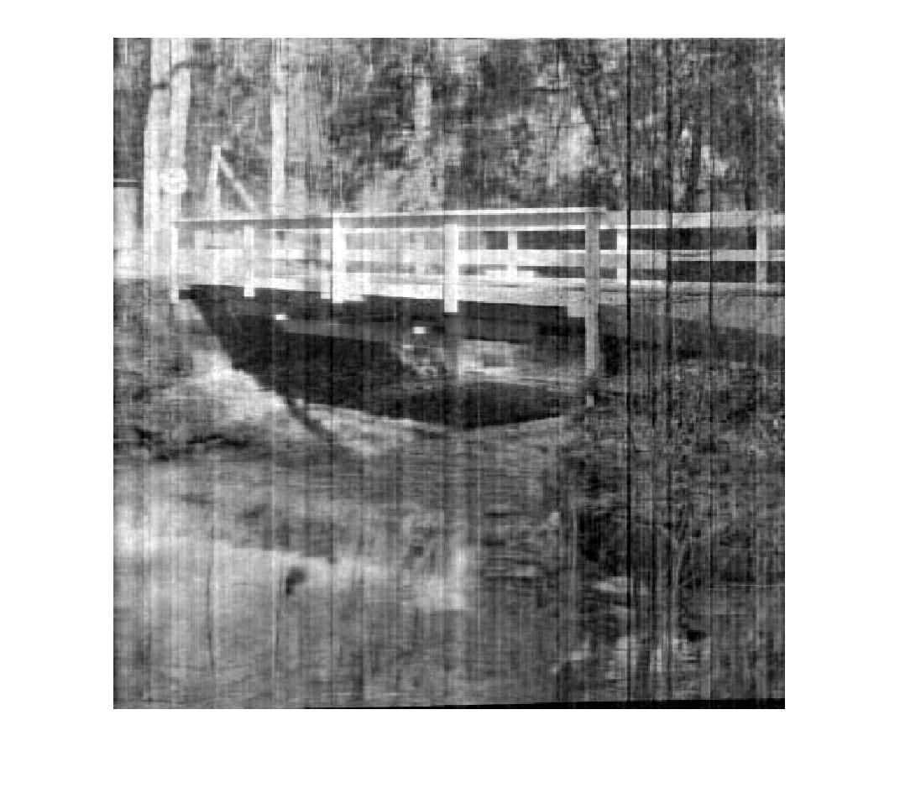

Figure 4: Compressed Image with 1st 50 PC (117k)