**Task 5**

I trained the training set with combinations: [Cost=5, Gamma=0.01], [Cost =5, Gamma =0.005] and [Cost =10, Gamma =0.001]. The Best Cross Validation Accuracy is 97.901% with the set [Cost=5, Gamma=0.01], so 327 out 333 points are classified correctly. In feature space, the smaller value of C increases the margin. So, data points that are closer to hyperplane are misclassified due to change in the orientation of hyperplane.

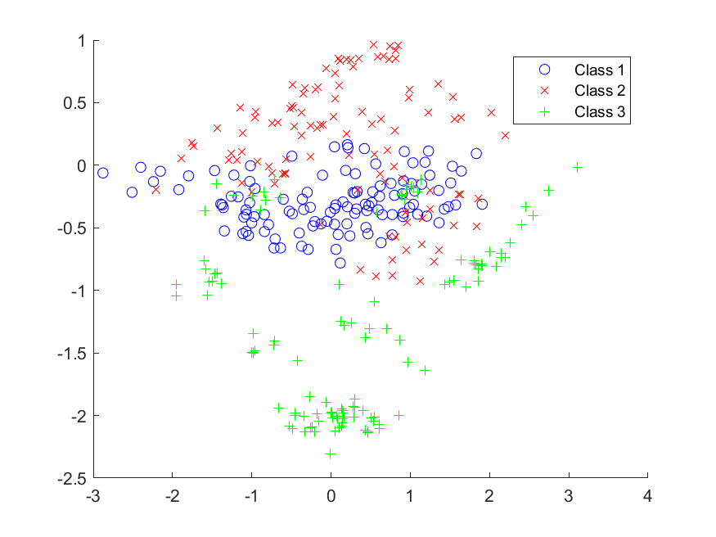

Figure : Actual testing set

The plot of Predicted Testing Set is on next page.

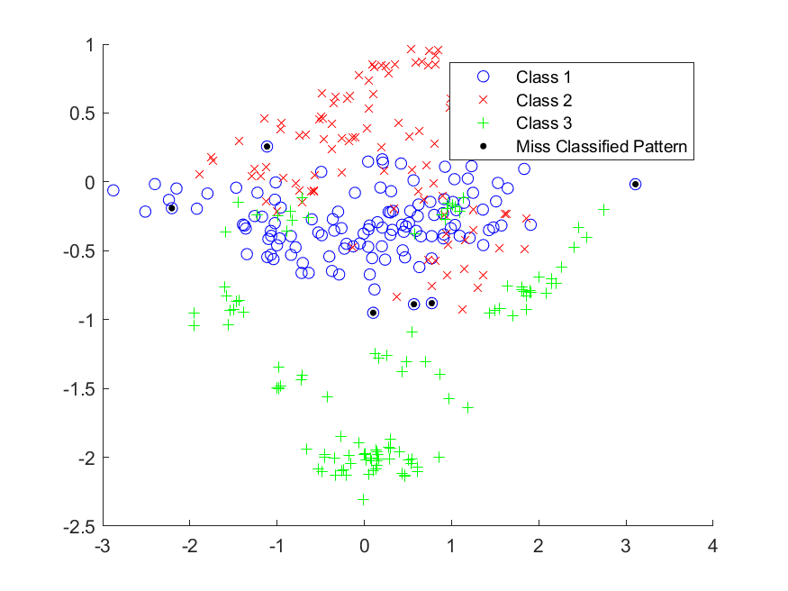

Figure : Predicted Testing Set with Miss-Classified Data Points