Home Assignment 3

# Potential field method

## Theory:

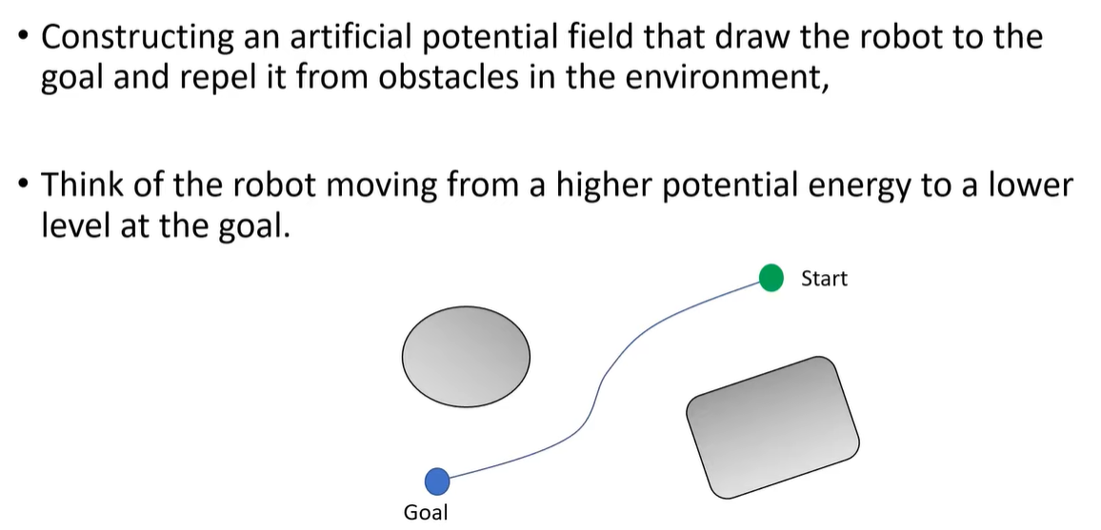

# ***Workspace:***

# ***For start = [200, 800]; goal = [850, 500]; Eta = 1000;Zeta = 1/1500;***

## Total Field

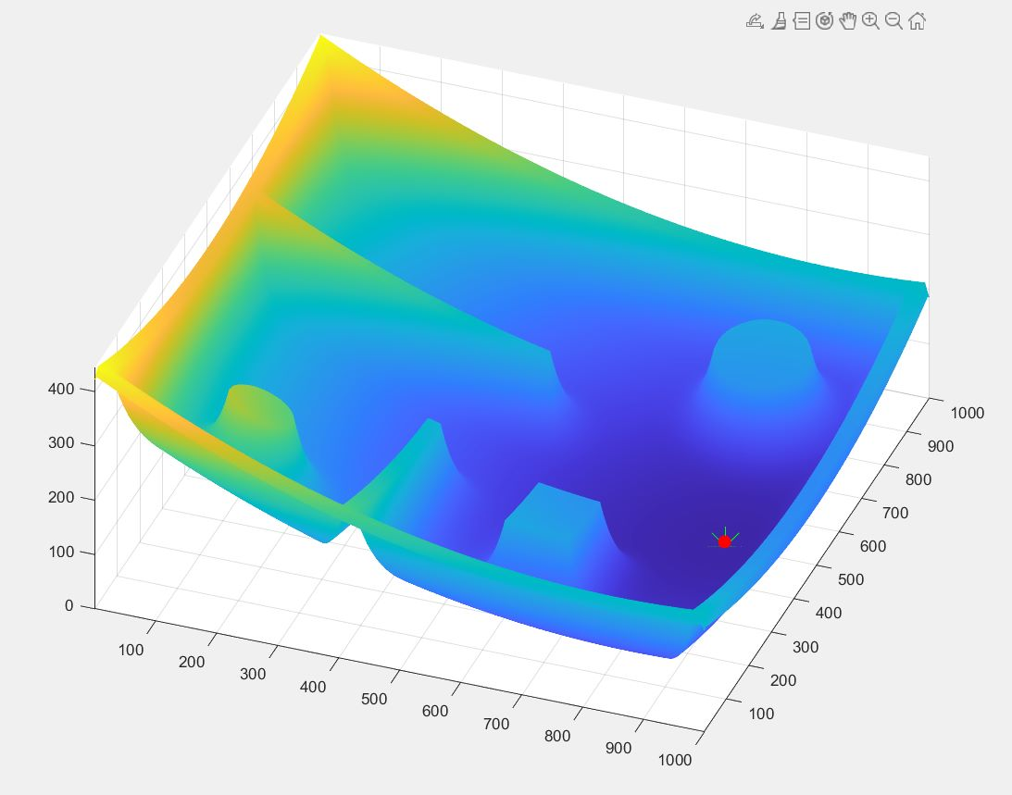

## Workspace Results

The video of the potential field interaction/visualizing with the graph is there in the code if we run it we can see the ball following through the gradient.

# ***For Failed Cases : start = [100, 400];***

# ***goal = [900, 100]; keeping zeta and eta same.***

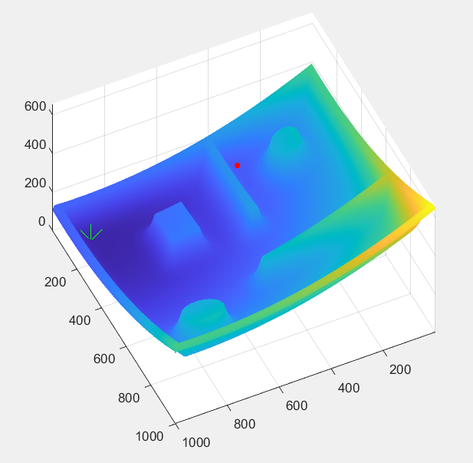

We can also change zeta and eta with respect to each other to get a failed case etc.

## ***Reasons For the failed case:***

1. Local Minima: The potential field method can get stuck in local minima, especially when the obstacles are placed close to the goal or when the robot has limited sensing capabilities. The repulsive potential generated by the obstacles can create multiple local minima, and the robot may get stuck in one of them instead of reaching the goal. ( this is what happened in the above case )
2. Oscillations: When the robot moves towards the goal, it can sometimes oscillate between the attractive and repulsive forces. This can happen when the robot is moving in a narrow corridor or when there are small obstacles in its path. The oscillations can cause the robot to deviate from the planned path or even get stuck.
3. Narrow Passages: The potential field method may not work well when the robot needs to pass through narrow passages or tight corners. In these cases, the repulsive forces generated by the obstacles can be too strong, making it difficult for the robot to navigate through the passage.
4. Scaling: The potential field method can also fail if the scaling factors for the attractive and repulsive potentials are not chosen carefully. If the scaling factor for the repulsive potential is too high, the robot may be too cautious and move too slowly, while if the scaling factor for the attractive potential is too high, the robot may overshoot the goal.

Matlab COde