DAC Minutes of Meeting Template
SCHOOL OF ALLIED HEALTH CARE PROFESSIONS
DEPARTMENT OF __________
Ref No. PU/ALL-DEPT/DAC-01/2026-27/Odd/Notice-01 | Date: 12.11.2026

Minutes of the 1st Meeting of Departmental Academic Committee
The 1st Meeting of the Departmental Academic Committee of the Department of __________, School of Allied Health Care Professions, University, was convened on 12.11.2026, at 10:30 in the Seminar Hall, Block B. The meeting was held in offline mode at the University campus in Bengaluru. The meeting link is provided below.
Members Present: (Provide the list of members who are present at the meeting)
Sl. No. | Name and Designation | Role | Signature
01 | Dr. Purnima Singh Head of the Department, School of Allied Health Care Professions | Chairperson
02 | Dr. Veena C.S Professor, Dept. of ECE, SoE | External Member
03 | Ms Apoorva Shetty Member Secretary (DAC), School of Allied Health Science | Member Secretary

The Chairperson welcomed all the members. The member secretary delivered the opening remarks and deliberated on the following agenda points.
Agenda No: 01 To consider the approval of the MoM of the 1st Departmental Academic Committee meeting held on 15.08.2026.
Discussion:
The Member Secretary presented the minutes of the 1st Departmental Academic Committee meeting held on 15.08.2026 for approval. Members reviewed the minutes agenda-wise, including the discussion and resolutions recorded for each agenda item of the 1st meeting. The committee considered the minutes carefully and confirmed that the minutes accurately reflect the deliberations and decisions of the meeting held on 15.08.2026. Members agreed that the approved minutes should be circulated to all members and filed in the department record. No major corrections were proposed, and members agreed that the minutes of the 1st meeting held on 15.08.2026 may be approved as the true record of the meeting.
Resolution:
The committee approved the minutes of the 1st Departmental Academic Committee meeting held on 15.08.2026 as the true record of the meeting held on 15.08.2026. The Member Secretary was directed to circulate the approved minutes to all members and file the approved minutes in the department record.
Document: Annexure 1.1 — CSA4708_Reinforcemnet_Learning_CA2_announcement.pdf
Agenda No: 02 To consider the approval of the Action Taken Report (ATR) of the 1st Departmental Academic Committee meeting held on 15.08.2026.
Discussion:
The Member Secretary presented the Action Taken Report (ATR) on the action items arising from the 1st Departmental Academic Committee meeting held on 15.08.2026. Members reviewed the action taken on each item, the persons responsible, and the target dates recorded in the Action Taken Report. The committee considered the progress reported in the ATR and noted that the completed actions were implemented as decided in the meeting held on 15.08.2026. Members discussed the action items that are in progress and agreed that the remaining actions should be completed within the target dates recorded in the Action Taken Report. Members also agreed that the persons responsible should report the completion of the remaining action items to the Member Secretary.
Resolution:
The committee approved the Action Taken Report (ATR) on the action items of the 1st Departmental Academic Committee meeting held on 15.08.2026. The persons responsible were directed to complete the remaining action items within the target dates recorded in the Action Taken Report and report the completion to the Member Secretary.
Ref. Document: Annexure 2.1 — DAC-1-Department-of-Artificial-Intelligence-and-Robotics.pdf
Agenda No: 03 Approval of courses available for registration in the upcoming semester.
Discussion:
The Member Secretary presented the list of courses available for registration in the upcoming semester for consideration and approval. The list placed before the committee and recorded as Annexure 02 comprised 6 courses available for registration in the upcoming semester, namely Advanced Calculus, Linear Algebra, Differential Equations, Numerical Methods, Probability and Statistics, and Mathematical Modelling, with credits and prerequisites as recorded in Annexure 02. Members reviewed the courses available for registration, including the course titles, credits, prerequisites, and the semester in which the courses are offered. The committee considered the courses available for registration and discussed the eligibility of students for registration in the upcoming semester. Members agreed that the 6 courses available for registration in the upcoming semester as listed in Annexure 02 are suitable for offering in the upcoming semester and may be approved for student registration. Members also agreed that the approved courses available for registration should be published for students and students should be informed about the registration in the upcoming semester.
Resolution:
The committee approved the 6 courses available for registration in the upcoming semester, namely Advanced Calculus, Linear Algebra, Differential Equations, Numerical Methods, Probability and Statistics, and Mathematical Modelling, as listed in Annexure 02 placed before the committee. The Member Secretary was directed to publish the approved courses available for registration as listed in Annexure 02 and inform students about the registration in the upcoming semester.
Ref. Document: Annexure 3.1 — Gmail_-_Congratulations_Your_Team_Has_Qualified_for_the_Final_Round_of_VecnaVerse_2026_.pdf

Additional discussion points (if any)

Geo-Tagged Photos and Online Platform Screenshots – Departmental Academic Committee
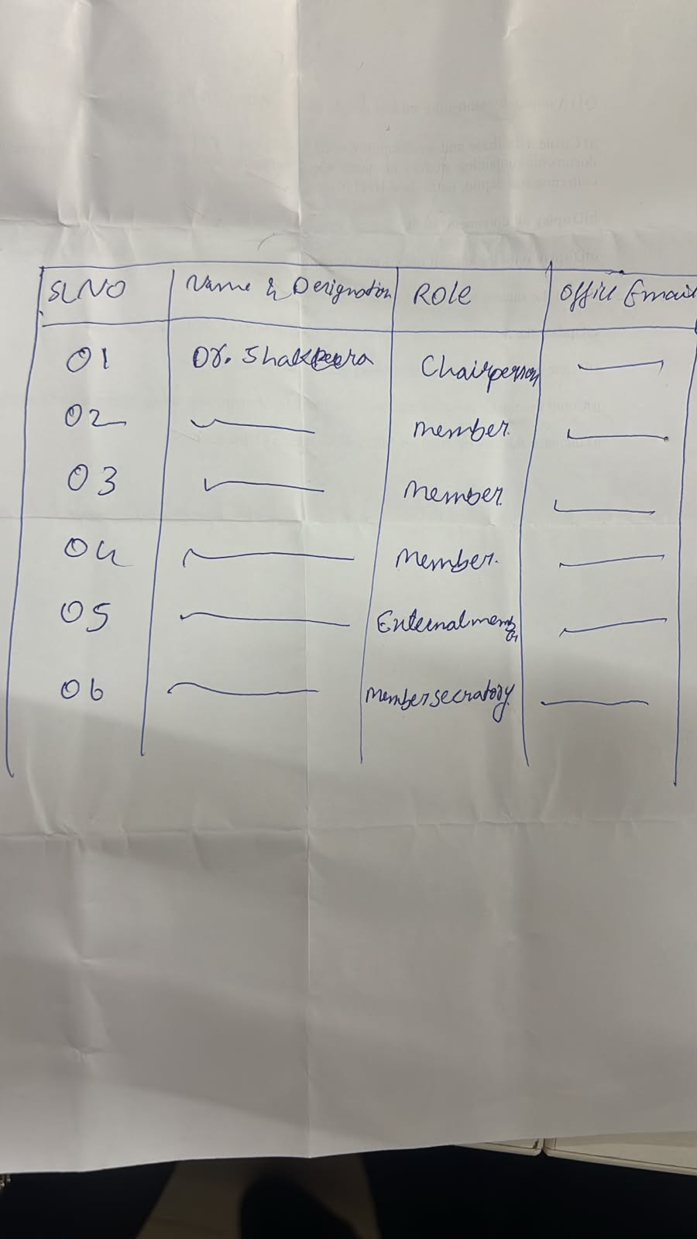
Image 1: WhatsApp Image 2026-11-13 at 3.49.04 PM
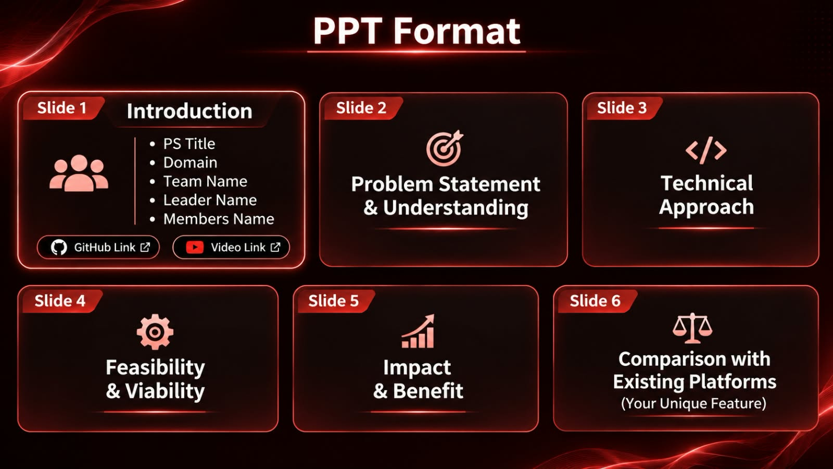
Image 2: vecna-hackathon

Action Items:
Agenda No | Action(s) to be Taken | Person(s) Responsible | Target Date
—

The Chairperson and the Member Secretary thanked all the members for their contributions and requested their continued support.

 |  | 
Ms Apoorva Shetty  Member Secretary  Signed 13 Nov 2026, 13:40 | Dr. Purnima Singh  Chairperson  Signed 13 Nov 2026, 13:45 | Academic Office Reviewer  Academic Office  Signed 13 Nov 2026, 14:23

Copy to:
• Hon’ble Vice Chancellor, PU
• Hon’ble Pro Vice Chancellor, PU
• Office of the Registrar, PU
• Dean-Academics, PU

Encl: Annexures

