
SMART INDIA HACKATHON 2026
V-CAPAT PRO
Virtual Camera Acquisition, Pointing & Tracking System
for Mobile Free Space Optical Communication Terminals
TECHNICAL REPORT - VERSION 1.1
Problem Statement ID: SIH26169
Organization: Department of Space / Indian Space Research Organisation
Category: Software | Theme: Smart Automation / Space Technology
Team: NeXGen Coder's | Team ID: 160644
Report date: 02 October 2026
Scope: software coarse alignment for optical beacon acquisition and tracking. This prototype is a research/hackathon testbed and is not a flight-qualified optical terminal.

1. Executive Summary and Problem Understanding
Free Space Optical Communication (FSOC) uses highly directional optical beams. Before fine pointing can take over, the coarse Pointing, Acquisition and Tracking (PAT) stage must observe the surrounding scene, acquire a remote optical beacon, estimate its position, and continuously reposition a camera or pointing mechanism so that the remote terminal remains inside the field of view.
The principal development barrier is that validating PAT algorithms directly on precision cameras, pan-tilt mechanisms and optical hardware is expensive and difficult to reproduce. V-CAPAT PRO addresses the software-development stage by providing a configurable virtual scene, movable virtual camera, synthetic optical beacon targets, disturbances, automatic detection, state estimation, closed-loop control, benchmark-video processing and measurable performance evidence.

1.1 Functional objective
- Autonomously detect and identify a designated moving optical beacon from image data.
- Estimate target position and short-term motion while avoiding use of simulator ground truth in the tracking/control loop.
- Continuously command virtual pan and tilt so the beacon remains close to the image centre.
- Recover after temporary loss using prediction and search/re-acquisition states.
- Expose disturbances representing noise, atmospheric degradation, jitter and platform motion.
- Generate real-time metrics and auditable session reports for benchmark evaluation.

1.2 Solution modes
Mode | Purpose | PTZ behaviour
Simulator | Repeatable virtual environment and stress testing | Virtual camera is actively controlled
External MP4/AVI/MOV | Judge-supplied or prerecorded benchmark footage | PTZ actuation is bypassed; tracking is measured
Live webcam | Host camera experimentation | Image tracking only; device dependent
Design principle: ground truth is available only to the metrics layer. The detector, Kalman estimator and controller operate on image-derived measurements.

2. Problem-Statement Requirements and Traceability
The implementation was tightened against the numerical reference values supplied with SIH26169. The canonical PS-compliant configuration is stored in scenarios/ps_compliant_reference.json and is checked by vcapat/config/ps_compliance.py.
Requirement | Reference target | V-CAPAT PRO implementation | Status
Virtual scene | >= 2000 x 2000 px | WorldConfig enforces minimum 2000 x 2000 | Implemented
Camera | 640 x 480 suggested; FOV 4 x 3 deg | Configurable resolution/FOV; reference 640 x 480, 4 x 3 | Implemented
Camera rate | >= 30 Hz | Validated 30-60 Hz | Implemented
Pan / tilt speed | 5-10 deg/s; default 5 | Validated 5-10 deg/s with command limiting | Implemented
Target size | 5-20 px each dimension; default 10 x 10 | Independent width/height, 5-20 px | Implemented
Target motions | Straight, circular, figure-8, random | All four plus spiral/sinusoidal and research presets | Implemented
Noise | Gaussian, Poisson, Salt & Pepper | Selectable/combinable; Gaussian std <= 20 px; S&P <= 10% | Implemented
Jitter | <= +/-20 px/frame | Bounded configurable camera jitter | Implemented
Atmosphere | Clear, haze, fog, rain, low light | All modes plus optional turbulence warp | Implemented
Platform motion | <= +/-20 px/frame | Per-frame displacement clamp | Implemented
Performance | Acq <=2s; error <=10px; loss <5%; reacq <=1s; >=20 FPS | Automatically measured with PASS/FAIL/N/A semantics | Implemented

2.1 Additional software capabilities
The system also provides multi-target designation, multi-algorithm comparison, point-ahead experimentation, sensor-physics approximations, session SQLite storage, stress-test utilities, plugin interfaces, local REST/WebSocket control and a browser companion interface. These additions do not replace the mandatory PS functions; they are separated as extensions.

3. System Architecture
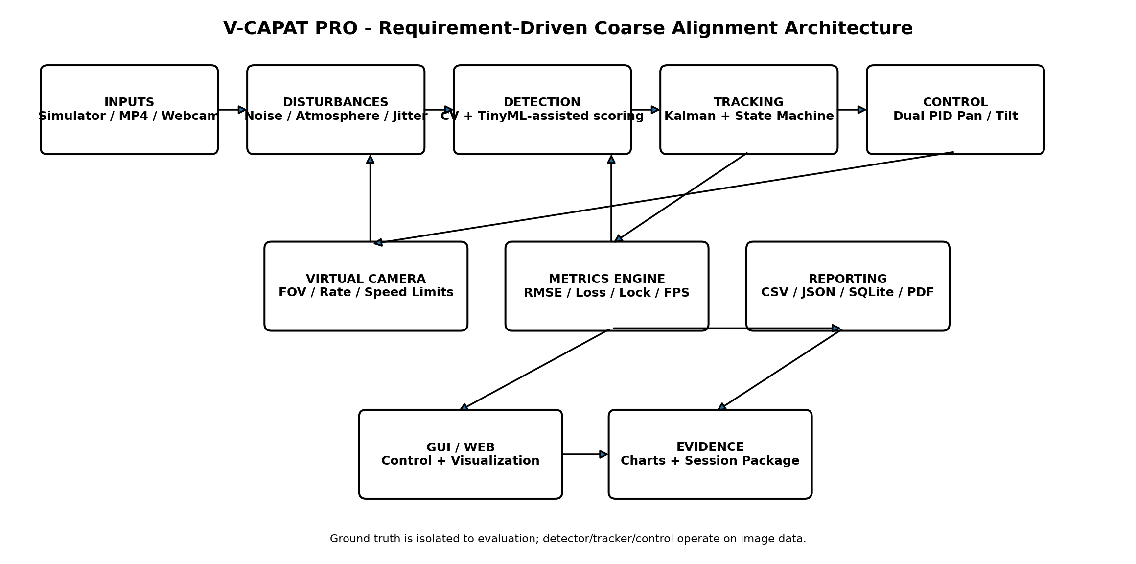
Figure 1. End-to-end software architecture. The engine is shared by desktop, browser, headless and benchmark modes.

3.1 Data flow
A frame is produced by the simulator, prerecorded video or webcam. Image-domain disturbances are applied before detection. Candidate regions are detected from the frame and optionally ranked by the TinyML-assisted scorer. The selected image centroid feeds a constant-velocity Kalman filter and lock-state machine. Pixel error relative to the image centre is mapped through the current FOV into angular error and processed by independent pan and tilt PID loops. The virtual camera applies speed/acceleration limits. The metrics subsystem records each frame and evaluates acquisition, tracking, loss, re-acquisition and processing performance.

3.2 Main modules
Subsystem | Primary modules | Responsibility
Simulation | simulation/world.py, camera.py, target.py, trajectories.py | World, beacon generation, motion and virtual camera
Disturbance | disturbance/* | Noise, atmosphere, jitter, platform motion, sensor approximations
Detection | detection/* | Classical CV, centroiding, TinyML-assisted candidate ranking
Tracking | tracking/*, core/state_machine.py | Kalman estimation, association, lock/recovery states
Control | control/* | Dual PID, search patterns, point-ahead and manual assist
Metrics | metrics/* | Per-frame telemetry, compliance, reports, stress evidence
Interfaces | gui/*, api/* | Desktop application, browser control room, REST/WebSocket

4. Configurable Virtual Environment, Camera and Targets

4.1 Virtual world and focal-plane camera
The simulator maintains a world larger than the camera viewport. The reference mission uses a 2000 x 2000 pixel scene. A virtual camera renders a configurable 640 x 480 default viewport with a 4 deg x 3 deg default FOV. Zero pan/tilt corresponds to the scene centre. Update rate is validated at 30-60 Hz and pan/tilt velocity is restricted to the 5-10 deg/s reference range. Optional digital zoom and acceleration limiting are available.

4.2 Beacon model
- One to five simultaneous optical beacon targets.
- Independent target width and height from 5 to 20 pixels; reference target 10 x 10 pixels.
- Square, Gaussian, circular and Airy-like visual profiles.
- Manual, centred or seeded-random initial position.
- Configurable brightness and optional colour representation; monochrome processing remains the default.
- Ground-truth coordinates retained separately for evaluation and never used to steer the tracker.

4.3 Motion library
Motion | Implementation intent
Straight line | Constant-direction movement with boundary handling
Circular | Periodic angular motion around a configured centre
Figure-8 | Two-axis periodic crossing trajectory
Random | Seeded stochastic movement for repeatability
Spiral / Sinusoidal | Optional additional benchmark patterns
LEO / UAV / HAPS / Aircraft / Star | Illustrative kinematic visual presets; not claimed as measured mission ephemerides
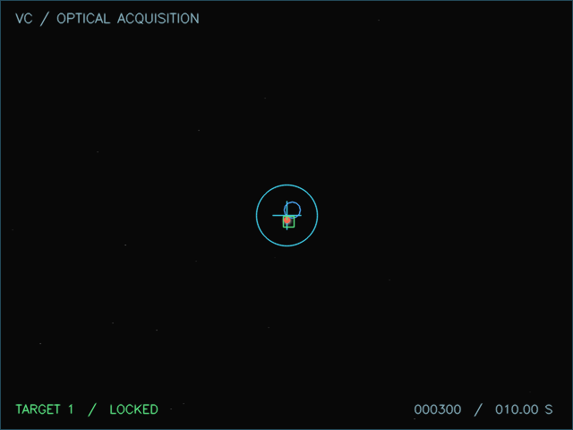
Figure 2. Example locked simulator frame from the development validation run.

5. Disturbance and Environmental Modelling
The disturbance chain is intentionally configurable so the same tracking algorithm can be exercised under repeatable changes in visibility and platform behaviour. The models are software-domain approximations intended for algorithm development; they are not a substitute for calibrated atmospheric propagation or laboratory optics.
Disturbance | Controls / limits | Purpose
Gaussian noise | std 0-20 px | Random sensor/image noise
Poisson noise | selectable | Photon-count style intensity variation
Salt & Pepper | 0-10% occupancy | Impulse/corruption robustness
Camera jitter | 0 to +/-20 px/frame | Platform/camera vibration proxy
Atmosphere | clear, haze, fog, rain, low-light | Visibility/contrast degradation
Turbulence warp | optional, configurable Fried parameter | Spatial distortion experiment
Contrast / brightness | operator adjustable | Explicit image degradation control
Platform motion | linear/circular/sinusoidal/random/figure-8; step <=20 px/frame | External platform motion proxy
Occlusion | scenario driven | Loss/coasting/re-acquisition testing
Sensor physics | QE/read/dark noise/exposure/bit-depth/hot pixels | Optional FPA-style engineering approximation

5.1 Reproducibility
Scenarios carry a random seed. Replaying the same configuration and seed reproduces the same simulator target/noise sequence within the software model, which supports fair algorithm comparisons and repeatable demonstrations.

5.2 Honesty of modelling scope
Atmospheric and sensor effects are image-domain or simplified engineering models. V-CAPAT PRO does not claim calibrated wave-optics propagation, scintillation certification, measured detector quantum-efficiency curves or flight qualification.

6. Automatic Beacon Detection and AI-Assisted Ranking

6.1 Classical computer-vision paths
The detection arena provides four independent image-processing paths: adaptive thresholding, morphological top-hat processing, template-based thresholding and optical flow. Connected components are evaluated using local brightness, geometry and track proximity. Weighted centroiding provides subpixel-like centroid refinement where intensity structure allows it.

6.2 TinyML-assisted candidate model
Version 1.1 includes a compact logistic classifier used in tinyml and ai_auto modes. It is trained deterministically at startup from synthetic candidate-feature distributions. Features include normalized brightness, compactness, aspect symmetry, plausible component area and distance from the predicted target location. The learned probability is fused with the interpretable candidate score.
Appropriate claim: "AI-assisted lightweight beacon candidate classification combined with explainable computer vision." The model is not presented as a deep neural network trained on real ISRO FSOC imagery.

6.3 Explainability and fallback
- Candidate score contributions are available for debugging/X-Ray views.
- Classical detection remains available if the learned candidate ranker is disabled.
- An ONNX/YOLO adapter exists for future trained weights, but no unverified beacon model is bundled.
- The detector never reads simulator ground-truth coordinates for target selection.

6.4 Automatic designation
For the mandatory single-target case, the highest-confidence valid candidate is associated with the active track. Multi-target extensions provide explicit designation and optional handover logic for research scenarios.

7. State Estimation, Acquisition and Pan-Tilt Control

7.1 Kalman state estimation
The tracker uses a constant-velocity state vector [x, y, vx, vy]. Prediction is performed every frame and measurement updates occur when a valid beacon candidate is associated. This reduces centroid noise and provides short-term motion prediction during brief detection gaps.

7.2 Lock-state machine
State | Meaning | Control behaviour
SEARCHING | No reliable target track | Search pattern / scene scan
ACQUIRING | Candidate observed but lock not yet confirmed | Prediction and bounded centring
LOCKED | Stable designated track | Closed-loop PID centring
COASTING | Short temporary detection gap | Kalman prediction maintains continuity
REACQUIRING | Loss threshold exceeded | Wider search/reassociation logic

7.3 Dual PID virtual pan-tilt control
The controller computes horizontal and vertical pixel error relative to the image centre. FOV and resolution convert pixel displacement to angular error. Independent PID loops generate pan and tilt velocity commands. Anti-windup, deadband and configured speed limits protect the simulated mechanism. Optional acceleration limiting prevents unrealistic instantaneous velocity changes.

7.4 External video behaviour
When a prerecorded benchmark is processed, the application deliberately bypasses simulated PTZ actuation. A prerecorded frame cannot be physically re-centred after capture; therefore detection/tracking quality is evaluated against labelled ground truth while keeping the control-path distinction explicit.

8. Metrics, Performance Logs and Evaluation Criteria
Every processed frame records source mode, timestamps, ground truth when available, detected/filtered coordinates, confidence, lock state, centroid and pointing errors, camera pan/tilt, processing time, instantaneous FPS and disturbance metadata. The session summary derives the metrics required by the problem statement.
Metric | Definition in V-CAPAT PRO | Acceptance target
Acquisition time | Time to first confirmed LOCKED state | <= 2 s
Tracking error | Pointing RMSE in simulator; centroid RMSE for labelled fixed-camera video | <= 10 px
Target loss | Percent of visible frames without valid lock/detection evidence | < 5%
Re-acquisition | Measured loss-to-recovered-lock event duration | <= 1 s
Processing rate | 1000 / average processing milliseconds | >= 20 FPS
Lock retention | Percent of visible frames retained in lock | Reported
Processing time | Average and maximum pipeline milliseconds | Reported
Error extrema | Mean/RMSE/maximum centroid or pointing error | Reported

8.1 Evidence outputs
- frames.csv - frame-by-frame telemetry
- summary.json and compliance.json - summary metrics and PASS/FAIL/N/A checks
- events.json - acquisition/loss/recovery events
- config_snapshot.json - exact scenario settings
- frames.sqlite - queryable time-series database
- charts/*.png - error/FPS/pan-tilt/link plots
- certificate.pdf - one-page software evidence summary
- optional annotated MP4 - visual audit trail
N/A is never silently counted as PASS. For example, a run with no target loss has no measured re-acquisition event and therefore reports re-acquisition as N/A.

9. Application Interfaces and Benchmark Workflow
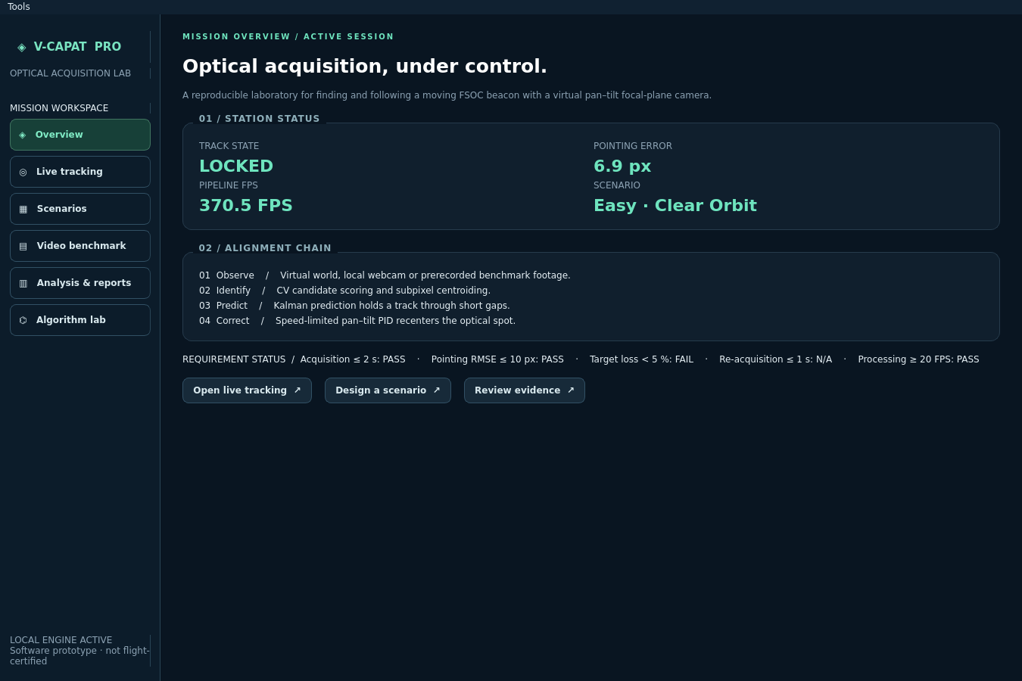
Figure 3. V-CAPAT PRO browser control room / project visual interface preview.

9.1 Desktop application
The PySide6 desktop interface exposes live tracking, scenario selection, camera and target configuration, disturbances, detector selection, control/tracking tuning, reports, stress tests and analysis tools. The reference constraints are validated before a scenario is accepted.

9.2 Browser companion control room
A six-page local control room provides Overview, Live Tracking, Scenarios, Video Benchmark, Analysis & Reports and Algorithm Lab views using the same shared engine. Version 1.1 exposes AI-assisted auto and TinyML detector selections in the browser as well as the desktop.

9.3 Judge benchmark path
The evaluator can open an MP4/AVI/MOV file. If a CSV with frame, timestamp_s, gt_x, gt_y and visible columns is supplied, the application measures centroid error and lock metrics against that file. The sample benchmark included under assets demonstrates the complete path.

10. Validation Methodology and Representative Results
Validation is layered: (1) unit/integration tests, (2) PS configuration/smoke validation, (3) deterministic scenario runs, and (4) labelled external-video processing. Performance values below are representative development-environment measurements from this codebase on 02 October 2026. They are not guaranteed on different hardware and are not flight-qualification results.
Run | Acq (s) | Error metric (px) | Loss (%) | Re-acq (s) | Proc. FPS | Result
Easy - Clear Orbit | 0.1 | Pointing RMSE 5.724 | 0.67 | N/A | 407.08 | All measured checks PASS
Emergency Maneuver | 0.1 | Pointing RMSE 9.323 | 0.74 | 0.867 | 83.36 | All five checks PASS
Labelled sample MP4 | 0.1 | Centroid RMSE 0.121 | 1.67 | N/A | 353.91 | Measured video checks PASS
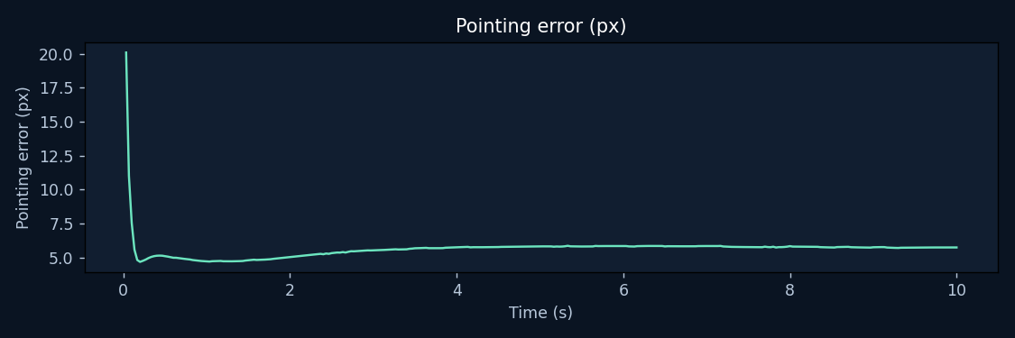
Figure 4. Easy clear-orbit pointing error across the 10 s validation run.

10.1 Automated test coverage
The source project includes tests for simulator configuration, target motion, disturbance/physics integration, tracking recovery, multi-target features, reports, plugin loading, web/API behaviour, compliance helpers and release-facing functionality. The Windows release pipeline installs all declared dependencies, runs the complete test suite, runs validate_mvp.py, then performs a packaged executable self-test.

11. Re-acquisition Stress Evidence
The Emergency Maneuver scenario is used because it contains an actual loss and recovery event; this avoids claiming re-acquisition performance from a run in which the target was never lost.
Measure | Observed | PS target | Assessment
Acquisition time | 0.1 s | <= 2 s | PASS
Pointing RMSE | 9.323 px | <= 10 px | PASS
Target loss | 0.74 % | < 5 % | PASS
Maximum re-acquisition | 0.867 s | <= 1 s | PASS
Average processing rate | 83.36 FPS | >= 20 FPS | PASS
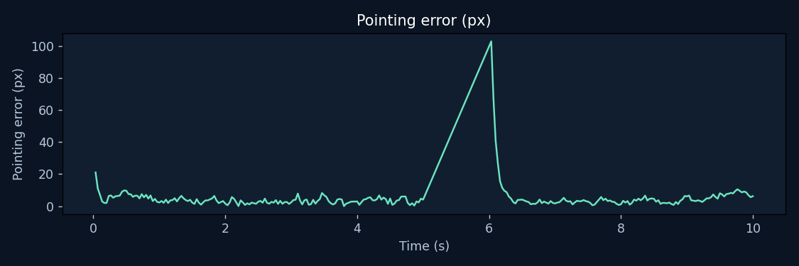
Figure 5. Emergency scenario pointing error. The large excursion corresponds to the forced loss/manoeuvre followed by recovery.
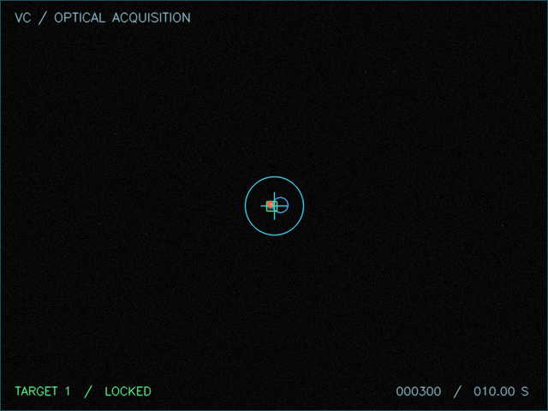
Figure 6. Final frame after recovery: target is re-centred and tracker state is LOCKED.

12. Standalone Windows Executable and Release Engineering
The mandatory standalone deliverable is addressed in v1.1 with a reproducible Windows release gate rather than an unverified PyInstaller command. The repository contains both an onedir and onefile build specification, Windows version metadata, packaged resource-path handling, executable self-test logic, SHA-256 release checksums and a GitHub Actions Windows builder.
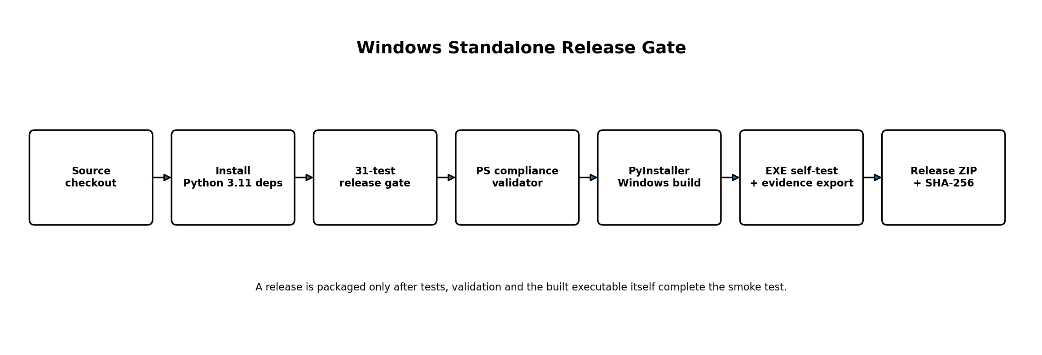
Figure 7. Release pipeline. Packaging is stopped if automated tests, PS validation or the built executable smoke test fails.

12.1 Primary build
Running build_release.bat builds and verifies both formats. The recommended SIH artifact is release/VCAPAT_PRO_v1.1.0_Windows_x64.zip, containing VCAPAT_PRO.exe and its runtime files plus a submission_docs folder. A onefile ZIP is generated as a secondary convenience build.

12.2 Packaged executable self-test
VCAPAT_PRO.exe --self-test checks that bundled scenarios, assets, sample benchmark data and this technical report are available from the frozen resource path. It then processes at least 30 frames and verifies that CSV/JSON/PDF evidence can be exported. The Windows build script runs this command against the freshly built executable before packaging the release.

12.3 CI option
The included .github/workflows/windows-release.yml workflow builds on GitHub windows-latest, runs the same release gate and uploads the verified release ZIPs. This provides a reproducible Windows build path even when a development machine does not have a clean packaging environment.
A Windows executable must still be built on Windows (or the provided Windows CI runner). This report does not falsely claim that a Linux-built binary is a verified Windows executable.

13. Limitations, Future Work and Conclusion

13.1 Current limitations
- Atmospheric turbulence and optical link effects are software approximations, not calibrated propagation through a measured channel.
- The TinyML classifier uses synthetic candidate-feature training data; a mission-quality detector needs representative labelled optical imagery.
- Webcam performance and final Windows GUI behaviour depend on the target demo machine and camera drivers.
- Synthetic LEO/UAV/HAPS/aircraft trajectories are visual/kinematic presets unless external ephemeris or measured data are explicitly supplied.
- Hardware-in-the-loop PTZ and real optical sensor calibration remain future integration tasks.

13.2 Future improvements
- Train and validate a compact neural beacon detector on representative real/synthetic optical datasets.
- Add calibrated wave-optics/turbulence propagation and measured FPA response models.
- Integrate real PTZ hardware through the existing controller/plugin boundary.
- Validate performance across multiple machines and long-duration sessions.
- Add signed Windows releases and organization-specific code-signing when a certificate is available.

13.3 Conclusion
V-CAPAT PRO implements the complete software coarse-alignment loop requested by SIH26169: configurable virtual environment, moving beacon generation, automatic acquisition, image-based position estimation, continuous tracking, closed-loop virtual pan-tilt control, disturbances, recovery states and real-time/reportable performance metrics. Version 1.1 additionally makes the two mandatory submission risks explicit and actionable: a formal 10-15 page technical report is delivered with the source, and the Windows standalone package is generated through a test-gated, self-verifying build pipeline.

References
1. Smart India Hackathon 2026, Problem Statement SIH26169: AI-Based Virtual Camera Tracking System for Coarse Alignment of Mobile FSOC Terminals.
2. ITU-R Recommendation P.1817-1, propagation data required for the design of terrestrial free-space optical links.
3. H. Kaushal and G. Kaddoum (2017), Free Space Optical Communication: Challenges and Mitigation Techniques, IEEE Communications Surveys & Tutorials.
4. NASA/JPL acquisition, tracking and pointing literature referenced in the project research slide (NASA NTRS citation 20060040875).
5. R. E. Kalman (1960), A New Approach to Linear Filtering and Prediction Problems.

