ShareAPlate: A Web-Based Smart Leftover Food Exchange Platform for Surplus Food Redistribution

Abstract—Edible surplus food often goes uneaten because the people who could use it hear about it late or not at all. This paper presents ShareAPlate, a web-based prototype in which donors publish surplus-food listings and recipients, NGOs and community organizations search, filter and request them. The client side uses HTML, CSS and JavaScript, the server side uses Core PHP, and data are held in MySQL/MariaDB and accessed through PDO prepared statements; development took place in a local XAMPP environment. The modules cover authentication, donor and recipient workflows, request management, notifications, administration and expiry-aware handling, which marks a listing as expired and rejects new requests once its expiry time has passed. Password hashing, session-based authentication, role-based authorization, CSRF protection, input validation and output escaping are included as baseline security controls. The paper describes the problem, architecture, database entities, module integration and interface screenshots of the working prototype. No field deployment or measurement of food-waste reduction has been carried out, so the work demonstrates the technical feasibility of the workflow only.
Index Terms—food redistribution, food waste reduction, surplus food, web application, PHP, MySQL, role-based access, community platform

I. Introduction
Food waste can arise at many points between preparation and consumption. The Food and Agriculture Organization (FAO) describes it as a decrease in the quantity or quality of food that results from the decisions and actions of retailers, food service providers and consumers [1]. The United Nations Environment Programme estimated that about 1.05 billion tonnes of food were wasted worldwide in 2022, equal to roughly 19% of the food available to consumers [2]. Alongside prevention, the FAO’s guidance on reduction includes recovering safe food for human consumption and redistributing it through channels such as food banks and community kitchens [3].
Redistribution depends on timely information. A donor has to say what is available, where it is and until when, and a recipient has to be able to respond while the food is still suitable for sharing. When this exchange takes place through calls and messages, nothing records who asked, who was accepted or whether the food was collected. ShareAPlate is a prototype built to supply that record. It is a full-stack web application with three roles, donor, recipient and administrator, each of which sees only the functions that concern it. The remaining sections describe the problem, the design, the implementation and the current limits of the prototype.

II. Problem Statement
Surplus food is easily lost when potential recipients do not know about it or find out too late. Informal arrangements leave no shared view of what is on offer, who has asked for it, whether the request was accepted or how much time remains before collection. Time is a real constraint: in a study of Italian manufacturers and retailers, surplus arose mainly as products approached their internal sell-by dates [4]. The problem addressed here is therefore the lack of a single role-based system that records listings, requests and their status and refuses requests for food that is past its expiry time.

III. Objectives
The objectives of ShareAPlate are:
- to improve coordination between surplus-food donors and recipients, NGOs and community organizations;
- to let donors post and manage surplus-food listings with little effort;
- to let recipients search, filter and request available food;
- to keep a traceable request lifecycle from submission to completion;
- to block new requests against donations whose expiry time has passed;
- to provide role-based access with secure authentication; and
- to keep structured records for administrative oversight and later evaluation of impact.

IV. Existing System
Surplus food is commonly shared by arrangement between a donor and someone they know, through a phone call, a message or word of mouth. This suits occasional small donations, but it produces no consistent record of what is available or of the state of each donation, and there is no single place from which an administrator could review users, donations, requests and complaints. Studies of organized donation describe political, legal, social and logistical barriers [5], and a case study of Italian food manufacturers identified measurement and control systems and carefully designed partnerships with non-profit organizations as key success factors [6]. ShareAPlate replaces the scattered process with one workflow and one set of records.

V. Proposed System
In the proposed system a donor creates a listing that gives the food, its quantity, its location and the time until which it is available. A recipient browses the listings, submits a request, and the donor accepts or rejects it. An accepted request moves on to collection or delivery and is finally marked complete.
Donation and request status are kept in a relational database rather than in participants’ memory. When a donation passes its configured expiry time, it is marked Expired and no new request can be made against it, which stops recipients from asking for food that is no longer available.

VI. System Architecture
ShareAPlate has four layers, shown in Fig. 1. The presentation layer (HTML, CSS and JavaScript) runs in the browser. The application layer, written in Core PHP, performs authentication, applies the business rules and handles requests. Below it, a data-access layer built on PDO prepared statements carries out validated database operations on the data layer, a MySQL/MariaDB database holding users, donations, requests and notifications. The Donor, Recipient and Administrator roles sit above this stack, and authorization in the application layer determines what each signed-in user may do.
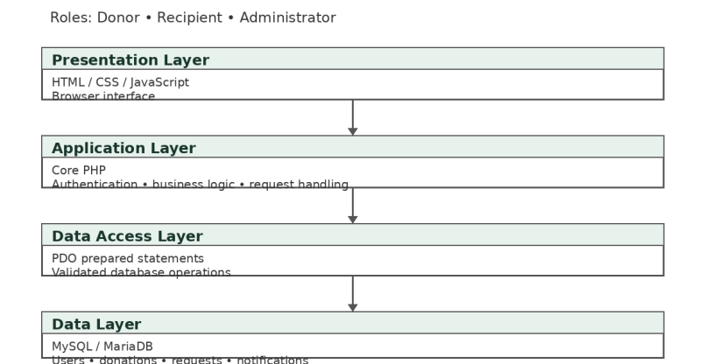
Fig. 1. High-level architecture of ShareAPlate.

VII. System Implementation

A. Development Environment and Backend
ShareAPlate was developed and run locally under XAMPP, a package that supplies Apache, MariaDB and PHP for development use [7]. The server-side logic is written in Core PHP and covers registration and login, donation operations, recipient requests, status transitions, notifications and administration.

B. Authentication and Security
Passwords are stored as hashes, never as plain text. PHP’s password_hash() function applies bcrypt by default and generates a random salt for each password [8], and login checks use password_verify(), which compares a password with its stored hash [9]. Every database operation uses a PDO prepared statement, which keeps user input separate from the SQL text and so helps prevent SQL injection [10]. The application also includes CSRF protection, the kind of control that OWASP advises adding to all state-changing requests [11], and it escapes user-supplied values before displaying them, a standard defence against cross-site scripting [12]. Session-based authentication, role-based authorization and input validation complete the baseline controls. These measures address common web risks and do not replace a formal security audit.

C. Donor Module
A signed-in donor creates and manages listings. Each listing records the food name, quantity, location, availability window, expiry time and current status. Donors answer incoming requests by accepting or rejecting them.

D. Recipient Module
Recipients browse the available listings, search and filter them by keyword, category, city and area, and submit a request against a listing for which they are eligible.

E. Request and Expiry Management
A donation normally passes through the states Available, Requested, Accepted or Rejected, Reserved, and Collected or Completed. Fig. 2 shows the main path together with the expiry rule: once the configured expiry time has passed, the donation is marked Expired and further requests against it are blocked.
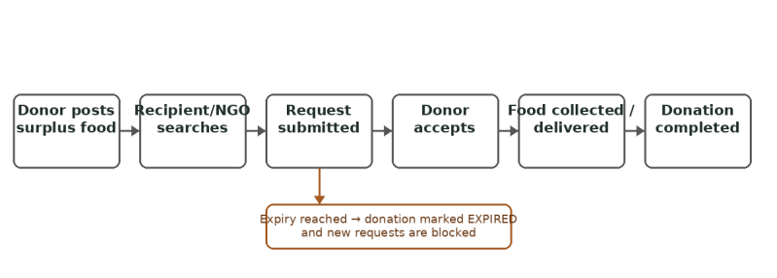
Fig. 2. Donation and request workflow with expiry handling.

F. Notifications and Administration
Notifications inform donors and recipients when the status of a donation or request changes. The administrator module gives one place from which to oversee users, donations, requests, complaints and system records.

VIII. Database Design
Five entities hold most of the data: Users, Food Donations, Food Requests, Notifications and Activity Logs. Table I lists representative fields and the purpose of each; it summarizes the design and is not a complete schema. A donation refers to its donor through donor_id, and a request refers to its donation and its recipient through donation_id and recipient_id.
TABLE I
Database Entities
Entity | Representative fields | Purpose
Users | id, name, email, password hash, role, contact, location | Identity and access
Food Donations | donor_id, food name, quantity, location, availability, expiry, status | Listings and lifecycle
Food Requests | donation_id, recipient_id, requested_at, status | Requests and outcomes
Notifications | user_id, type, message, read status, created_at | Event communication
Activity Logs | user_id, action, entity type/id, created_at | Operational traceability

IX. Application Interfaces and Module Integration
The modules in Table II are linked through the database and the role model. Authentication gates every page and determines which dashboard a user reaches. The request module joins a donation to a recipient and records the outcome, the notification module reports each change of state, and the administration module reads across all of these records. The application is an ordinary PHP web application and contains no machine-learning component: its workflow rules, authentication and role-specific views are deterministic and rule-based, which keeps their behavior predictable and easy to inspect.
TABLE II
Application Modules
Module | Interface / Function | Purpose
Authentication | Login / Registration / Logout | User access control
Donor | Donation management | Create and manage listings
Recipient | Search / Filter / Request | Discover and request food
Request | Accept / Reject / Status | Manage lifecycle
Notification | Donation and request updates | Communicate state changes
Administration | Users / Donations / Requests / Complaints | System oversight

X. Results and Discussion
The prototype joins listing, discovery, requests, notifications and administration in one application. The landing page (Fig. 3) invites a visitor either to donate food or to find available food, and it shows a counter of meals rescued that is updated from completed collections. After login, donors and recipients each reach their own dashboard. The donor dashboard (Fig. 4) shows counts of total donations, available, reserved and collected items, meals shared and pending requests, together with a “Post food” button. The recipient page (Fig. 5) shows the recipient’s request counts and filters for keyword, category, city and area.
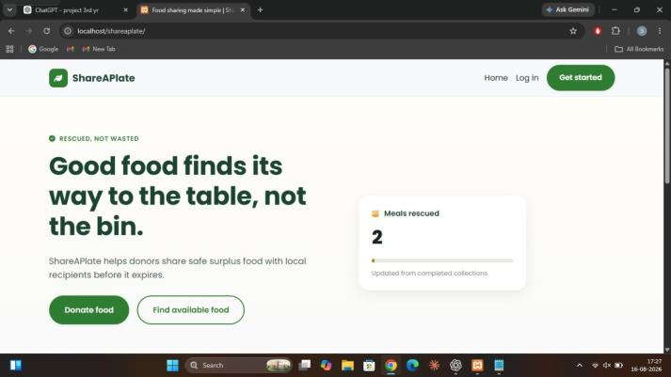
Fig. 3. ShareAPlate landing interface.
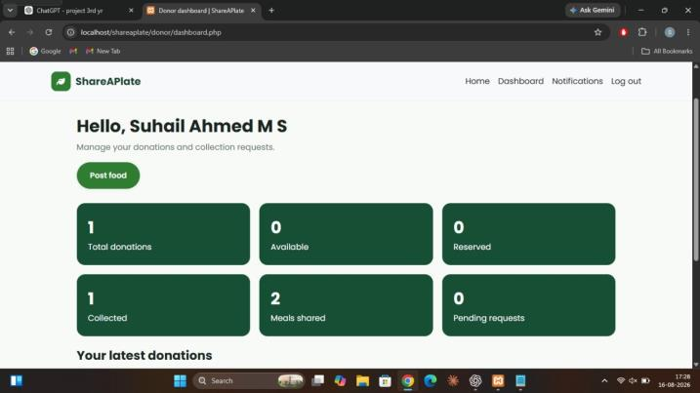
Fig. 4. Donor dashboard interface.
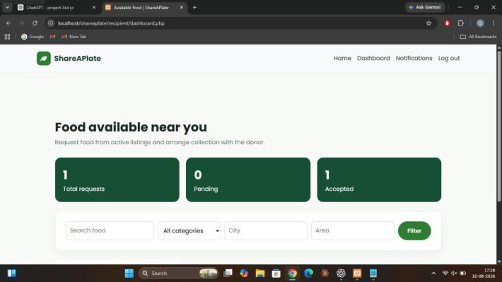
Fig. 5. Recipient dashboard interface.
The screenshots were taken from a local instance (localhost) and show that the application flow works from end to end. They say nothing about impact at community scale, and the counter values in them should not be read as results. Establishing impact would require a pilot with a defined method that records completed collections, utilization, the share of donations that expire unused, participation, the time taken to answer requests and, ultimately, any change in food waste.

XI. Advantages
The proposed system offers the following advantages:
- It brings listing, discovery, requests, notifications and administration into one application.
- Each role is given only the access it needs.
- Donation and request status are tracked in structured records rather than informally.
- Expired donations are handled by the application instead of by manual checks.
- It applies the baseline web-security controls described in Section VII-B.
- The data model leaves room for later analytics.
- It can be extended with mapping, messaging, verification and mobile access.

XII. Limitations
ShareAPlate is an academic prototype run on a local XAMPP installation, which is intended for development rather than production use [7]. It has not been security-audited. Besides the controls in Section VII-B, practices such as renewing the session identifier after login, setting the Secure, HttpOnly and SameSite cookie attributes and enforcing session timeouts on the server [13] should be reviewed before any public deployment.
No field study has measured the effect of the system on a community. The software also does not verify food safety, the identity or eligibility of donors and recipients, or legal compliance. In India, donation of surplus food to non-profit organizations is covered by regulations from the Food Safety and Standards Authority of India that are meant to give donation a legal footing [14]; observing them is a matter for the people and organizations involved, not something the application enforces. Physical logistics, meaning the movement of food from donor to recipient, also lie outside the software, and earlier work lists legal and logistical barriers to food donation [5].

XIII. Future Scope
Location-based matching with map integration, SMS, email and push notifications, and image upload with moderation would make listings easier to find and to judge. Careful partnership design with non-profit organizations has been reported as a success factor in surplus-food redistribution [6], which makes verified accounts for NGOs and community organizations a natural next step.
A mobile or progressive-web-app version, multilingual support, accessibility improvements and analytics on demand patterns and expiry risk are further options, as is integration with approved public-service systems. Above all, a formal pilot with defined indicators and food-safety procedures is needed before any claim about impact can be made.

XIV. Conclusion
ShareAPlate combines donor-side publishing, recipient-side discovery, request-status management, notifications, expiry handling, role-based authentication and administrative oversight in a single web application for surplus-food redistribution.
The current build shows that this coordination workflow is technically feasible. It does not show that any measurable community impact has been achieved. Moving toward real use would call for a controlled pilot with clear food-safety procedures, user verification, privacy safeguards, defined operational responsibilities, measurable indicators and independent evaluation.

