Production-grade RAG
A local, cited, evaluated question-answering system over policy and runbook documents
Walkthrough · architecture · 7 build phases · demo · evaluation · interview notes

Suhail Ahmed · October 2026

Component | Choice
Vector DB | Weaviate 1.27.27 (Docker), hybrid BM25 + HNSW
Embeddings | bge-m3 via Ollama (local, 1024-dim)
Reranker | cross-encoder/ms-marco-MiniLM-L-6-v2 (sentence-transformers, CPU)
LLM | qwen2.5:7b via Ollama, temperature 0
Serving | FastAPI + Streamlit
Quality | 40-question golden set, metrics, thresholds, GitHub Actions gate

1. What this project is
A retrieval-augmented generation (RAG) system that answers questions about 21 internal-style documents (investment policies, risk frameworks, fund factsheets, data-platform runbooks, ADRs, security standards) and cites every sentence with a numbered source. It runs fully locally on a CPU laptop: no cloud API keys, no GPU. It is built to show the production concerns that a toy RAG skips:
- Document versions: superseded documents (e.g. Risk Management Framework v1.0) are filtered out, so the current 2.0% VaR limit wins over the old 2.5%.
- Exact identifiers: hybrid search (BM25 keywords + vectors) so codes like ERR-PIPE-4012 are found exactly.
- Precision: a cross-encoder reranker picks the best 5 of 30 candidates.
- Grounding: a deterministic citation checker rejects uncited sentences, invalid source numbers and numbers that do not appear in the cited source; one retry, then a refusal.
- Honest refusals: questions the documents cannot answer get "I don't know based on the documents."
- Measurement: a 40-question golden set, retrieval + generation metrics, thresholds and a CI gate.

Headline numbers (full 40-question run, alpha 0.5)
Metric | Value | What it means
hit@5 | 1.000 | the right document is in the final top 5
section hit@5 | 1.000 | the right section is in the final top 5
MRR (after rerank) | 0.898 | how high the right section ranks
citation valid | 0.975 | answers that passed the citation checker
unanswerable refusal accuracy | 1.000 | never invents an answer (5/5 refused)
wrong refusal rate | 0.143 | answerable questions refused (5/35): the cost of strictness
cited correct doc | 1.000 | answers cite an expected document
Ragas faithfulness (5-Q subset) | 1.000 | local LLM judge: claims supported by context
avg seconds / question (box) | 14.5 | ~3x slower on the CPU laptop

2. Architecture
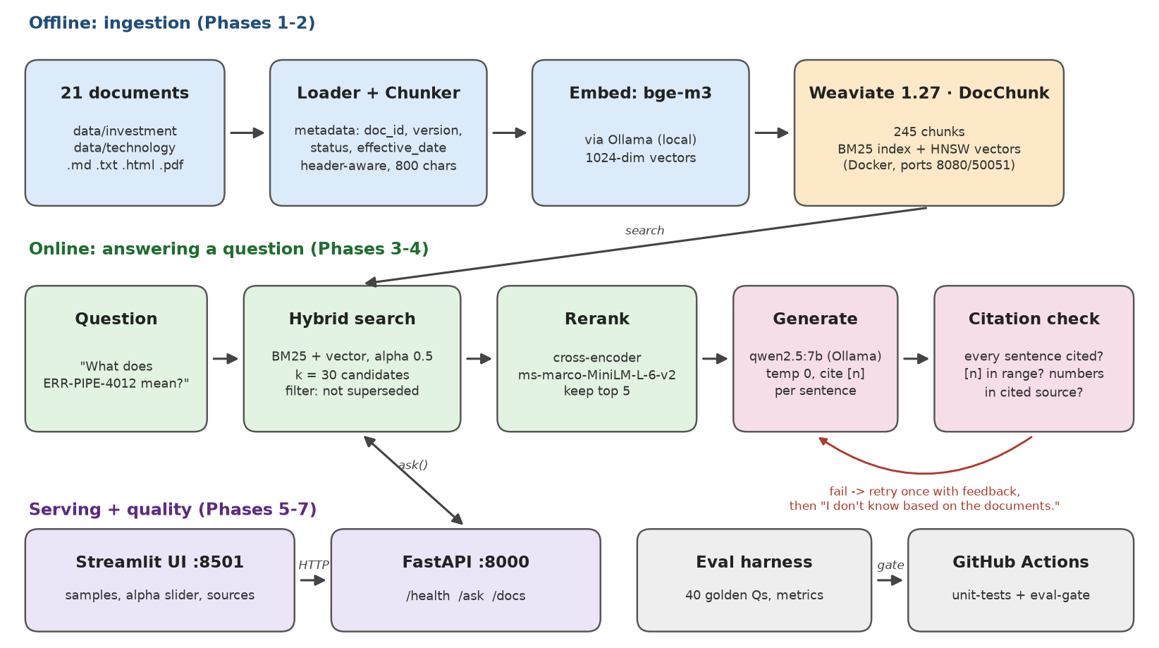
Figure 1. End-to-end architecture: offline ingestion, online answering, serving and quality gates.
- Ingestion (offline): loaders read .md/.txt/.html/.pdf and attach metadata (doc_id, version, status, effective_date); the chunker splits on headings (800 characters, 100 overlap, tables kept whole); bge-m3 embeds each chunk; Weaviate stores text + vector + metadata in the DocChunk collection (245 objects).
- Answering (online): hybrid search returns 30 candidates (alpha 0.5, superseded excluded) -> the reranker keeps 5 -> qwen2.5:7b writes a cited answer -> the checker validates it (retry once, else refuse).
- Serving: FastAPI loads everything once at startup and exposes /health and /ask; Streamlit is a thin client.
- Quality: run_eval computes metrics on the golden set; check_gate compares them with thresholds.yaml; GitHub Actions runs unit tests and a retrieval gate on every PR, and a generation subset nightly.

3. The seven build phases

Phase 1 - Load and chunk
Files: src/ingest/loaders.py, src/ingest/chunker.py, tests/test_chunker.py
Read four file formats into one Document shape with metadata parsed from front matter / headers (doc_id, version, status, effective_date). Split by Markdown headings first, then by size, keeping the heading path in each chunk ('Runbook > 3. ERR-PIPE-4012 ...') and never cutting a table in half.
pytest -v tests/test_chunker.py

Phase 2 - Embed and index
Files: docker-compose.yml, src/ingest/indexer.py
Start Weaviate 1.27.27 in Docker, embed chunks with bge-m3 through Ollama and upsert them with deterministic ids (doc_id::version::index) so re-running is safe. Note: Weaviate 1.27.0 had a bug; 1.27.27 fixes it.
docker compose up -d
ollama pull bge-m3
uv run python -m src.ingest.indexer --recreate

Phase 3 - Retrieve and rerank
Files: src/retrieval/retriever.py, src/rerank/reranker.py, compare_demo.py, tests/test_reranker.py
Hybrid search (BM25 + vector, alpha) with a filter that excludes superseded documents, then a cross-encoder re-scores question+chunk pairs. compare_demo prints top-5 before and after reranking.
uv run python -m src.retrieval.search_demo "What does ERR-PIPE-4012 mean?"
uv run python -m src.retrieval.compare_demo

Phase 4 - Generate with citations
Files: src/generate/prompt.py, citations.py, answer.py, tests/test_citations.py
Numbered sources [1]..[5] in the prompt; strict rules (cite every sentence, exact refusal string). A pure-Python checker splits sentences, validates [n] and numbers; on failure the model gets the errors as feedback once.
uv run python -m src.generate.answer "What is the current equity VaR limit?"

Phase 5 - Evaluation harness
Files: src/eval/run_eval.py, metrics.py, ragas_judge.py, sweep_alpha.py, eval/thresholds.yaml, check_gate.py
40 golden questions in five types. Retrieval metrics (hit@5, recall@5/30, section hit@5, MRR), generation metrics (citation validity, refusal accuracy, wrong refusals, cited-correct-doc, number recall), optional Ragas faithfulness with a local judge. Resumable, filterable, with an alpha sweep.
uv run python -m src.eval.run_eval --retrieval-only
uv run python -m src.eval.sweep_alpha
uv run python -m src.eval.run_eval # full, ~10 min box / ~30-45 min laptop
uv run python -m src.eval.check_gate

Phase 6 - CI eval gate
Files: .github/workflows/rag-ci.yml, src/eval/summary_md.py, scripts/ci_eval_gate.sh, README_CI.md
unit-tests job (no services) -> eval-gate job (Weaviate service container, Ollama + bge-m3 cached, index, retrieval-only eval, gate, Markdown summary, artifact). Nightly/manual full-eval adds the LLM on a subset. Branch protection requires unit-tests and eval-gate.
bash scripts/ci_eval_gate.sh # same steps locally

Phase 7 - Demo portal
Files: src/api/app.py, ui/streamlit_app.py, tests/test_api.py, scripts/demo_screenshots.py
FastAPI with a lifespan hook that builds ONE pipeline (Weaviate connection, warmed reranker, embedder and LLM) and closes it on shutdown; Pydantic validation; 503 when services are down. Streamlit page with health badge, sample questions, alpha slider, cited answers, source expanders, refusals and history.
uv run uvicorn src.api.app:app --reload
uv run streamlit run ui/streamlit_app.py

4. Windows setup (CPU laptop)
Prerequisites: Python 3.12, uv, Docker Desktop, Ollama for Windows, Git. All commands in PowerShell from the repo root.
# one-time
uv sync # creates .venv from pyproject.toml + uv.lock
uv add fastapi "uvicorn[standard]" streamlit httpx requests
docker compose up -d # Weaviate 1.27.27 on :8080 / :50051
ollama pull bge-m3 # ~1.2 GB
ollama pull qwen2.5:7b # ~4.7 GB
$env:RERANK_MODEL = "cross-encoder/ms-marco-MiniLM-L-6-v2" # ~90 MB, downloaded on first use
uv run python -m src.ingest.indexer --recreate # ~3 min on the laptop (245 chunks)
uv run pytest -v # 41 tests, no services needed

Run the demo (two terminals)
# Terminal 1 - API (wait for "Pipeline ready, warm-up took ...s")
$env:RERANK_MODEL = "cross-encoder/ms-marco-MiniLM-L-6-v2"
uv run uvicorn src.api.app:app --reload # http://localhost:8000/docs

# Terminal 2 - UI
uv run streamlit run ui/streamlit_app.py # opens http://localhost:8501

# Quick check from a third prompt
curl.exe http://localhost:8000/health

- Use curl.exe (not curl) in PowerShell: plain curl is an alias for Invoke-WebRequest.
- --reload restarts the API on every code save, and every restart re-runs warm-up (~30-60 s on the laptop). Drop --reload when demoing.
- Set RERANK_MODEL in the same terminal as uvicorn; environment variables are per terminal.
- First answer on the laptop: roughly 40-150 s for generation; the UI allows up to 10 minutes.

5. Demo walkthrough
All screenshots were taken with headless Chromium (Playwright) at 1400x900 against the running API and UI (scripts/demo_screenshots.py). Each answer is a real model output.
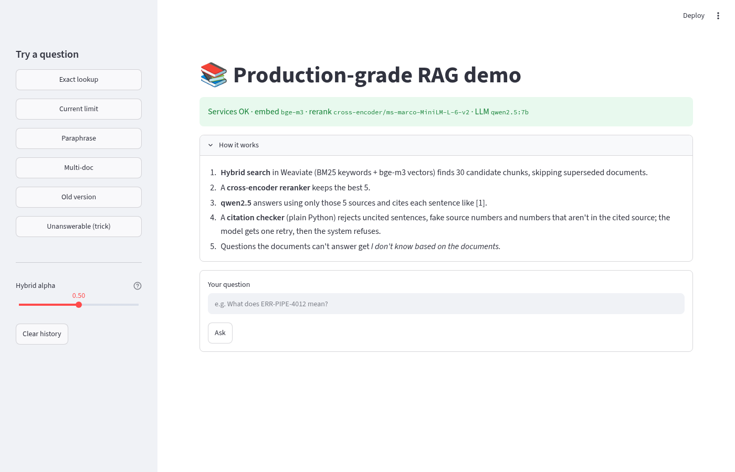
Figure 2. Home page: green health badge listing the three models, sample questions in the sidebar, the hybrid alpha slider, and the 'How it works' explainer.
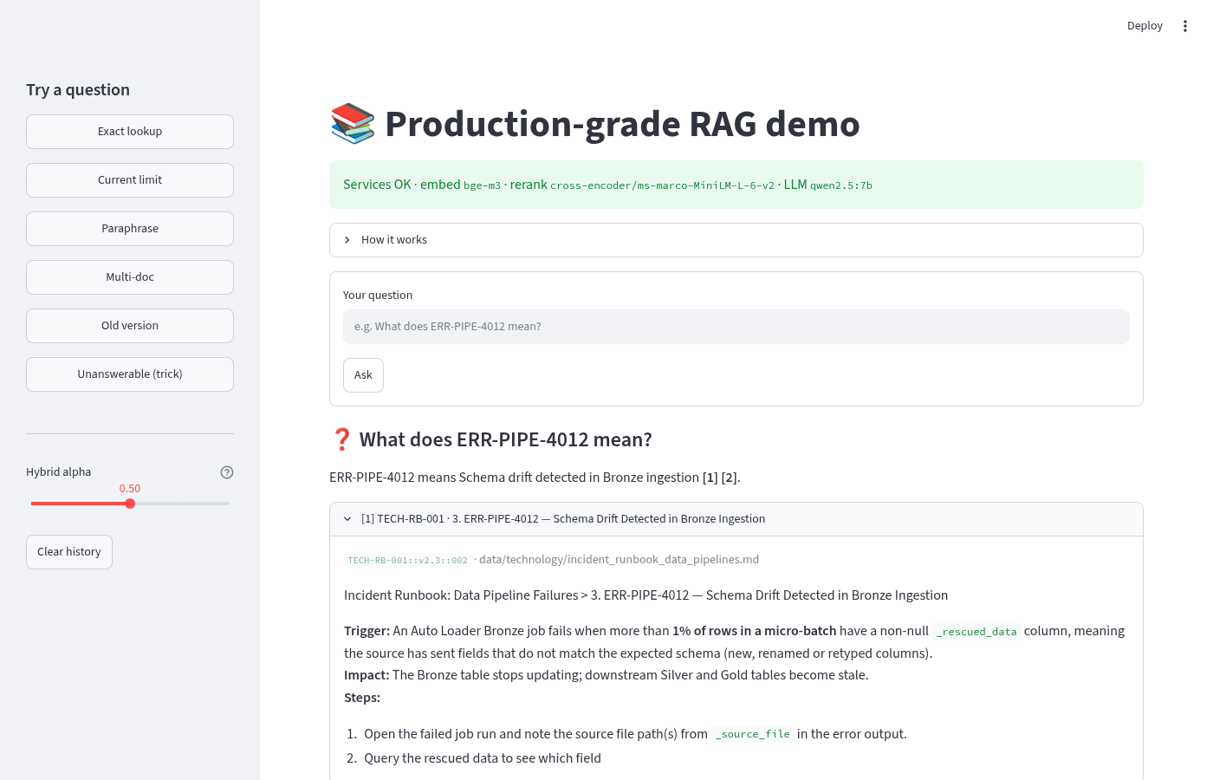
Figure 3. Exact lookup: 'What does ERR-PIPE-4012 mean?' answered with citations [1][2]; source [1] expanded to show the runbook chunk, its chunk id and file.
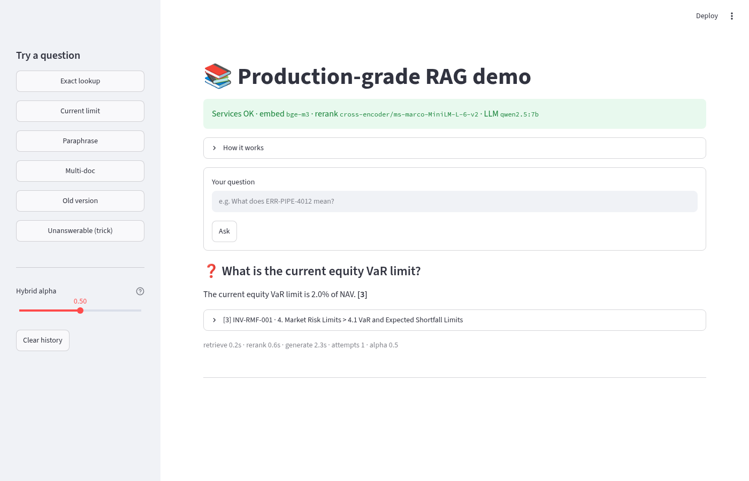
Figure 4. Version conflict handled: the current equity VaR limit is 2.0% of NAV from RMF v2.0. The superseded 2.5% (v1.0) is filtered out of retrieval.
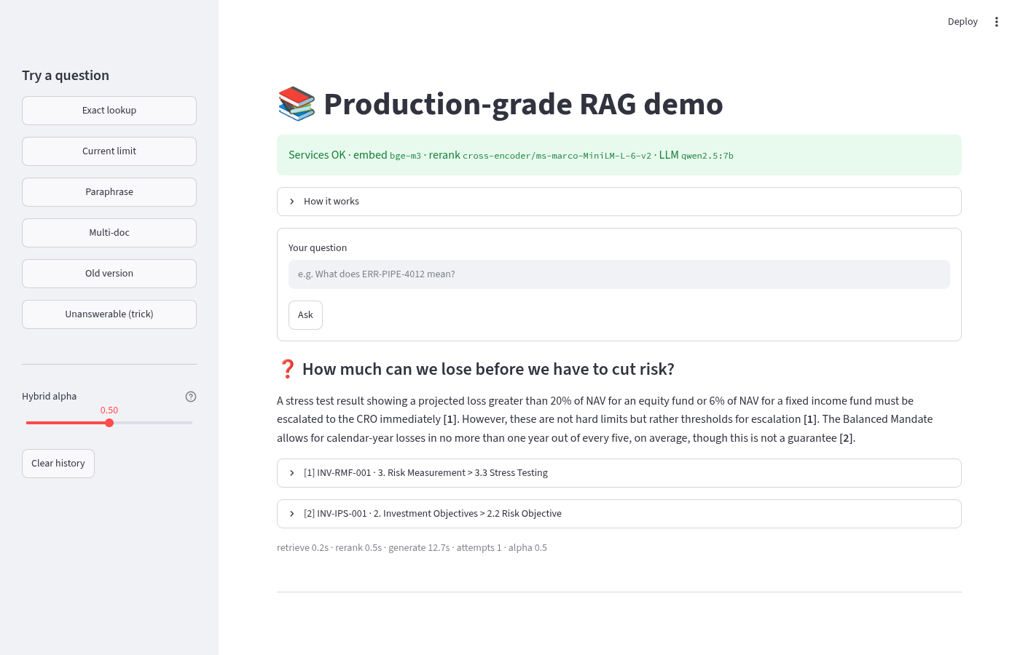
Figure 5. Paraphrase: 'How much can we lose before we have to cut risk?' shares no keywords with the policy text; vector search still reaches the stress-testing and risk-objective sections.
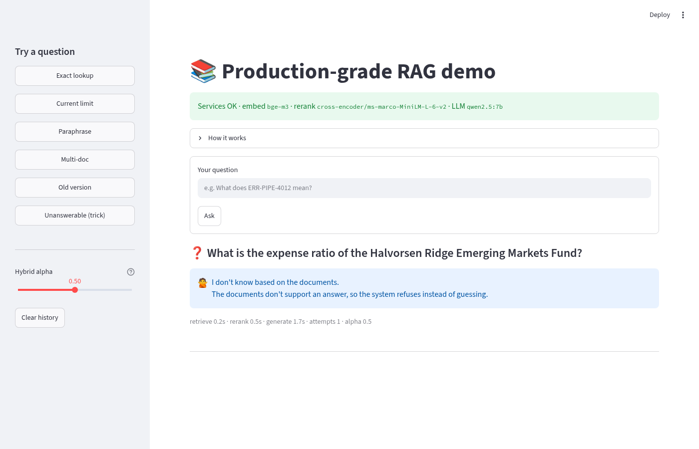
Figure 6. Unanswerable trick question (a fund that does not exist): the system refuses with the exact refusal string instead of inventing an expense ratio.
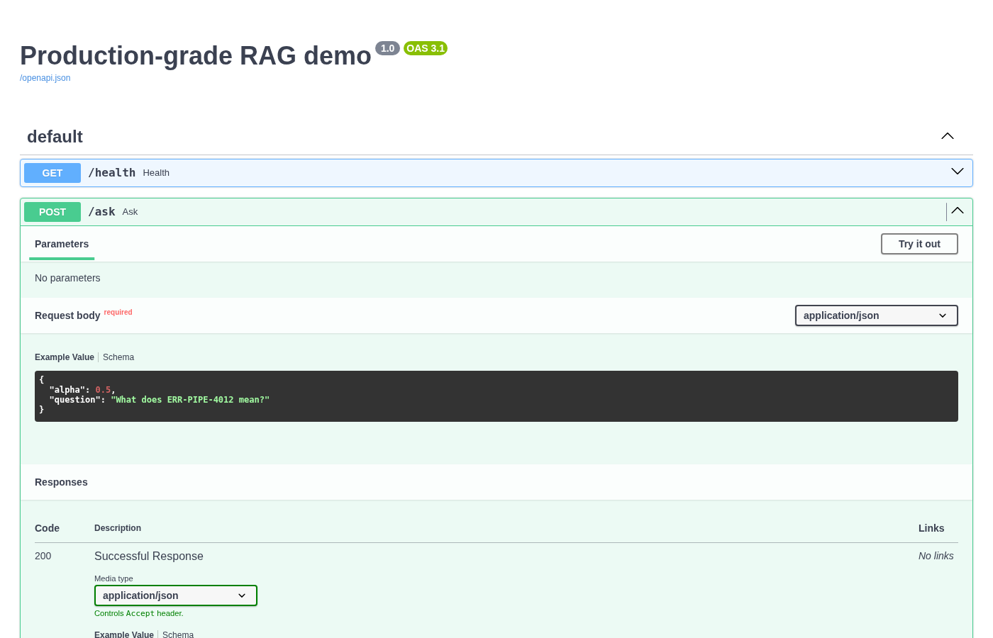
Figure 7. FastAPI Swagger UI at /docs: the /ask request schema with its example, generated from the Pydantic models.
A 25-second screen recording of typing a question and opening a source is included as demo_ask_question.mp4 (and .webm).

API responses (curl)
POST /ask {"question": "What does ERR-PIPE-4012 mean?"}
{
"question": "What does ERR-PIPE-4012 mean?",
"answer": "ERR-PIPE-4012 means Schema drift detected in Bronze ingestion [1][2].",
"refused": false,
"attempts": 1,
"sources": [
{
"n": 1,
"chunk_id": "TECH-RB-001::v2.3::002",
"doc_id": "TECH-RB-001",
"section": "3. ERR-PIPE-4012 — Schema Drift Detected in Bronze Ingestion",
"source_file": "data/technology/incident_runbook_data_pipelines.md",
"text": "Incident Runbook: Data Pipeline Failures > 3. ERR-PIPE-4012 — Schema D..."
},
"..."
],
"timings": {
"retrieve": 0.21,
"rerank": 0.55,
"generate": 3.44
},
"check_errors": []
}

POST /ask {"question": "What is the expense ratio of the Halvorsen Ridge Emerging Markets Fund?"}
{
"question": "What is the expense ratio of the Halvorsen Ridge Emerging Markets Fund?",
"answer": "I don't know based on the documents.",
"refused": true,
"attempts": 1,
"sources": [],
"timings": {
"retrieve": 0.32,
"rerank": 0.52,
"generate": 1.26
},
"check_errors": []
}

GET /health
{
"status": "ok",
"weaviate": true,
"ollama": true,
"missing_models": [],
"models": {
"embed": "bge-m3",
"rerank": "cross-encoder/ms-marco-MiniLM-L-6-v2",
"chat": "qwen2.5:7b"
}
}

POST /ask {"question": ""} -> 422 Unprocessable Entity
POST /ask {"question":"ok?","alpha":2} -> 422 "Input should be less than or equal to 1"
Pipeline not started (services down) -> 503 "Pipeline not available: ..."

6. Evaluation results
Golden set: 40 questions - 14 exact_lookup, 9 semantic, 7 multi_doc, 5 conflict_version, 5 unanswerable. Box timings: retrieval-only run 28 s; full run 580 s (14.5 s per question); expect ~3x on the laptop.

6.1 Retrieval-only run (alpha 0.5)
Type | n | hit@5 | recall@5 | recall@30 | section hit@5 | MRR hybrid | MRR rerank
conflict_version | 5 | 1.000 | 0.900 | 0.900 | 1.000 | 1.000 | 0.900
exact_lookup | 14 | 1.000 | 0.964 | 1.000 | 1.000 | 0.911 | 0.911
multi_doc | 7 | 1.000 | 0.857 | 1.000 | 1.000 | 0.738 | 0.810
semantic | 9 | 1.000 | 1.000 | 1.000 | 1.000 | 0.833 | 0.944
unanswerable | 5 | - | - | - | - | - | -
ALL | 40 | 1.000 | 0.943 | 0.986 | 1.000 | 0.869 | 0.898

MRR hybrid is the rank of the right section before reranking; MRR rerank after. Reranking lifts it from 0.869 to 0.898 overall (unanswerable questions have no expected source, so retrieval metrics are blank).

6.2 Alpha sweep (retrieval-only, 35 answerable questions)
alpha | hit@5 | section hit@5 | recall@30 | MRR hybrid | MRR rerank | exact MRR hybrid | semantic MRR hybrid
0.0 | 0.971 | 0.971 | 0.986 | 0.681 | 0.869 | 0.748 | 0.534
0.25 | 1.000 | 1.000 | 0.986 | 0.743 | 0.898 | 0.780 | 0.647
0.5 | 1.000 | 1.000 | 0.986 | 0.869 | 0.898 | 0.911 | 0.833
0.75 | 1.000 | 1.000 | 0.986 | 0.893 | 0.898 | 0.917 | 0.944
1.0 | 1.000 | 1.000 | 0.986 | 0.898 | 0.898 | 0.881 | 0.944

alpha 0 = BM25 only, 1 = vectors only. Pure BM25 misses one question entirely (hit@5 0.971). From 0.25 up the final top 5 is perfect because the reranker repairs the order; the hybrid ranking itself improves up to 0.75. 0.5 was kept as a balanced default: exact-ID questions peak at 0.5-0.75 and the final metrics are identical from 0.25 to 1.0.

6.3 Full end-to-end run (qwen2.5:7b, no Ragas)
Type | n | citation valid | unanswerable refused | wrong refusal | cited correct doc | number recall | avg s
conflict_version | 5 | 1.000 | - | 0.000 | 1.000 | 0.504 | 16.0
exact_lookup | 14 | 1.000 | - | 0.000 | 1.000 | 0.833 | 14.7
multi_doc | 7 | 0.857 | - | 0.429 | 1.000 | 0.286 | 15.6
semantic | 9 | 1.000 | - | 0.222 | 1.000 | 0.556 | 15.2
unanswerable | 5 | 1.000 | 1.000 | - | - | - | 9.5
ALL | 40 | 0.975 | 1.000 | 0.143 | 1.000 | 0.605 | 14.5

Most wrong refusals are multi-doc questions (3/7): the strict citation rules make the 7B model play safe when an answer needs facts from two documents. That is the deliberate trade-off: a refusal is cheaper than a wrong number in a risk context. Ragas faithfulness on a 5-question subset scored 1.00.

6.4 Quality gate output
Gate check: reports/full_run.json (mode=full, 40 questions, 2026-10-09T10:15:31)
PASS hit_at_5 1.0 (min 0.95)
PASS recall_at_5 0.943 (min 0.88)
PASS recall_at_30 0.986 (min 0.95)
PASS section_hit_at_5 1.0 (min 0.94)
PASS mrr 0.898 (min 0.82)
PASS citation_valid 0.975 (min 0.92)
PASS unanswerable_refusal_acc 1.0 (min 1.0)
PASS wrong_refusal_rate 0.143 (max 0.2)
PASS cited_correct_doc 1.0 (min 0.95)
PASS number_recall 0.605 (min 0.5)
SKIP faithfulness - (min 0.8)

GATE PASSED
exit 0

Gate check: reports/latest.json (mode=retrieval-only, 40 questions, 2026-10-09T11:04:25)
PASS hit_at_5 1.0 (min 0.95)
PASS recall_at_5 0.943 (min 0.88)
PASS recall_at_30 0.986 (min 0.95)
PASS section_hit_at_5 1.0 (min 0.94)
PASS mrr 0.898 (min 0.82)

GATE PASSED
exit 0

A forced failure (e.g. a stricter threshold) prints FAIL lines and exits 1, which fails the CI job and blocks the merge.

6.5 Unit tests
Test file | Tests | Needs services?
tests/test_api.py | 8 | no
tests/test_chunker.py | 8 | no
tests/test_citations.py | 9 | no
tests/test_gate.py | 6 | no
tests/test_metrics.py | 7 | no
tests/test_reranker.py | 3 | model download (MiniLM)
TOTAL | 41 | 41 passed in 8.29s

7. Interview talking points
- Why hybrid search? Vectors understand paraphrases ('lose before we cut risk') but blur exact tokens like ERR-PIPE-4012 or fund codes; BM25 is the opposite. The alpha sweep shows BM25-only misses a question and vector-only ranks exact IDs lower; hybrid gets both. I chose alpha with data, not by feel.
- Why a reranker? Bi-encoders compare two separately computed vectors; a cross-encoder reads question and chunk together, so it is more accurate but too slow for the whole corpus. Retrieve 30 cheaply, rerank to 5: MRR 0.87 -> 0.90.
- Document versions are a data problem, not a model problem. Every chunk carries version/status/effective_date metadata and retrieval filters out superseded documents, so the LLM never sees the stale 2.5% limit.
- Grounding is enforced in code. The prompt asks for citations, but a deterministic checker verifies them (every sentence cited, valid [n], numbers present in the cited chunk). One retry with feedback, then refuse. Cheap, explainable, no second LLM call in the happy path.
- Refusal is a feature. Unanswerable refusal accuracy is gated at 1.0. The cost is a 14% wrong-refusal rate, which I track with its own threshold (max 0.20) so strictness can't silently grow.
- Evaluation before tuning. A typed golden set (exact, semantic, multi-doc, conflict, unanswerable) shows where the system is weak (multi-doc). File-level hit@5 saturated at 1.0, so I added section-level hit and MRR to keep the metric informative.
- CI gate that fits the budget. Retrieval eval runs on every PR in minutes on a CPU runner with cached models; generation eval is nightly on a subset because a 7B model on 4 vCPUs is too slow for every PR.
- Serving design. Models load once in a FastAPI lifespan hook and are warmed so the first user doesn't wait; def endpoints run in a threadpool; a lock serializes LLM calls on CPU; /health reports each dependency and returns 503 when degraded; Pydantic validates input (422).
- Testability. The pipeline is injected through a FastAPI dependency, so API tests swap in a fake and run in seconds with no services. Unit tests cover chunking, citations, metrics, the gate and the API (41 tests).
- Local and private. Everything runs on a laptop (Ollama, Weaviate in Docker): no data leaves the machine, which matters for investment and security documents.
- What I'd do next. Streaming responses, a query rewriter for multi-doc questions, async job queue for concurrency, auth + rate limiting on the API, tracing (Langfuse/OpenTelemetry), a larger golden set with human-reviewed answers, and a GPU or hosted model for faster generation.

Likely questions and short answers
Question | Answer
How do you stop hallucinations? | Retrieve only current docs, force citations, verify them in code, refuse when unsupported; measure with faithfulness + refusal metrics.
How did you choose chunk size? | 800 chars with heading-aware splits keeps one procedure/table per chunk; section hit@5 = 1.0 confirms the right section is retrievable.
How do you know a change didn't break things? | The CI eval gate: PRs fail if retrieval metrics drop below thresholds set from measured numbers with a margin.
Latency? | Retrieve 0.2 s, rerank 0.5 s, generation 2-15 s on the box; generation dominates and scales with answer length.
Why local models? | Privacy and zero cost; the design is model-agnostic (swap CHAT_MODEL or point to a hosted endpoint).

