USER MANUAL

1. First, you will see the dashboard. Here you may choose any activities you want to do.

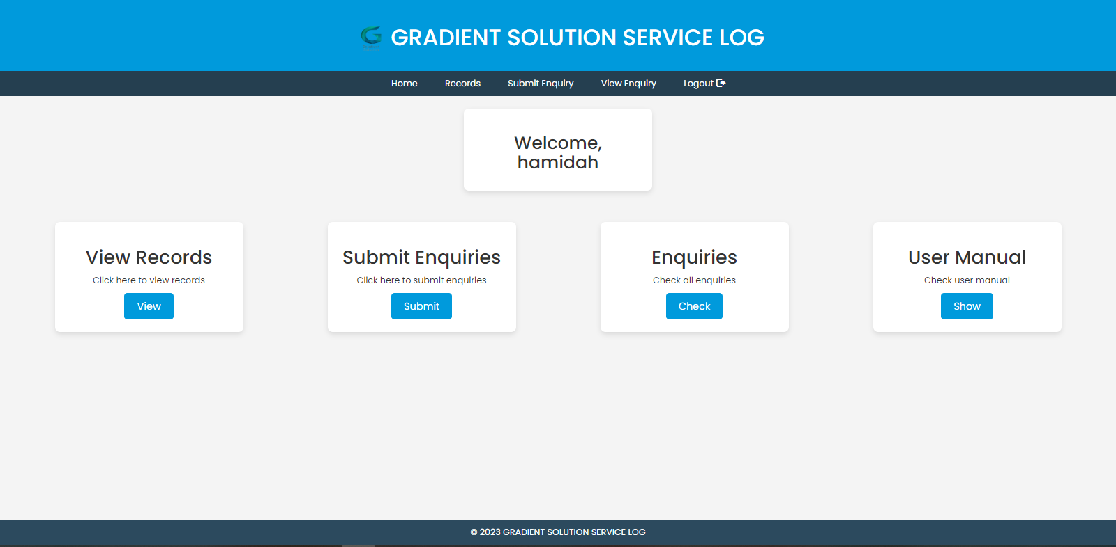

1. Here is the view records page. You can view you past service records.

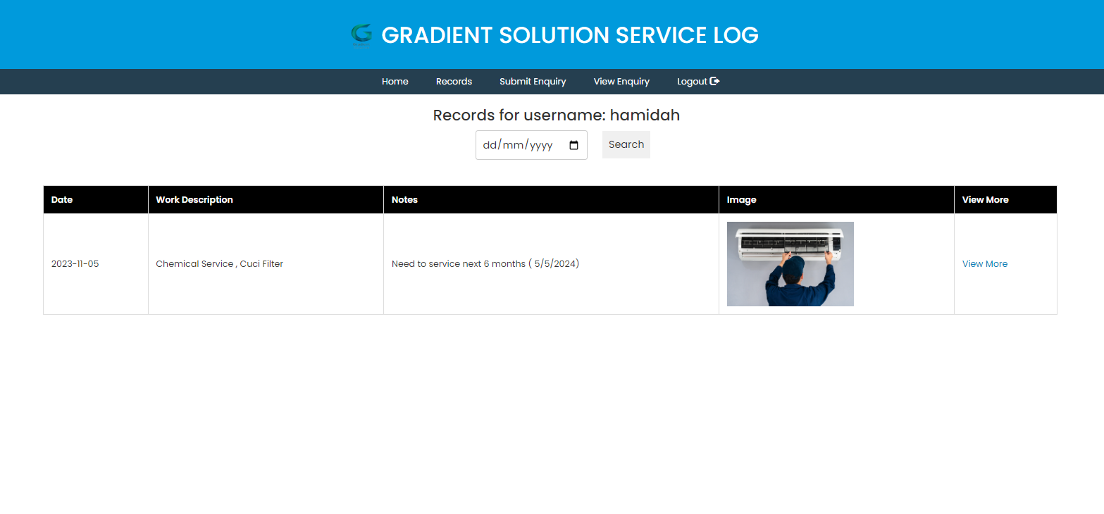

1. If you click ‘View More’ it will give you more detailed service records. You can click print f you want to print the record.

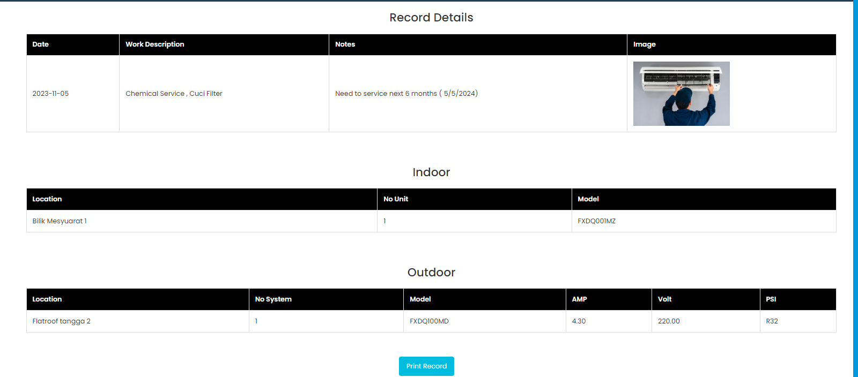

1. Here, you can submit enquiry to the team.

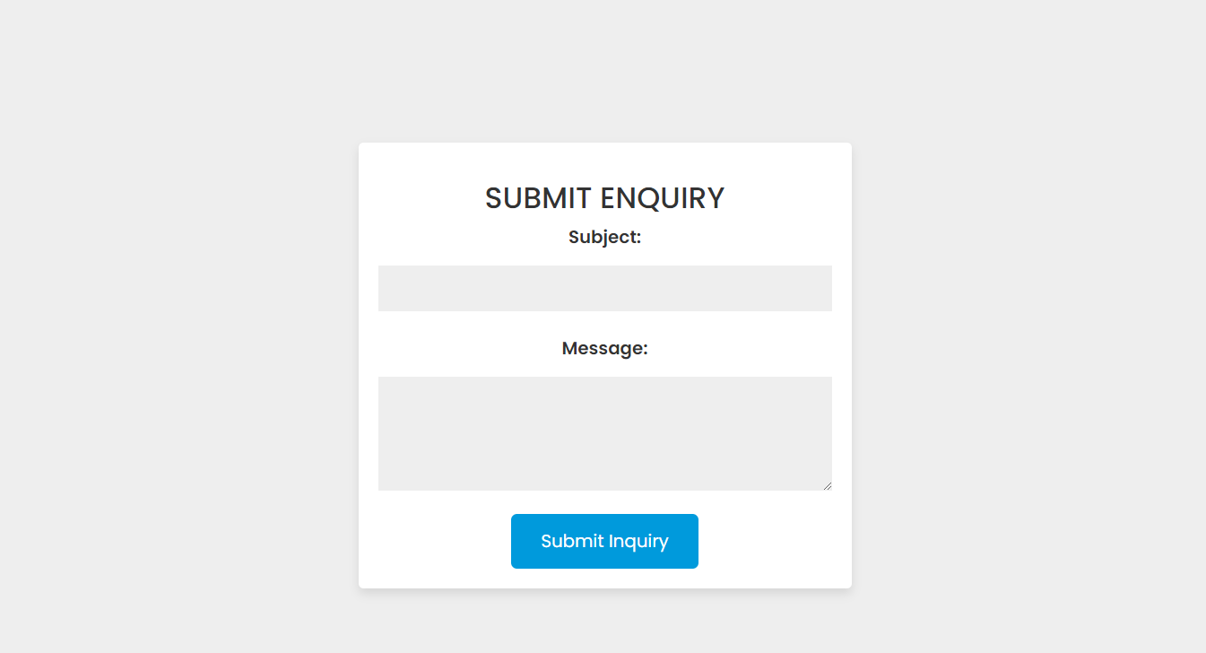

1. Here you will see all your enquiries. The green one is already answered by the team, and the red one has not yet been answered by the teams.

