**1.write a program to print the numbers from 10 to 50 using loop**

class First {

    public static void main(String[] args) {

        // Iterating from 10 to 50 using a for loop

        for (int i = 10; i <= 50; i++) {

            System.out.print(" "+i); // Printing the current value of 'i' in each iteration

        }

    }

}

**Output**



**2.write a program that find a given number is negative or positive**

import java.util.Scanner; // Importing the Scanner class to take user input

class Second {

    public static void main(String args[]) {

        Scanner obj = new Scanner(System.in); // Creating a Scanner object to read input

        System.out.print("Enter the number - ");

        int a = obj.nextInt(); // Taking an integer input from the user

        // Checking if the number is positive or negative

        if (a > 0) {

            System.out.println("positive"); // Printing "positive" if the number is greater than 0

        } else {

            System.out.println("negative"); // Printing "negative" if the number is 0 or negative

        }

    }

}

**Output**

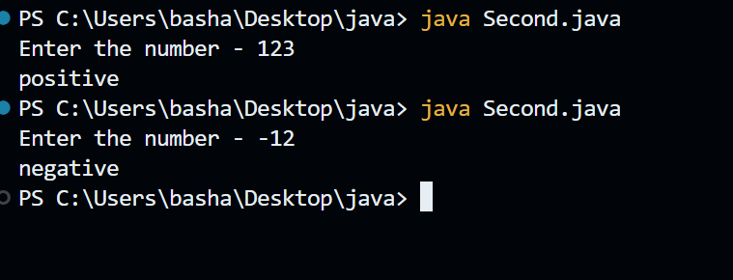

**3.Reverse the number**

class Third {

    public static void main(String args[]) {

        int n = 876;

        int m = 0;

        // Loop to reverse the number

        while (n > 0) {

            m = (n % 10) + (m * 10);  // Extract last digit and add it to the reversed number

            n = n / 10;  // Remove the last digit from n

        }

        // Print the reversed number

        System.out.println("Reverse number - " + m);

    }

}

**Output**

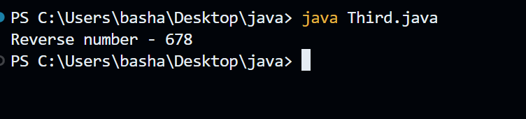

**4.Find the smallest number among three numbers**

import java.util.Scanner;

class Four {

    public static void main(String[] args) {

        Scanner scanner = new Scanner(System.in);

        // Taking three numbers as input from the user

        System.out.print("Enter the first number: ");

        int num1 = scanner.nextInt();

        System.out.print("Enter the second number: ");

        int num2 = scanner.nextInt();

        System.out.print("Enter the third number: ");

        int num3 = scanner.nextInt();

        // Finding the smallest number using conditional statements

        int smallest = num1;

        if (num2 < smallest) {

            smallest = num2;

        }

        if (num3 < smallest) {

            smallest = num3;

        }

        // Displaying the smallest number

        System.out.println("The smallest number is: " + smallest);

    }

}

**Output**

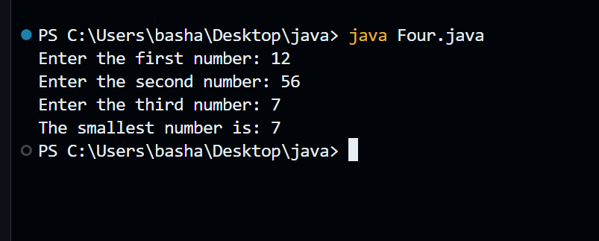

**5.Calculates the amount apply the discount**

import java.util.Scanner; // Importing Scanner class to take user input

class Five {

    public static void main(String args[]) {

        Scanner obj = new Scanner(System.in); // Creating a Scanner object to read input

        int amt = obj.nextInt(); // Taking an integer input for amount

        int dis; // Variable to store the discount amount

        // Checking if the amount is between 500 and 1000 (inclusive)

        if (amt >= 500 && amt <= 1000) {

            dis = amt * 10 / 100; // Calculating 10% discount

            amt = amt - dis; // Reducing discount from total amount

        }

        // Checking if the amount is greater than 1000

        else if (amt > 1000) {

            dis = amt * 20 / 100; // Calculating 20% discount

            amt = amt - dis; // Reducing discount from total amount

        }

        // If amount is less than 500, no discount is applied

        else {

            System.out.println("no discount");

        }

        // Printing the final amount after discount (if applicable)

        System.out.println(amt);

    }

}

**Output**

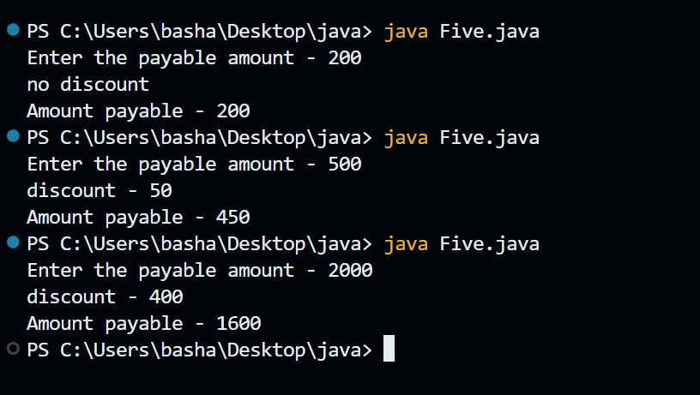

**6.Pattern printing**

class Six {

    public static void main(String args[]) {

        int n = 5; // Initialize the variable 'n' with value 5

        // Outer loop controls the number of rows (i.e., 5 rows)

        for (int i = 0; i < 5; i++) {

            // Inner loop controls the number of columns (i.e., 5 columns)

            for (int j = 0; j < 5; j++) {

                // Condition to check the position and print the respective value

                if (j <= i) {

                    System.out.print(n - j); // Print decreasing values from 'n' based on 'j'

                } else {

                    System.out.print(n - i); // Print a constant value based on 'i'

                }

            }

            System.out.println(); // Move to the next line after each row

        }

    }

}

**Output**

