**Wire-Frame Design**

**STORE SALES PREDICTION**

|  |  |
| --- | --- |
| Written By | Suhail Fazal |
| Document Version | 1.0 |
| Last Revised Date | 20-Feb-2022 |

**Document Change Control Record**

|  |  |  |  |
| --- | --- | --- | --- |
| **Version** | **Date** | **Author** | **Comments** |
|  |  |  |  |
|  |  |  |  |
|  |  |  |  |
|  |  |  |  |
|  |  |  |  |
|  |  |  |  |
|  |  |  |  |
|  |  |  |  |
|  |  |  |  |
|  |  |  |  |
|  |  |  |  |
|  |  |  |  |
|  |  |  |  |
|  |  |  |  |

**Reviews**

|  |  |  |  |
| --- | --- | --- | --- |
| **Version** | **Date** | **Reviewer** | **Comments** |
|  |  |  |  |

**Approval Status:**

|  |  |  |  |  |
| --- | --- | --- | --- | --- |
| **Version** | **Review date** | **Reviewed By** | **Approved By** | **Comments** |
|  |  |  |  |  |

# Homepage

Input data is taken from the html page and passed to the model to predict the output.

Input data for all the variables is int/float values as categorical variables are label and one hot encoded to convert to numerical.

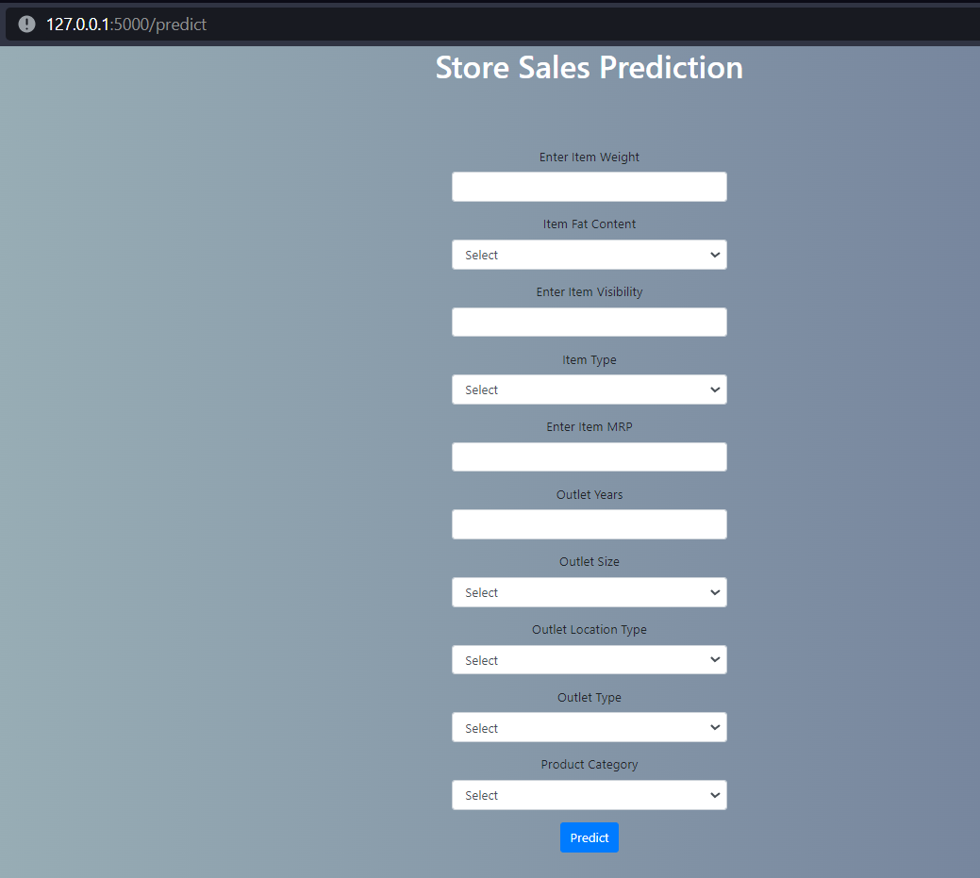

# Prediction Result

After all the input values are filled, prediction is shown at the bottom of the screen as shown in the image below.

