JUNIOR DATA ANALYST – ADVANCED EXCEL INTERNSHIP
WEEK 2 – ANALYTICAL PLANNING AND
STRATEGIC DATA ANALYSIS USING EXCEL
Prepared by: Mahboob Alam
Internship: YuvaIntern / NSDC
Internship Period: 03-Sep-2026 to 08-Oct-2026

1. Introduction
This report presents the analytical planning and strategic data analysis completed in Microsoft Excel for Week 2 of the Junior Data Analyst – Advanced Excel Internship. The analysis uses a prepared employee dataset containing 10 employees across five departments: Sales, HR, IT, Finance, and Marketing.
The purpose of the task is to convert structured data into measurable business insights. The analysis focuses on employee count, sales performance, average salary, department-level performance, and employment status. Excel formulas, PivotTables, and analytical planning techniques were used to calculate and interpret the results.
The report records actual calculated results from the completed Excel work so that the analysis can be reviewed using concrete numerical evidence.

2. Dataset Overview
The Week 2 analysis is based on an employee-level dataset prepared in Excel. It contains 10 employee records distributed equally across five departments. The analysis uses fields such as Employee ID, Department, Salary, Sales Amount, and Employment Status.
Dataset Item | Details
Total Employees | 10
Departments | Sales, HR, IT, Finance, Marketing
Employees per Department | 2
Employment Status | 10 Active; 0 Inactive
Total Sales Amount | ₹13,83,000
Analysis Tool | Microsoft Excel
Main Analysis Sheets | Week2 Data, Analysis Plan, Data Analysis, PivotTable
The dataset provides a structured example for demonstrating business analysis, KPI calculation, descriptive hypothesis testing, and PivotTable-based summarization.
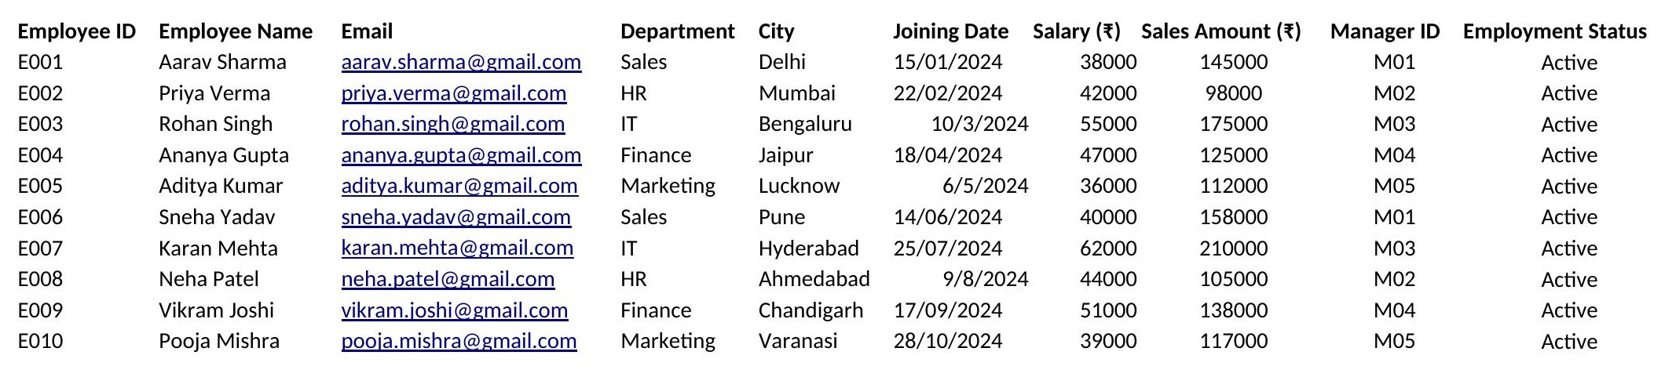
Figure 1: Week 2 Data — employee dataset (source: Week2 Data sheet)

3. Analysis Objectives & Business Questions
- Measure the total number of employees included in the dataset.
- Measure total sales generated across all departments.
- Compare sales performance between departments.
- Identify the department with the highest and lowest sales.
- Calculate the difference between the highest and lowest department sales.
- Check the distribution of employees by employment status.
- Use Excel formulas and PivotTables to produce traceable analytical results.
- Present findings using measurable business evidence.
Key business questions:
- How many employees are included in the dataset?
- What is the total sales amount?
- Which department has the highest sales amount?
- Which department has the lowest sales amount?
- What is the sales difference between the highest and lowest departments?
- Are all employees currently active?
- How can department-wise employee counts and sales totals be summarized using a PivotTable?

4. KPIs & Their Importance
KPI | Actual Result | Importance
Total Employees | 10 | Shows the size of the analyzed workforce.
Total Sales | ₹13,83,000 | Measures total sales generated in the dataset.
Highest Department Sales | IT – ₹3,85,000 | Identifies the department with the largest recorded sales amount.
Lowest Department Sales | HR – ₹2,03,000 | Identifies the department with the smallest recorded sales amount.
Sales Difference | ₹1,82,000 | Measures the gap between highest and lowest department sales.
Active Employees | 10 / 100% | Shows the active workforce recorded in the dataset.
Inactive Employees | 0 / 0% | Shows whether any employees are recorded as inactive.
These KPIs were selected because they directly answer the workforce and sales questions defined for the analysis and can be verified from the Excel calculations.

5. Hypotheses
Hypothesis | Expected Relationship | Evidence Used
H1: Sales performance differs between departments. | Department sales amounts will vary. | Department-wise sales results and PivotTable.
H2: One department will have the highest sales contribution. | At least one department will have the maximum sales. | IT sales = ₹3,85,000.
H3: One department will have the lowest sales contribution. | At least one department will have the minimum sales. | HR sales = ₹2,03,000.
H4: The workforce is currently active in the dataset. | Active employees will represent the full dataset. | 10 active and 0 inactive employees.
These hypotheses are analytical questions about the dataset, not assumptions about the causes of the observed results.

6. Excel Methodology & Functions Used
The workflow was: review the prepared dataset → define objectives → select KPIs → formulate hypotheses → calculate metrics → create PivotTable → interpret findings → perform final quality checks.
Excel Feature / Function | Purpose
COUNTA | Count total employee records.
SUM | Calculate total sales.
AVERAGE | Calculate overall average salary and average sales.
UNIQUE | Extract the distinct list of departments for department-wise analysis.
COUNTIF | Count employee records per department and by employment status.
SUMIF | Calculate total sales for each department.
AVERAGEIF | Calculate average salary for each department.
INDEX / MATCH | Identify the department names linked to the highest/lowest sales, salary, and average-sales values.
MAX / MIN | Identify the highest and lowest sales, salary, and average-sales values.
PivotTable | Summarize department, employment status, employee count, and sales amount.
Sorting / Filtering | Support comparison and data inspection.
Note: this table reflects the functions actually present in the Week2 Data, Analysis Plan, and Data Analysis sheets. The generic IF function appears only in the workbook's excluded reference sheets and was removed from this list accordingly, so that every function named here is one used in the analysis that this report covers.
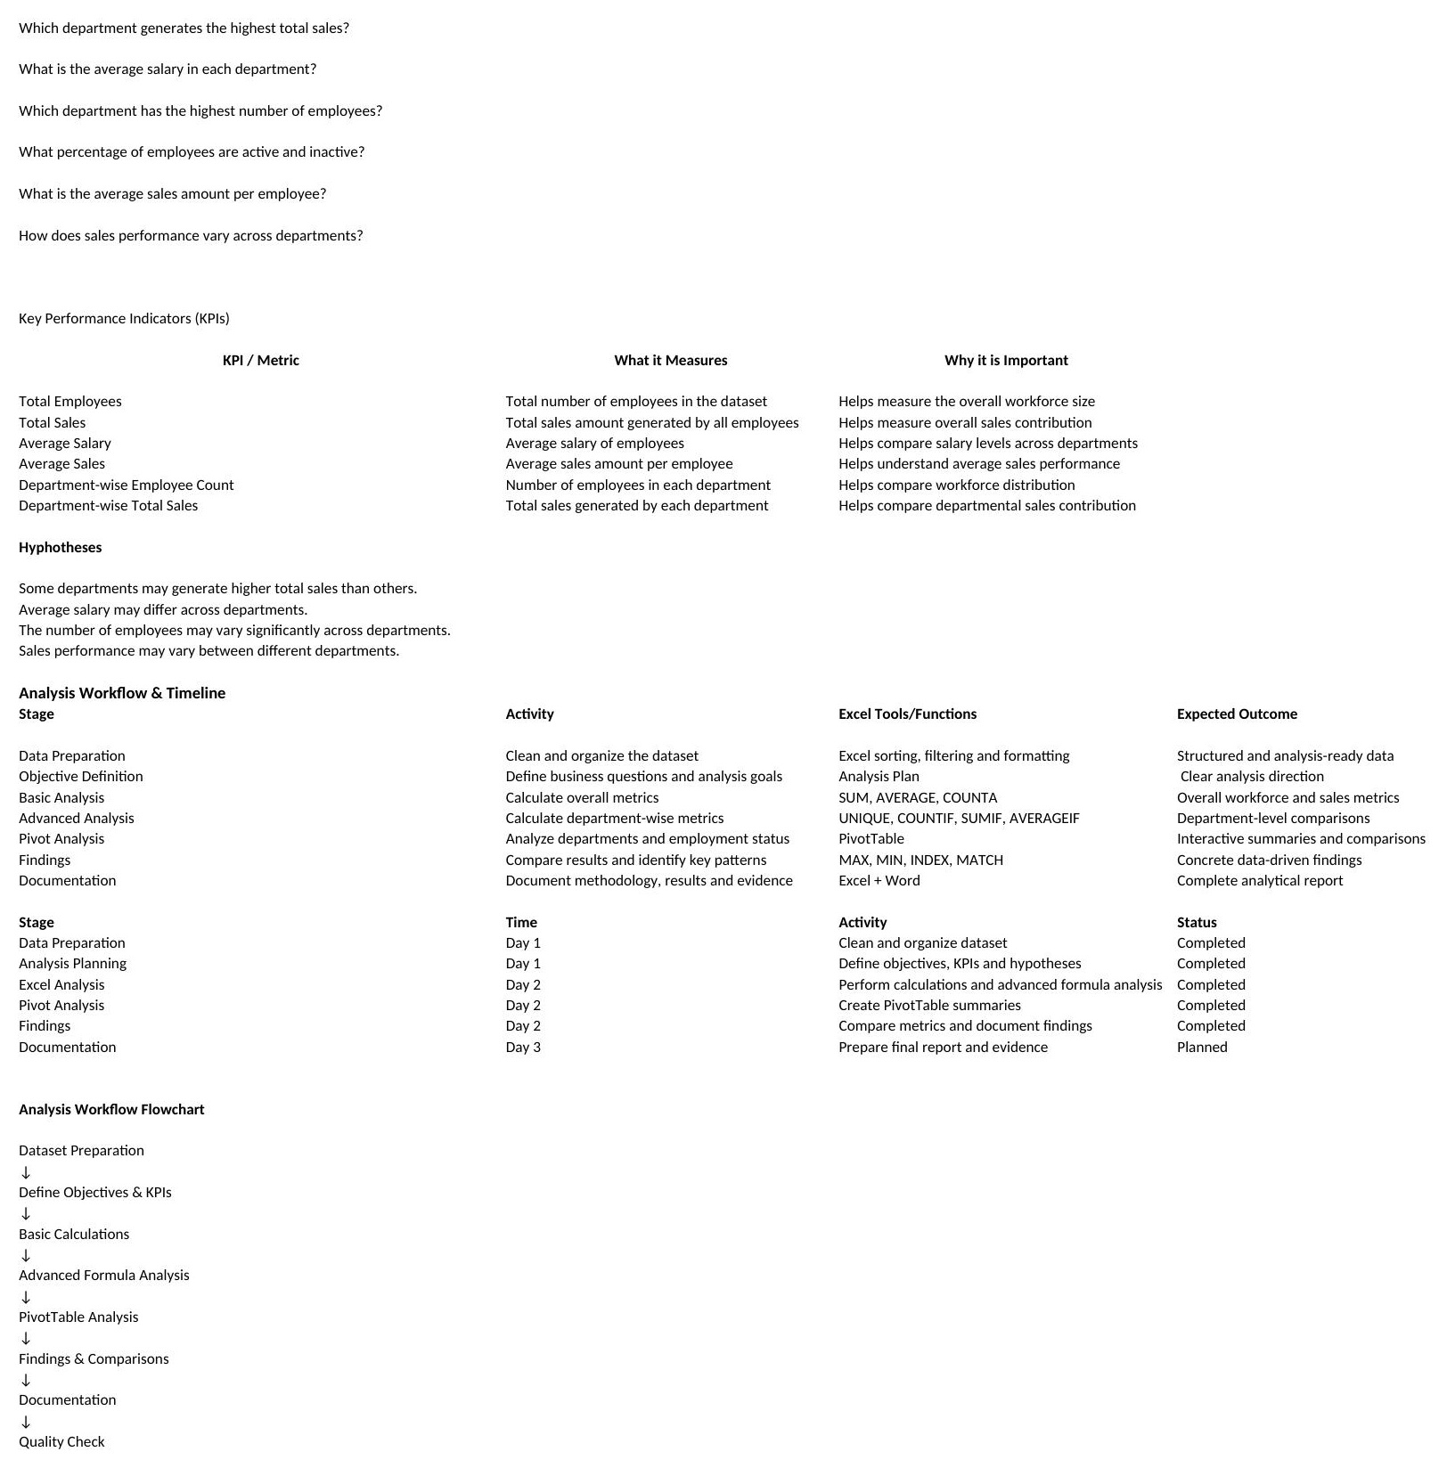
Figure 2: Analysis Plan — objectives, KPIs, hypotheses, workflow/timeline, and flowchart

7. Analysis Results
Metric | Result
Total Employees | 10
Total Sales | ₹13,83,000
Highest Sales Department | IT
IT Sales | ₹3,85,000
Lowest Sales Department | HR
HR Sales | ₹2,03,000
Sales Difference | ₹1,82,000
Active Employees | 10 / 100%
Inactive Employees | 0 / 0%
The 10-employee dataset generated total sales of ₹13,83,000. IT recorded the highest department sales at ₹3,85,000, while HR recorded the lowest at ₹2,03,000. The difference between these department totals is ₹1,82,000.
Employment-status analysis shows that all 10 employees are recorded as Active, representing 100% of the dataset, while no employees are recorded as Inactive.
Department-Wise Breakdown
The Data Analysis sheet also computes a full department-wise breakdown, giving a more complete picture than the headline KPIs alone:
Department | Employees | Total Sales (₹) | Average Sales (₹) | Average Salary (₹)
Sales | 2 | 3,03,000 | 1,51,500 | 39,000
HR | 2 | 2,03,000 | 1,01,500 | 43,000
IT | 2 | 3,85,000 | 1,92,500 | 58,500
Finance | 2 | 2,63,000 | 1,31,500 | 49,000
Marketing | 2 | 2,29,000 | 1,14,500 | 37,500
IT also has the highest average salary (₹58,500) and highest average sales per employee (₹1,92,500), while Marketing has the lowest average salary (₹37,500) and HR has the lowest average sales per employee (₹1,01,500).
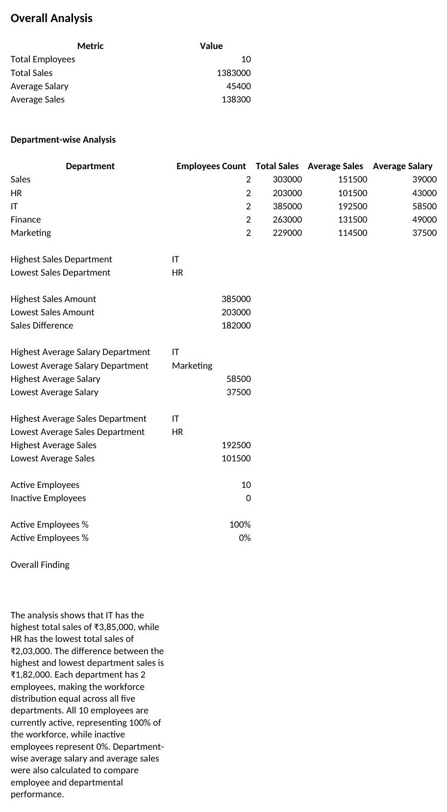
Figure 3: Data Analysis — formulas, calculated metrics, and department-wise results

8. PivotTable Analysis
A PivotTable was used to summarize employee data by Department and Employment Status. It includes Count of Employee ID and Sum of Sales Amount, allowing workforce size and sales performance to be viewed together.
PivotTable Field | Role
Department | Groups records by department.
Employment Status | Shows employee status within each group.
Count of Employee ID | Measures the number of employee records.
Sum of Sales Amount | Measures total sales for each group.
The PivotTable provides a structured summary that supports the formula-based calculations and makes department-level comparison easier. As shown in Figure 4, the Grand Total confirms 10 employees and ₹13,83,000 in total sales, matching the results in Section 7.
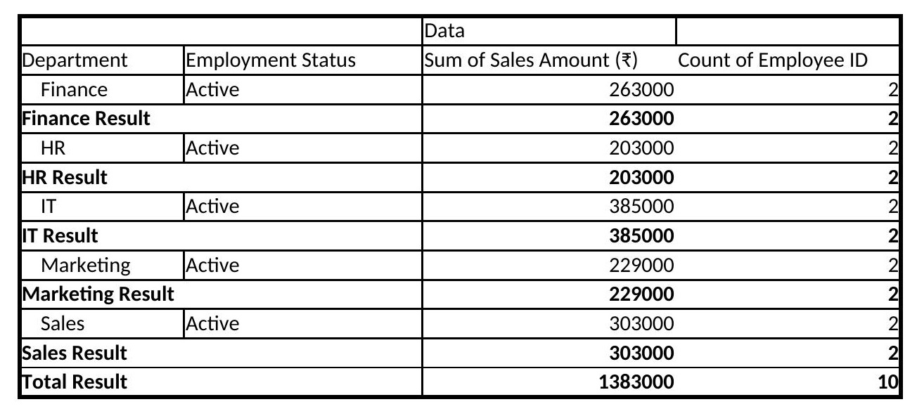
Figure 4: PivotTable Analysis — Department, Employment Status, Count of Employee ID, Sum of Sales Amount

9. Key Findings
- The dataset contains 10 employees across five departments.
- Total sales across the dataset are ₹13,83,000.
- IT has the highest recorded department sales at ₹3,85,000.
- HR has the lowest recorded department sales at ₹2,03,000.
- The difference between the highest and lowest department sales is ₹1,82,000.
- All 10 employees are recorded as Active, giving an active rate of 100%.
- No employees are recorded as Inactive.
- IT also leads in average salary (₹58,500) and average sales per employee (₹1,92,500); Marketing has the lowest average salary (₹37,500) and HR the lowest average sales per employee (₹1,01,500).
- The PivotTable provides a compact view of department, employment status, employee count, and sales amount.
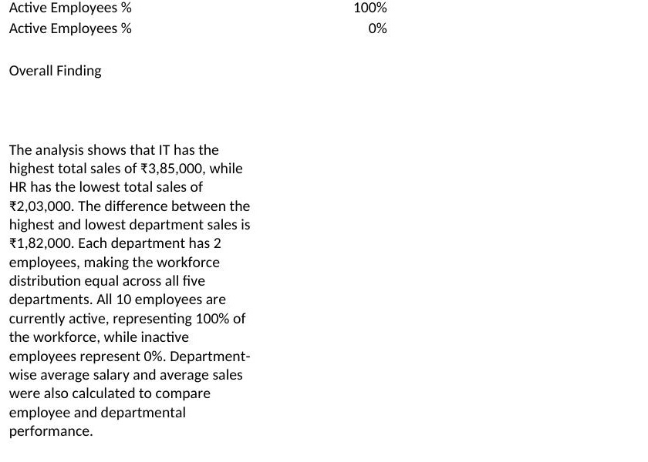
Figure 5: Overall Findings — written interpretation from the Data Analysis sheet

10. Workflow & Timeline
Stage | Work Completed | Output
1. Dataset Review | Reviewed Week 2 employee data. | Analysis-ready dataset.
2. Objective Setting | Defined objectives and business questions. | Analysis Plan.
3. KPI Definition | Selected measurable workforce and sales KPIs. | KPI framework.
4. Hypothesis Planning | Created descriptive hypotheses. | Hypothesis list.
5. Excel Calculations | Calculated employee, sales, salary and status metrics. | Data Analysis results.
6. PivotTable | Summarized department, status, employee count and sales. | PivotTable summary.
7. Findings | Interpreted numerical results. | Overall Findings.
8. Quality Check | Checked required sections, results and error values. | Final reviewed workbook.

11. Analysis Workflow Flowchart
[ START ]
↓
[ Review Week 2 Data ]
↓
[ Define Objectives & Business Questions ]
↓
[ Select KPIs & Hypotheses ]
↓
[ Calculate Metrics in Excel ]
↓
[ Create & Review PivotTable ]
↓
[ Compare Department Results ]
↓
[ Document Key Findings ]
↓
[ Final Quality Check ]
↓
[ END ]

12. Expected Outcomes
- A clear understanding of employee and department-level data.
- Accurate measurement of total sales and workforce KPIs.
- Identification of highest and lowest department sales.
- A transparent comparison of department performance levels.
- A structured PivotTable combining employee count, department, status and sales.
- Improved ability to communicate Excel findings using concrete numerical evidence.
- A reusable analytical workflow for similar business datasets.

13. Conclusion
The Week 2 Analytical Planning and Strategic Data Analysis task was completed using Microsoft Excel. The analysis transformed the prepared employee dataset into a structured set of business metrics, departmental comparisons, hypotheses, and PivotTable summaries.
The completed results show 10 employees and total sales of ₹13,83,000. IT recorded the highest department sales at ₹3,85,000, while HR recorded the lowest at ₹2,03,000, creating a difference of ₹1,82,000. All 10 employees are recorded as Active, representing 100% of the dataset.
Overall, the task provided practical experience in planning an analysis, selecting relevant KPIs, applying Excel functions, using PivotTables, interpreting numerical results, and documenting findings with measurable evidence.

14. Screenshots / Evidence
The following screenshots were captured directly from the completed Excel workbook ("Week2 Data", "Analysis Plan", "Data Analysis", and "PivotTable" sheets only). The "Sheet" and "Raw Data" worksheets were excluded from every screenshot, as they are not part of this analysis.
Evidence | What It Demonstrates
Figure 1 – Week 2 Data | Employee dataset and source values.
Figure 2 – Analysis Plan | Objectives, KPIs, hypotheses, workflow and flowchart.
Figure 3 – Data Analysis | Formulas and calculated results, including department-wise breakdown.
Figure 4 – PivotTable | Department + Employment Status + Count of Employee ID + Sum of Sales Amount.
Figure 5 – Overall Findings | Written interpretation of the calculated results.
Figure 6 – Final Quality Check | Final workbook review and absence of visible Excel errors.
Figure 1: Week 2 Data
Figure 2: Analysis Plan
Figure 3: Data Analysis
Figure 4: PivotTable Analysis
Figure 5: Overall Findings
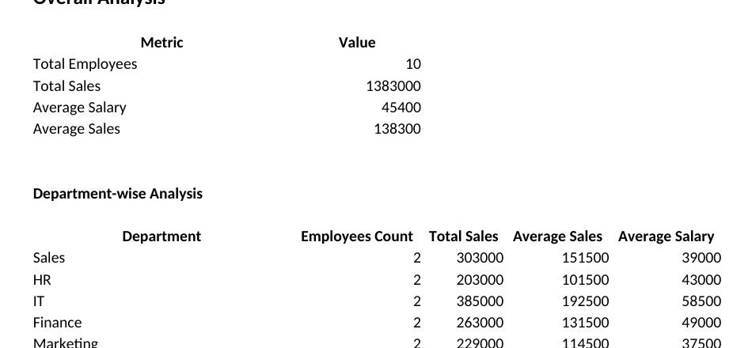
Figure 6: Final Quality Check

15. Final Quality Check
Check | Status
Week 2 Data contains the prepared dataset | Completed
Analysis Plan contains objectives, KPIs, hypotheses, workflow and flowchart | Completed
Data Analysis contains formulas and results | Completed
PivotTable contains required fields | Completed
Overall Findings paragraph is present | Completed
All numerical values and department names cross-checked against the Excel workbook | Completed
No #VALUE!, #REF!, #DIV/0!, or #NAME? errors in the completed workbook | Checked – none found
"Sheet" and "Raw Data" worksheets excluded from analysis, text, and screenshots | Confirmed

Figure 6: Final Quality Check — KPI and department-wise results computing cleanly, with no error values

