YuvaIntern / NSDC

JUNIOR DATA ANALYST – ADVANCED EXCEL INTERNSHIP
WEEK 4 – ADVANCED STATISTICAL ANALYSIS AND SCENARIO MODELING IN EXCEL

Prepared by: Mahboob Alam
Internship: YuvaIntern / NSDC

1. Introduction
Week 4 of the Junior Data Analyst – Advanced Excel Internship focuses on moving from data organisation and summarisation to statistical analysis and scenario modeling. The purpose of this week was to apply Microsoft Excel to measure the spread of business data, study the relationship between two variables, and test how business outcomes change under different assumptions.
Excel was used to calculate descriptive statistics, perform a simple regression analysis, present the results through charts, and build a What-If scenario model for projected sales. Together, these techniques help convert raw figures into clear business insights that support decision-making.

2. Objectives
The objectives of the Week 4 task were to:
- Descriptive statistics: Calculate and interpret descriptive statistics for key numeric fields.
- Regression analysis: Examine the relationship between Salary and Sales Amount using correlation, R-Squared, slope and intercept.
- Data visualization: Present the relationship and the scenario results using a scatter chart and a column chart.
- Scenario / What-If analysis: Model the effect of 0%, 10%, 20% and 30% sales increases on total sales.
- Interpretation of business insights: Translate the numerical results into simple, meaningful business observations.

3. Dataset Overview
The same 10-employee dataset used in the previous weeks was used for this analysis. The data is stored in the DATA4 worksheet of the Excel workbook. Each row represents one employee, and all ten employees have an Employment Status of Active. The main fields are summarised below.
Field | Description
Employee ID | Unique identifier for each employee (E001 to E010)
Employee Name | Name of the employee
Department | Department of the employee (Sales, HR, IT, Finance, Marketing)
Salary (₹) | Salary of the employee – used as the X variable in the regression
Sales Amount (₹) | Sales amount linked to the employee – used as the Y variable in the regression
Employment Status | Current status of the employee (Active for all records)

Other supporting fields in the sheet include Email, City, Joining Date and Manager ID. The analysis in this report concentrates on the two numeric fields, Salary and Sales Amount.

4. Descriptive Statistics

4.1 Measures Used
Descriptive statistics summarise a set of values using a few easy-to-read numbers. The following measures were calculated in Excel for both Salary and Sales Amount:
- Average: the arithmetic mean, found by adding all values and dividing by the number of values.
- Median: the middle value when the data is arranged in order; it is less affected by very high or very low values.
- Minimum: the smallest value in the data.
- Maximum: the largest value in the data.
- Standard Deviation: a measure of how widely the values are spread around the average. A larger value means greater variation.

4.2 Results
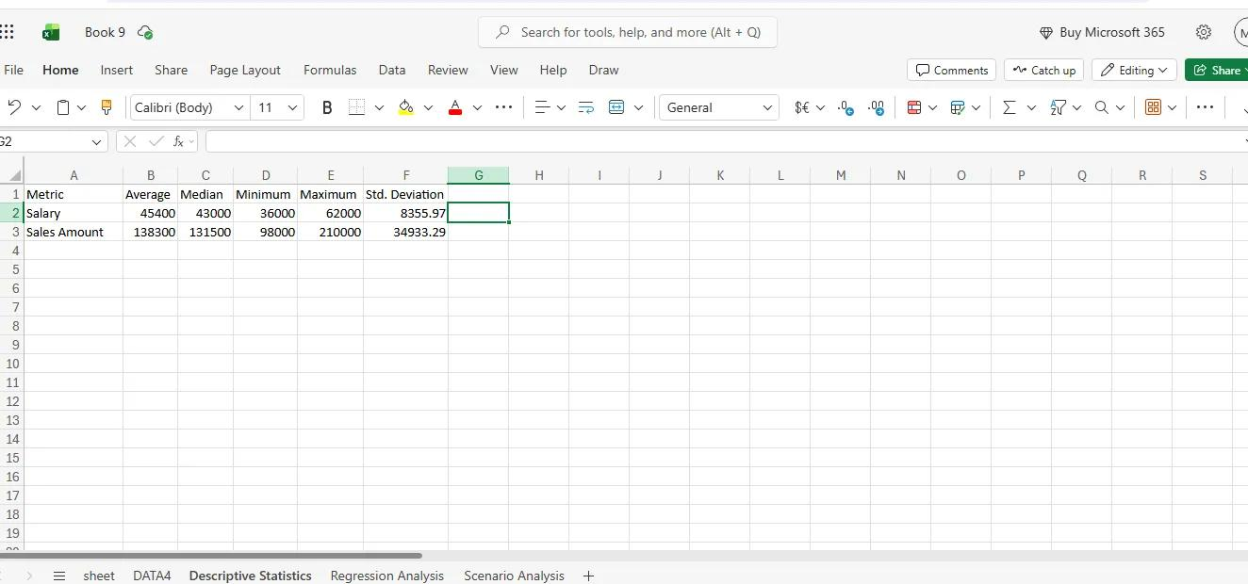
Figure 1 – Descriptive Statistics
Metric | Average | Median | Minimum | Maximum | Std. Deviation
Salary (₹) | 45,400 | 43,000 | 36,000 | 62,000 | 8,355.97
Sales Amount (₹) | 1,38,300 | 1,31,500 | 98,000 | 2,10,000 | 34,933.29

4.3 Interpretation
The average salary is ₹45,400 against a median of ₹43,000, and the average sales amount is ₹1,38,300 against a median of ₹1,31,500. In both cases the average is slightly higher than the median, which suggests that a few higher values (the highest salary of ₹62,000 and the highest sales amount of ₹2,10,000) pull the average upward.
Salary ranges from ₹36,000 to ₹62,000, while Sales Amount ranges from ₹98,000 to ₹2,10,000. The standard deviation of Sales Amount (34,933.29) is much larger in absolute terms than that of Salary (8,355.97), showing that sales performance varies more widely across employees than salary does.

5. Regression Analysis

5.1 Approach
A simple regression analysis was performed to understand whether employees with higher salaries also tend to have higher sales amounts. Salary was taken as the X variable (independent variable) and Sales Amount as the Y variable (dependent variable). The four regression measures are explained below in simple terms.
Measure | Meaning
Correlation | Shows the strength and direction of the relationship between two variables. It lies between -1 and +1; values closer to +1 indicate that both variables tend to rise together.
R-Squared | Shows the share of the variation in Sales Amount that is explained by Salary. A higher value means a better fit.
Slope | Shows the average change in Sales Amount for every ₹1 increase in Salary.
Intercept | The starting value of the regression line, i.e. the estimated Sales Amount when Salary is zero. It is a mathematical constant of the line and has limited practical meaning here.

5.2 Regression Results
The regression results calculated in Excel are shown in Figure 2.
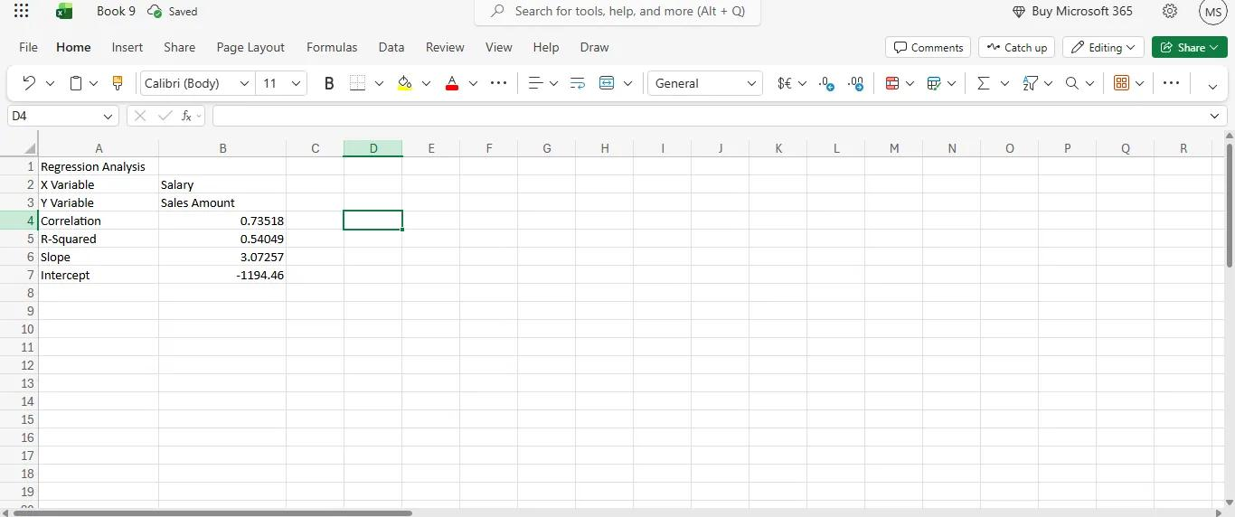
Figure 2 – Regression Analysis
Measure | Value | Brief Reading
Correlation | 0.73518 | Positive relationship
R-Squared | 0.54049 | About 54% of the variation explained
Slope | 3.07257 | About ₹3.07 more sales per ₹1 salary
Intercept | -1194.46 | Starting point of the line

The correlation of approximately 0.73 indicates a positive relationship between Salary and Sales Amount in this small dataset: employees with higher salaries generally show higher sales amounts. The R-Squared value of about 0.54 means that roughly 54% of the variation in Sales Amount is explained by Salary, while the remaining variation is due to other factors. The slope of about 3.07 means that, on average, each additional ₹1,000 of salary is associated with about ₹3,073 of additional sales.
As the analysis is based on only 10 employees, the result should be treated as an indication of a pattern and not as proof that salary causes higher sales.

5.3 Salary vs Sales Amount Scatter Chart
A scatter chart titled “Salary vs Sales Amnt – Regression Analysis” was created in the DATA4 sheet next to the dataset. Figure 3 shows the chart together with the employee data it is based on.
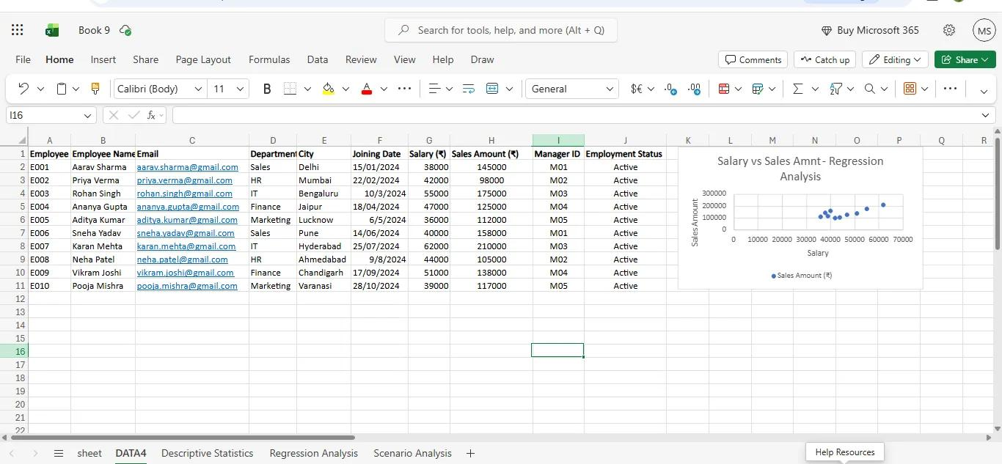
Figure 3 – Salary vs Sales Amount Scatter Chart
In the chart, Salary is plotted on the horizontal axis and Sales Amount on the vertical axis, and each blue dot represents one employee. The dots move upward from left to right, showing that higher salaries are generally accompanied by higher sales amounts. This agrees with the positive correlation of 0.73518. The point with the highest salary (₹62,000) also has the highest sales amount (₹2,10,000), while the other points are grouped closer together at lower salary levels. The chart shows the data points only; no trendline was added.

6. Scenario Analysis

6.1 Scenario Model
A scenario (What-If) model was created in the Scenario Analysis worksheet to estimate how total sales would change if sales increased by fixed percentages. The original total sales of the dataset are ₹13,83,000 (approximately ₹13.83 lakh). Four scenarios were set up, and the Projected Sales were calculated by applying each percentage increase to the original sales.
Scenario | Sales Increase | Original Sales (₹) | Projected Sales (₹)
Base | 0% | 13,83,000 | 13,83,000
10% Increase | 10% | 13,83,000 | 15,21,300
20% Increase | 20% | 13,83,000 | 16,59,600
30% Increase | 30% | 13,83,000 | 17,97,900

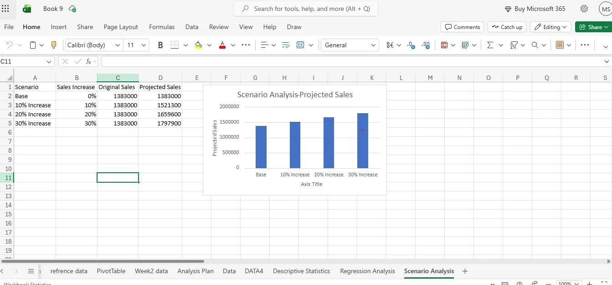
Figure 4 – Scenario Analysis

6.2 Scenario Chart
The column chart titled “Scenario Analysis – Projected Sales” (visible in Figure 4) compares the projected sales of the four scenarios. The Base column is the lowest, and the columns rise steadily from the 10% Increase to the 20% Increase and then to the 30% Increase scenario. This makes it easy to see how much additional sales would be generated at each level of improvement.
Compared with the Base scenario, projected sales rise by ₹1,38,300 under the 10% scenario, by ₹2,76,600 under the 20% scenario and by ₹4,14,900 under the 30% scenario.

7. Key Findings
The following findings are based only on the results visible in the Excel workbook and screenshots:
- The average salary is ₹45,400 (median ₹43,000), and the average sales amount is ₹1,38,300 (median ₹1,31,500).
- Salary ranges from ₹36,000 to ₹62,000, and Sales Amount ranges from ₹98,000 to ₹2,10,000.
- The standard deviation is 8,355.97 for Salary and 34,933.29 for Sales Amount, showing wider variation in sales than in salary.
- The correlation between Salary and Sales Amount is 0.73518, indicating a positive relationship in this small dataset.
- The R-Squared value is 0.54049, so about 54% of the variation in Sales Amount is explained by Salary.
- The slope is 3.07257 and the intercept is -1194.46.
- The scatter chart shows sales amounts generally rising as salary increases; no trendline was added.
- Original total sales are ₹13,83,000 (about ₹13.83 lakh). Projected sales are ₹15,21,300 at a 10% increase, ₹16,59,600 at a 20% increase and ₹17,97,900 at a 30% increase.

8. Overall Analysis / Interpretation
The descriptive statistics give a clear picture of the dataset: salaries are relatively close to each other, while sales amounts vary more widely and include a few high performers. The regression analysis adds that, within these 10 employees, higher salary levels are generally linked with higher sales, with a correlation of about 0.73 and an R-Squared of about 0.54. This is a moderate-to-strong relationship, but it also shows that nearly half of the variation in sales is influenced by factors other than salary.
The scenario model then shows how the business total could change if sales improve. Each 10% increase adds ₹1,38,300 to the original total of ₹13,83,000, which helps in understanding the possible impact of targets or improvement plans. Taken together, the three analyses show how Excel can be used to describe data, explore relationships and support planning with simple, transparent calculations. Because the dataset is small, the results are best used for learning and indicative analysis.

9. Conclusion
Week 4 successfully demonstrated practical Excel skills in statistical analysis, relationship analysis, visualization and scenario modeling. Descriptive statistics were calculated for Salary and Sales Amount, a regression analysis was completed with a supporting scatter chart, and a four-case scenario model with a column chart was built to project sales. The week strengthened the ability to interpret numerical results and present them in a clear, professional manner, and it provides a solid foundation for more advanced data analysis tasks.

10. Screenshots / Evidence
All screenshots from the Excel workbook have been placed in their relevant sections, as listed below.
Figure | Title | Section
Figure 1 | Descriptive Statistics | 4. Descriptive Statistics
Figure 2 | Regression Analysis | 5. Regression Analysis
Figure 3 | Salary vs Sales Amount Scatter Chart | 5. Regression Analysis
Figure 4 | Scenario Analysis (with chart) | 6. Scenario Analysis

11. Final Quality Check
Checklist Item | Status
Descriptive Statistics completed | ✔ Completed
Regression Analysis completed | ✔ Completed
Regression chart completed | ✔ Completed
Scenario Analysis completed | ✔ Completed
Scenario chart completed | ✔ Completed
Excel results checked for visible errors | ✔ Checked

