YuvaIntern NSDC
Junior Data Analyst – Advanced Excel Internship
WEEK 3 REPORT
Data Visualization and Reporting with Advanced Excel

Student Name | Mahboob Alam
Internship | YuvaIntern NSDC – Junior Data Analyst
Programme | Advanced Excel Internship
Task | Week 3 – Data Visualization and Reporting
Tool Used | Microsoft Excel

Contents
1. Introduction
2. Objectives
3. Dataset and Data Preparation
4. Data Visualization Process
5. Pivot Tables and Pivot Charts
6. Conditional Formatting
7. Rationale of Each Visualization
8. Key Insights
9. Business Implications
10. Limitations
11. Conclusion
12. Submission Description

1. Introduction
This report presents my work for Week 3 of the YuvaIntern NSDC Junior Data Analyst – Advanced Excel Internship. The task for this week was Data Visualization and Reporting with Advanced Excel. In the earlier weeks, I worked on preparing and organizing the data. In this week, I used that data to build Pivot Tables and Pivot Charts and to apply conditional formatting, so that the results can be understood quickly.
The dataset contains employee records for ten employees across five departments. It includes details such as department, city, joining date, salary, sales amount, manager ID and employment status. The Excel workbook contains separate sheets for each stage of the work, including Data, Pvt1, Pvt2, Pvt3 and Visualization. Screenshots of these sheets are included in this report as evidence of the work done.

2. Objectives
The objectives of this week’s task were:
- To organize the employee data in a clear table so that it can be summarized easily.
- To create Pivot Tables that summarize the data by department.
- To create Pivot Charts that show the Pivot Table results visually.
- To apply conditional formatting to highlight differences in the Salary and Sales Amount columns.
- To write key insights based on the results shown in the tables and charts.
- To prepare a clear report that explains the work and its findings.

3. Dataset and Data Preparation
The data used for this task is stored on the “Data” sheet of the workbook. It has 10 employee records (E001 to E010) and 10 columns. All employees have the employment status “Active”. The employees are spread across five departments (Sales, HR, IT, Finance and Marketing) and are based in different cities such as Delhi, Mumbai, Bengaluru, Jaipur, Lucknow, Pune, Hyderabad, Ahmedabad, Chandigarh and Varanasi. Joining dates fall between January 2024 and October 2024.
Table 1: Columns in the dataset
Column | Description
Employee ID | Unique ID of each employee (E001 to E010)
Employee Name | Name of the employee
Email | Email address of the employee
Department | Sales, HR, IT, Finance or Marketing
City | City where the employee is based
Joining Date | Date on which the employee joined
Salary (₹) | Salary of the employee in rupees
Sales Amount (₹) | Sales amount linked to the employee in rupees
Manager ID | ID of the manager (M01 to M05)
Employment Status | Current status of the employee (Active for all records)

Before building the Pivot Tables, the data was kept in a clean table layout with one header row and one record per row. Each column has a single type of data, there are no blank rows inside the table, and the column headings are clear. This structure is needed so that Excel can read the data correctly when a Pivot Table is created. The Salary and Sales Amount columns were also formatted with conditional formatting, which is explained in Section 6.
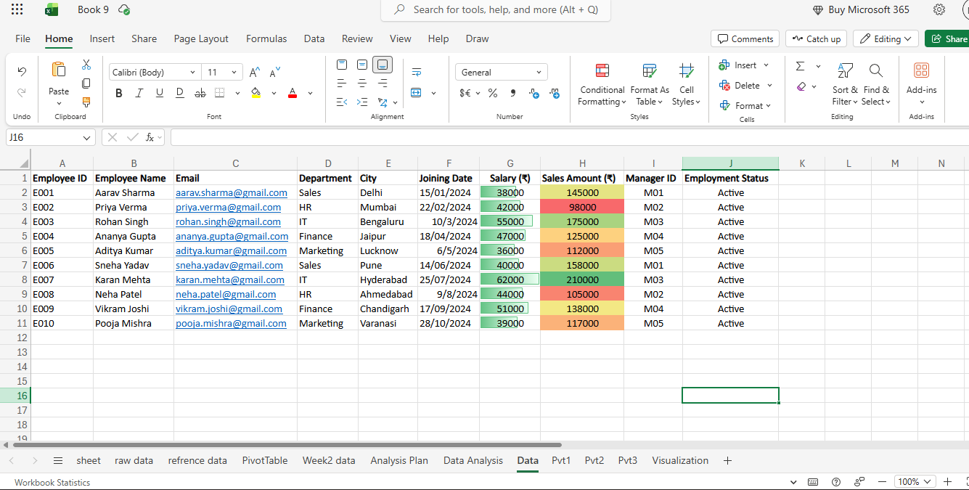
Figure 1: Employee dataset on the “Data” sheet with conditional formatting applied

4. Data Visualization Process
The work was done in the following steps, as shown by the sheets in the workbook:
- The employee data was arranged on the “Data” sheet.
- Conditional formatting was applied to the Salary (₹) and Sales Amount (₹) columns.
- A Pivot Table was created on the “Pvt1” sheet to count employees in each department, with a column chart.
- A second Pivot Table was created on the “Pvt2” sheet to find the total sales amount by department, with a column chart.
- A third Pivot Table was created on the “Pvt3” sheet to find the average salary by department, with a column chart.
- The main findings were written on the “Visualization” sheet under the heading “Week 3 Data Visualization”.
In all three Pivot Tables, Department is used in the Rows area. Only the Values field changes: Count of Employee ID, Sum of Sales Amount (₹) and Average of Salary (₹).

5. Pivot Tables and Pivot Charts

5.1 Employees by Department (Pvt1)
The first Pivot Table uses Department in Rows and Count of Employee ID in Values. It shows that each of the five departments (Finance, HR, IT, Marketing and Sales) has 2 employees, giving a Grand Total of 10. The Pivot Chart is a column chart titled “Employees by Department”. All five columns are the same height, which shows the equal split of employees.
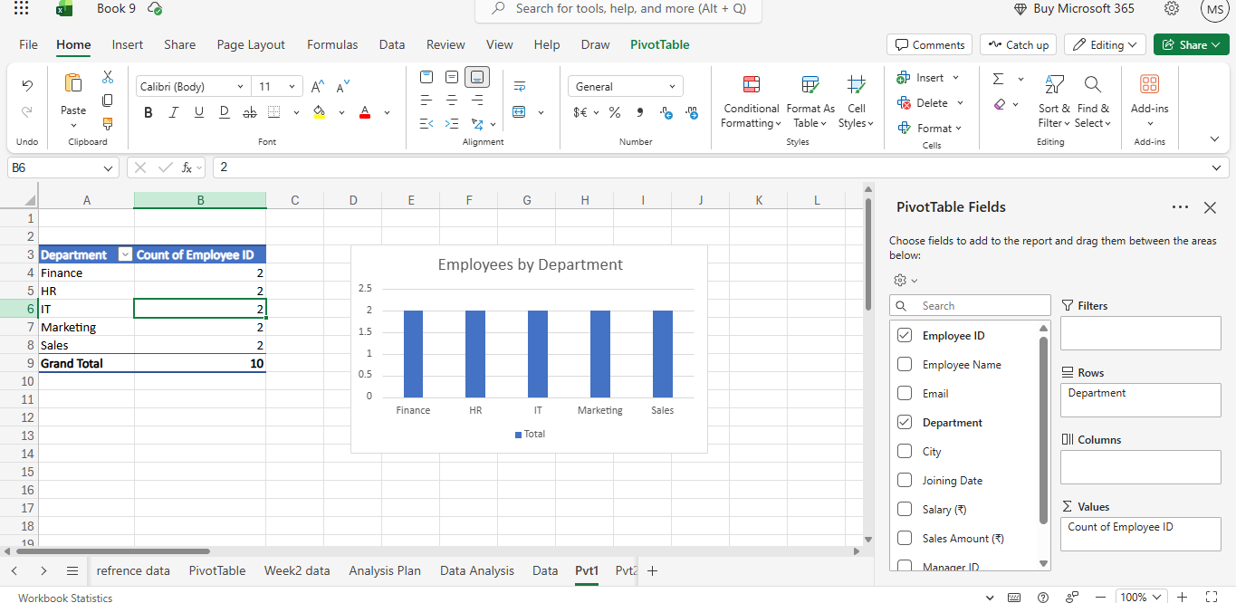
Figure 2: Pivot Table and Pivot Chart – Employees by Department (Pvt1 sheet)
Table 2: Employee count by department
Department | Count of Employee ID
Finance | 2
HR | 2
IT | 2
Marketing | 2
Sales | 2
Grand Total | 10

5.2 Total Sales by Department (Pvt2)
The second Pivot Table uses Department in Rows and Sum of Sales Amount (₹) in Values. The Pivot Chart is a column chart titled “Total Sales by Department”. The IT department has the highest total sales at ₹385,000, followed by Sales at ₹303,000 and Finance at ₹263,000. Marketing has ₹229,000 and HR has the lowest at ₹203,000. The Grand Total is ₹1,383,000.
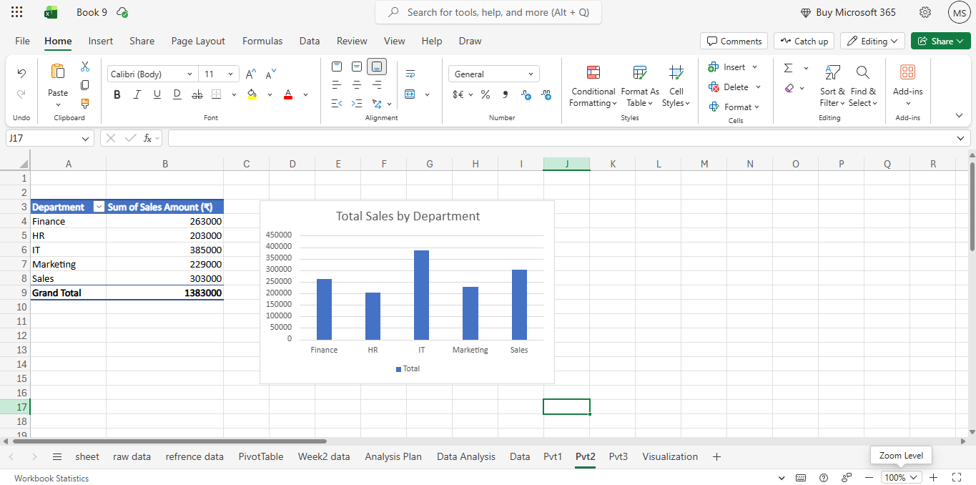
Figure 3: Pivot Table and Pivot Chart – Total Sales by Department (Pvt2 sheet)
Table 3: Total sales amount by department
Department | Sum of Sales Amount (₹)
Finance | 263,000
HR | 203,000
IT | 385,000
Marketing | 229,000
Sales | 303,000
Grand Total | 1,383,000

5.3 Average Salary by Department (Pvt3)
The third Pivot Table uses Department in Rows and Average of Salary (₹) in Values. The Pivot Chart is a column chart titled “Average Salary by Department”. IT has the highest average salary at ₹58,500, followed by Finance at ₹49,000 and HR at ₹43,000. Sales has ₹39,000 and Marketing has the lowest at ₹37,500. The overall average salary (Grand Total) is ₹45,400.
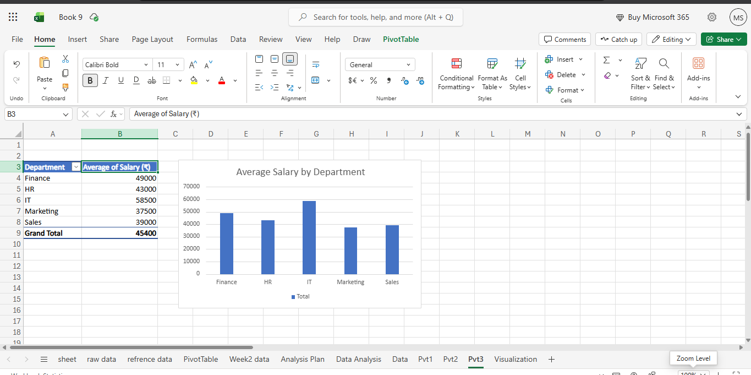
Figure 4: Pivot Table and Pivot Chart – Average Salary by Department (Pvt3 sheet)
Table 4: Average salary by department
Department | Average of Salary (₹)
Finance | 49,000
HR | 43,000
IT | 58,500
Marketing | 37,500
Sales | 39,000
Grand Total | 45,400

6. Conditional Formatting
Conditional formatting was applied on the “Data” sheet (see Figure 1) to make the values in two columns easier to compare.
- Salary (₹): green data bars are shown inside the cells. A longer bar means a higher salary. For example, the bar for ₹62,000 (Karan Mehta) is longer than the bar for ₹36,000 (Aditya Kumar).
- Sales Amount (₹): a red-yellow-green colour scale is used. Higher values are shaded green and lower values are shaded red. The highest value, ₹210,000 (Karan Mehta), is dark green, and the lowest value, ₹98,000 (Priya Verma), is red.
With this formatting, the highest and lowest values can be seen at a glance without reading every number.

7. Rationale of Each Visualization
Table 5: Reason for each visualization
Visualization | Type | Reason for use
Employees by Department | Column chart | To compare the number of employees in each department. A column chart makes equal values easy to see.
Total Sales by Department | Column chart | To compare total sales across departments and quickly find the highest and lowest.
Average Salary by Department | Column chart | To compare the average pay level of each department.
Salary data bars | Conditional formatting | To compare individual salaries inside the table itself.
Sales Amount colour scale | Conditional formatting | To highlight high and low sales performance using colours.

Column charts were chosen because the data is grouped by department, and each department has a single value to compare. This is the simplest way to show such data and keeps the charts easy to read.

8. Key Insights
The following insights are based on the Pivot Tables, charts and the “Visualization” sheet. The same three points are written on the Visualization sheet of the workbook.
- The IT department has the highest total sales of ₹385,000.
- The IT department has the highest average salary of ₹58,500.
- Each department has 2 employees, showing an equal employee distribution.
In addition, the following points can be seen from the data and the conditional formatting:
- HR has the lowest total sales (₹203,000), and the lowest individual sales value in the dataset (₹98,000) belongs to an HR employee.
- Marketing has the lowest average salary (₹37,500), and Sales has the second lowest (₹39,000).
- The highest individual sales value (₹210,000) and the highest individual salary (₹62,000) both belong to the same IT employee.
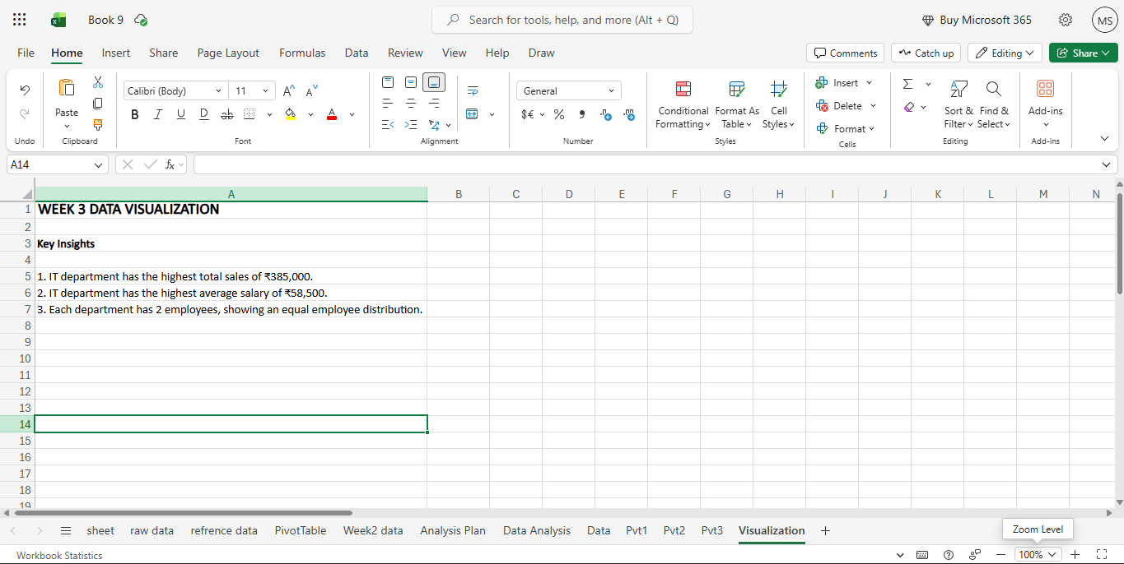
Figure 5: “Visualization” sheet showing the Week 3 Key Insights

9. Business Implications
Based on the results, the following points may be useful for the business. These are observations from a small dataset and should be confirmed with more data.
- IT is the highest in both sales and average salary. This suggests that the department is a strong contributor and is also the highest paid. Management may want to review whether this is the case with a larger dataset.
- HR has the lowest total sales. Since HR is not usually a sales-focused department, management should check how sales are credited to this department before drawing any conclusion.
- Marketing and Sales have the lowest average salaries. Management may want to compare these with their sales results and decide if pay levels need a review.
- Because every department has the same number of employees, department totals can be compared fairly in this dataset.

10. Limitations
- The dataset is small, with only 10 employees and 2 employees per department. Averages and totals can change a lot if one value changes.
- The charts show only one measure each and do not show a time trend. Joining dates were not analysed in this week’s Pivot Tables.
- Sales Amount is shown as a single figure per employee, with no date or period, so it is not clear what time frame it covers.
- Sparklines are not used in this workbook, so small trend charts inside cells were not created.
- No slicers or interactive filters are visible in the screenshots, so the charts show fixed summaries by department.
- The Pivot Charts do not have axis titles. Adding them would make the charts clearer.

11. Conclusion
In this Week 3 task, I used Advanced Excel to visualize and report on the employee dataset. I created three Pivot Tables with matching column charts to show employees by department, total sales by department and average salary by department. I also applied data bars and a colour scale on the Data sheet to highlight salary and sales values, and I summarized the findings on the Visualization sheet.
The results show that IT has the highest total sales (₹385,000) and the highest average salary (₹58,500), while each department has 2 employees. This task helped me understand how Pivot Tables and Pivot Charts can turn raw data into clear summaries, and how conditional formatting helps readers notice important values quickly. In the future, I would like to work with larger datasets and add features such as slicers and sparklines.

12. Submission Description
For the Week 3 task, Data Visualization and Reporting with Advanced Excel, I worked on an employee dataset of 10 records covering five departments: Sales, HR, IT, Finance and Marketing. The data includes salary, sales amount, city, joining date and manager details. I kept the data in a clean table on the Data sheet and applied conditional formatting, using data bars on the Salary column and a red-yellow-green colour scale on the Sales Amount column, so that high and low values are easy to see.
I then created three Pivot Tables with Pivot Charts. The first (Pvt1) counts the employees in each department and shows that every department has 2 employees. The second (Pvt2) shows total sales by department, where IT is highest at ₹385,000 and the grand total is ₹1,383,000. The third (Pvt3) shows average salary by department, where IT is again highest at ₹58,500 and the overall average is ₹45,400. All three charts are column charts with clear titles.
I summarized the main insights on the Visualization sheet and explained them in this report with screenshots of my actual Excel work. I also noted the limitations of the analysis, such as the small dataset and the absence of sparklines and slicers. Through this task, I improved my skills in building Pivot Tables, creating charts, using conditional formatting and presenting findings in a simple and professional way.

