YuvaIntern / NSDC
Junior Data Analyst – Advanced Excel Internship
INTERNSHIP REPORT
Week 5
Interactive Data Analytics Dashboard in Excel
Student Name | Mahboob Alam
Internship | Junior Data Analyst – Advanced Excel Internship
Organization | YuvaIntern / NSDC
Week | Week 5
Task | Interactive Data Analytics Dashboard in Excel

1. Introduction
This report documents the work completed in Week 5 of the Junior Data Analyst – Advanced Excel Internship at YuvaIntern / NSDC. The task for this week was to build an interactive data analytics dashboard in Microsoft Excel.
The dashboard is built on the employee dataset used in the earlier weeks of the internship, which holds 10 employee records on the DATA4 sheet. Pivot Tables were used to summarise the data by department, charts were created from these summaries, and slicers and a department selection cell were added to make the workbook interactive. All results and values in this report are taken from screenshots of the completed workbook.

2. Objectives
- To prepare summary tables from the employee data using Pivot Tables.
- To calculate key performance indicators (KPIs) for the dashboard.
- To present department-wise results through charts.
- To add slicers for filtering the Pivot Table data.
- To add a department selection dropdown cell to the dashboard.
- To arrange all elements on a single dashboard sheet and interpret the results.

3. Dataset / Dashboard Data Overview
The source data is stored on the DATA4 sheet of the workbook. Each row represents one employee, and the data is shown in Figure 1.
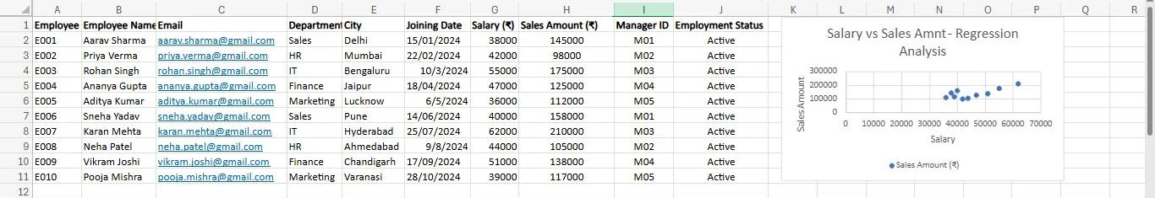
Figure 1 – Source Data (DATA4 Sheet)
The sheet also shows a scatter chart of Salary against Sales Amount, which belongs to the earlier regression analysis and is not part of the Week 5 dashboard. The main features of the dataset are summarised below.
Table 1 – Dataset Summary
Item | Details
Number of records | 10 employees (E001 to E010)
Columns | Employee ID, Employee Name, Email, Department, City, Joining Date, Salary (₹), Sales Amount (₹), Manager ID, Employment Status
Departments | Finance, HR, IT, Marketing, Sales (2 employees each)
Salary range | ₹36,000 to ₹62,000
Sales Amount range | ₹98,000 to ₹210,000
Managers | M01 to M05
Employment Status | All 10 employees are Active

The workbook contains the following sheets: sheet, DATA4, Descriptive Statistics, Regression Analysis, Scenario Analysis, pvt, pvt2, Dashboard, pvt3 and Dashboard data. The Week 5 work is spread over the Pivot Table sheets (pvt, pvt2 and pvt3), the Dashboard sheet and the Dashboard data sheet.

4. KPI Summary
Four KPIs are displayed at the top of the dashboard, as shown in Figure 2.
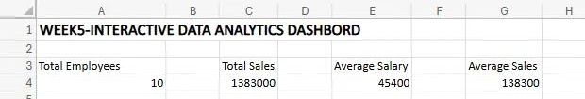
Figure 2 – Dashboard KPI Summary
Table 2 – KPI Values
KPI | Value | Description
Total Employees | 10 | Number of employee records in the dataset
Total Sales | 1,383,000 | Sum of the Sales Amount of all employees
Average Salary | 45,400 | Average salary across all employees
Average Sales | 138,300 | Average Sales Amount per employee

These KPI values agree with the Grand Totals of the Pivot Tables in Section 5. Average Sales of 138,300 is also equal to Total Sales (1,383,000) divided by the 10 employees.

5. Pivot Table Analysis
Three Pivot Tables were prepared, each summarising one measure by department.

5.1 Total Sales Amount by Department
The first Pivot Table shows the Sum of Sales Amount (₹) for each department. IT has the highest total at 385,000, and HR has the lowest at 203,000. The Grand Total is 1,383,000.
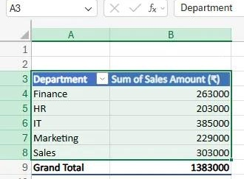
Figure 3 – Pivot Table: Sum of Sales Amount by Department

5.2 Average Salary by Department
The second Pivot Table shows the Average of Salary (₹) for each department. IT has the highest average salary at 58,500, and Marketing has the lowest at 37,500. The overall average is 45,400.
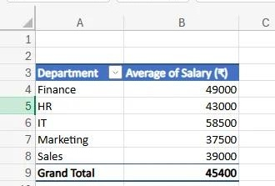
Figure 4 – Pivot Table: Average Salary by Department

5.3 Employee Count by Department
The third Pivot Table shows the Count of Employee ID for each department. Every department has 2 employees, giving a Grand Total of 10.
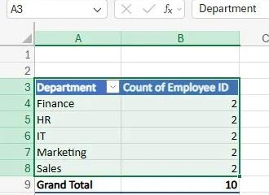
Figure 5 – Pivot Table: Employee Count by Department

5.4 Combined Department Summary
The table below brings the three Pivot Tables together. The share of sales and the sales per employee are calculated from the values shown in the Pivot Tables.
Table 3 – Department-wise Summary
Department | Employees | Total Sales (₹) | Share of Total Sales | Average Salary (₹) | Sales per Employee (₹)
Finance | 2 | 263,000 | 19.0% | 49,000 | 131,500
HR | 2 | 203,000 | 14.7% | 43,000 | 101,500
IT | 2 | 385,000 | 27.8% | 58,500 | 192,500
Marketing | 2 | 229,000 | 16.6% | 37,500 | 114,500
Sales | 2 | 303,000 | 21.9% | 39,000 | 151,500
Grand Total | 10 | 1,383,000 | 100.0% | 45,400 | 138,300

6. Data Visualization / Charts
Three column charts were placed on the Dashboard sheet. Each chart shows one of the Pivot Table results, and the legend in each chart is labelled “Total”.
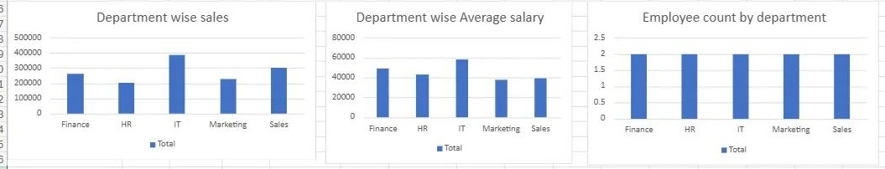
Figure 6 – Dashboard Charts
Table 4 – Charts on the Dashboard
Chart Title | Chart Type | What It Shows
Department wise sales | Column chart | Total sales amount of each department; IT is the tallest column (385,000) and HR the shortest (203,000)
Department wise Average salary | Column chart | Average salary of each department; IT is the highest (58,500) and Marketing the lowest (37,500)
Employee count by department | Column chart | Number of employees in each department; all five columns are equal at 2

7. Interactive Slicers
Two slicers were added next to the Sales Amount Pivot Table: Department and Employment Status. They are shown in Figure 7.
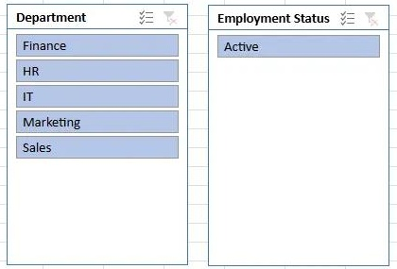
Figure 7 – Department and Employment Status Slicers
- Department slicer: lists Finance, HR, IT, Marketing and Sales. All five departments are selected, so the Pivot Table shows every department and the Grand Total of 1,383,000.
- Employment Status slicer: shows a single option, Active. Since all 10 employees in the dataset are Active, this slicer does not change the totals.
Slicers allow the user to filter the Pivot Table with a single click on a department name, instead of using the filter drop-down menu of the Pivot Table.

8. Data Validation / Dropdown
A “Select Department” cell was added on the Dashboard sheet below the charts (label in cell A18 and selection in cell A19). The cell currently shows IT as the selected department. The cell and the sheet tabs of the workbook are shown in Figure 8.
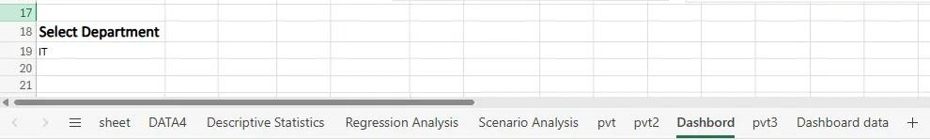
Figure 8 – Select Department Cell and Workbook Sheets
A dropdown created with Data Validation lets the user choose a department from a list instead of typing it. This avoids spelling mistakes and keeps the input limited to valid entries. A separate sheet named Dashboard data is also present in the workbook.

9. Dashboard Overview and Interpretation
The Dashboard sheet brings all the elements together on one page. The title of the dashboard is placed in row 1, followed by the KPI values, the three charts and the department selection cell.
Table 5 – Dashboard Layout
Area | Location | Content
Title | Row 1 | Dashboard heading for Week 5
KPI section | Rows 3 to 4 | Total Employees, Total Sales, Average Salary, Average Sales
Charts | Rows 6 to 16 | Department wise sales, Department wise Average salary, Employee count by department
Department selection | Rows 18 to 19 | “Select Department” label and the selected value (IT)

From the KPIs, the user can see that the 10 employees together generated total sales of 1,383,000, with an average salary of 45,400 and average sales of 138,300 per employee. The charts then explain how these totals are divided between the departments. The first chart shows that sales are not spread evenly, the second shows that salary levels differ by department, and the third confirms that the departments are of equal size.

10. Key Findings
- IT leads in sales: IT recorded the highest total sales of 385,000, which is 27.8% of the overall total of 1,383,000.
- HR has the lowest sales: HR recorded 203,000, which is 14.7% of the total.
- IT also has the highest average salary: 58,500, compared with the overall average of 45,400.
- Marketing has the lowest average salary: 37,500.
- Equal team size: each of the five departments has 2 employees, so the differences in total sales are not caused by differences in headcount.
- Active workforce: all 10 employees in the dataset are Active.

11. Overall Analysis / Business Insights
Because every department has the same number of employees, total sales can be compared directly. IT has both the highest sales per employee (192,500) and the highest average salary, while HR has the lowest sales per employee (101,500). Sales and salary do not follow the same order in every department. For example, the Sales department is second in total sales (303,000) but its average salary of 39,000 is lower than that of Finance (49,000) and HR (43,000).
Marketing has the lowest average salary and ranks fourth in total sales, ahead of only HR. These observations can help management compare the sales contribution of each department with its salary cost.
The dataset contains only 10 records, so these observations describe this sample and should be confirmed with a larger dataset before being used for decisions.

12. Conclusion
In Week 5, an interactive data analytics dashboard was created in Excel using the employee dataset. The work included KPI calculations, three Pivot Tables, three department-wise column charts, Department and Employment Status slicers, and a Select Department cell, all arranged on a single Dashboard sheet.
The dashboard shows that IT is the strongest department in both total sales and average salary, while HR has the lowest sales. This task helped me practise combining Pivot Tables, charts and interactive controls into a clear summary that is easy for a reader to understand.

13. Screenshots / Evidence
The screenshots from the workbook are included in the relevant sections of this report. They are listed below.
Table 6 – List of Figures
Figure | Description | Section
Figure 1 | Source Data (DATA4 Sheet) | 3. Dataset
Figure 2 | Dashboard KPI Summary | 4. KPI Summary
Figure 3 | Pivot Table: Sum of Sales Amount by Department | 5. Pivot Table Analysis
Figure 4 | Pivot Table: Average Salary by Department | 5. Pivot Table Analysis
Figure 5 | Pivot Table: Employee Count by Department | 5. Pivot Table Analysis
Figure 6 | Dashboard Charts | 6. Data Visualization
Figure 7 | Department and Employment Status Slicers | 7. Interactive Slicers
Figure 8 | Select Department Cell and Workbook Sheets | 8. Data Validation

14. Final Quality Check
Table 7 – Checks Carried Out
Check | Result
Total Sales on dashboard | 1,383,000 matches the Grand Total of the Sum of Sales Amount Pivot Table
Average Salary on dashboard | 45,400 matches the Grand Total of the Average Salary Pivot Table
Total Employees on dashboard | 10 matches the Grand Total of the Employee Count Pivot Table
Average Sales on dashboard | 138,300 equals 1,383,000 divided by 10 employees
Department values in Table 3 | Taken from the Pivot Table screenshots; the share and sales per employee are calculated from them
Charts | Chart columns agree with the Pivot Table values for each department
Screenshots | All figures are taken from the Week 5 workbook, inserted in the relevant sections without duplication

