Assignment1

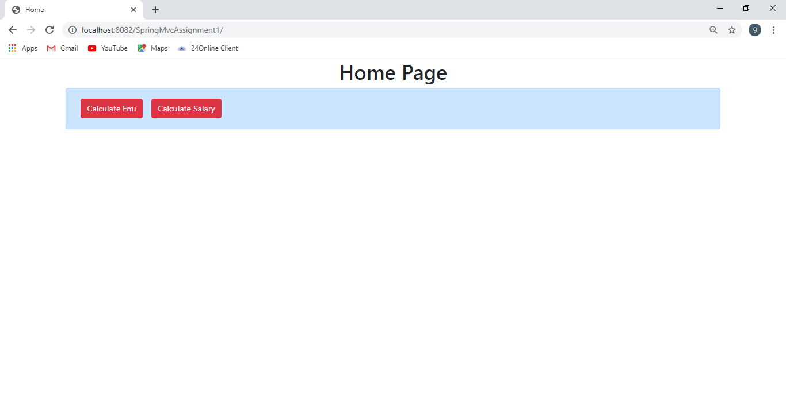

Click on Calculate EMI

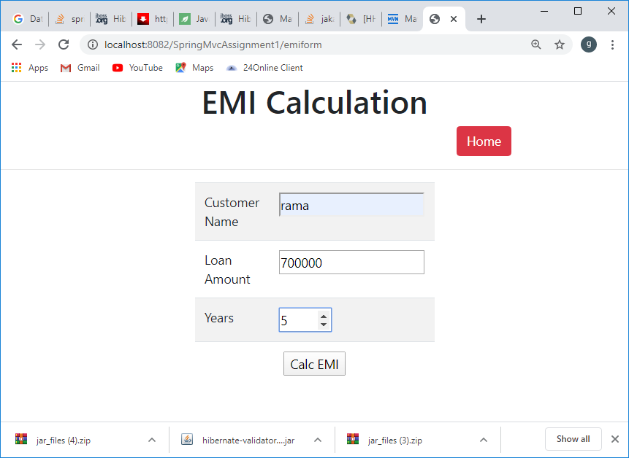

When click on submit button

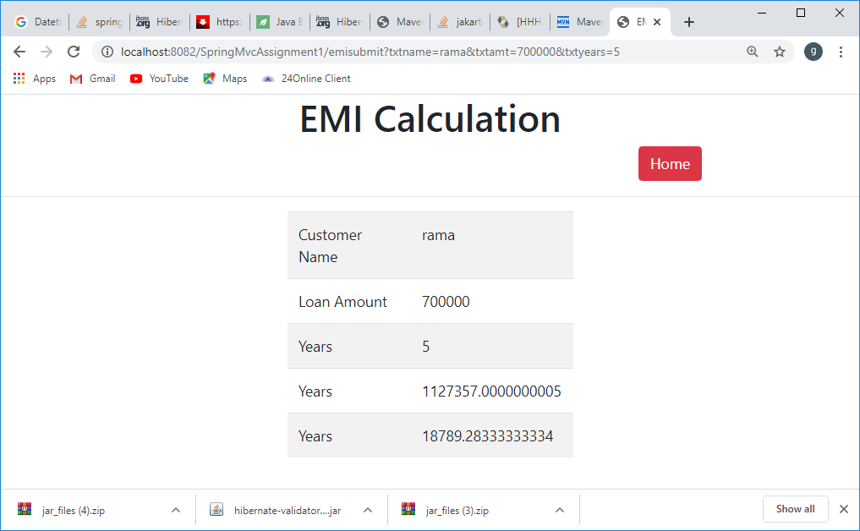

Task 2:

When clicking on Calculate Salary

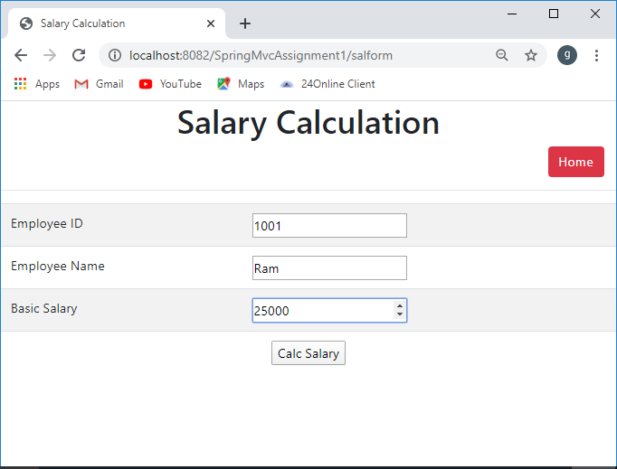

When clicking on submit button

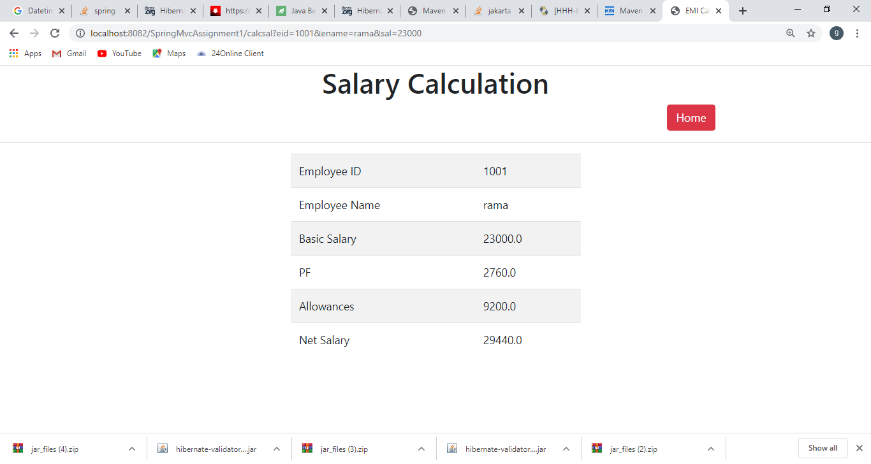

Create dynamic project in eclipse

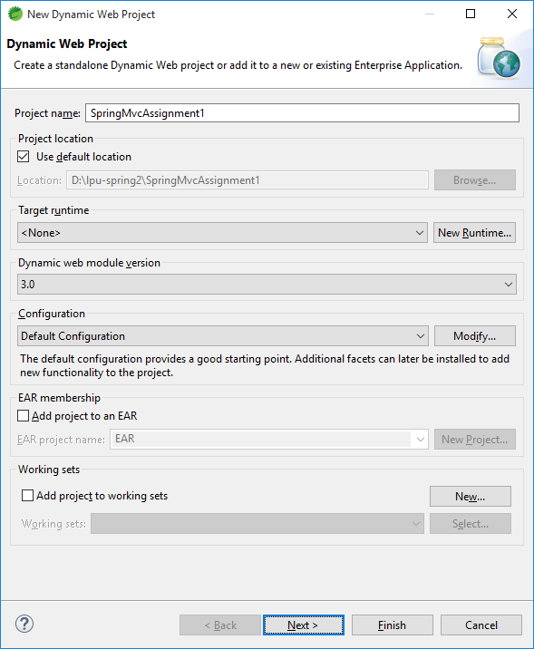

Check web.xml

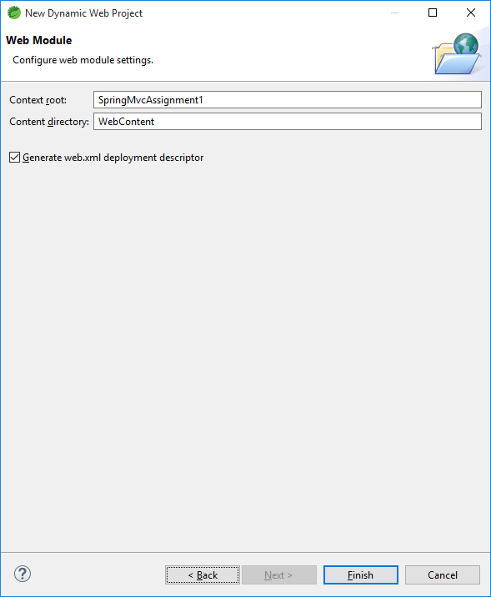

Click on finish button

Copy and paste Spring jars in WEB-INF/lib folder

Add server runtime

Rightclick your project🡪 properties 🡪 javabuild path 🡪Add Library🡪Server runtime

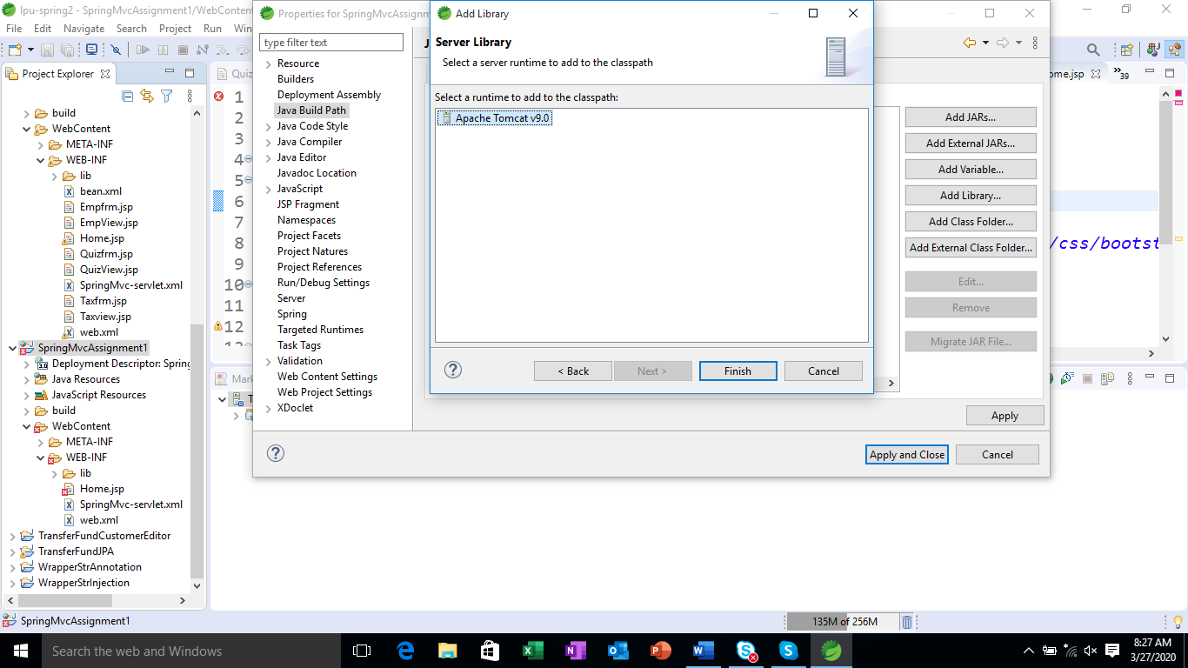

Confiure DispatcherServlet in web.xml

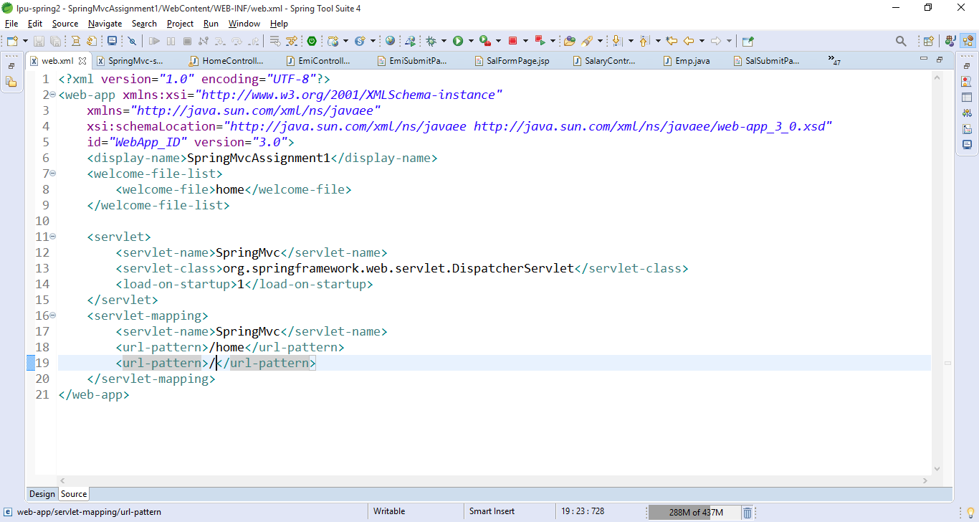

Any URL maps to DispatcherServlet.

Configure viewreolver in SPringMvc-servlet.xml

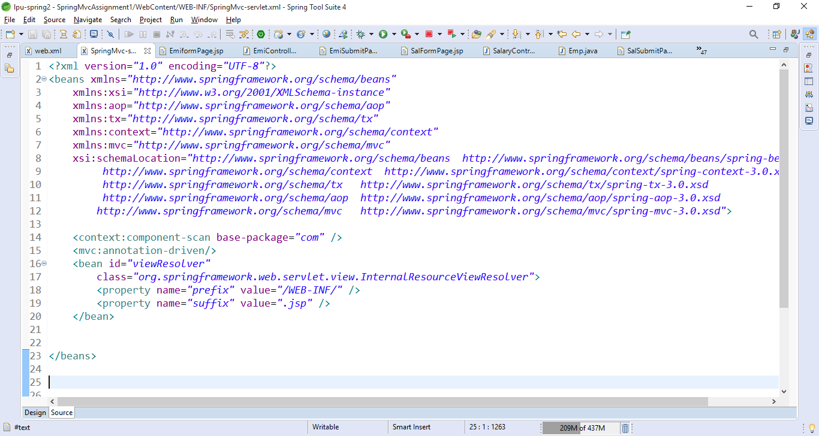

Create a Home page.

|  |  |  |
| --- | --- | --- |
| URL to acess the home page | /home | HomeController  Method 🡪displayHomePg()  View 🡪HomePage.jsp |
|  |  |  |
|  |  |  |

Create a HomPage.jsp

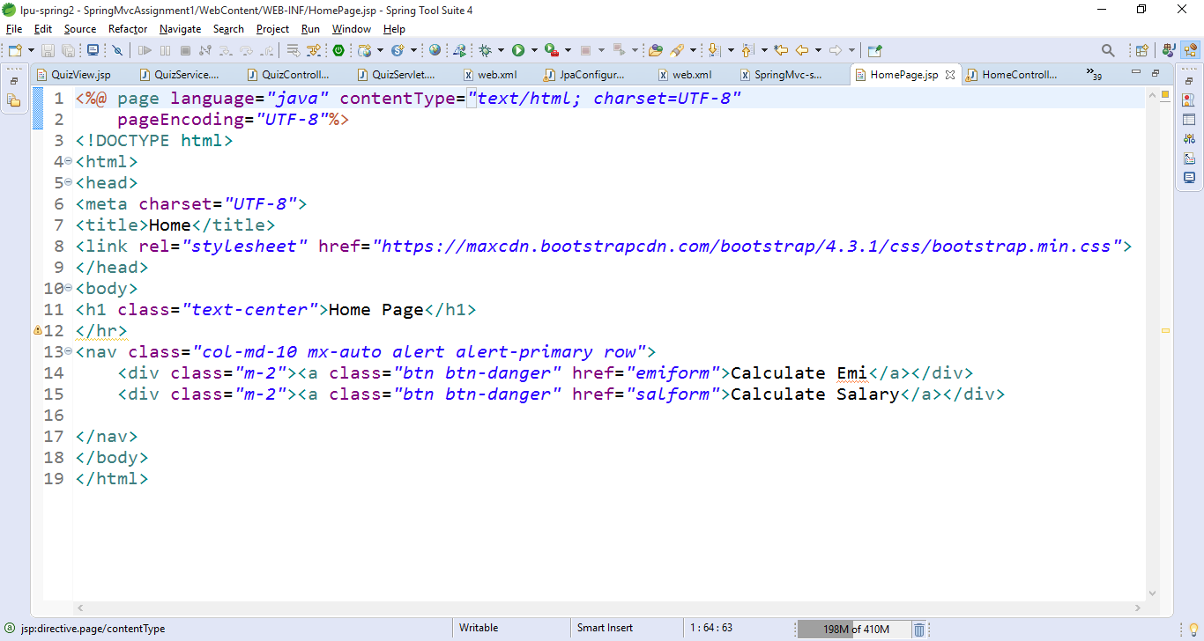

Create HomeController

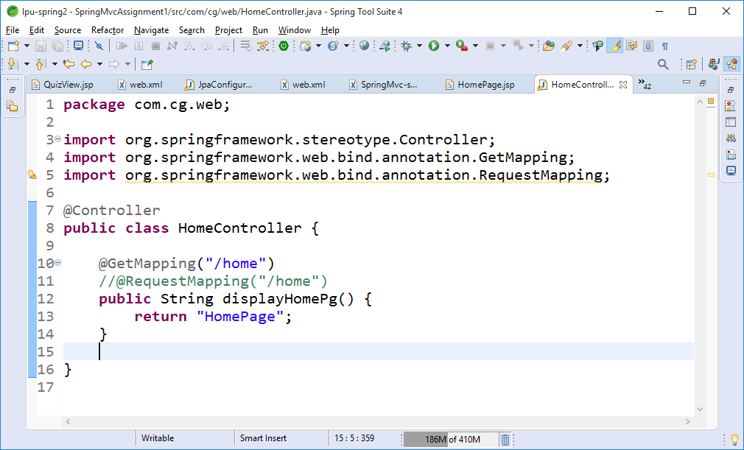

Task 1: To calculate EMI

|  |  |  |
| --- | --- | --- |
| To Display EmiFormPage | /emiform | EmiController  Method🡪displayEmiForm()  View 🡪 EmiFormPage.jsp |
| To Caluclate EMI for emi form data | /emisubmit | EmiController  Method 🡪calcEmi()  View 🡪EmiSubmitPage.jsp |
|  |  |  |

Create EmiFormPage.jsp

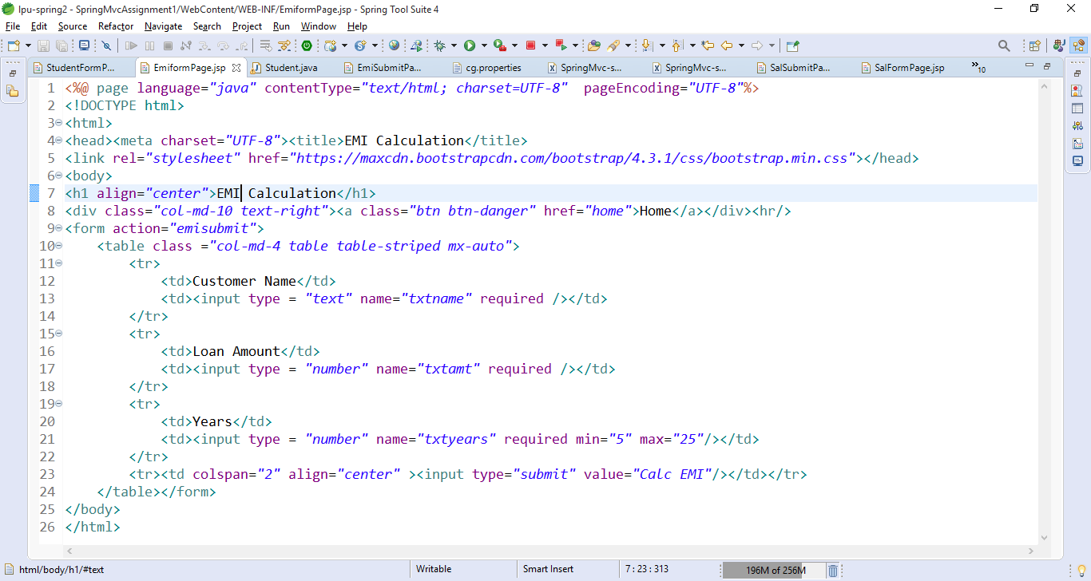

Create EmiController

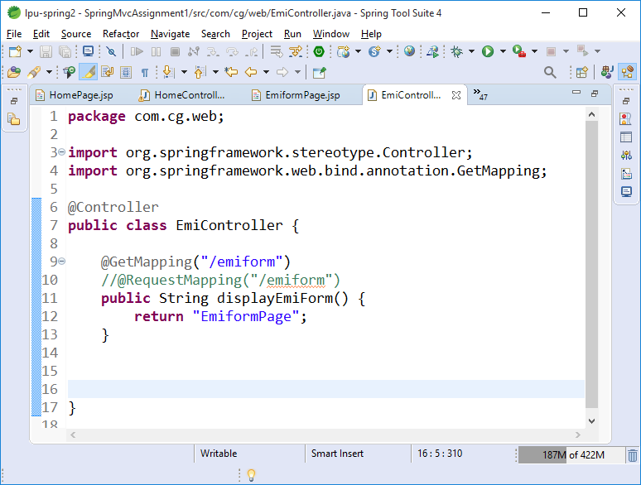

Test the url /emiform

Add the method in the EmiController to calculate Emi and map the URI /emisubmit to that method.

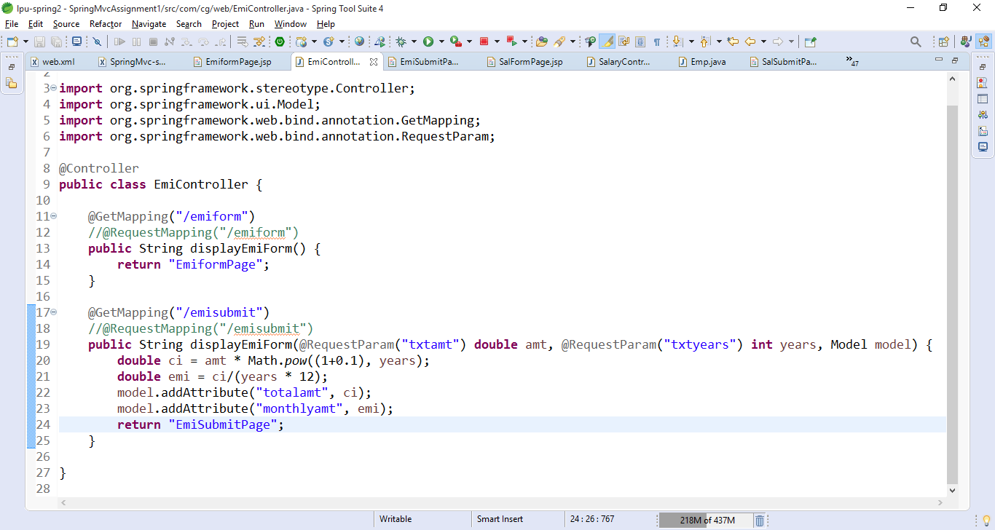

Create EmiSubmitPage.jsp

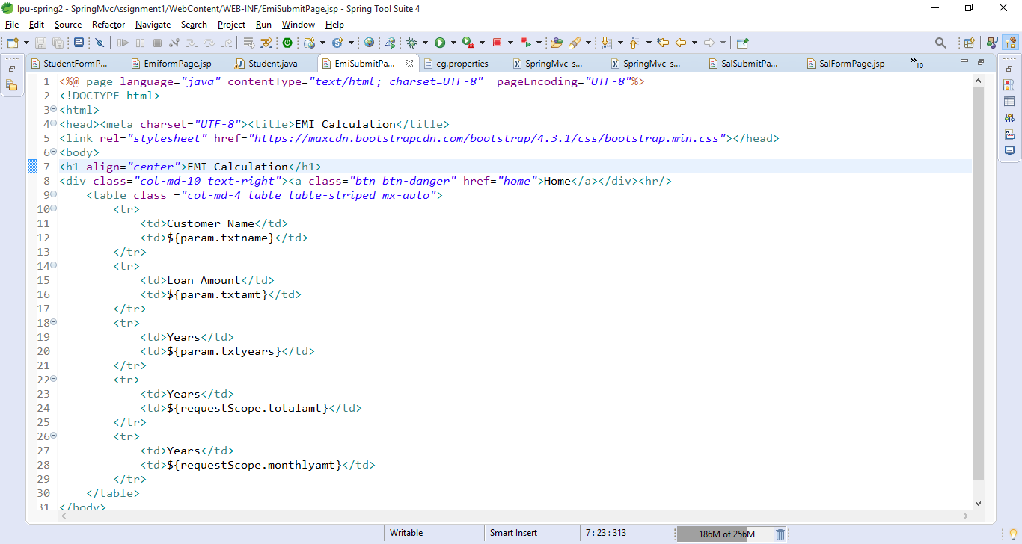

Task 1: To calculate the salary

|  |  |  |
| --- | --- | --- |
| To Display SalFormPage | /salform | SalaryController  Method🡪displaySalForm()  View 🡪 SalFormPage.jsp |
| To Caluclate EMI for emi form data | /calcsal | SalaryController  Method 🡪calcEmpSalary()  View 🡪SalSubmitPage.jsp |

Create a Entity class

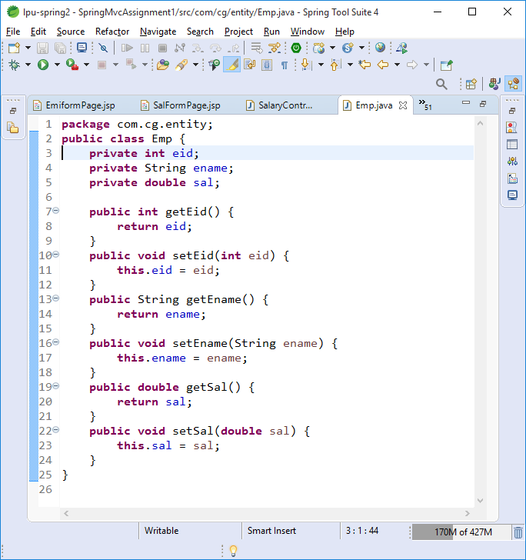

Create SalFormPage.jsp

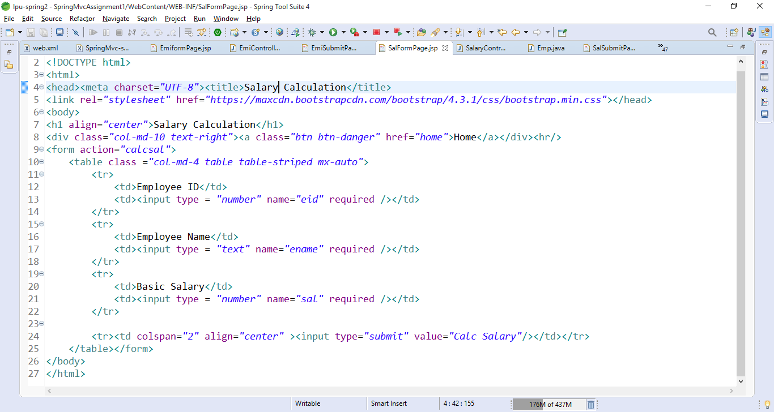

Create SalaryController

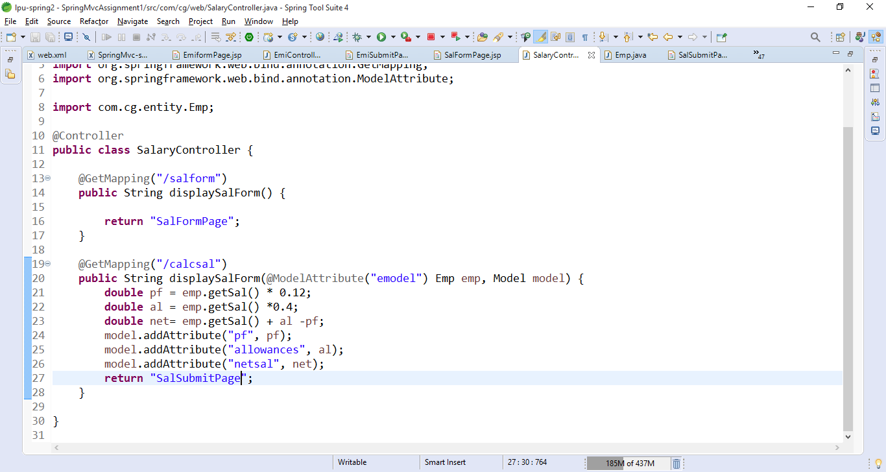

Create SalSubmitPage.jsp

