Spring Assignment 3

Internationalization

Re-visit Spring Mvc Assignment1

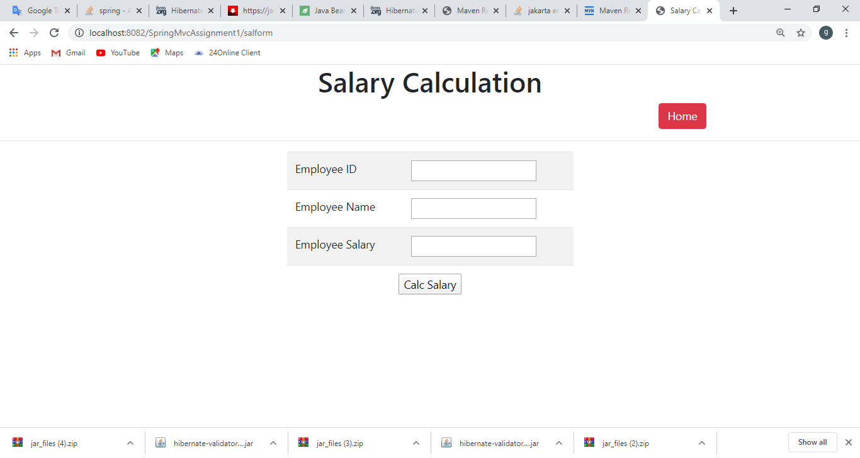

Change the browser locale in Google chrome

Goto settings 🡪 type language in search settings text box

Expand language and click on Add Language 🡪 choose telugu

Move that language to the top

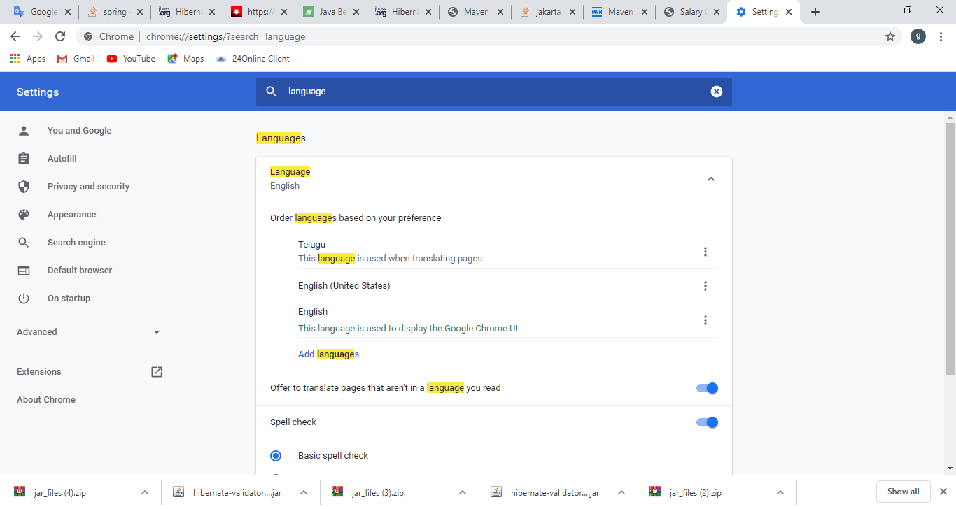

Run the same page in the browser by refreshing it

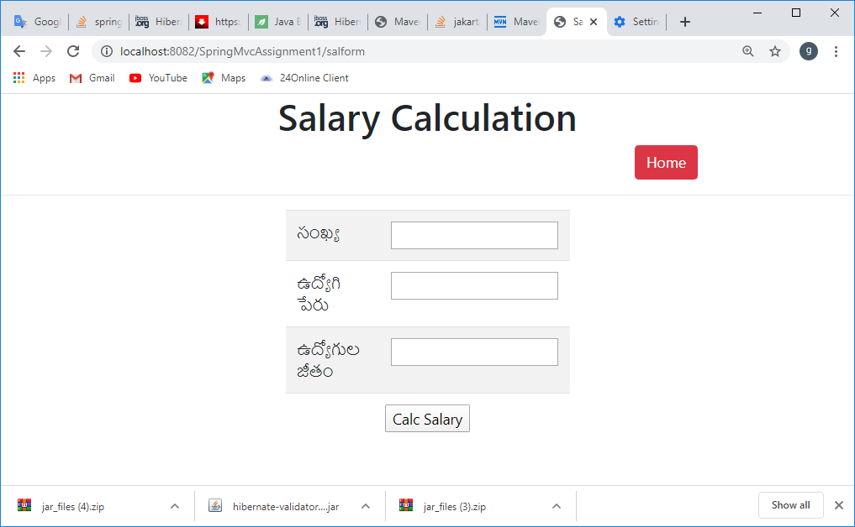

Again change the language setting to hindi in browser

Refresh the page

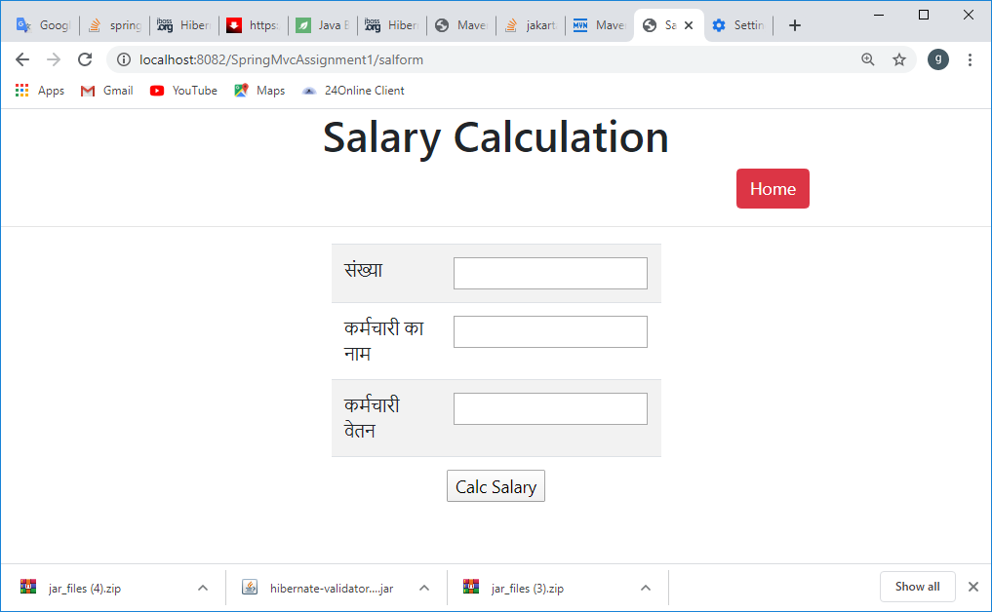

To do so

* Create the base/ default properties file in src folder.
  + cg.properties

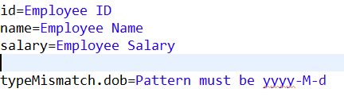

* Create the base_language.properies file
  + cg_te.properties

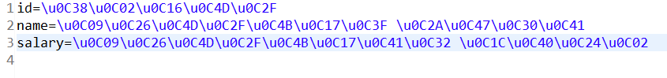

* + cg_hi.properties



* Translate using google translator and copy in .properties file, It will paste as universal char set say \u0938\u0902\u0916
* Configure ResourceBundleMessageSource bean in SpringMvc-servlet.xml

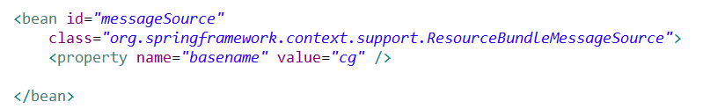

* In JSP
  + Change the charset into UTF-8
  + Reference the tag library
    - <[%@taglib uri=*"http://www.springframework.org/tags"* prefix=*"s"* %](%25@taglib%20uri=%22http://www.springframework.org/tags%22%20prefix=%22s%22%20%25)>
    - Instead hardcoding the captions and label, fetch from respective locale specific properties file <s:message code=”id”/>

SalFormPage.jsp

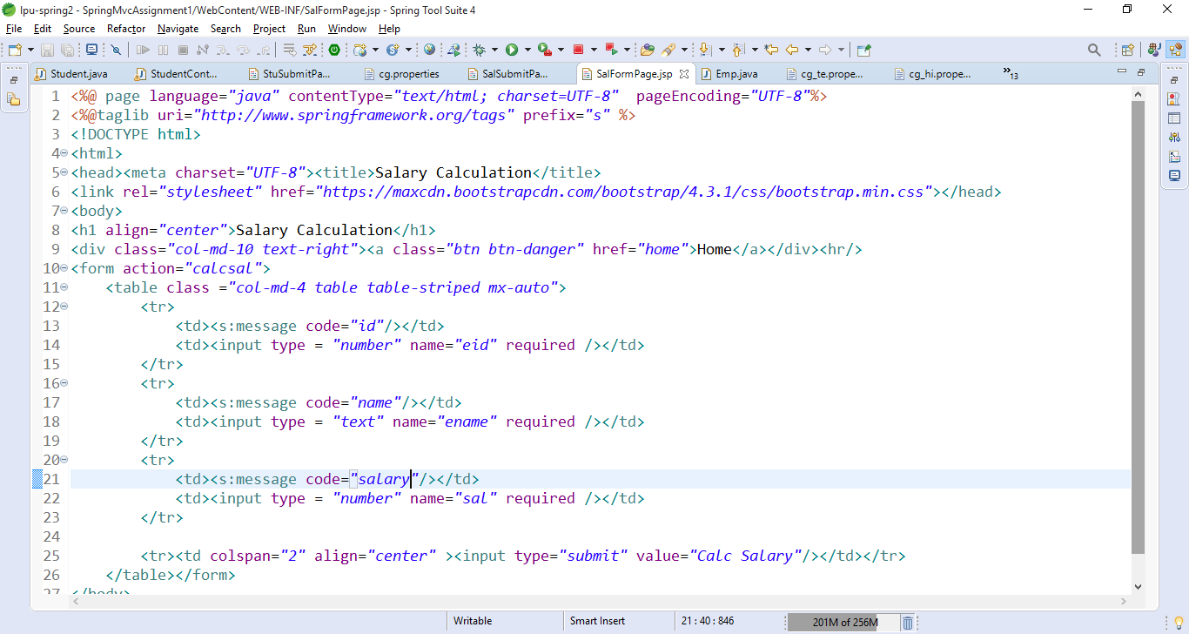

SalSubmit.jsp

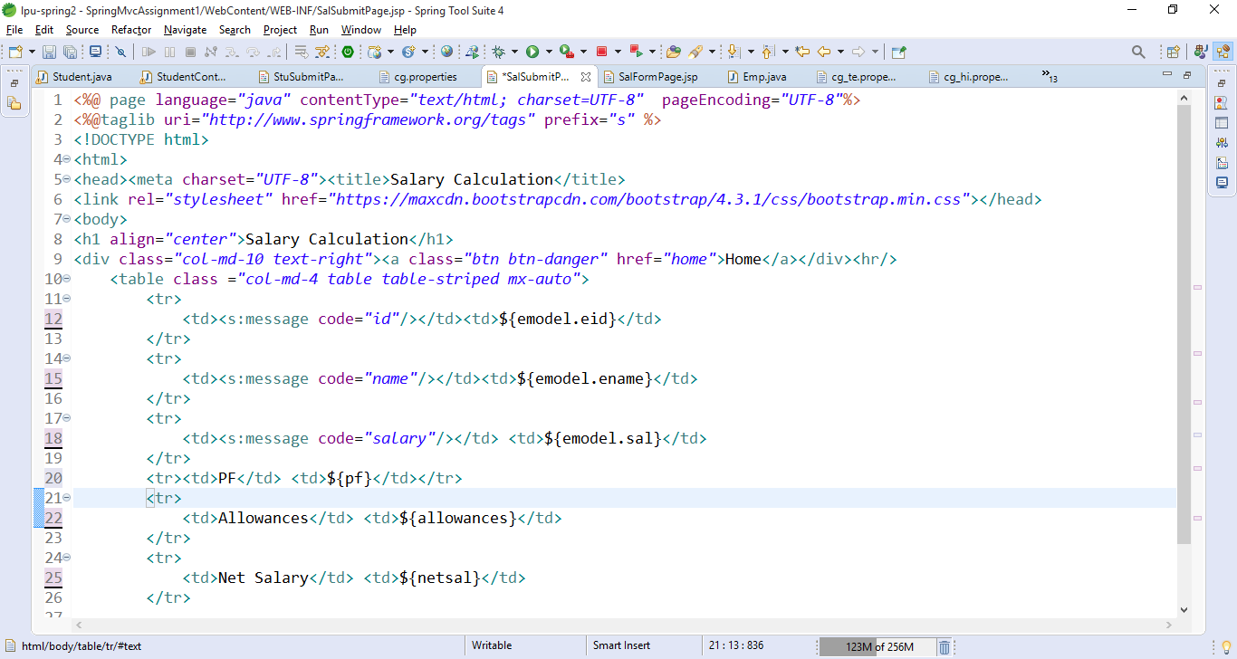

Spring Form Tags

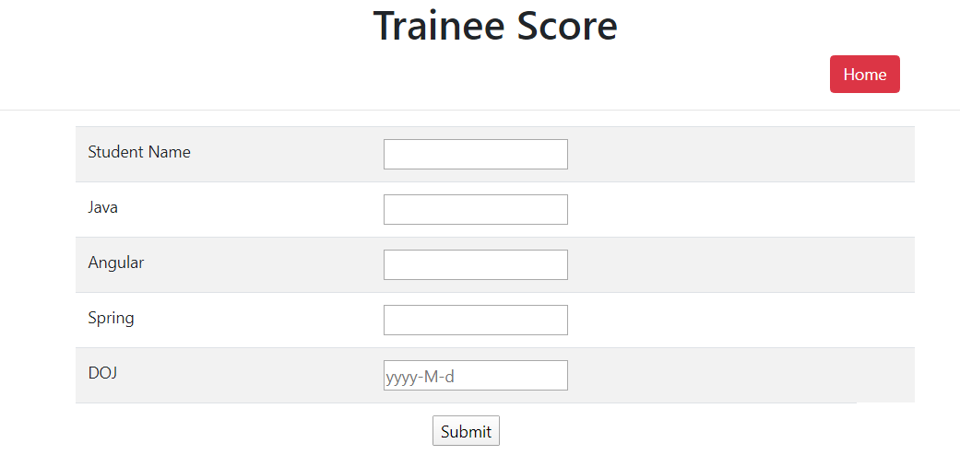

When submit with blank fields

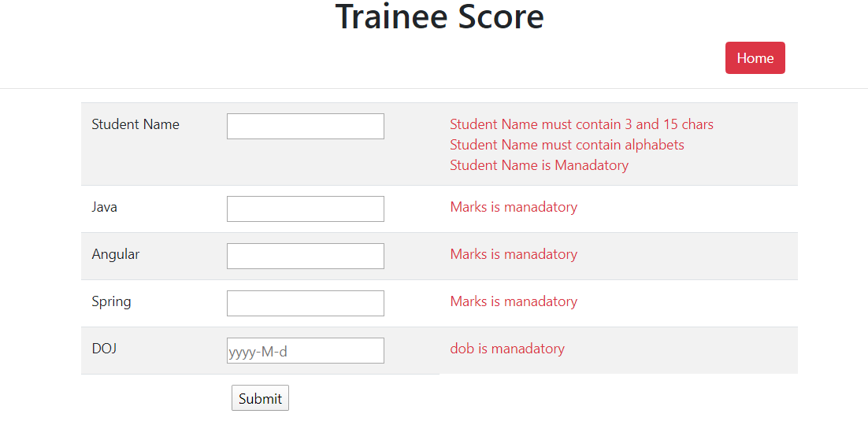

Enter correct data

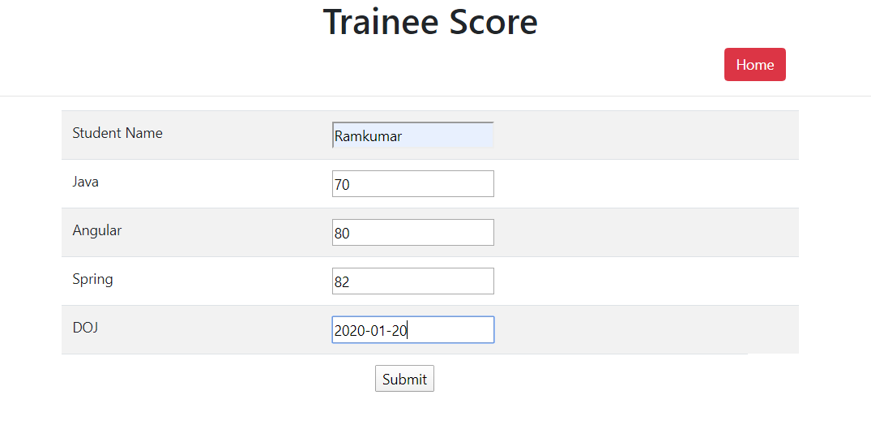

After entering the data click on submit button

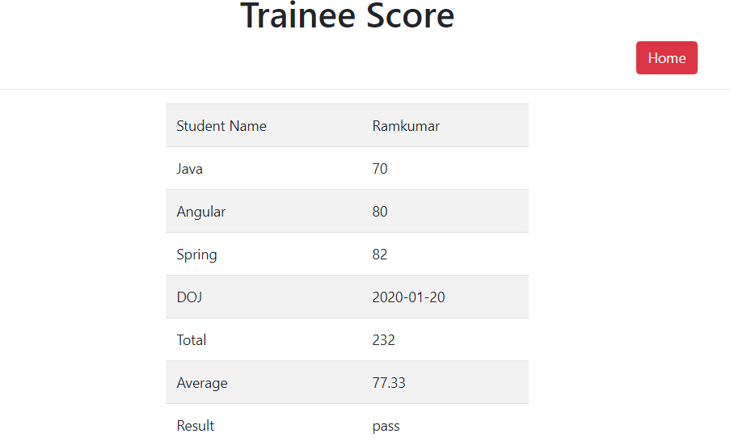

* Spring form tags are server side tags that can bind the parameters to the bean.
* It also displays the validation error messages if server side validation fails

|  |  |  |  |
| --- | --- | --- | --- |
| To display StuFormPage  Request 🡪 GET | /stuform | StudentController  Method🡪displayStuForm()  View🡪StuFormPage.jsp |  |
| After filling the student details and click on submit button | /stusubmit | Studentcontroller  Method=calcStuScore()  View 🡪StuFormPage.jsp if validation fails  View🡪StuSubmit.jsp, if validation passes | Parameters  stuName  javaMarks  angMarks  springMarks  doj |

Server side form/bean validation

* stuName must be required field, and it must contain alphabets and having 3 and 15 chars
* All the marks must be required field and having min is zero and max is 100
* DOJ field must be required and it contains past date and the pattern is yyyy-M-d
* Copy and paste 4 more jars in to lib folder
  + Hibernate-validator-6.0.2.Fianl.jar
  + Classmate-1.3.1.jar
  + Validation-api-2.0.0.Final.jar
  + Jboss-logging-3.3.0.Final.jar
* Create the Form bean, It can be the entity bean. Specify the bean validations using annotations at field level
  + Student.java 🡪 provide getters and setters

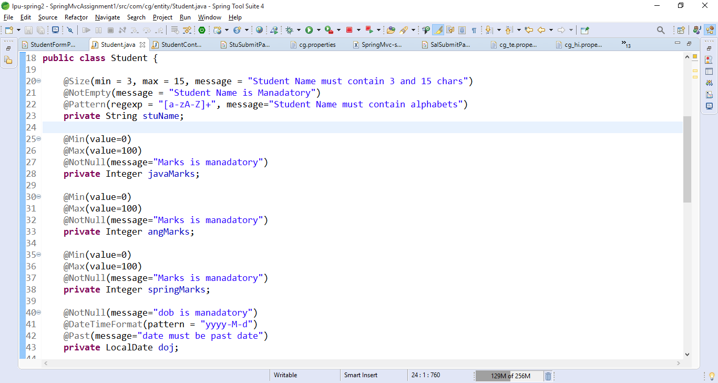

Create the Student Controller

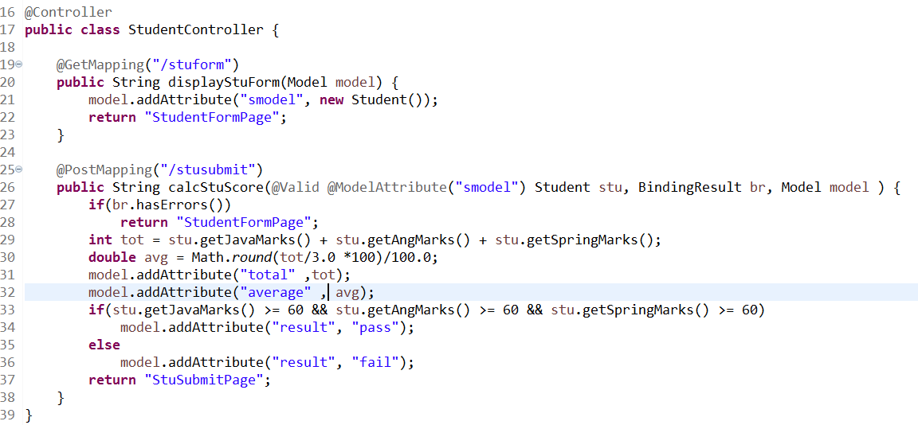

Create StuFormPage.jsp

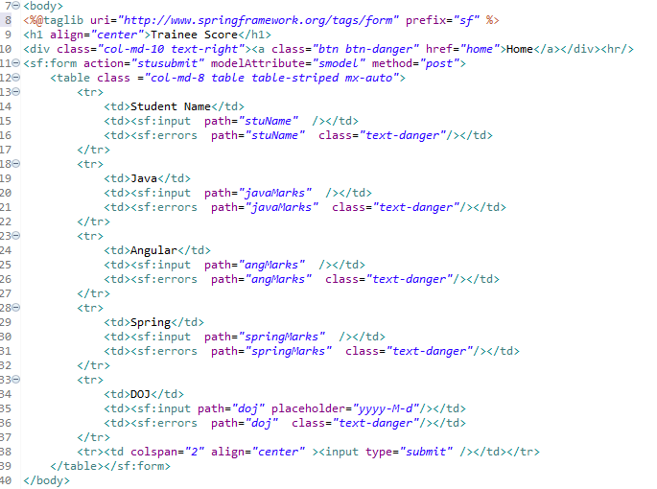

Create StuSubmitPage.jsp

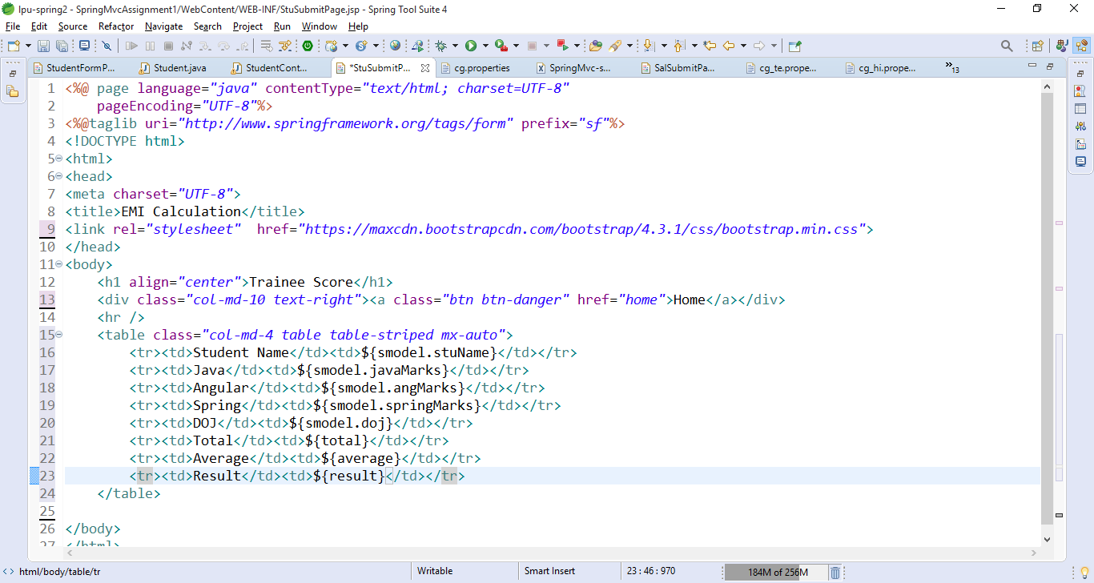

Finally add the Calculate Trainee Score link in home page

