Task 1:Develop a spring web mvc application for the following

* TO view all the accounts
* To add a new account
* To transfer fund
* Use Server side validations using spring form bean validations

Create a Spring starter project

* File🡪New 🡪Spring Starter Project
* Enter project name, select packaging🡪 war and package 🡪 com.cg
* Select the dependency 🡪 Spring web, Spring data jpa
* Add two more dependency 🡪 JSTL, Tomcat Embed Jasper

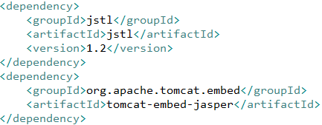

* Add server port, context-path, view resolver’s prefix and suffix and Jpa properties in application.properties
* Create the folder WEB-INF folder under webapp and have JSP files in it

**#configure server port**

server.port=8082

**#configure Context path**

server.servlet.context-path=/springmvctransferfund

**#configure prefix and suffix for the view resolver**

spring.mvc.view.prefix=/WEB-INF/

spring.mvc.view.suffix=.jsp

**#connection details for JPA with hibernate**

spring.datasource.driver-class-name=oracle.jdbc.driver.OracleDriver

spring.datasource.url=jdbc:oracle:thin:@localhost:1521:XE

spring.datasource.username=xe

spring.datasource.password=govind

**#Hibernate JPA Properties**

#spring.jpa.hibernate.ddl-auto=update

spring.jpa.show-sql=true

spring.jpa.properties.hibernate.dialect=org.hibernate.dialect.Oracle10gDialect

Account.java 🡪 Entity class

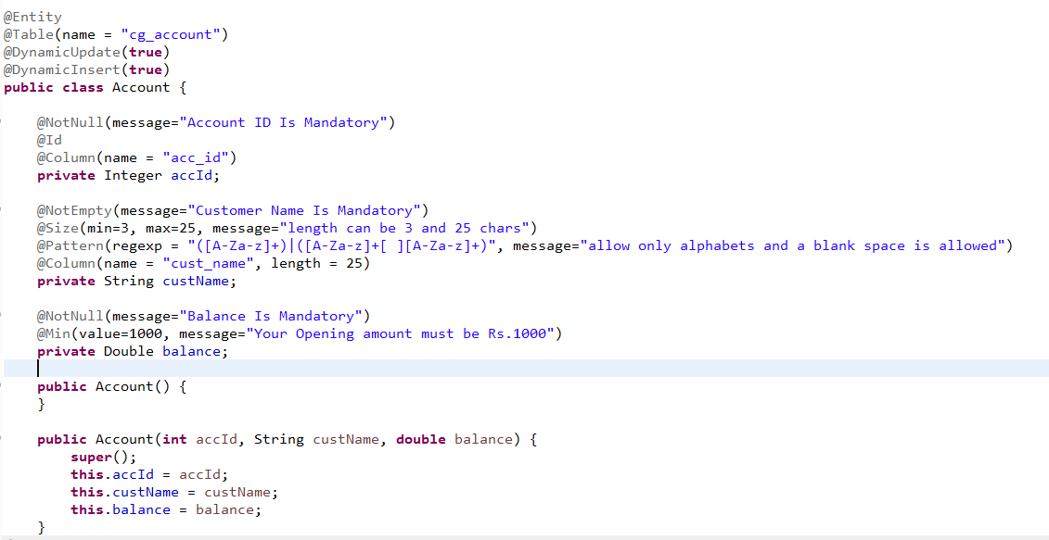

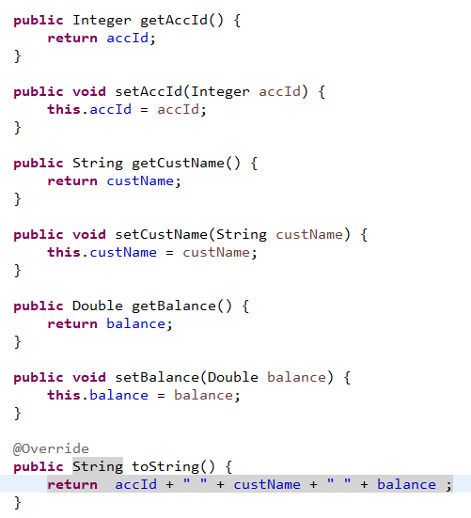

TransferBean 🡪 form bean

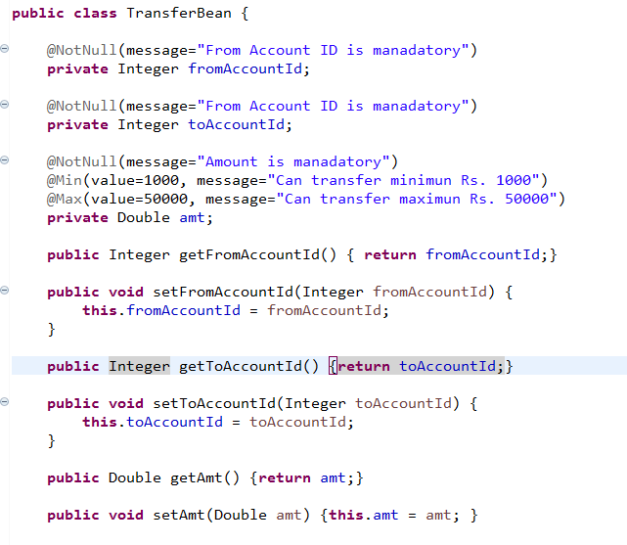

Operation1: Display Home page

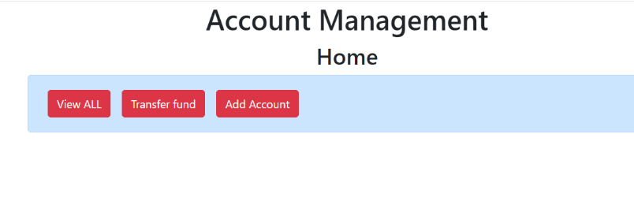

|  |  |  |
| --- | --- | --- |
| URI | Controller | Jsp |
| / or /home | HomeController | HomePage.jsp |

HomeController

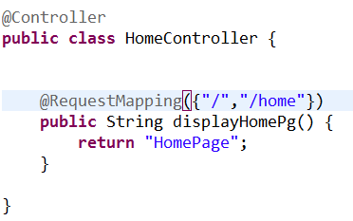

HomePage.jsp

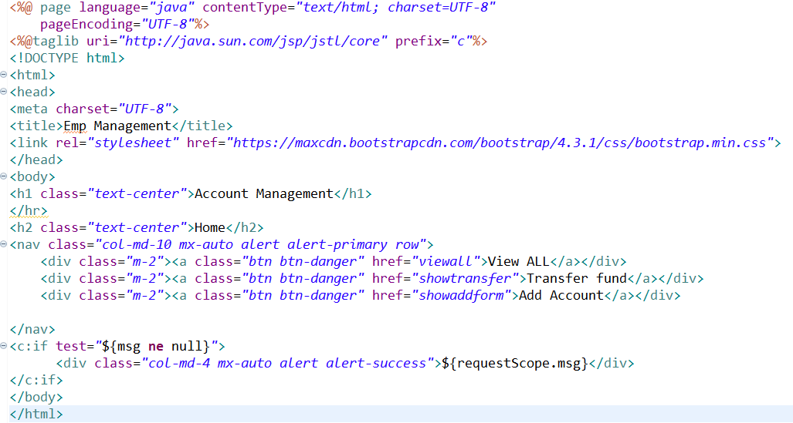

Operation 2: To view all accounts

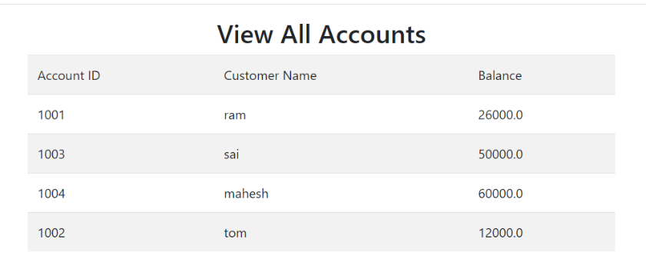

|  |  |  |
| --- | --- | --- |
| URI | Controller | View |
| /viewall | AccountController | AccountViewPage.jsp |

AccountController

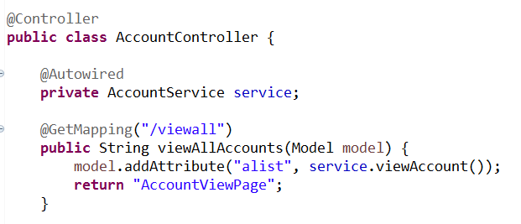

AccountViewPage.jsp

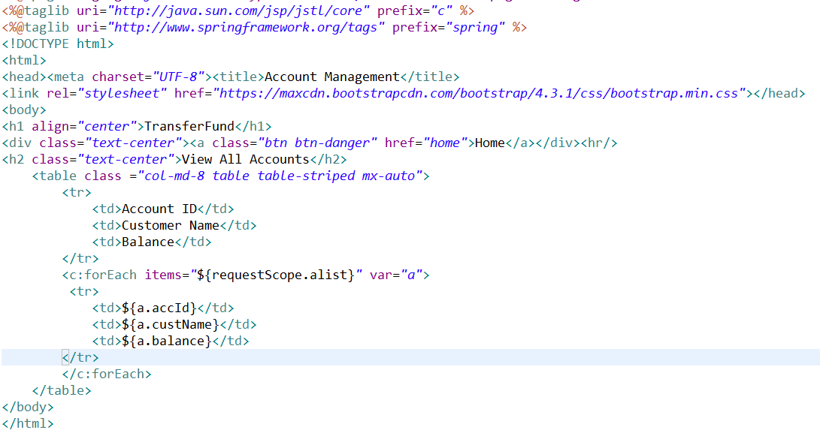

Operation 3:To add new Account

|  |  |  |
| --- | --- | --- |
| URI | Controller | View |
| /showaddform | AccountController | AddAccountPage.jsp |
| /add | AccountController | HomePage 🡪 Validation is successful  AddAccountPage 🡪If Validation fails or ID already exists |

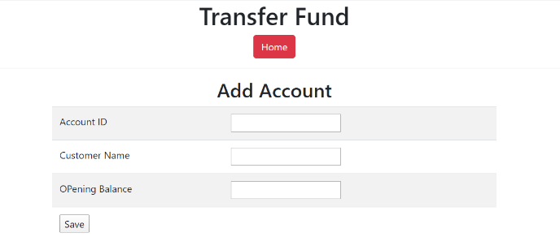

Without entering the data and click on save button

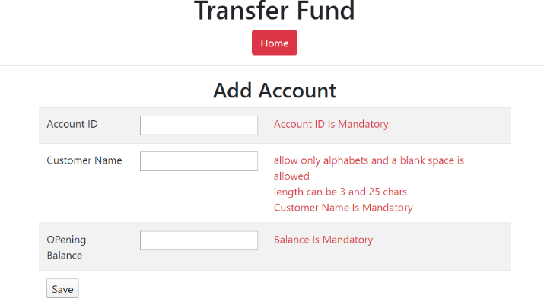

Enter the data for the account ID already exists and click on save button. If fails it must display the same page with the existing data entered by the user

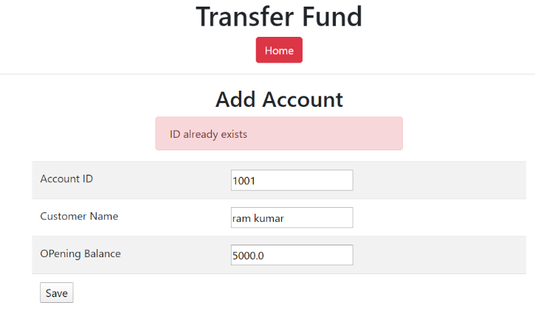

Enter correct data and click on save

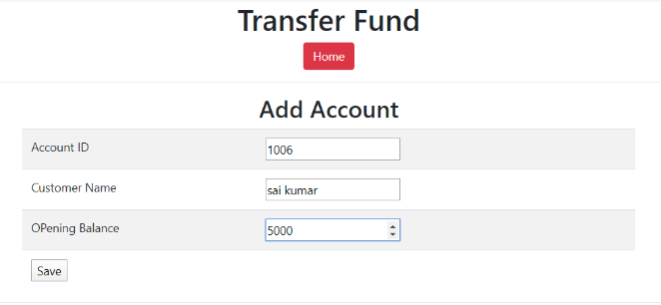

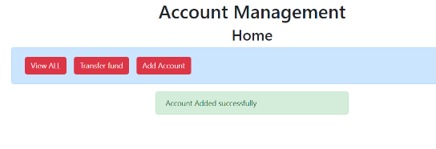

AccountController

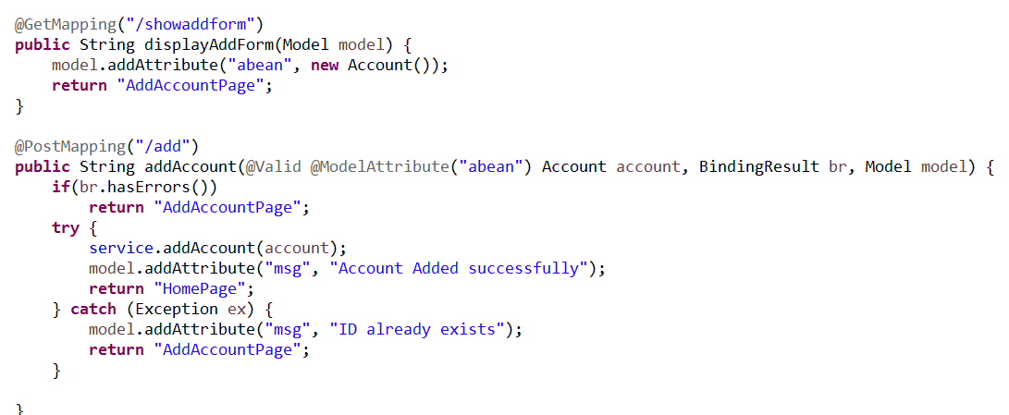

AddAcountPage.jsp

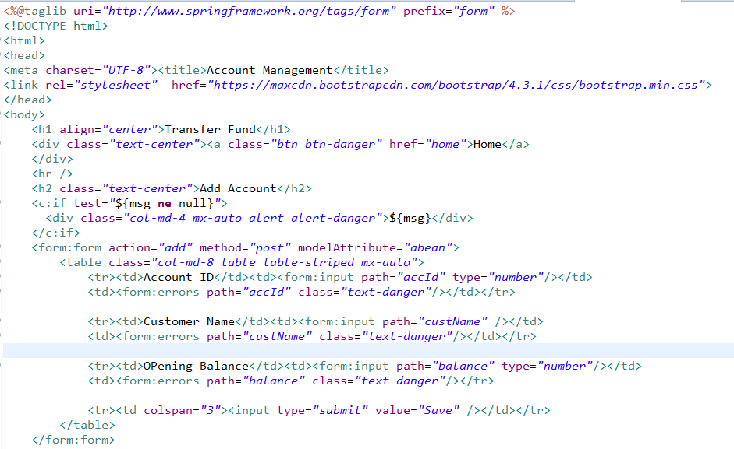

Operation 4:To transfer fund from one account to another account

|  |  |  |
| --- | --- | --- |
| URI | Controller | View |
| /showtransfer | AccountController | TransferformPage.jsp |
| /submittransfer | AccountController | HomePage.jsp 🡪If Successful  TransferformPage.jsp🡪If field validation fails/ Invalid account/ Insufficient balance |

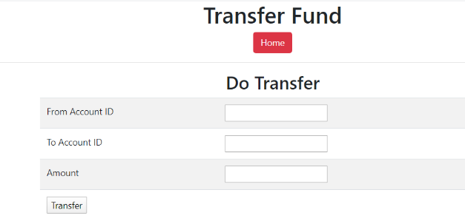

Without entering data and click on save

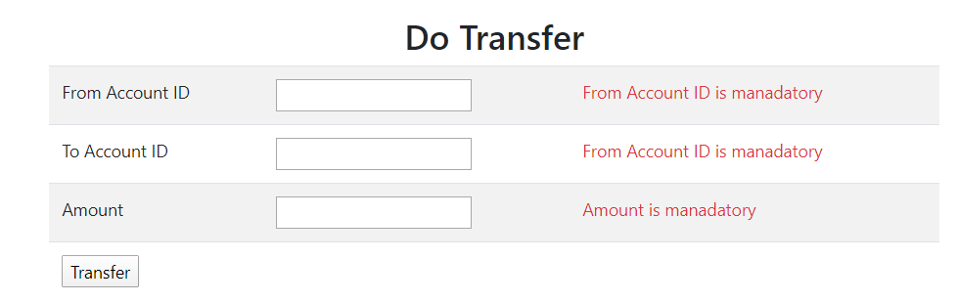

Enter Invalid Account ID and click on transfer, it must display the exception message in the same page and existing data of that page must be available

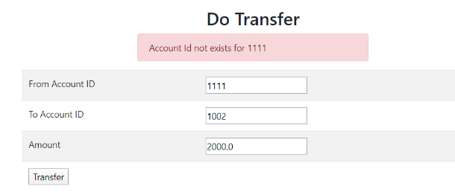

Checking for insufficient balance

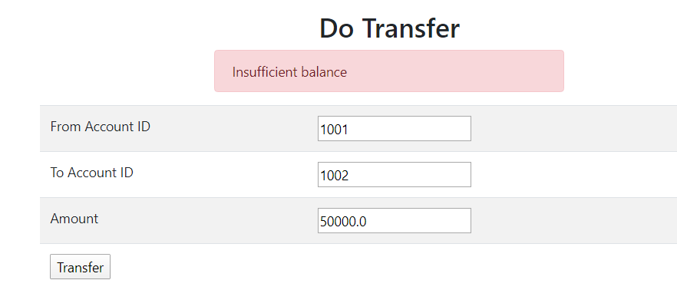

Enter correct data and click on transfer

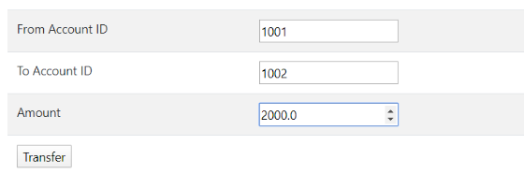

It must display the successful message in home page

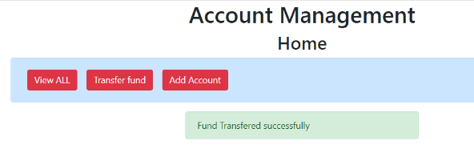

AccountController

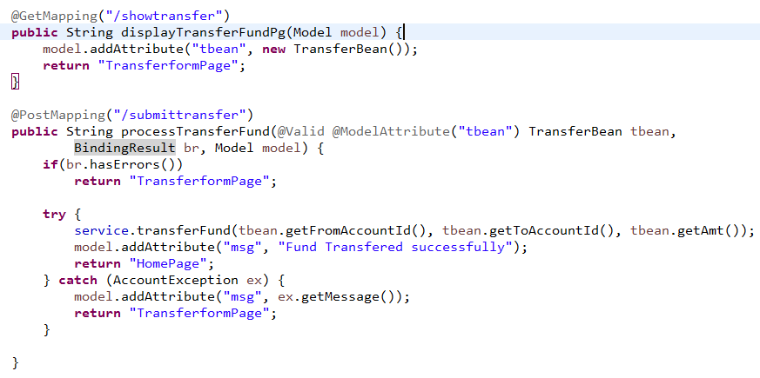

TransferformPage.jsp

