**Assignment-04(Selenium / Automation Testing)**

**Name:** Suhail Taank

**Student Id:** 8679275

**Date:** 20 November, 2019

**Rubric:**

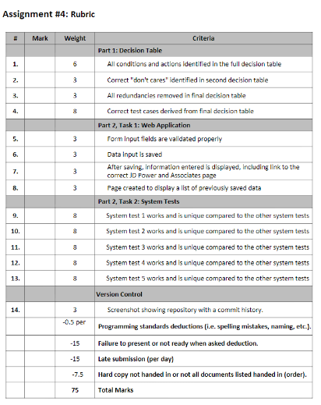

**Part 1: Decision Table**

**Do not care decision table:**

|  |  |  |  |  |  |  |  |  |  |  |  |  |  |  |  |  |  |
| --- | --- | --- | --- | --- | --- | --- | --- | --- | --- | --- | --- | --- | --- | --- | --- | --- | --- |
| **Stats** | **Conditions** | | | | | | | | | | | | | | | | |
| *Number of Accidents* | >=3, <3 | <3 | <3 | <3 | <3 | <3 | <3 | <3 | <3 | >=3 | >=3 | >=3 | >=3 | >=3 | >=3 | >=3 | >=3 |
| *Experience* | 0-9, >9, >2 | 0 years | 1-9 years | >=2 years | >9 years | 0 years | 1-9 years | >=2 years | >9 years | 0 years | 1-9 years | >=2 years | >9 years | 0 years | 1-9 years | >=2 years | >9 years |
| *Age* | >30, <30 | <30 | <30 | <30 | <30 | <30 | <30 | <30 | <30 | >30 | >30 | >30 | >30 | >30 | >30 | >30 | >30 |
| *No Insurance* |  |  |  |  |  |  |  |  |  | **X** | **X** | **X** | **X** | **X** | **X** | **X** | **X** |
| *Base Rate $3000* |  | **X** |  |  |  | **X** |  |  |  |  |  |  |  |  |  |  |  |
| *Base Rate $2000* |  |  | **X** |  |  |  | **X** |  |  |  |  |  |  |  |  |  |  |
| *Base Rate $1000* |  |  |  |  | **X** |  |  |  | **X** |  |  |  |  |  |  |  |  |
| *Reduction of 22%* |  |  |  | **X** |  |  |  |  |  |  |  |  |  |  |  |  |  |

|  |  |  |  |  |  |  |  |  |  |  |  |  |  |  |  |  |  |
| --- | --- | --- | --- | --- | --- | --- | --- | --- | --- | --- | --- | --- | --- | --- | --- | --- | --- |
| **Stats** | **Conditions** | | | | | | | | | | | | | | | | |
| *Number of Accidents* | >=3, <3 | <3 | <3 | <3 | <3 | <3 | <3 | <3 | <3 | >=3 | >=3 | >=3 | >=3 | >=3 | >=3 | >=3 | >=3 |
| *Experience* | 0-9, >9, >2 | 0 years | 1-9 years | >=2 years | >9 years | 0 years | 1-9 years | >=2 years | >9 years |  |  |  |  |  |  |  |  |
| *Age* | >30, <30 |  |  | <30 |  |  |  | <30 |  |  |  |  |  |  |  |  |  |
| *No Insurance* |  |  |  |  |  |  |  |  |  | **X** | **X** | **X** | **X** | **X** | **X** | **X** | **X** |
| *Base Rate $3000* |  | **X** |  |  |  | **X** |  |  |  |  |  |  |  |  |  |  |  |
| *Base Rate $2000* |  |  | **X** |  |  |  | **X** |  |  |  |  |  |  |  |  |  |  |
| *Base Rate $1000* |  |  |  |  | **X** |  |  |  | **X** |  |  |  |  |  |  |  |  |
| *Reduction of 22%* |  |  |  | **X** |  |  |  |  |  |  |  |  |  |  |  |  |  |

**Redundancy Decision Table**

|  |  |  |  |  |  |  |
| --- | --- | --- | --- | --- | --- | --- |
| **Stats** | **Entry** | | | | | |
| *Number of Accidents* | >=3, <3 | <3 | <3 | <3 | <3 | >=3 |
| *Experience* | 0-9, >9, >2 | 0 Years | 1-9 Years | >=2Years | >9Years | - |
| *Age* | >30, <30 | - | - | >30 | - | - |
| *No Insurance* |  |  |  |  |  | **X** |
| *Base Rate $3000* |  | **X** |  |  |  |  |
| *Base Rate $2000* |  |  | **X** |  |  |  |
| *Base Rate $1000* |  |  |  |  | **X** |  |
| *Reduction of 22%* |  |  |  | **X** |  |  |

**Test Cases:**

|  |  |  |
| --- | --- | --- |
| **Test Id** | **Test Steps** | **Expected Outcome(s)** |
| 1 | Age is 29, 2 accidents and experience of 12 years | Insurance of $1000 |
| 2 | Age is 33, 1 accident and experience of 15 years | Insurance of $2000 with 22% deduction |
| 3 | Age is 20, 2 accidents and experience of 7 years | Insurance of $2000 |
| 4 | Age is 36, 2 accidents and experience of 8 years | Insurance of $2000 and 22% deduction |
| 5 | Age is 30, 1 accident and experience of 2 years | Insurance of $2000 |
| 6 | Age is 28, 0 accident and no driving experience | Insurance of $3000 |
| 7 | More than 3 accidents | No Insurance |
| 8 | More than 3 accidents and 20 years of experience | No Insurance |