Unicode and structure

Chapter one
Ligatures ﬁ ﬂ; nonbreaking space; café résumé.
Curly “quotes” and apostrophe ’; en–dash em—dash; £ € ¥; ± × ÷ ≤ ≥ ≠ ∑.
العربية हिन्दी 中文 日本語 한국어
- First bullet
- First numbered item
Name | Qty | Total
Widget |  | 12.50
Merged label
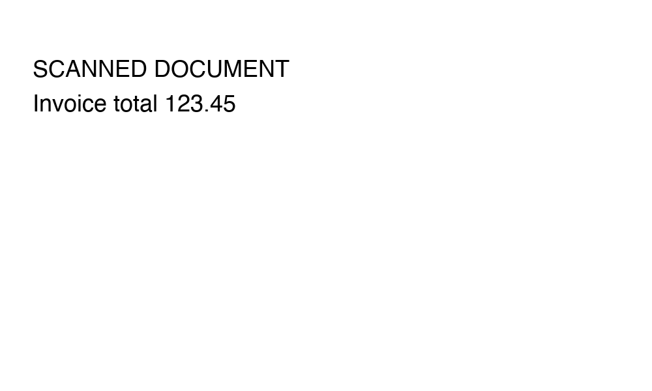
Figure 1: Embedded invoice

