SUPPLY CHAIN
DIAGNOSTIC REPORT
Product Portfolio Analysis — Skincare, Haircare & Cosmetics
Prepared for: Supply Chain & Operations Review
Report type: Diagnostic Analysis & Recommendations
Dataset: 100-SKU Supply Chain Extract (Skincare, Haircare, Cosmetics)
Prepared using Power BI–style diagnostic methodology

Table of Contents
1 Executive Summary 3
2 Scope, Objectives & Methodology 3
3 Revenue & Sales Performance 4
4 Cost Structure & Unit Economics 5
5 Lead Time & Quality Trade-offs 6
6 Supplier Quality Analysis 6
7 Quality Inspection Analysis 7
8 Logistics: Carriers & Transportation 8
9 Regional Performance 9
10 Risk Assessment & Data Limitations 9
11 Recommendations & Implementation Roadmap 10
A Appendix: Data Dictionary & Definitions 11

1. Executive Summary
This report presents a diagnostic analysis of a 100-SKU product portfolio spanning three categories — skincare, haircare, and cosmetics — covering revenue performance, unit economics, supplier quality, logistics, and regional distribution. The objective is to identify the operational bottlenecks with the greatest impact on cost, quality, and revenue, and to translate those findings into a prioritized set of recommendations.
$577,605  Total Revenue | $519,399  Total Profit* | 2.28%  Avg. Defect Rate | 16 days  Avg. Lead Time
*Profit = Revenue − Manufacturing costs − Shipping costs − Total costs, at portfolio level. See Section 4 for a unit-economics caveat that affects this figure.

Key Findings
- Skincare accounts for 41.8% of total revenue ($241,628), ahead of haircare (30.2%) and cosmetics (28%) — a concentration worth monitoring as a single-category risk.
- 44 of 100 SKUs (44%) are priced below their own recorded manufacturing cost, including one item priced at $4 against a $99 manufacturing cost. This is the single most consequential finding in this analysis (Section 4).
- Supplier 5 has the highest average defect rate at 2.67%, nearly 50% higher than the best-performing supplier.
- 36% of inspected units failed quality inspection outright, with failed units averaging a 2.57% defect rate — the highest of any inspection outcome (Section 7).
- Road transport shows the highest defect rate of any transportation mode (2.62%), while Air is both the cleanest (1.82%) and the most expensive.

2. Scope, Objectives & Methodology

2.1 Scope
This analysis covers the full 100-SKU dataset provided, spanning three product categories (skincare, haircare, cosmetics), five suppliers, five supplier locations, three shipping carriers, and four transportation modes. No rows were excluded, fabricated, or supplemented from outside sources.

2.2 Objectives
- Identify the primary sources of cost, quality, and delivery risk across the product portfolio.
- Compare performance across product categories, suppliers, carriers, and regions to surface actionable patterns.
- Translate findings into a prioritized, implementable set of recommendations.

2.3 Methodology
Data was cleaned and validated in Power Query (data types corrected, checked for nulls and duplicate SKUs — none found). Derived metrics were calculated as follows: Profit = Revenue generated − Manufacturing costs − Shipping costs − Total costs; Profit margin = Profit ÷ Revenue generated; Stock-to-sales ratio = Stock levels ÷ Number of products sold. All figures in this report are computed directly from the provided dataset using these definitions.

3. Revenue & Sales Performance
Revenue is concentrated in skincare, which generates more revenue than haircare and cosmetics combined would need to approach. This concentration means a supply disruption or quality incident in skincare would disproportionately affect total revenue relative to the other two categories.
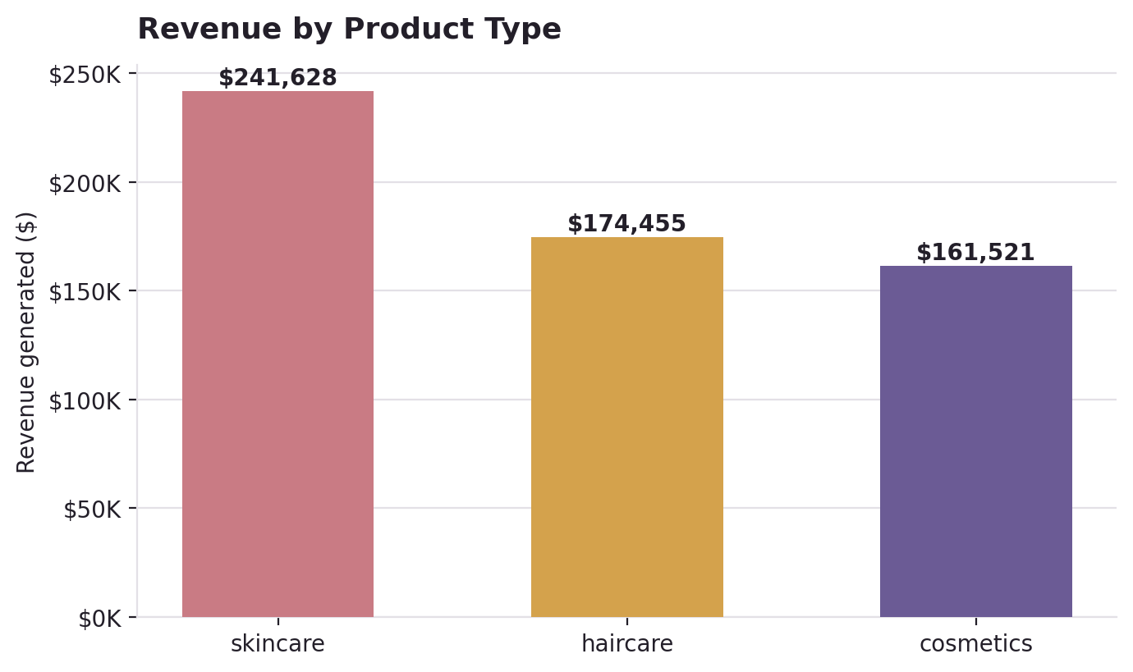
Figure 1. Total revenue generated by product type.

3.1 Category Economics at a Glance
Product Type | Revenue | Revenue Share | Avg. Margin | Avg. Mfg. Cost
Skincare | $241,628 | 41.8% | 86% | $49
Haircare | $174,455 | 30.2% | 85.3% | $48
Cosmetics | $161,521 | 28% | 87.3% | $43

4. Cost Structure & Unit Economics
Priority Finding
44 of 100 SKUs (44%) are priced below their recorded manufacturing cost per unit — an implausibly high proportion for a healthy retail portfolio, and the finding most worth validating against source systems before acting on it.
A direct comparison of unit price against manufacturing cost reveals that 44 SKUs (44% of the catalog) are priced below what they cost to manufacture on a per-unit basis. The most extreme case is SKU23 (cosmetics), priced at $4 against a manufacturing cost of $99 — a shortfall of over $94 per unit before any shipping or overhead is applied.
This pattern is broad enough that it is unlikely to reflect isolated pricing mistakes. Two explanations are worth investigating: (1) the "Manufacturing costs" field in source systems may represent a batch-level or amortized cost rather than a true per-unit cost, which would make this comparison misleading; or (2) unit pricing genuinely is not covering manufacturing cost for a meaningful share of the catalog, which would be a material margin issue. Either way, this is a data-validation and pricing-governance question that should be resolved before the portfolio-level profit figures in Section 1 are used for planning.
Separately, price shows only a weak relationship with manufacturing cost (correlation coefficient: -0.184) and almost no relationship with revenue generated (correlation coefficient: 0.038). In a portfolio with cost-reflective pricing, a stronger positive price–cost correlation would normally be expected.

4.1 Top 5 Highest-Cost SKUs to Manufacture
SKU | Product Type | Manufacturing Cost | Price
SKU7 | cosmetics | $99 | $43
SKU23 | cosmetics | $99 | $4
SKU13 | skincare | $98 | $16
SKU83 | haircare | $98 | $69
SKU15 | skincare | $97 | $37
Four of these five highest-cost-to-produce SKUs are also priced below their manufacturing cost, reinforcing the pattern above.

5. Lead Time & Quality Trade-offs
Plotting lead time against defect rate by product type shows no strong universal correlation, but haircare clusters toward both longer lead times and higher defect rates relative to cosmetics, which trends faster and cleaner on average.
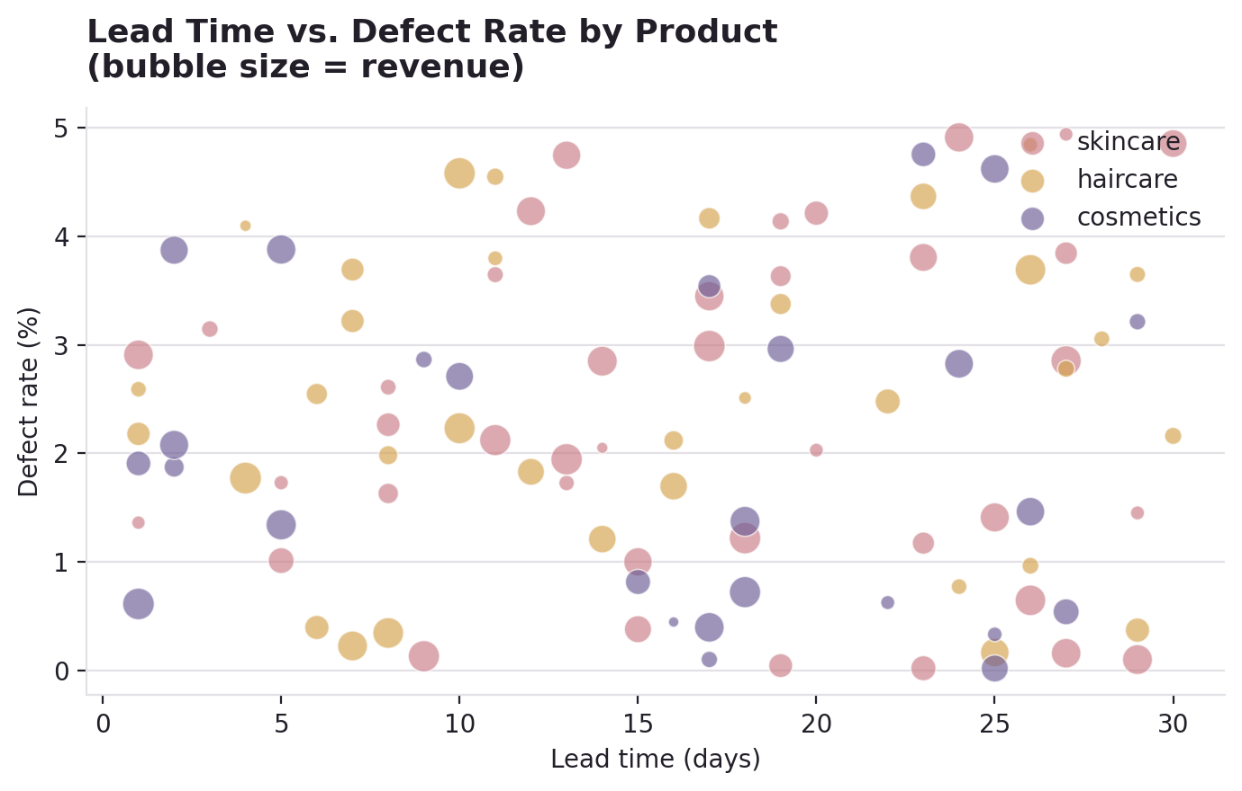
Figure 2. Lead time vs. defect rate, bubble size proportional to revenue per SKU.

6. Supplier Quality Analysis
Defect rate varies meaningfully by supplier — nearly a full percentage point separates the best and worst performers. Because defect rate directly affects returns, rework, and customer satisfaction, supplier-level quality is one of the most actionable levers identified in this analysis.
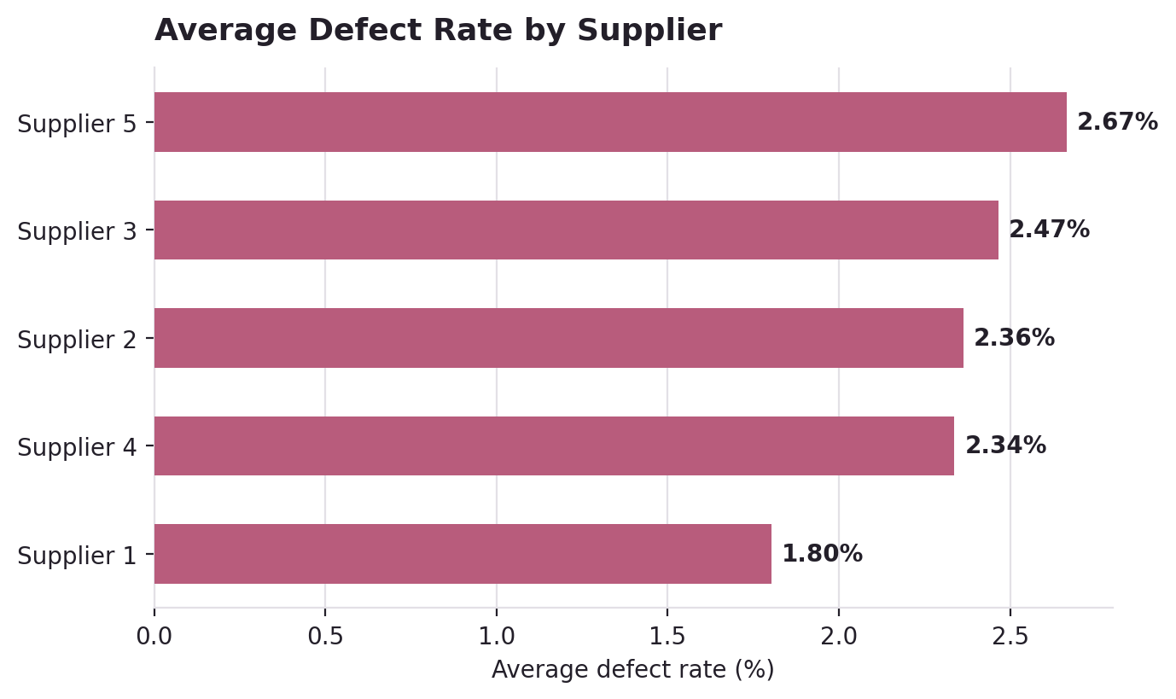
Figure 3. Average defect rate by supplier, worst to best.

7. Quality Inspection Analysis
Of all inspected units, 36 (36%) failed inspection outright, 23 (23%) passed, and 41 (41%) remain pending at the time of this data extract. Failed units carry the highest average defect rate (2.57%) of the three outcomes, which is directionally consistent — failed inspection should correlate with higher defects — but a 36% outright fail rate is high enough to warrant root-cause investigation rather than routine monitoring.

7.1 Inspection Outcomes by Product Type
Product Type | Fail % | Pass % | Pending %
Cosmetics | 38.5% | 23.1% | 38.5%
Haircare | 38.2% | 17.6% | 44.1%
Skincare | 32.5% | 27.5% | 40%
Haircare shows both the highest fail rate and the lowest pass rate of the three categories, aligning with its elevated defect rate noted in Section 5.

8. Logistics: Carriers & Transportation
Carrier B is the least expensive carrier on average shipping cost per order and simultaneously drives the highest total revenue of the three carriers — an efficient combination worth protecting contractually. Carrier C costs more on average without a corresponding revenue advantage.
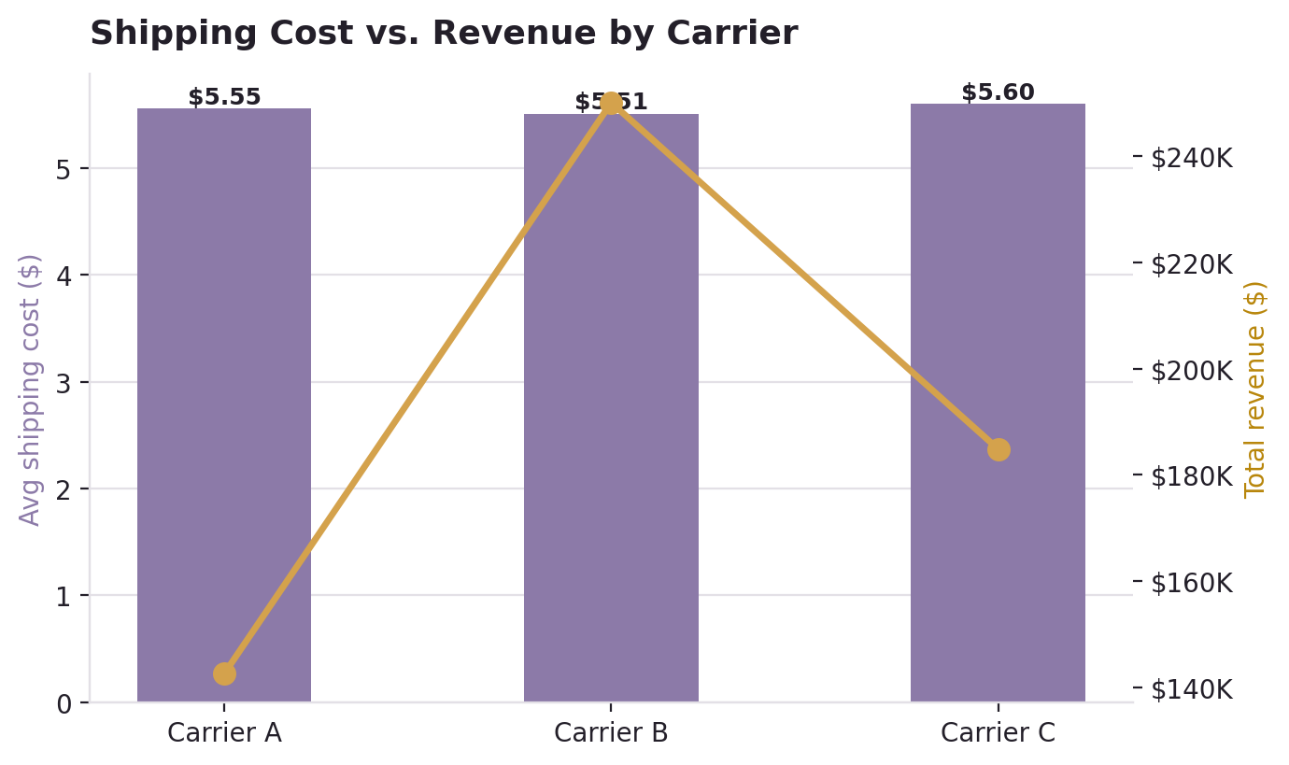
Figure 4. Average shipping cost (bars) vs. total revenue (line) by carrier.
Transportation mode also affects quality outcomes: Road shipments carry the highest defect rate of any mode, while Air — despite a higher per-shipment cost — is the cleanest.
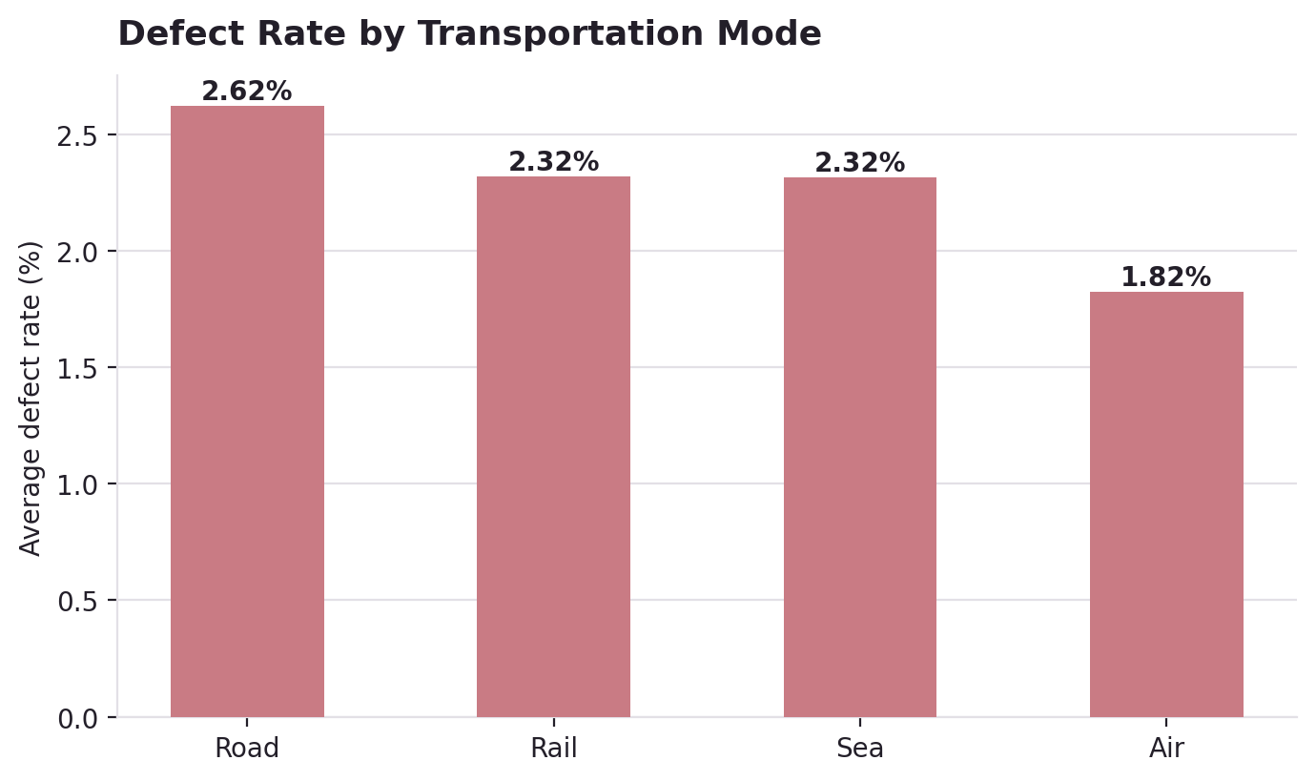
Figure 5. Average defect rate by transportation mode.

9. Regional Performance
Mumbai and Kolkata are the strongest-performing supplier locations by both revenue and profit, while Delhi lags meaningfully behind on both metrics — worth investigating whether this reflects supplier mix, product mix, or local logistics costs specific to that location.
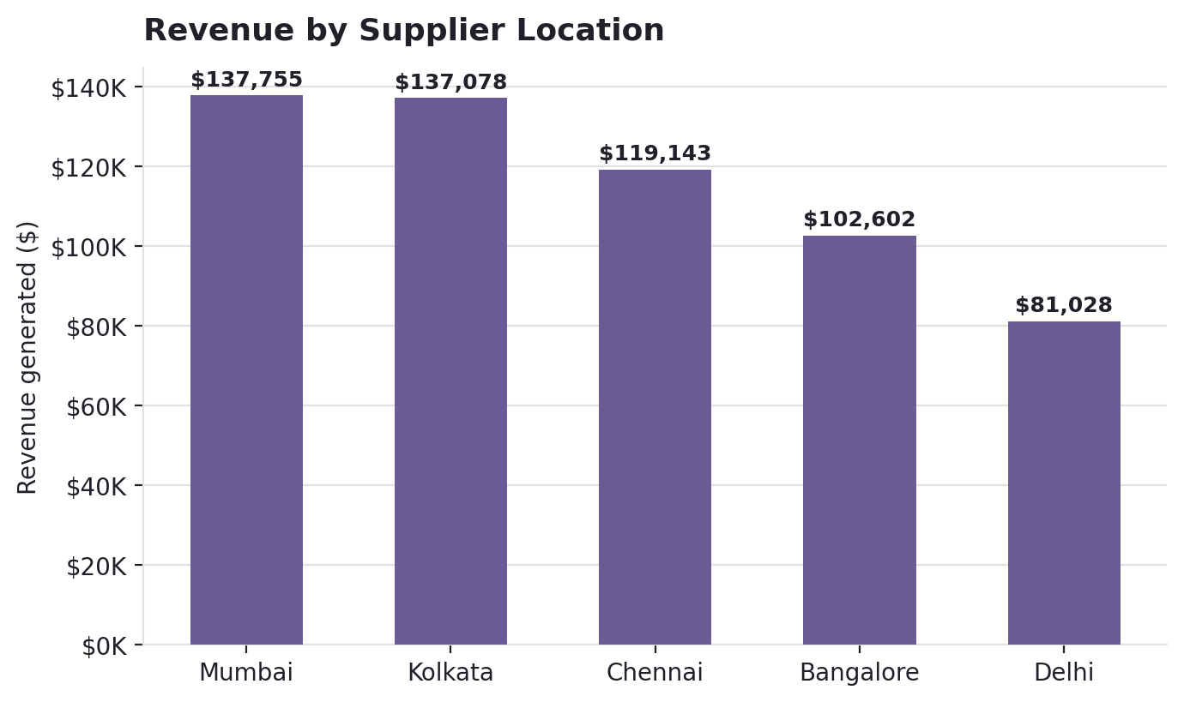
Figure 6. Total revenue generated by supplier location.
Location | Revenue | Profit
Mumbai | $137,755 | $127,386
Kolkata | $137,078 | $123,605
Chennai | $119,143 | $105,591
Bangalore | $102,602 | $90,822
Delhi | $81,028 | $71,995

10. Risk Assessment & Data Limitations
The findings in this report are based on a 100-SKU extract. Directional patterns (which supplier, carrier, or category underperforms) are likely to hold at scale, but exact percentages should be re-validated against the complete dataset before being used in financial planning.

10.1 Identified Risks
- Revenue concentration: skincare represents over 40% of revenue — a category-level disruption would have outsized impact.
- Unit economics data quality: the price-vs-manufacturing-cost anomaly in Section 4 affects the reliability of portfolio-level profit and margin figures until resolved.
- Supplier concentration risk: quality varies by up to 0.9 percentage points across only five suppliers, meaning a single underperforming relationship has outsized influence on portfolio-wide defect rate.
- Inspection backlog: 41% of units remain in "Pending" inspection status in this extract, which limits full visibility into true quality performance.

10.2 Assumptions
- Profit was derived using the formula in Section 2.3; no separate overhead, tax, or return-rate adjustments were available in the source data.
- "Location" is treated as supplier/manufacturing location, consistent with the data dictionary provided with the dataset.

11. Recommendations & Implementation Roadmap

1. Validate and resolve the unit-economics data anomaly
Before any pricing or margin decision is made from this data, reconcile the "Manufacturing costs" field against source ERP/costing systems to confirm whether it reflects true per-unit cost. If confirmed accurate, initiate an immediate pricing review for the 44 affected SKUs.

2. Audit and re-negotiate with the highest-defect supplier
Supplier 5 posts the highest average defect rate (2.67%) in the network. Recommend a formal quality audit within the next quarter, with a corrective action plan or phased volume reduction if defect rates do not improve within 90 days.

3. Investigate the root cause of the 36% inspection fail rate
A more than one-in-three outright fail rate is high enough to suggest a systemic issue rather than isolated defects — recommend a targeted root-cause review focused on haircare, which shows the weakest inspection outcomes of the three categories.

4. Shift a portion of haircare shipments off Road transport
Haircare combines an above-average defect rate with above-average stock-to-sales ratio, and Road transport shows the worst defect performance of any mode. Piloting Air or Rail for haircare's highest-value SKUs could reduce returns even after accounting for higher freight cost.

Implementation Roadmap
# | Action | Priority | Timeframe | Owner
1 | Validate unit-economics data anomaly | Critical | 2 weeks | Finance / Data
2 | Supplier quality audit & corrective plan | High | 1 quarter | Procurement
3 | Root-cause review of inspection fail rate | High | 6 weeks | Quality Assurance
4 | Pilot alternate transport for haircare | Medium | 1 quarter | Logistics

Appendix: Data Dictionary & Definitions
Field | Definition
Product type | Product category: skincare, haircare, or cosmetics
Price | Unit retail price
Revenue generated | Price × Number of products sold
Manufacturing costs | Recorded per-unit cost to manufacture (see Section 4 caveat)
Lead times | Days from order placement to product availability
Defect rates | Percentage of units failing quality standards
Stock-to-sales ratio | Stock levels ÷ Number of products sold (derived)
Profit (derived) | Revenue − Manufacturing costs − Shipping costs − Total costs

