**Assignment – 4**

Module–4(Automation Core Testing {Load runner and selenium IDE})

1. Which components have you used in Load Runner?

There are mainly three components of load runner:

1. Virtual user generator(VUGEN)

It records Vuser scripts that emulate the step of real users using the application.

1. Controller

It is an administrative centre for creating, maintaining, and executing scenarios .starts and stops load tests, and perform other administrative tasks

1. Analyser

Uses the load test results to create graphs and reports that are used to correlate system information and identify both bottlenecks and performance issues.

2. How can you set the number of Vusers in Load Runner?

In HP Load Runner (now Micro Focus Load Runner), setting the number of Vusers involves configuring scenarios in the Load Runner Controller. Here's a step-by-step guide:

1. **Open Load Runner Controller**: Launch the Load Runner Controller application.
2. **Create or Open a Scenario**: You can either create a new scenario or open an existing one.
3. **Define Vuser Groups**: In the scenario, define one or more Vuser groups. A Vuser group represents a collection of Vusers that emulate the actions of a group of real users.
4. **Assign Scripts to Vuser Groups**: For each Vuser group, assign the scripts that you want to simulate. These scripts contain the actions that Vusers will perform during the load test.
5. **Set Vuser Properties**: Configure the properties of each Vuser group, including the number of Vusers. You can specify whether the number of Vusers remains constant throughout the test or if it varies according to specific parameters.
6. **Set Ramp-Up and Ramp-Down**: Optionally, you can set the ramp-up and ramp-down periods for your Vusers. The ramp-up period determines how gradually Vusers are launched at the beginning of the test, while the ramp-down period specifies how gradually they are stopped at the end of the test.
7. **Execute the Scenario**: Once you've configured the scenario with the desired number of Vusers and other settings, you can execute the scenario. Load Runner will start simulating the specified number of Vusers according to the defined configuration.
8. **Monitor the Test**: During the test execution, you can monitor various performance metrics, such as response times, throughput, and resource utilization, to evaluate the behaviour of your system under load.

By following these steps, you can effectively set the number of Vusers in HP Load Runner and conduct performance tests to assess the scalability and reliability of your application under different loads.

3. What is Correlation?

Correlation in Load Runner is a critical process that ensures the smooth execution of scripts during load testing. It handles the dynamic nature of client-server communication, making scripts more robust and reliable.

4. What is the process for developing a Vuser Script?

Developing a Vuser script in Load Runner involves several steps to accurately simulate user actions and interactions with your application. Here's a general process:

1. **Recording**:
2. **Enhancing the Script**:
3. **Parameterization**:
4. **Verification**:
5. **Checkpoints**:
6. **Parameterization and Load Distribution**:
7. **Script Execution**:
8. **Analysis**:

By following these steps, you can develop effective Vuser scripts in Load Runner to simulate realistic user behaviour and evaluate the performance of your application under different load conditions.

Top of Form

Bottom of Form

5. How Load Runner interacts with the application?

Load Runner simulates user activity by generating messages between application components or by simulating interactions with the user interface such as key presses or mouse movements. The messages and interactions to be generated are stored in scripts.

6. How many VUsers are required for load testing?

Minimum 2 and maximum 50 VUsers required for load testing display in the screen shot below , still every version may differ their capacity.

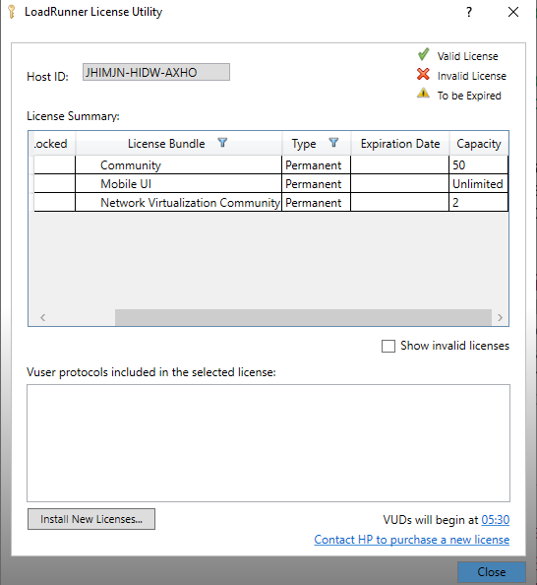

7. What is the relationship between Response Time and Throughput?

In general, there is an inverse relationship between response time and throughput. When the system is under load, increasing throughput often leads to an increase in response time, and vice versa.

8. To test the Performance testing on

<https://www.saucedemo.com>

1. To Record all top level menu

2. To Record minimum 10 Vuser on this website

3. Save all (Script,Design,Graph)

<https://github.com/suhamali04/Suha-Manual-Testing/tree/main/Assignment/Assignment4Practicle/Assignment4_Qustion8_SauceDemo>

9. Create a normal script of above website with correlate using hp default website (HP web tours application).

https://github.com/suhamali04/Suha-Manual-Testing/tree/main/Assignment/Assignment4Practicle/Assignment4_Question9_webtour

Selenium IDE)

10. What is Automation Testing?

Automated testing is the application of software tools to automate a human-driven manual process of reviewing and validating a software product. Most modern agile and DevOps software projects now include automated testing from inception.

11. Which Are The Browsers Supported By Selenium Ide?

Currently, Firefox, Chrome, Edge, IE, and Safari are supported by selenium Ide.

12. What are the benefits of Automation Testing?

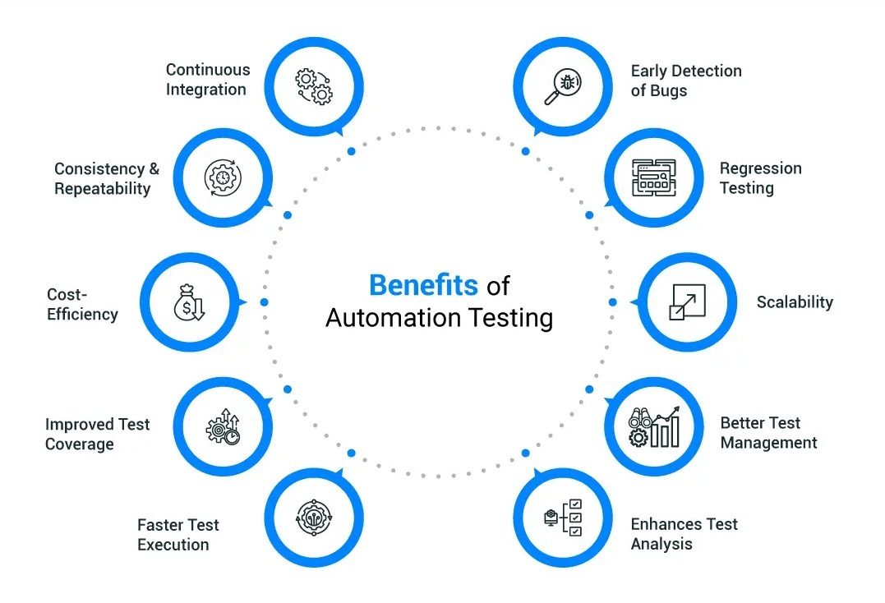

13. What are the advantages of Selenium?

1) Language and Framework Support.

2) Open Source Availability.

3) Multi-Browser Support.

4) Support across Various Operations.

5) Ease of Implementation.

6) Reusability and Integrations.

7) Flexibility.

8) Parallel test execution and faster market launch.

14. Why testers should opt for Selenium and not QTP?

|  |  |
| --- | --- |
| **QTP(Quick test professional)** | **Selenium** |
| Commercial tool and you have to purchase the license. | It is an Open source tool. |
| Supports VBScript | Supports Java, C#, Ruby, Python, Perl, PHP and JavaScript |
| Works only on Windows | Works on Windows, macOS, Linux, UNIX |
| Internet Explorer, Mozilla Firefox, Google Chrome, Apple Safari are supporting browsers | Runs across all major browsers |
| Support mobile devise using 3rd party software only | Support mobile devices. |
| Can only execute in parallel but using quality centre which is again a paid product | Can execute tests in parallel |

15. To validate side menu” <https://www.saucedemo.com>

<https://github.com/suhamali04/Suha-Manual-Testing/blob/main/Assignment/Assignment4Practicle/Assignment4_Q15_SeleniumSauceDemo.side>