Assignment – 3
Module–3(Testing on live application)

1. What is RDBMS?

Relational database management system (RDBMS) is a program that allows you to create, update, and administer a relational database. Most relational database management systems use the SQL language to access the database.

2. What is SQL?

SQL is Structured Query Language which is a programming language used to communicate with data stored in a relational database management system. SQL syntax is similar to the English language, which makes it relatively easy to write, read, and interpret.

3. Write SQL Commands?

SQL commands are the instructions used to communicate with a database to perform tasks, functions, and queries with data.
There are mainly four types of SQL Commands used:

- DDL (Data Definition Language)
- DML (Data Manipulation Language)
- DCL (Data Control Language)
- DQL (Data Query Language)

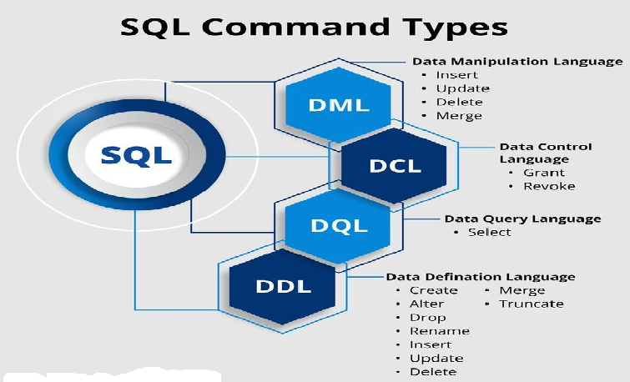

4. What is join?
A Join clause is used to combine rows from two or more tables, based on a related column between them.
5. Write type of joins.
Here are the different types of the JOINs in SQL:
- (INNER) JOIN: Returns records that have matching values in both tables
- LEFT (OUTER) JOIN: Returns all records from the left table, and the matched records from the right table
- RIGHT (OUTER) JOIN: Returns all records from the right table, and the matched records from the left table
- FULL (OUTER) JOIN: Returns all records when there is a match in either left or right table
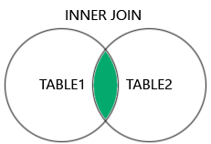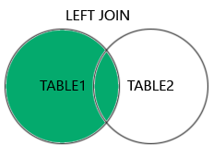

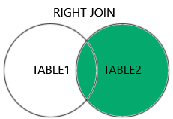

6. How Many constraint and describes it self

Constraints are the rules that we can apply on the type of data in a table. That is, we can specify the limit on the type of data that can be stored in a particular column in a table using constraints.
The available constraints in SQL are:
NOT NULL: This constraint tells that we cannot store a null value in a column. That is, if a column is specified as NOT NULL then we will not be able to store null in this particular column any more.

UNIQUE: This constraint when specified with a column, tells that all the values in the column must be unique. That is, the values in any row of a column must not be repeated.

PRIMARY KEY: A primary key is a field which can uniquely identify each row in a table. And this constraint is used to specify a field in a table as primary key.

FOREIGN KEY: A Foreign key is a field which can uniquely identify each row in another table. And this constraint is used to specify a field as foreign key.

CHECK: This constraint helps to validate the values of a column to meet a particular condition. That is, it helps to ensure that the value stored in a column meets a specific condition.

DEFAULT: This constraint specifies a default value for the column when no value is specified by the user.

7. Difference between RDBMS vs DBMS

RDBMS | DBMS
RDBMS stands for Relational database management system. | DBMS stands for Database management system
RDBMS stores data in tabular form. | DBMS stores data as file.
Multiple data elements can be accessed at the same time. | Data elements need to access individually.
Data is stored in the form of tables which are related to each other. | No relationship between data.
It deals with large amount of data. | It deals with small quantity of data.
Data fetching is fast because of relational approach. | Data fetching is slower for the large amount of data.
Examples: MySQL, SQL server, Oracle, Microsoft Access etc. | Examples: XML, Window Registry, FoxPro etc.

9. Types of API

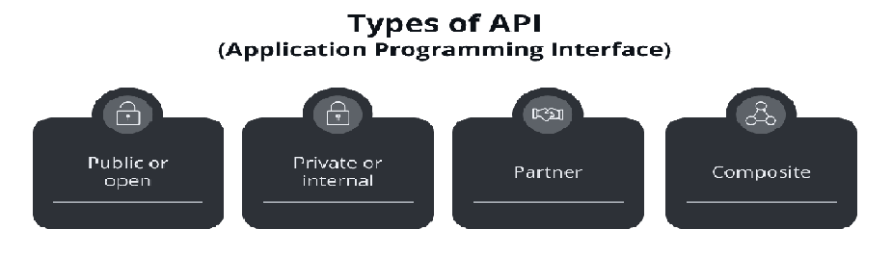

Public/Open APIs
Public APIs, also known as external or open APIs, are APIs made available to developers, businesses, and the public by companies, organizations, or platforms. These APIs provide access to certain functionalities or data that the API provider exposes to external users or third-party developers. You can access these APIs via a form of authentication – usually an API key.
Some public APIs are free while others require a payment based on the number of times the API is called. An example of a paid public API is the Google Translate API, which costs $20 for every 1 million characters translated.

Private/Internal APIs
Internal APIs, also called private APIs or in-house APIs, are developed to be used within an organization. These APIs serve as the communication bridge between different components, services, or applications within a company and are not intended for external access or use by third parties. While internal APIs are flexible in their documentation and naming conventions, as they usually don’t follow the Open API standard they are generally less secure than other types of APIs.

Partner APIs
Partner APIs are also called external APIs. These APIs facilitate communication and data exchange between different businesses, organizations, or entities and enable controlled access to certain functionalities, services, or data between partnering companies.
Imagine a partnership between a cloud-based accounting software and a payment processing company. A partnership API allows the software to integrate with the payment processor’s services. The payment company provides the API to multiple companies in this way.

Composite APIs
Composite APIs allow you to execute multiple API requests into a single call. So, in short you can perform complex operations with a single call, reducing the number of round trips to the server and improving performance. Composite APIs are particularly useful for scenarios where multiple API calls are tightly related and need to be executed in a specific sequence.
Think of an e-commerce website. There are multiple steps to making a purchase: Search for a product, Click on the result, Add to cart, Checkout. Rather than execute each call separately, it is more efficient to combine and execute them at once

10. What is Responsive Testing?

Responsive testing involves how a website or web application looks and behaves on different devices, screen sizes, and resolutions. The goal of responsive testing is to ensure that the website or web application can be used effectively on various devices, including desktops, laptops, tablets, and smartphones.

11. Which types of tools are available for Responsive Testing?

There are many types of testing tools available in the market like:
L T Browser, Lambda testing, Google resizer, Am I Responsive, Pixel tuner.

12. What is the full form of .ipa, .apk?

.ipa and .apk these both are the extension of mobile applications.
IPA = IPhone application.
APK= Android application packages.

13. How to create step for to open the developer option mode ON?

For Android:
Go to Settings > about phone > Scroll down to Build number Tap Build number seven times

For IPhone:
Go to Settings > Privacy & Security> Navigate to the Developer Mode> Switch to the developer mode, by enabling the toggle

