**SECOND SMALLEST**

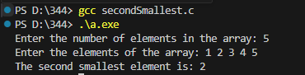

**SECOND LARGEST**

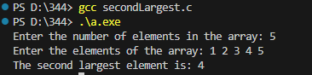

**MATRIX SUM LEFT DIAGONALS**

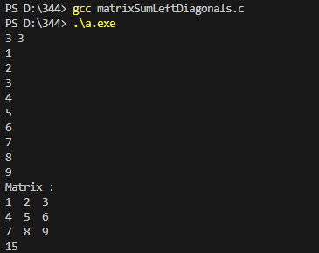

**MATRIX SUM**

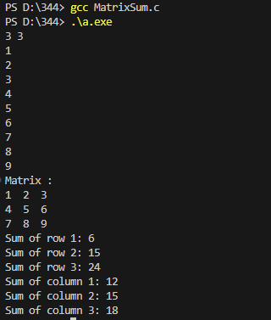

**DELETE ELEMENT**

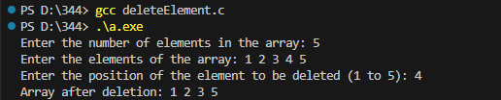

**COUNT DUPLICATES**

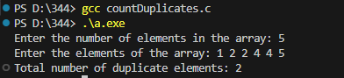

**FCFS**

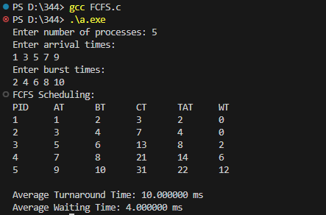

**SJF**

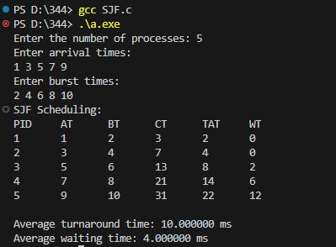

**PRIORITY**

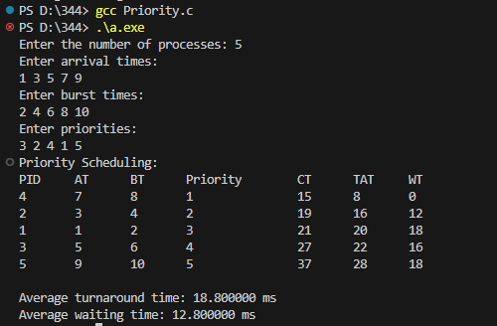

**ROUND ROBIN (RR)**

